PERFECT STEPS PUBLISHERS
END TERM EXAMS 2015
0721 745374/ 0721 707626 NAIROBI
NAME..............................................................................................ADM........................................
AGRICULTURE EXAMINATION FORM THREE
Section A (80 marks)
Answer all the questions in this section in the spaces provided
- List three methods of treating water for use on the farm
................................................................................................................................................................................................................................................................................................(3mks)
- State two disadvantages of plastic pipes
..................................................................................................................................................................................................................................................................................................(2mk)
- State four disadvantages of communal land tenure system
......................................................................................................................................................................................................................................................................................................................................................................................................................................................(4mks)
- Give two ways in which gabions control soil erosion
..............................................................................................................................................................................................................................................................................................(2mk)
- List two types of farm structures that are used in propagation of plants .................................................................................................................................................................................................................................................................................................................................................................................................................................................... (2mks)
- Give two forms in which nitrogen is absorbed from the soil by crops
.................................................................................................................................................................................................................................................................................................................................................................................................................................................... (2mks)
- Give a reason for carrying out Pricking out on nursery bed.
..................................................................................................................................................................................................................................................................................................(1mk)
- Study the table below and fill in the missing words ( 3mks)
Description | Cattle | Pigs | Poultry
Young from birth/ hatching to weaning | ……….. | ………….. | Chick
Young female before first parturition | ……….. | Gilt | …………
Mature male for breeding | Bull | …………. | …………..

9 Name two viral diseases that affect each of the following livestock:
(a) Cattle ................................................................................ (1mk)
(b) Poultry.......................................................................................................(1mk)
10a) Give four reasons for feeding a lamb with colostrums
................................................................................................................................................................................................................................................................................................................................................................................................................................................(2mks)
b) State four advantages of artificial insermination
........................................................................................................................................................................................................................................................................................................................
.......................................................................................................................................................................................................................................................................................................................................................................................................................................................................(2mks)

11a) Why is raddling essential in sheep management
......................................................................................................................................................................................................................................................................................(1mk)

b) Give four reasons for steaming up in dairy cattle management
.............................................................................................................................................................................................................................................................................................................................................................................................................................................................................................................................................................................................. (4mks)
- Give two reasons for maintaining a wheelbarrow in good working condition
............................................................................................................................................................................................................................................................................................. (1mks)
- a) Differentiate between crutching and ringing
..........................................................................................................................................................................................................................................................................................................................................................................................................................(2mks) b) State two reasons why castration is carried out
.............................................................................................................................................................................................................................................................................................................................................................................................................................................................................(1mk)
- State four ways of restraining cattle during routine management
............................................................................................................................................................................................................................................................................................................(2mk)
What is meant by the following terms as used in livestock health:
a)Incubation period
.......................................................................................................................................................................................................................................................................(1mk)
b) Mortality rate ...............................................................................................................................(1mk)
- Give four reasons for rearing indigenous cattle in marginal areas
...............................................................................................................................................................................................................................................................................................................................................................................................................................................................(2mks)
- a) State four major factors considered when designing a crop rotation programme
...........................................................................................................................................................................................................................................................................................................................................................................................................................................................................(4mks)
b) Define the term seed inoculation as used in crop production
............................................................................................................................................................................................................................................................................................................(2mk)

SECTION B ( 20 MARKS Answer ALL the questions in this section in the spaces provide
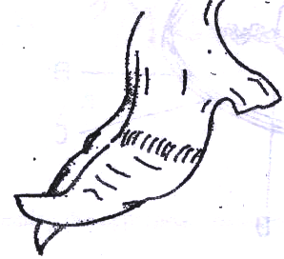18 The diagram below illustrates a hoof of a sheep. Study it carefully and answer the questions that follow.

- Name the routine management practice that should be carried out on the hoof illustrated
...................................................................................................................................................................................................................................................................................... (2mks)

(b) State two reasons for carrying out the management practice in (a) above ........................................................................................................................................................................................................................................................................................................................................................................ (2mks)
c) Give two tools which can be used to carry out the management practice in (a) above
...............................................................................................................................................................................(2mk)
19 The diagram below illustrates a final seedbed after tertiary operation done during land
preparation. Study it carefully and answer the questions that follow.
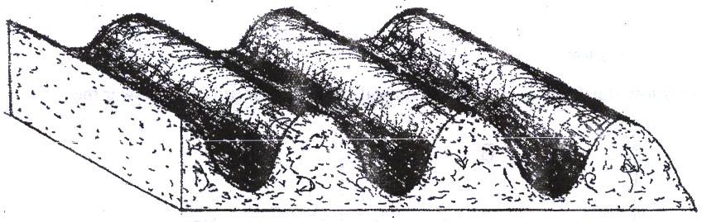

(a) Name the tertiary operation carried out on the seedbed
...........................................................................................................................................(1 mk)
(b) State three advantages of the tertiary operation indicated above .............................................................................................................................................................................................................................................................................................................................................(3mks)
c) State one other tertiary operation which may be carried out during land preparation
.......................................................................................................................................(1mk)
(d) Give two advantages of planting crops on the final seed back illustrated above .........................................................................................................................................................................................................................................................................................(2mks)
20 What is the function of each of the following ingredients in the preparation of compost manure?
(a) Wood ash................................................................................................................(1mk)
(b) Top Soil..................................................................................................................(1mk)

(c) well rotten organic manure.....................................................................................(1mk)
(d) State four characteristics of fertile soil............................................................... (4mks)

SECTION C ( 20 MARKS) Attempt one Question only from this section
21 (a) Explain five factors that a farmer should consider when sitting a bee hive to
prevent swarming of bees
.........................................................................................................................................................................................................................................................................................................................................................................................................................................................................................................................................................................................................................................................................................................................................................................................................................................(10 mks)

(b) Describe ten safety precautions that should be taken when using herbicides to control
Weed....................................................................................................................................................................................................................................................................................................................................................................................................................................................................................................................................................................................................................................................................................................................................................................................................................................................................................................................................................................................................................................................................................................................................................................................................................................................................................................................................................................................................................................................................................................................................................................................................................................................................................................................................................................................................................................................................................................................... (10mk)

22 (a) A farmer wanted to prepare a 200kg of calf rearing ration containing 20% DCP. Using
the Pears Square Method, calculate the amount of Maize containing 10% DCP and
Sunflower containing 35% DCP the farmer would need to prepare the ration. (Show your
work) (4mks)

b) Discuss Foot and Mouth disease under the following headings:
(i) Casual organisms......................................................................(1mk)

(ii) Livestock species attacked ..........................................................................................................................(2mks)

(iii) Symptoms of attack. (4mks)

...........................................................................................................................................................................................................................................................................................................................................................................................................................................................................................................................................................................................................................................................................................................................................................................................................................................................................................................................................................................

(iv) Control measures. (3mks)

c) Explain the factors that influence the type of irrigation to be used in a farm (6mks).
.........................................................................................................................................................................................................................................................................................................................................................................................................................................................................................................................................................................................................................................................................................................................................................................................................................................................................................................................................................................................................................................................................................................................................................................................................................................................................................................................................................6mks

PRINTED AND COMPILED BY PERFECT STEPS PUBLISHERS: 0721 745374/0721707626 NAIROBI

