GATITU MIXED SECONDARY SCHOOL
AGRICULTURE FORM 2 END OF TERM 2 EXAM 2015

- What are the necessary precautions observed when carrying out soil sampling? 2mks

- Distinguish between fertilizer grade and fertilizer ratio 2mks

(b) List four elements whose deficiency results into chlorosis in plants 3mks

3. A compound of fertilizer has a fertilizer grade of 25:10:5.calculate the mount
of phosphorus fore sent in 400kg of this fertilizer 3mks

b) The diagram below illustrate methods of collecting soil sample from a field

2
X
X
X
X
X
X
X
X
X
X
X
X
X
1
X
X
X
3
4
5
8
7
6
10
9

- Identify the methods illustrated 1- 1mk

- xx 1mk

- State three importance of carrying out soil sampling and testing 3mks

- What is an incomplete compound fertilizer? 1mk

(b) State four reasons why a maize crop continued showing deficiency of potassium despite applications recommended amount of potassic fertilizer 4mks

5. Below are diagrams showing vegetative material used for propagation.
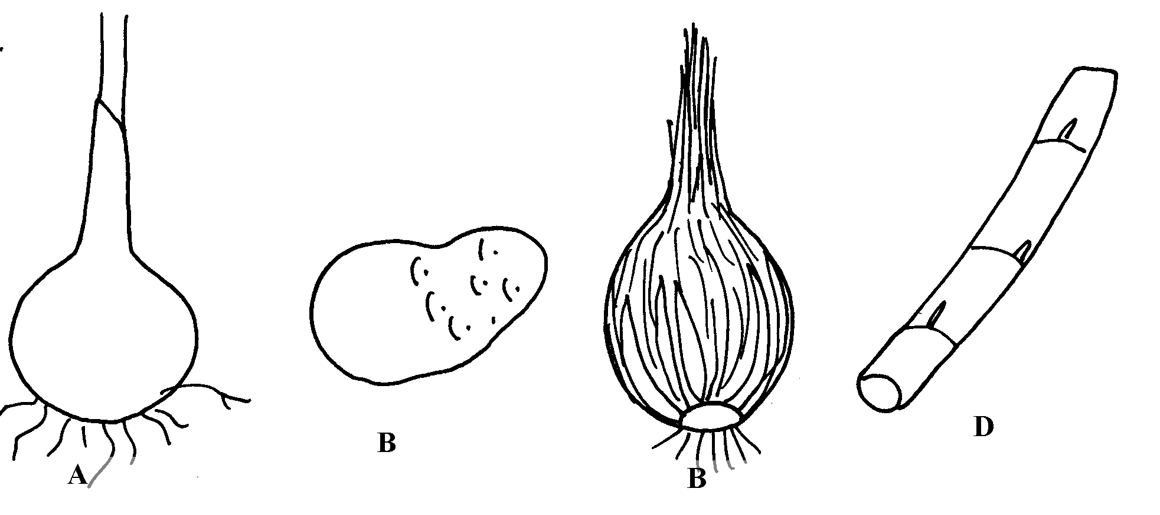
C

- Name the propagation materials A, B, C, D 4mks

- What is the term used for inducing B to start germinating? 1mk

- State four advantages of vegetative propagation on crop production 4mks

- State two advantages of adding organic matter to sandy soil 2mks

- A farmer planted 100 maize seeds and 90 seeds germinated.
Calculate the germination percentage 3mks

b) Given that maize is planted at a spacing of 75cm by 25cm, calculate the plant population in a plot measuring 4m by 3m 3mks

- Give four qualities of a mother plant which should be considered when selecting vegetative Material for propagation 4mks

