PERFECT STEPS PUBLISHERS
END TERM EXAMS 2015
0721 745374/ 0721 707626 NAIROBI
NAME..............................................................................................ADM........................................
AGRICULTURE EXAMINATION FORM TWO
Section A 40 marks Answer all the questions in this section in the spaces provided
- Define the following terms as used in livestock health

i.Disease. .....................................................................................................................1mk
ii)Health................................................................................................................1mk

2.State four advantages of keeping a herd of dairy cattle healthy.
......................................................................................................................................................................................................................................................................................................................................................................................................................................3mks

3.Give two causes of blossom end rot in tomatoes. ................................................................................................................................................................................................................................................................................................................................................. 2mks

4.State two methods of controlling blossom end rot in tomatoes. ..................................................................................................................................................................................................................................................................................................................................................................................................................................... 2mks

5 The diagram labeled D below shows a Kale crop infested by a pest
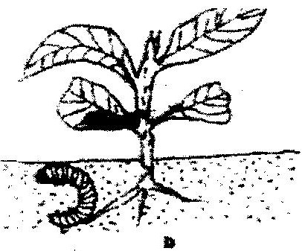

i Identify the pest.
..................................................................................................................................2mks

ii What damage does the pest cause the crop?
.............................................................................................................................................................................................................................................................................................. 1mk

iii State two methods of controlling the pest ...........................................................................................................................................
......................................................................................................................................2mks

6) Give four the major features of exotic beef breeds .....................................................................................................................................................................................................................................................................................................................................................................................................................................................4mks
- Study the diagrams of workshop tools shown below
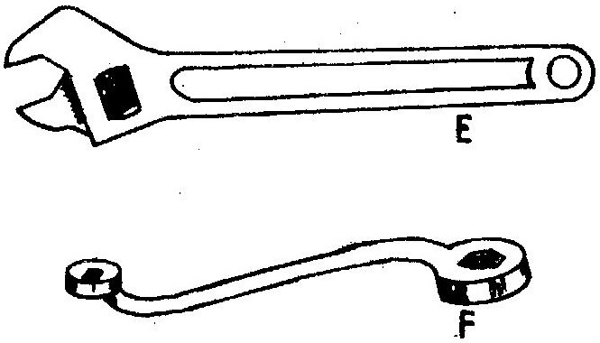

(i) Identify the tools labeled E and F (2mk)
E __________________
F __________________

(ii) What functional advantage does tool E have over tool F?

....................................................................................................................................2mk

- State three reasons why water should be treated in the farm
..........................................................................................................................................................................................................................................................................................................................(3mks)
- State four types of pumps used in the farm
.............................................................................................................................................................................................................................................................................................................................................................................................................................................................................................(4mks)
- Study the table below and fill in the missing words
Description | Planting material
Banana
Pine apple
 | Vine
2mks

- Name two crop production practices carried after planting to achieve optimum plant
Population.
.............................................................................................................................................................................................................................................................................(2mks)
- Give the three main methods of conveying water within the farm .............................................................................................................................................................................................................................................................................(3mks)
- State two methods of storing water on a farm. ..................................................................................................................................................... (2mks)
- State two ways of overcoming the problem of water logging in crop production......................................................................................................................................................................................................................................................................(2mks)
- State four methods of treating water for domestic use.
.............................................................................................................................................................................................................................................................................(4mks)
- Name four types of water pumps which can be used in the farm. ............................................................................................................................................................................................................................................................................ (2mks)
- Give four reasons why it is advantageous to use organic manure instead of straight fertilizer
...................................................................................................................................................................................................................................................................................................................................... (4mks)
- State four harmful effect of parasite to livestock. .................................................................................................................................................................................................................................................................................................................................................................................................................. (4mks)
- a) State four ways by which plant nutrients may be lost from the soil.
.................................................................................................................................................................................................................................................................................................................................................................................................. (4mks)
b)Define soil fertility ....................................1mk
c) List the major characteristics of a fertile soil (4mks)

- Differentiate between macro – nutrients and micro – nutrients
.............................................................................................................................................................................................................................................................................(2mks)
- State four functions of Calcium in plant growth and development .............................................................................................................................................................................................................................................................................(2mks)
- Calculate the plant population per hectares of a maize crop planted at a spacing of 100cm x 50cm. Show your working

(4mks)
- Name two crop production practices carried after planting to achieve optimum plant population.......................................................................................................................2mks
- State five general measures which can be used to control livestock diseases.
.................................................................................................................................................................................................................................................................................................................(5mks).

SECTION B 20 MARKS ANSWER ONE QUESTION ONLY FROM THIS SECTION IN THE SPACES PROVIDED

- State and explain biotic factors which affect both livestock production and crop production in kenya.
.........................................................................................................................................................................................................................................................................................................................................................................................................................................................................................................................................................................(20mks)

26. Study the illustration below carefully and answer the questions which follow River.
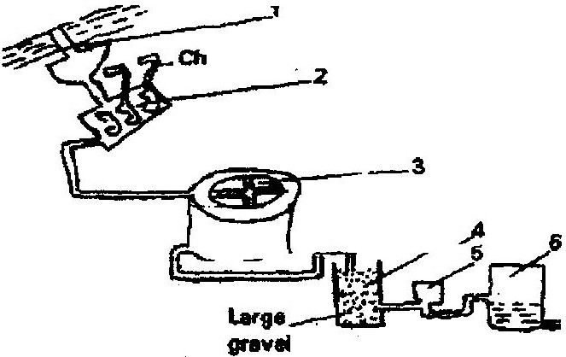

a) Explain part 1- 5 ......................................................................................................................................................................................................................................................................................................................................................................................................................................................................................................................................................................................................................................................................................................................................................................................................................................................................................................................
10mks
b) Describe advantages of practicing rotational cropping.

............................................................................................................................................................................................................................................................................................................................................................................................................................................................................................................................................................................................................................................................................................................................................................................................................................................................................................................10mks

PRINTED AND COMPILED BY
PERFECT STEPS PUBLISHERS
0721 745374/ 0721 707626 NAIROBI

