NAME____________________________ INDEX NO____________________
DATE___________________________ SIGNATURE
3KNT FRATERNITY 2017
TERM II FORM IV EXAM
AGRICULTURE PAPER 2
443/2
TIME: 2HOURS
Instructions to candidates
- Answer all the questions in section A and B
- Section C has 3 questions choose 2 questions
- Answer all the questions in spaces provided

SECTION | QUESTIONS | MARKS
A | 1-21
B | 22
 | 23
 | 24
 | 25
C | 26
 | 27
 | 28

SECTION A 30MK ANSWER ALL THE QUESTIONS IN SPACES PROVIDED
- Name four tools that are used when laying concrete blocks during construction of a wall (2mks)

- Name the breed of goat which is brown with strips running down to the nose (¹/₂mk)

- State four ways of controlling lice in poultry (2mks)

- Give four disadvantages of inbreeding in livestock production (2mks)

- State four disadvantages of inbreeding in livestock production (2mks)

- State four factors that can affect digestibility of a feedstuff in livestock (2mks)

- Give the difference between a roughage and concentrate in livestock nutrition (1mk)

- Give two reasons for castration in piglets (1mk)

- Name four parts of a farm building that can be reinforced using concrete (2mks)

- Differentiate between a notifiable and a zoonotic disease (1mk)

- Which organisms causes Newcastle disease in birds (1mk)

b.State four specific symptoms of Newcastle disease (2mks)

c).Give three methods of controlling Newcastle disease in chicken (1¹/₂mks)

- Name two commercial feeds fed on layers (1mk)

- State two causes of soft shelled eggs (1mk)

- State two disadvantages of fold system in poultry rearing (1mk)

- Give the main reason for each of the following in dairy farming (1¹/₂mks)
- Milking quickly and evenly

- Milking at regular interval

- Compete milking

- List down four maintenance practices on a mould board plough (2mks)

- Give three factors that may lead to conception failure after service in heifers (1¹/₂mk)

- State two factors that can affect digestibility of a feedstuff in livestock (1mk)

- Give four characteristics of a good site for a fish pond (2mks)

- Name three methods of extracting honey from combs (1¹/₂mks)

- Name one feed additives that can be included in livestock diet (1mk)

SECTION B 20MKS
Answer all questions in this section
- Below are photographs showing parts of a ruminant stomach.
Study them and answer the questions

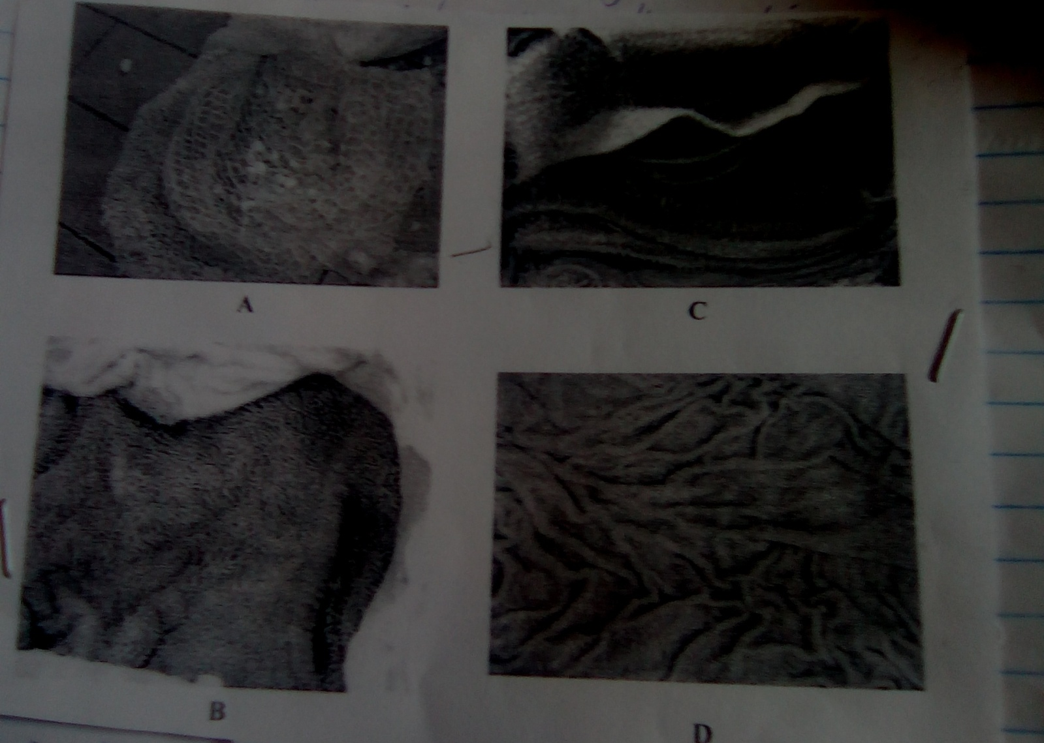

- Identify the parts labeled A and B (2mks)
A
B
- State one function of the part labeled (2mks)
A
C
- Name one enzyme that is produced in the part labeled D (1mk)

23. Study the diagram of an ox-plough below and answer the questions that follow.

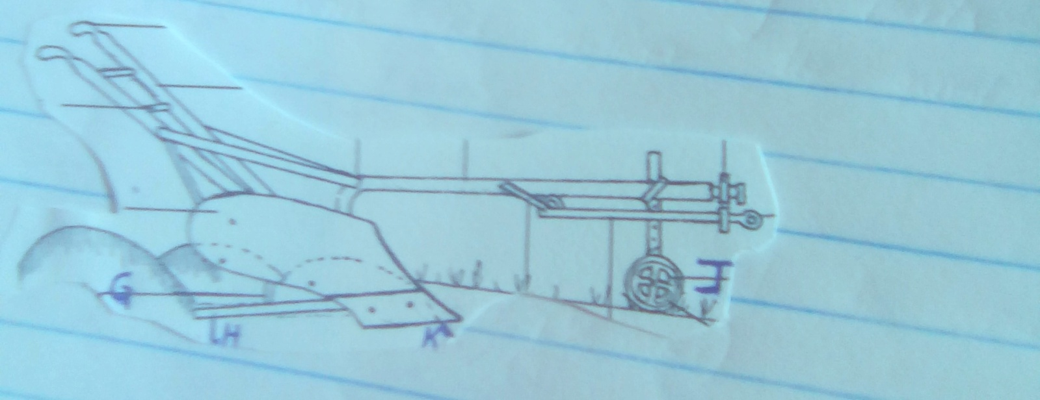
G
H
K
J

- Name the parts labeled G and H (2mks)
G
H
- State one maintenance practice that should be carried out on each part labeled J and K (2mks)
J
K
- State the function of the part labeled H (1mk)

24. The diagram below illustrates an activity carried out by a poultry farmer keeping layers. Study the diagram carefully and answer the questions that follow.

a. Identify the activity carried out using the set up illustrated in the diagram (1mk)

b) List down four preparation that should be carried out to the structure before arrival of day old chicks (2mks)

c) .Name four materials used in constructing the structure above (2mks)

25. Below is a diagram illustrating the reproductive system of a bull. Study it and answer the questions that follow.

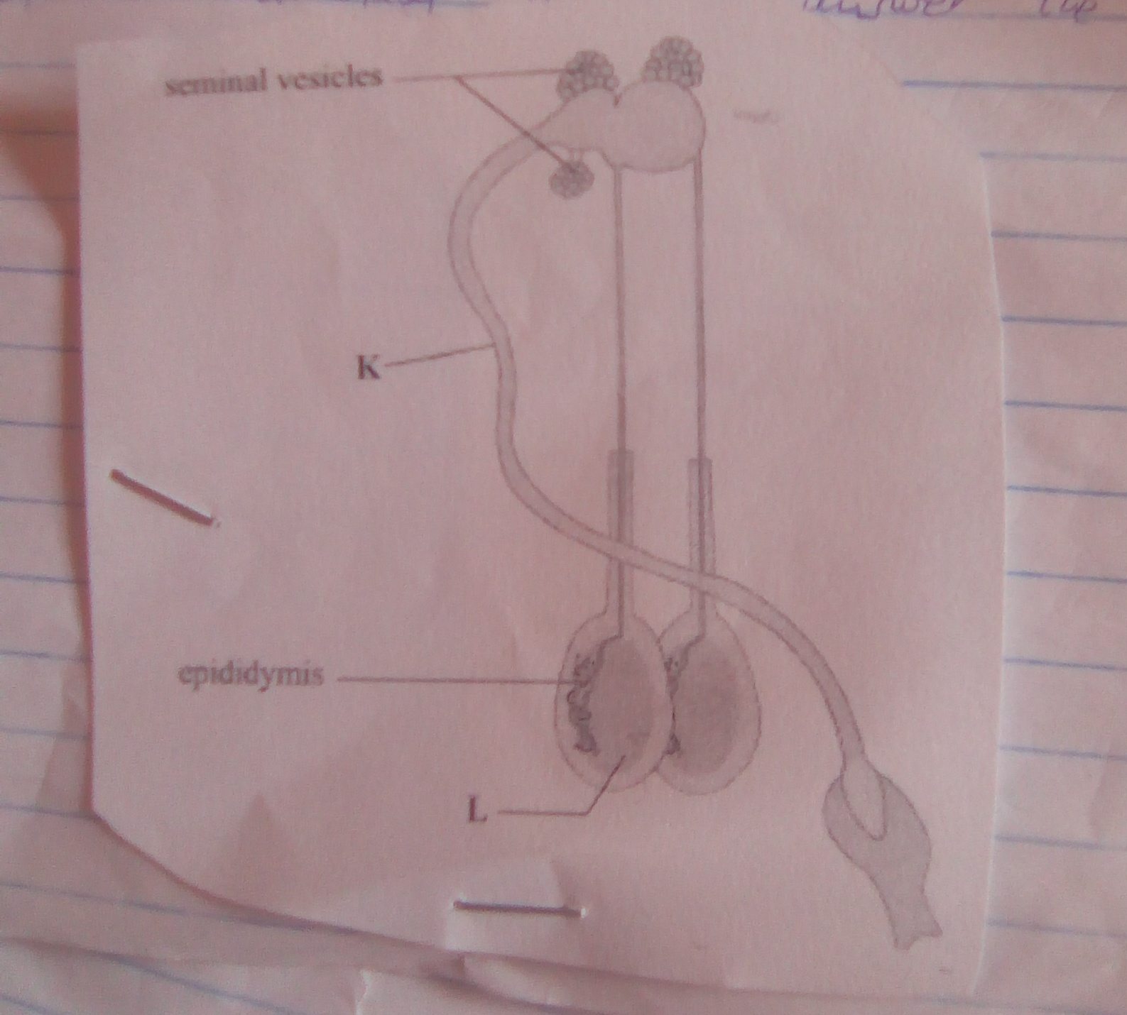

a. Identify the parts labeled K and L (2mks)
K
L
b).State the function of the parts labeled (2mks)
- Epididymis

- Seminal vesicles

SECTION C
Answer any two questions from this section in the spaces provided
25a.Describe the body conformation features of Dairy heifer (5mks
b.State the disadvantages of using live fences on a farm (7mks
c. Describe how a four stroke cycle petrol engine works (8mks

26a.Describe the disease control routine management practices in calf rearing (7mk

b.Describe the contagious abortion (brucellosis) diseases under the following sub-headings
- Causal organism (1mks)
- Animals affected (2mks)
- Symptoms (4mk
- Control measure (6mks)
27a.State and explain the components of zero grazing unit (14mk
b.Outline six advantages of raising dairy cattle in a zero grazing unit (6mks)

