Name: …………………………………………………………Index No: ……………………..……………
Candidate’s Signature:……………………………….
Date: ……………….……………….…

443/1
AGRICULTURE
PAPER 1
JULY/AUGUST 2014
TIME: 2 HOURS

Kenya Certificate of Secondary Education

443/1
Agriculture
Paper 1
2 hours

INSTRUCTIONS TO CANDIDATES:
- This paper contains three sections A, B and C
- Answer ALL the questions in section A and B
- Answer any Two questions from section C
- All answers should be written in the spaces provided.

FOR EXAMINERS USE ONLY
SECTION | QUESTIONS | MAX SCORE | CANDIDATES SCORE
A | 1-19 | 30
B | 20-23 | 20
C | 24-26 | 20
 |  | 20
TOTAL |  | 90

This paper consists of 8 printed pages. Candidates should check to ascertain that all pages are printed as indicated and that no questions are missing.
SECTION A (30 MARKS)
Answer all questions from this section in the spaces provided.
- Name three physical agents of weathering (1 ½ mks)
……………………………………………………………………………………………….……………………
……………………………………………………………………………………………….……………………
……………………………………………………………………………………………….……………………
- Outline three methods of breaking seed dormancy (1 ½ mks)
……………………………………………………………………………………………….……………………
……………………………………………………………………………………………….……………………
……………………………………………………………………………………………….……………………
- List three signs shown by crops when they are attacked by nematodes (1 ½ mks)
……………………………………………………………………………………………….……………………
……………………………………………………………………………………………….……………………
……………………………………………………………………………………………….……………………
- Differentiate between Net Revenue and Marginal Revenue as used in production economics (1mk)
……………………………………………………………………………………………….……………………
……………………………………………………………………………………………….……………………

- Give one use of each of the following materials in the preparation of compost manure (1 ½ mks)
- Top soil
……………………………………………………………………………………………….……………………
- Wood ash
……………………………………………………………………………………………….……………………
- Organic manure
……………………………………………………………………………………………….……………………
- List three advantages of using polythene sleeves in raising seedlings (1 ½ mks)
……………………………………………………………………………………………….……………………
……………………………………………………………………………………………….……………………
……………………………………………………………………………………………….……………………
……………………………………………………………………………………………….……………………
……………………………………………………………………………………………….……………………
……………………………………………………………………………………………….……………………

- State three disadvantages of commercial land tenure system (1 ½ mks)
……………………………………………………………………………………………….……………………
……………………………………………………………………………………………….……………………
……………………………………………………………………………………………….……………………

- Outline four methods used to improve efficiency and productivity of farm labour (2mks)
……………………………………………………………………………………………….……………………
……………………………………………………………………………………………….……………………
……………………………………………………………………………………………….……………………
……………………………………………………………………………………………….……………………
- State four factors that determine the choice of an irrigation system to use in a farm. (2mks)
……………………………………………………………………………………………….……………………
……………………………………………………………………………………………….……………………
……………………………………………………………………………………………….……………………
……………………………………………………………………………………………….……………………
- Mention four characteristics of shifting cultivation as a method of farming (2mks)
……………………………………………………………………………………………….……………………
……………………………………………………………………………………………….……………………
……………………………………………………………………………………………….……………………
……………………………………………………………………………………………….……………………
- Differentiate between thinning and pricking out as used in crop management (1mk)
……………………………………………………………………………………………….……………………
……………………………………………………………………………………………….……………………
- List three books of account used in the farm (1 ½ mks)
……………………………………………………………………………………………….……………………
……………………………………………………………………………………………….……………………
……………………………………………………………………………………………….……………………
- State three cultural measures taken by farmers to control weeds in the field (1 ½ mks)
……………………………………………………………………………………………….……………………
……………………………………………………………………………………………….……………………
……………………………………………………………………………………………….……………………
- State three precautions taken when harvesting pyrethrum (1 ½ mks)
……………………………………………………………………………………………….……………………
……………………………………………………………………………………………….……………………
……………………………………………………………………………………………….……………………
- Mention four advantages of minimum tillage (2mks)
……………………………………………………………………………………………….……………………
……………………………………………………………………………………………….……………………
……………………………………………………………………………………………….……………………
……………………………………………………………………………………………….……………………
- Name three crop diseases caused by viruses (1 ½ mks)
……………………………………………………………………………………………….……………………
……………………………………………………………………………………………….……………………
……………………………………………………………………………………………….……………………

- Outline three examples of joint products in crop production (1 ½ mks)
……………………………………………………………………………………………….……………………
……………………………………………………………………………………………….……………………
……………………………………………………………………………………………….……………………
- State three advantages of land fragmentation (1 ½ mks)
……………………………………………………………………………………………….……………………
……………………………………………………………………………………………….……………………
……………………………………………………………………………………………….……………………
- Give four advantages of using zero grazing system of grazing (2mks)
……………………………………………………………………………………………….……………………
……………………………………………………………………………………………….……………………
……………………………………………………………………………………………….……………………
……………………………………………………………………………………………….……………………

SECTION B (20 MARKS)
Answer ALL questions in this section in the spaces provided
- The following are diagrams illustrating a soil profile labeled A and two types of soil structure labeled B and C. Use them to answer the questions that follow.

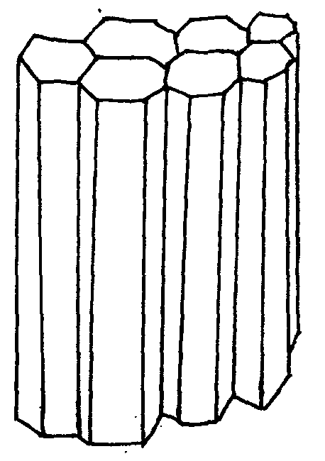
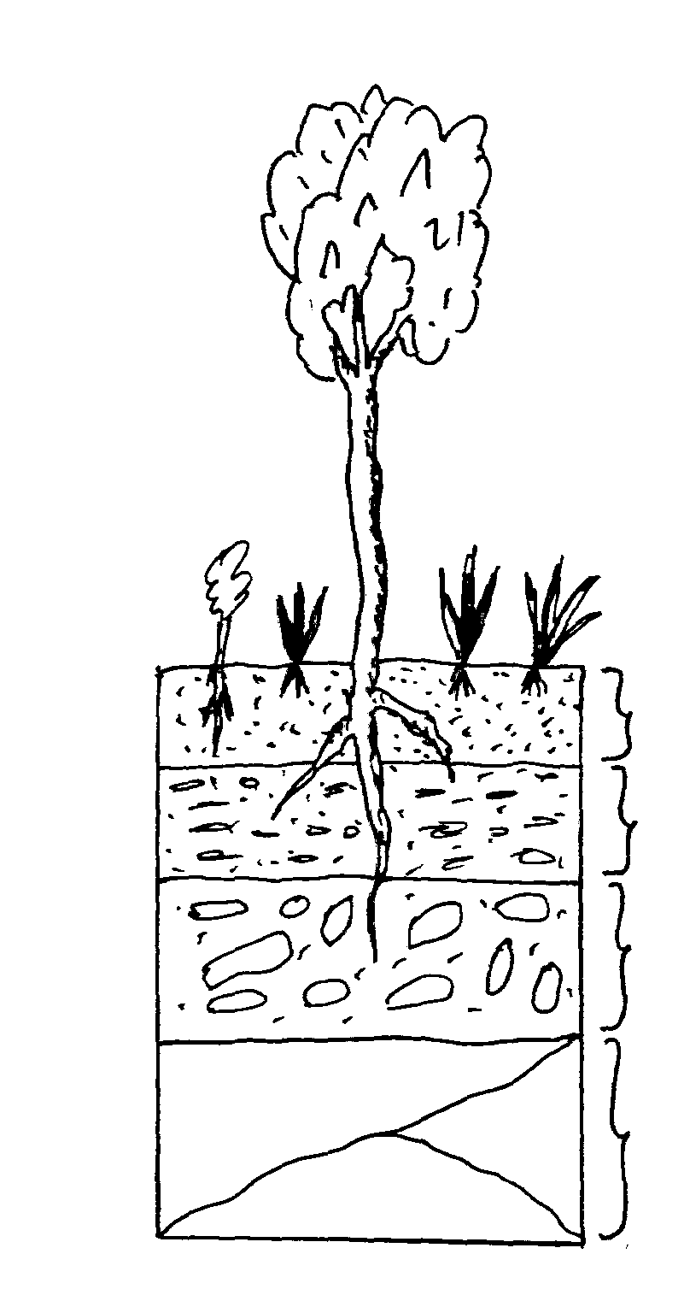
1
2

3

4
C
B
A

- Identify the strata of the soil profile labeled 1, 3 and 4 (1 ½ mks)
1………………………………………………
3………………………………………………
4………………………………………………

- Identify the types of soil structure labeled B and C (1mk)
B………………………………………………
C………………………………………………
- Name a natural process that may change soil structure B into structure C ( ½ mk)
5
……………………………………………………………………………………………….……………………
……………………………………………………………………………………………….……………………
- State two limitations of the hard layer of soil that develops in layer 2 (1mk)
……………………………………………………………………………………………….……………………
……………………………………………………………………………………………….……………………

- List two farming practices that may destroy structure B (1mk)
……………………………………………………………………………………………….……………………
……………………………………………………………………………………………….……………………
- The following are illustrations of methods of vegetative crop propagation labeled D and E. use them to answer the questions that follow
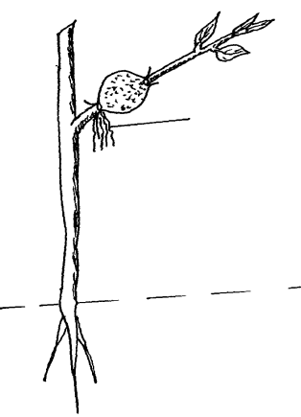
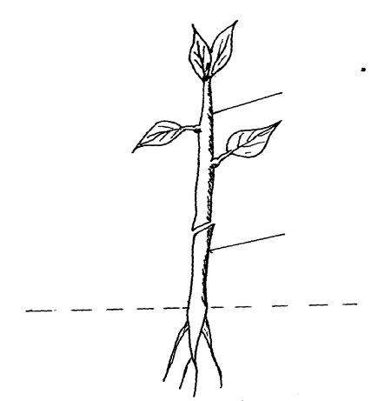
Roots

E
D
6

- Identify methods of crop propagation labeled D and E (1mk)
……………………………………………………………………………………………….……………………
……………………………………………………………………………………………….……………………
- Identify parts of D labeled 5 and 6 above (1mk)
……………………………………………………………………………………………….……………………
……………………………………………………………………………………………….……………………
- When does method E become necessary in crop production (1mk)
……………………………………………………………………………………………….……………………
……………………………………………………………………………………………….……………………
- Outline four characteristics you would desire part 6 to have (2mks)
……………………………………………………………………………………………….……………………
……………………………………………………………………………………………….……………………
……………………………………………………………………………………………….……………………
……………………………………………………………………………………………….……………………

- The following diagram is of a method of draining waterlogged land for crop production. Study it carefully and answer the questions that follow.
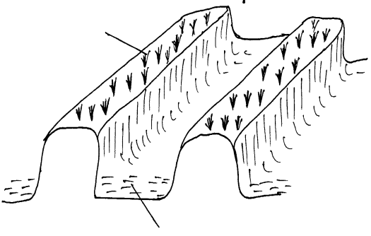
Crop

Furrow

- Identify the methods of drainage illustrated above (1mk)
……………………………………………………………………………………………….……………………
……………………………………………………………………………………………….……………………
- Apart from the above method of drainage, name two other methods of draining farm/land (2mks)
……………………………………………………………………………………………….……………………
……………………………………………………………………………………………….……………………
- Give two reasons for draining farm/land (2mks)
……………………………………………………………………………………………….……………………
……………………………………………………………………………………………….……………………
- A farmer was adviced to top-dress his maize crop with C.A.N at the rate of 200 kg/ha. CAN contains 20% Nitrogen.
- Calculate the amount of Nitrogen applied per hectare (show your working) (3mks)

- Name two methods the farmer may have used to top-dress the maize crop (2mks)

SECTION C (40 MARKS)
Answer any two questions from this section in the spaces provided after the question.

- (a) Outline problems facing agriculture in Kenya (10mks)
- Explain the importance of the following soil constituents
- Soil air (3mks)
- Mineral matter (2mks)
- State the uses of water in the farm (5mks)

- (a) Explain how five factors lead to loss of soil fertility (10mks)
(b) Explain how five factors affect efficiency and effectiveness of herbicides (10mks)

- (a) Outline the roles played by co-operative societies in Kenya (10mks)
(b) Explain how farmers adjust to risk and uncertainties in farming (10mks)
……………………………………………………………………………………………….……………………
……………………………………………………………………………………………….……………………
……………………………………………………………………………………………….……………………
……………………………………………………………………………………………….……………………
……………………………………………………………………………………………….……………………
……………………………………………………………………………………………….……………………
……………………………………………………………………………………………….……………………
……………………………………………………………………………………………….……………………
……………………………………………………………………………………………….……………………
……………………………………………………………………………………………….……………………
……………………………………………………………………………………………….……………………
……………………………………………………………………………………………….……………………
……………………………………………………………………………………………….……………………
……………………………………………………………………………………………….……………………
……………………………………………………………………………………………….……………………
……………………………………………………………………………………………….……………………
……………………………………………………………………………………………….……………………
……………………………………………………………………………………………….……………………
……………………………………………………………………………………………….……………………
……………………………………………………………………………………………….……………………
……………………………………………………………………………………………….……………………
……………………………………………………………………………………………….……………………
……………………………………………………………………………………………….……………………
……………………………………………………………………………………………….……………………
……………………………………………………………………………………………….……………………
……………………………………………………………………………………………….……………………
……………………………………………………………………………………………….……………………
……………………………………………………………………………………………….……………………
……………………………………………………………………………………………….……………………
……………………………………………………………………………………………….……………………
……………………………………………………………………………………………….……………………
……………………………………………………………………………………………….……………………
……………………………………………………………………………………………….……………………
……………………………………………………………………………………………….……………………
……………………………………………………………………………………………….……………………
……………………………………………………………………………………………….……………………
……………………………………………………………………………………………….……………………
……………………………………………………………………………………………….……………………
……………………………………………………………………………………………….……………………
……………………………………………………………………………………………….……………………
……………………………………………………………………………………………….……………………
……………………………………………………………………………………………….……………………
……………………………………………………………………………………………….……………………
……………………………………………………………………………………………….……………………
……………………………………………………………………………………………….……………………
……………………………………………………………………………………………….……………………
……………………………………………………………………………………………….……………………
……………………………………………………………………………………………….……………………
……………………………………………………………………………………………….……………………
……………………………………………………………………………………………….……………………
……………………………………………………………………………………………….……………………
……………………………………………………………………………………………….……………………
……………………………………………………………………………………………….……………………
……………………………………………………………………………………………….……………………
……………………………………………………………………………………………….……………………
……………………………………………………………………………………………….……………………
……………………………………………………………………………………………….……………………
……………………………………………………………………………………………….……………………
……………………………………………………………………………………………….……………………
……………………………………………………………………………………………….……………………
……………………………………………………………………………………………….……………………
……………………………………………………………………………………………….……………………
……………………………………………………………………………………………….……………………
……………………………………………………………………………………………….……………………
……………………………………………………………………………………………….……………………
……………………………………………………………………………………………….……………………
……………………………………………………………………………………………….……………………
……………………………………………………………………………………………….……………………
……………………………………………………………………………………………….……………………
……………………………………………………………………………………………….……………………
……………………………………………………………………………………………….……………………

