**443/1**

**AGRICULTURE**

**PAPER 1**

**2 HOURS**

**FORM 3 TERM 2**

**NAME……………………………………………………………..................ADM NO……………**

**SECTION A [30 MARKS]**

Answer all the questions in this section in the spaces provided.

1. Give four reasons why timely weed control is advisable in crop production.(2 marks)
2. State four disadvantages of use of vegetative propagation in bananas (2 marks)
3. Outline four functions of magnesium in crops. (2 marks)
4. State two conditions when you recommend fertilizer application by spraying method.(1 marks)
5. Name two macronutrients whose deficiency in crops causes chlorosis (1 mark)

6 State four characteristics of a good rootstock for grafting (2mks)

7. Give four precautions observed in pruning mature tea (2 marks)

8. List four morphological features of plants that influence the selectivity of herbicides. (2 marks)

9. State four conditions that may lead to land sub division in Kenya. (2 marks)

10. State two practices carried out to ensure field hygiene (1 mark)

11. State four roles of irrigation water in a rice field. (2 marks)

12 .State four ways of classifying pests (2mks)

13. What is solifluction erosion? (1mk)

14. State four ways by which trees help in soil conservation. (2 marks)

15. Give four characteristics of materials used in the preparation of compost manure. (2 marks)

16. Give four benefits of a good soil structure in crop production. (2 marks)

17. State four objectives of land tenure reform. (2marks)

**SECTION B (20 MARKS)**

**Answer all questions in the spaces provided in this section**

18.The diagram below illustrates a tertiary operation. Study it and answer the questions that follow.

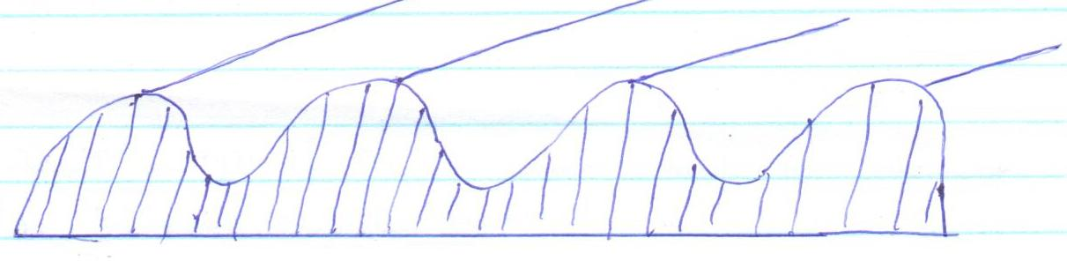

* 1. Identify the tertiary operation. (½ mk)
  2. State **three** reasons for carrying out the above tertiary operation. (1½mk)
  3. Other than the above tertiary operation, name two other tertiary operation. (1mk)

19.The illustration below represents a method used in preparation of a compost manure.

**X**

**Y**

**X**

**Z**

* 1. Name the method illustrated above. (1mk)
  2. Name the crop in which the use of the manure is most appropriate. (1mk)
  3. State three indicators to show that the manure is ready for use in the farm. (3mks)

20. Study the record below and use is to answer the questions that follow.

Season:………………………………………… Field No. ……………………………..

Crop grown:……………………………………. Net area:………………………………

Ploughing date:……………………………….. Variety;………………………………..

Inputs:………………………………………….. Planting date:…………………………

Remarks:…………………………………………………………………………………………….

* + 1. Identify the farm record represented above. (1mk)
    2. What other **two** pieces of information may be contained in the farm record above? (1mk)
    3. Why is it important for a farmer to keep such a record in the farm? (1mk)

21.

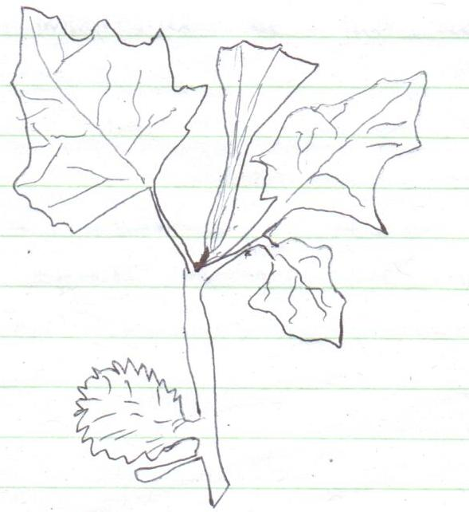

(i)Identify the above weed. (1mk)

(ii)Classify the weed according to its lifespan. (1mk)

(iii)State **two** reasons why the weed should be controlled. (2mks)

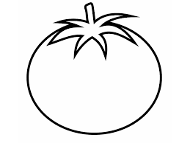22.The diagrams below represents tomato fruits.



**R S**

(a)Which of the diagrams represents tomato variety for?

* + - 1. Processing(1mk)
      2. Fresh market.(1mk)

(b) State **two** importance of the above vegetable to a farmer. (2mks)

(C) Give **two** effects of too much nitrogen on tomato fruits. (1mk)

**SECTION C (40 MARKS)**

Answer ***only two*** questions in this section in the spaces provided.

1. a)Describe the methods used in preparing materials in readiness for planting. (8 marks)
2. Explain the factors that may determine spacing of crop in the farm (8 marks)
3. Explain briefly the factors that influence timely planting. (4marks)

24a Describe ten safety precautions that should be taken when using herbicides to control weeds. (10marks)

1. Explain ten farming practices which help to conserve soil on a farm. (10marks)

25. Describe the production of kales under the following sub-heading.

1. Nursery bed siting (4mks)
2. Nursery bed preparation (4mks)
3. Nursery management 7mks)
4. Trans planting (5mks)