MWAKICAN JOINT EXAM TEAM

FORM 3 AGRICULTURE PAPER 2
MARKING SCHEME
END OF TERM 2 – 2016

SECTION A
- (i) Harvesting wheat (1/2 mk)
(ii) Cutting grass to make hay (1/2 mk)

- Zoonotic disease – Disease usually transmitted from livestock to human beings and vice versa.
Notifiable – Diseases whose occurrence should be reported to government veterinary authorities.

- - Location of the homestead.
- Security.
- Direction of prevailing wind.
- Farmers’ tastes and preferences.
- Proximity to amenities such as water, feed. (1 1/2mks)

- - Crush
- Fence
- Milking shed
- Calf pen
- Cattle shed (4 x ½ = 2mks)

- - Ploughing off the pasture
- Burning infested pasture
- Hand-picking and killing
- Rotational grazing
- Fencing (4 x ½ = 2mks)

- - Wood is cheap
- It’s easily available
- It doesn’t require a lot of skills
- Easily workable (2x 1/2 = 1mk)

- (a) - Its when fertilized ovum from superior female and male is implanted into
an inferior female. (1 x 1 = 1mk)

(b) - Embryo’s from superior animals can be stored to be used in future.
- Easy to transplant embryo even for long distances.
- Enables the use of inferior female to develop superior offspring.

- - To wash the foot off mud.
- Holds the chemical to control foot rot. Disease (Blue vitrol)

- - Crutching loggets and ewes.
- Ringing of the rams
- Raddling of rams
- Flushing – Giving high nutritious feed during mating. (4 x ½ = 2mks)

- - Crutching is the practice of cutting wool around the external reproductive organs of
a female sheep to facilitate mating.
- Ringing – It’s practice of trimming wool around the sheath of the penis of the rams to facilitate mating. (2 x 1 = 2mks)

- - To stimulate growth.
- To improve feed efficiency.

- (a) - Rendering a bird sterile (1mk)

(b) - To prevent random breeding.
- Increase rate of weight gain.
- Increase quality of meat.
- Make the males tame (4 x ½ = 2mks)

- - By injections
- Through the cloaca
- Orally through the mouth
- By inhalation through the nose (4 x ½ = 2mks)

- - Removal of excess water from the pond.
- Prevents overflow on the dykes (2 x ½ = 1mk)

- - Anglo – Nubian goat
- Toggen burg
- Saanen
- Jamnapari
- Angora (4 x ½ = 2mks)

- - Sow becomes restless
- Enlargement of vulva
- Loss of appetite
- Udder and teats become enlarged
- Muscles on each side of the tail slacken
- Sow collects bedding materials at one corner to build a nest. (3 x ½ = 1 ½ mks)

- - Angora goat

SECTION B

18.(i) Structure – A fold unit

- A – Wiremesh
B – Corrugated iron sheet

- - For shelter against heat
- For sleeping
- For exercises
- For resting (2 x 1 = 2mks)

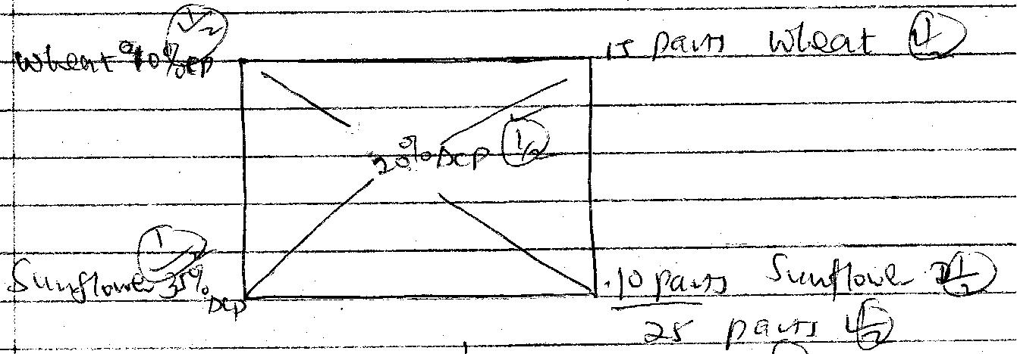

19.

Wheat = 10/24 x 100 (1/2 mk) = 40kg (1mk)

Sunflower – 15/25 x 100 (½ mk) = 60kg (1mk)
Total (6mks)

20. (a) H - Dibber
J - Watering can
K - Fork jembe
L - Jembe

(b) H - Making holes for transplanting
J - For watering young seedlings in the nursery
K - For cultivating, removing roots, large stones and breaking soils.
L - For cutting and digging hard soils

(c) M - Handle
P - Spout
T - Rose

21. (a) Liver fluke (1 x ½ mk)

(b) (i) Pot bellied due to watery swelling on the body.
(ii) Loss of weight and emaliation.
(iii) Animal suffer indigestion
(iv) Damage of liver tissues and haemorrhage.
(v) Anaemic condition due to sucking of blood.
(vi) Dullness and animal appears depressed. (2 x ½ = 1mk)

SECTION C
22(a) - Keep off animals / domestic animals.
- Add aesthetic value
- Add value to the farm
- Provide livestock feeds, fuel and human food.
- Control pests and disease spread
- Some act as wind breaks
- Control breeding
- Control grazing by use of paddocks

- Marking boundaries
- Keep off intruders / thieves / wild animals (10 x 1 = 10mks)

(b) - Take many years to grow and make an effective fence.
- Not good for paddocking
- Irregular growth creates gaps for thieves.
- Its labourious and expensive to manage.
- Are hiding places for rodents and thieves. (5 x 1 = 5mks)

(c) - Replace falling or broken parts noticed.
- Repaint any worn out paint.
- Strength fences and gates.
- Trim live fences when overgrown
- Seal any cracks in wall fences.
- Weeding for live fences during early stages of growth. (5 x 1 = 5mks)

23(a) (i) Branding - Marking of animals on the animal skin using permanent marks
by the use of hot iron.
(ii) Ear tagging - Fixing of plastic metal tags bearing numbers or letters on a perforated hole on the ears of the animal.
(iii) Ear notching – Perforations on the ears of the animal to make different shapes in different positions using an ear notch.
(iv) Tatooing - Tatoos inform of shapes, numbers or letters are made on the skin with permanent ink or dye. It’s done using a tattooing machine containing a series of needles.
(v) Neck strap or chain – A piece of metal or wood is made into different shapes and numbers or letters used to identify the animal inscribed on it.
5 x 3 = 15 mks.
(Identity of method - I mk, proper explanation – 2mks)

(b) - Poor health
- Age (old age)
- Poor production
- Physical deformities
- Hereditary defects
- Poor mothering ability
- Infertility
(1 x 5 = 5mks)

24(a) - Availability of materials
- Workability of the materials
- Suitability to the climatic factors of the area.
- Durability of the material
- Cost of materials
- Flexibility of the material
(5 x 1 = 5mks)

(b) - The location of homestead - should be easy to view the structure from the homestead.
- Accessibility – should be easy to reach the structure from all parts of the farm.
- Security – The area should be safe from predators, thieves and trespassers.
- Direction of prevailing wind – Construction structures on leeward side.
- Drainage – The area should be free from damp conditions / water logging.
- Relationship with other structures – Should be constructed close to each other.
- Topography of the area – Free drainage of water in the area.
- Proximity to amenities such as water, electricity, should be considered.
- Farmers tastes and preferences – Interests of farmers should be considered.
10 x 1 = 10mks

(c) - They protect the farmer and livestock from predators.
- Help in control of livestock diseases and parasites.
- Provide shelter against extreme weather conditions.
- Provide storage of farm produce and other variable inputs.
- They increase the efficiency of production and management in the farm. (5 x 1 = 5mks)

