443/2 AGRICULTURE Paper 2
(THEORY)
2 Hours
Name ………………………… ….. Index Number …………………
Candidate’s Signature ……………….. Date ………………………
Instructions to Candidates
- Write your name and index number in the spaces provided above
- This paper consists of three sections: A, B and C
- Answer all the questions in sections A and B
- Answer any two questions in section C
- Candidates should answer all the questions in English
For Examiner’s Use Only
Section | Questions |  | Maximum score | Candidate’s score
A | - 17 |  | 30
B | 18 - 22 |  | 20
C |  |  | 20
 |  |  | 20
Total Score |  | 90

SECTION A (30 MARKS)
Answer all questions in this section
- State the class of each of the following feedstuff (1 mk)
- Molasses ………………………….
- Maclick ……………………….
- State one way by which each of the following practices help in disease control (2 mks)
- Proper feeding ……………………………………………………………………………………………………………………………………………………………………………………………………………………………………………………………………
- Proper housing …………………………………………………………………………………………………………………………………………………………………………………………………………………………………………………………….
- Name a disease in cattle that may be spread through breeding (1 mk)

……………………………………………………………………………………………
- Name two implements that may be connected to power take off shaft of a tractor (1 mk)

…………………………………………………………………………………………..
…………………………………………………………………………………………
- Differentiate between the following tools (2 mks)
- Marking gauge and mortise gauge
…………………………………………………………………………………………………………………………………………………………………………………………………………………………………………………………………………..
- A cold chisel and a wood chisel
……………………………………………………………………………………………………………………………………………………………………………………………………………………………………………………………………………..
- Study the table below and fill in the missing words (2 mks)
Description | Cattle | Pigs | Poultry
Young from birth/ hatching |  |  | Chick
Young female before parturition / laying |  | Gilt

- Name one intermediate host for each of the following parasites (1 mk)
- Liverfluke (Fascola spa)
………………………………………………………………….
- Tapeworm (Taenia spp)
……………………………………………………………………
- State four ways of restraining cattle during routine management (2 mks)
…………………………………………………………………………………………………………………………………………………………………………………………………………………………………………………………………………………………………………………………………………………………………………………………………………………………………………………………………………………………………………………………………………………………………………………………….
- A deep litter poultry house measures 9m by 3m. Suppose the amount of space allowed for one bird is 0.27m² , calculate the number of birds that can be kept comfortable in the house.
Show your working (2 mks)
………………………………………………………………………………………………………………………………………………………………………………………………………………………………………………………………………………………………………………………………………………………………………………………………………………………………………………………………………………………………
- State four predisposing factors of mastitis (2 mks)
………………………………………………………………………………………………………………………………………………………………………………………………………………………………………………………………………………………………………………………………………………………………………………………………
- Name any two hormones associated with milk let down in cattle (1 mk)
………………………………………………………………………………………………………………………………………………………………………………………………………………………………………………………………………………………………
- State two reasons under which would make it necessary to feed bees (1 mk)
………………………………………………………………………………………………………………………………………………………………………………………………………………………………………………………………………………………………
- State three effects of tsetsefly infestation (3 mks)
……………………………………………………………………………………………………………………………………………………………………………………………………………………………………………………………………………………………………………………………………………………………………………………………………………………………………………………………………………………………………………………………………………………………………………………………

- Give one reason for packing eggs with the broadside facing upwards in an egg tray (1 mk)
……………………………………………………………………………………………………………………………………………………………………………………………..
- List four strokes in a four stroke cycle engine (2 mks)
…………………………………………………………………………………………………………………………………………………………………………………………………………………………………………………………………………………………………………………………………………………………………………………………..
- State four reasons why feeding of colostrum is important in rearing of piglets (2 mks)
……………………………………………………………………………………………………………………………………………………………………………………………………………………………………………………………………………………………………………………………………………………………………………………………
- List two factors associated to the animal that determines the amount of feeds taken by animals (2 mks)
……………………………………………………………………………………………………………………………………………………………………………………………………………………………………………………………………………………………
- Give two signs that would show that a doe is just about to give birth (2 mks)
……………………………………………………………………………………………………………………………………………………………………………………………………………………………………………………………………………………………..

SECTION B (20 MARKS )
Answer all questions in this section
- The diagrams labelled A and B below shows the teeth arrangement in hand workshop tools.
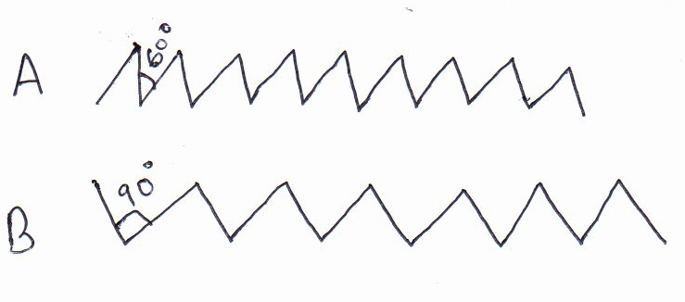

- Identify the tools represented with the teeth arrangements A and B (2 mks)
A………………………………………………………………………..
B………………………………………………………………………

- Give one function of each the tools mentioned above (1 mk)
A……………………………………………………………………………………………………………………………………………………………………………………………B…………………………………………………………………………………………...................................................................................................................................................

- Give two management practices done on the above tools (2 mks)
…………………………………………………………………………………………………………………………………………………………………………………………………………………………………………………………………………………………………….

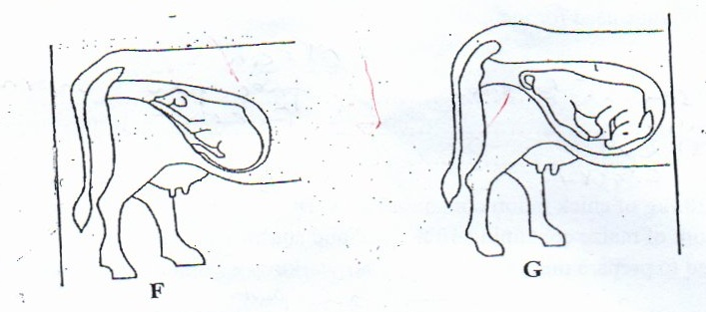
- Study the diagram below and use them to answer the questions that follow.

- Which of the foetus is in the correct position of parturition (1 mk)
…………………………………………………………………………………………………………………………………………………………………………………
- Name the type of parturition for foetus F and G (2 mks)
…………………………………………………………………………………………………………………………………………………………………………………………………………………………………………………………………………….
- Give two problems associated with parturition in cattle (2 mks)
……………………………………………………………………………………………………………………………………………………………………………………………………………………………………………………………………………
- Study the diagram of an egg below and answer the questions that follow.

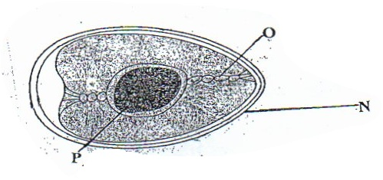

- Name the parts labelled (3 mks)
O. …………………………………
N…………………………………
P………………………………….
- State the functions of parts labelled (2 mks)
O ……………………………………………………………………………………….
N……………………………………………………………………………………….

- The diagram below represents a tractor implement.

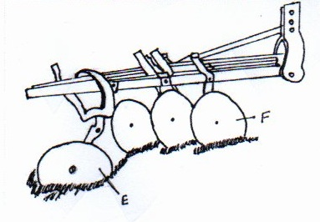

- Identify the implement (1 mk)
……………………………………………………………………………………
- Name the parts labelled E and G
E ……………………………………………………………………… 1mk
G ……………………………………………………………………… 1mk
- State 2 maintenance practices carried out on the implement shown in the diagram (2 mks)
………………………………………………………………………………………………………………………………………………………………………………………………………………………………………………………………………………………………………………………………………………………………………………………………………………………………………………………………………………………………………………………………………………………………………………………………………………………………………………………………………………………………………………………………………….

SECTION C (40 MARKS)
Answer only two questions in this section.

- Explain factors to consider when siting farm structures (5 mks)

- Describe foot rot disease in sheep under the following subheadings
- Symptoms (4 mks)
- Control measures (6 mks)
- State the disadvantages of using animal power on the farm (5 mks)
- .
- Describe the components of a spray race (5 mks)
- Describe the characteristics which will be considered when selecting a gilt for breeding (5 mks)
- Discuss the maintenance practices carried out on a tractor (10 mks)

- .
- Describe the procedure of honey harvesting in a Kenya top bee hive
- Describe the digestion in the rumen in a ruminant animal (5 mks)

- Discuss the factors that influence output of fish in a fish pond (5 mks)
- Mention five precautions taken when using workshop tools. (5 mks)

MARKING SCHEME
SECTION A

- Mollases – carbohydrates – ½ mk
- Maclick – minerals – ½ mk
- .
- Proper feeding – to make them strong to resist disease attack
- Avoid deficiency diseases
- 1 x1 = 1mk
- Proper housing – reduces dampness which can result into pneumonia and navel ill
- Reduces draught which can result into pneumonia
- Allows easy cleaning
- Allows in sunlight, hence animals get Vit. D
- 1 x 1 = 1mk
- Diseases spread through breeding
- Brucellosis
- Campylobacteriosis
- Vibriosis
- Trichonomiasis
- 1x1 = 1mk
- – mowers
- Planters
- Rotavators
- Sprayers
- Fertilizer
- 2x2 = (1 mk)
- .
- Marking gauge – used to mark parallel lines to the edge of the stock
Mortise gauge – used to mark two parallel lines at the edge of the stock
1x1 = 1mk
A cold chisel – used in cutting thick sheets of metal
Wood chisel – used to cut grooves & chopping off rough wood surfaces in joinery work.
1x1 = 1mk
NB: Mark as a whole = 1mk

- .
Cattle | Pigs | Poultry
Calf | Piglet | Chick
Heifer | Gilt | Pullet
- .
- Fresh water snail – ½ mk
- Pig or cattle – ½ mk
- .
- Bull ring and lead stick
- Tethering
- Crush
- Head yoke
- 4x ½ = 2mks
- Number of birds =$\frac{area }{space/bird}$

$\frac{9 x 3}{0.27}$ = $\frac{27m2}{0.27}$ 1mk
= 100 birds 1mk
- Predisposing factors of mastitis
- Age
- Stage of lactation
- Udder attachment
- Incomplete milking
- Mechanical injuries
- Poor sanitation
- Poor milking technique
- 4 x ½ = 2 mks
- .
- Oxytocin
- Adrenaline
- 2 x ½ = 1mk
- .
- To maintain colony
- Encourage multiplication
- To supplement during dry season with syrup
- Effects of tsetse fly infestation
- Transmit diseases
- Suck blood causing anemia
- Damage skins and hides
- Create wounds for secondary infection
- 4 x ½ = 2mks
- To allow gaseous exchange

- .
- Induction
- Compression
- Power
- Exhaust
- 4 x ½ = 2 mks
- .
- Highly digestible
- Highly nutritious
- Has antibodies which help to resist early disease infection
- Has laxative effect (cleaning the bowels)
- Highly palatable
- 4 x ½ = 2 mks
- .
- The species of the animal
- The quantity of feed already present in the digestive system of an animal
- 2 x 1 = 2 mks
- .
- Nest building by plucking off hair from her belly
- Loss of appetite / goes off feed
- 2 x 1 = 2 mks

SECTION B

(a)
- Cross cut – 1mk
- Rip saw – 1mk
(b) A – Cutting across the grain
B – Cutting along the grain
1 x 1 = 1 mk (Mark as a whole)
(c)
- Cleaning
- sharpening teeth
- replacing broken handles / repair
- Teeth setting
- tighten loose nuts & screws
- straighten the blade when bent
- hang the saw properly
- apply oil when storing for long
2 x 1 = 2 mks
- .
- F – 1mk
- F- Normal presentation – 1mk
G – Breach / abnormal presentation (1 mk)
- – difficult in giving birth (dystocia)
- Retained placenta / after birth
2 x 1 = 2 mks
- .
- O – Chalaza
P – Yolk
N – Egg shell
3 x 1 = 3 mks
- O – Hold the yolk in position
N – Allows gaseous exchange
- Protects the inner content
- 2 x 1 = 2 mks

- .
- Disc plough
- E – rear thrust wheel / furrow wheel
F – Disc / concave discs
- – lubricate the hubs & furrow wheel bearings
- Clean after work NB: reject washing
- Repair broken discs
- Apply oil on unpainted parts to prevent rusting for long storage
- Tighten loose nuts & bolts
- Blunt discs should be hammered
- 2 x 1 = 2 mks

- .
- .
- Location of homestead – for viewing the farm.
- accessibility – easy to reach parts of the farm
- Security – free from predators, thieves etc
- Drainage – to prevent dampness that may destroy buildings & result into diseases
- Direction of prevailing wind – to prevent bad / fowl smells
- Relationship between the structures – structures with related uses should be close to each other to save time and labor
- Farmers taste and preferences
- Proximity to electricity & water supply
- Topography – for proper drainage
5 x 1 = 5 mks
- .
- Symptoms
- Swollen foot
- Pain / limping / lameness
- Pus oozing out
- Rotten smell
- Kneeling while grazing
- Animal spent most of their time lying down
- Emaciation due to lack of feeding
- Control
- Provide clean environment
- Regular foot examination / hoof trimming
- Regular walk through footbaths with copper sulphate / formalin
- Disinfect wounds on feet
- Isolate sick animals
- Move sheep to dry clean grazing grounds
- 6 x 1 = 6 mks
- Disadvantages of using animal power
- More tedious
- More than one person is required
- It is slower
- Less work output
- Animal get tired
- Animal are affected by diseases
- Land must be set aside for feeding animals
- 5 x 1 = 5 mks
- .
- Components of a spray race
- Side walls – provide support to the piping system
- Spray pipe system – they atomize the chemical into spray form
- Drainage pipe – re-cycles chemicals back to the pump
- The pump / reservoir – it is a mixing tank
- Pressure gauge – measures the recommended working pressure
- 5 x 1 = 5 mks
- Selection
- Young age – that have not produced more than once
- Good level of performance – high growth rate, good mothering ability etc
- Good physical fitness – no defects e.g lameness
- Healthy – free from diseases
- Body conformation
- Behavior – not aggressive
- High quality products
- Mothering ability
- Adaptability
- More prolific
- .
- Check engine oil , if low add
- Check fuel / diesel , if low add
- Check the tyre pressure if low add
- Add water in the radiator if low
- Tighten loose bolts & nuts
- Apply grease
- Check fan belt tension and ensure it deflects between 1.9cm – 2.5 cm
- Add break fluid if low
- Remove sediments from the sediment bowl
- Check the level of electrolyte if low add distilled water
- .
- Procedure of honey harvesting
- Approach the hive quietly
- Apply smoke
- Lower the hive to the ground
- Remove the lid and inspect the top bars / cut the combs
- Place back the top bars
- Return the hive to its position
5 x 1 = 5 mks

- .
- Fermentation of food
- Synthesis of Vit. B complex and Vit. K
- Synthesis of amino acid from ammonia gas
- Break down of proteins to peptides, amino acids and ammonia gas
- Breakdown of carbohydrates and cellulose into volatile fatty acids
- 5 x 1 = 5 mks
- .
- Proper stocking / right population of fingerlings in the pond
- Proper feeding, excess feeds will pollute the pond / avoid underfeeding
- Prevent fish from predators that will reduce the number of fish in the pond
- Siltation / pollution can result into death of fish in the pond
- Adequate flow of fresh water through inlet to supply enough oxygen
- 5 x 1 = 5 mks
- .
- Store in a safe place after use
- Use correct tool for the correct job
- Maintain and service tools
- Handle tools correctly to avoid injury to the user
- Use safety devices e.g goggles while soldering
- Store tools properly in tool racks
- 5 x 1 = 5 mks

