PERFECT STEPS PUBLISHERS
0721745374/0721707626
Nairobi

END OF YEAR EXAMS 2015

NAME..............................................................................................ADM........................................
AGRICULTURE EXAMINATION FORM ONE
Section A (60 marks)
Answer all the questions in this section in the spaces provided

- State three advantages of drip irrigation
........................................................................................................................................................................................................................................................................................................................................................................................................................................................................................................................................................................................................................................................................................................................(3mks)
- State four advantages of adding organic manure to a sandy ........................................................................................................................................................................................................................................................................................................................................................................................................................................................................................................................................................................................................................................................................................................................(2mks)
- What is plantation farming system?
.................................................................................................................................................................................................................................................................................................................................................(2mks)
4.State the main characteristics of organic farming. ..................................................................................................................................................................................................................................................................................................................................................2mks
5.Distinguish between olericulture and pomoculture
....................................................................................................................................................................................................................................................................................................................................................................................................................................................................................................................................................................................(2mks)
6.State four reasons why agriculture is important to Kenya’s economy
..................................................................................................................................................................................................................................................................................................................................................................................................................................................................................................................................................................................................................................................................................................................................................................(2mks)
7.List four climatic factors that affect crop distribution in Kenya
....................................................................................................................................................................................................................................................................................................................................................................................................................................(4mks)

8)Give two roles of macro-organisms in the soil that are beneficial to crops
......................................................................................................................................................................................................................................................................................................................................................(2mks)
9)(a) State three properties of soil that are influenced by its texture.
....................................................................................................................................................................................................................................................................................................................................................................................................................................................................................................................(3mks)
(b) Define the term soil structure
....................................................................................................................................................................................................................................................................................................................................................................................................................................................................................................................................................................................(2mks)

10)(a) List down the four aspects of rainfall that affect agriculture.
.......................................................................................................................................................................................................................................................................................................................................................................................................................................................................................................................................(2mks)
b.State two causes of hard pan.
.............................................................................................................................................................................................................................................................................................................................................................................................................................................. 2mk
11) Give one use of each of the following hammers;
Ball pein hammer
..........................................................................................................................................................................................................................................(1mk)

Sledge hammer
.............................................................................................................................................................................................................................................1mk
12)State two maintenance practices that should be carried out on a wheelbarrow
............................................................................................................................................................................................................................................................................................................................................................(2mk)

13)The diagram below shows a farm equipment. Study it and answer the
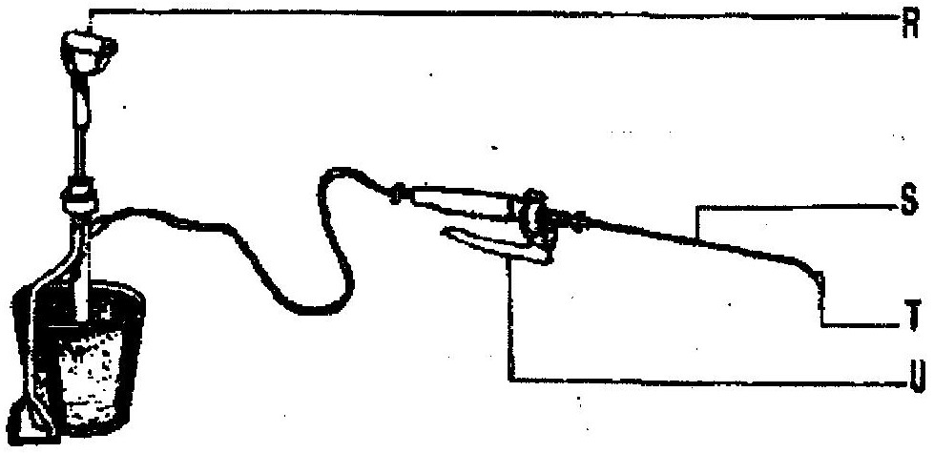
questions that follow

i Identify the equipment.......................................................................................................1mk
ii) Name the parts labeled
R,...................................................................................................................................1mk

S,.....................................................................................................................................1mk

T....................................................................................................................................1mk

U......................................................................................................................................1mk

14 (a) State four reasons why use of fire in clearing land is discouraged.
......................................................................................................................................................................................................................................................................................................................................................................................................................................................................................................................................................................................................................................................................................................4mks
(b) Outline three reasons why secondary tillage is carried out during land preparation
............................................................................................................................................................................................................................................................................................................................................................................................................................................................................................................................................................................................................................................................................................................................................................................................................................................................................................................................................................... 3mk
( c) State four main benefits of minimum tillage
............................................................................................................................................................................................................................................................................................................................................................................................................................................................................................................................................................................................................................................................................................................................................................................................................................................................................................................4mk
(d) Give three maintenance practices carried on an ox – plough.
...............................................................................................................................................................................................................................................................................................................................................................................................................................................................................................................................................................................................................................................................................................................................................................................3mk
(e) Give four farming practices that may help in achieving minimum tillage.
.................................................................................................................................................................................................................................................................................................................................................................................................................................................................................................................................................................................................................................................................................................................................................................................3mk
15) State four methods used to maintain soil fertility
...............................................................................................................................................................................................................................................................................................................................................................................................................................................................................................................................................................................................................................................................................................................................................................................4mks
16 State two methods used in preventing water pollution.
.......................................................................................................................................................................................................................................................................................................................................................................................................................................................................................................................................................................2mks
SECTION B 20 MARKS ANSWER ONE QUESTION ONLY FROM THIS SECTION IN THE SPACES PROVIDED
19 Diagrams M, N, P and Q represents some farm tools.

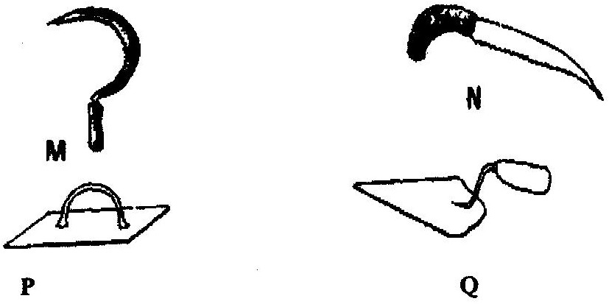

i) Identify the tools; M,N,P and Q.

M............................................N.........................................P............................................Q...............
(4mks)

ii) Give the use of each of the tools named above.
..............................................................................................................................................................................................................................................................................................................................................................................................................................................................................................................................................................................................................................................................................................................................................................................................................................................................................................................................................................4mks
iii) State two maintenance practices that should be carried out on tool M.
.................................................................................................................................................................................................................................................................................................................................................................................................................................................................................................................................................................................2mks
20 a)State four reasons why land preparation should be done before planting ..............................................................................................................................................................................................................................................................................................................................................................................................................................................................................................................................................................................................................................................................................................................................................................................................................................................................................................................................................................4mks
b) State factors which determine number of times secondary cultivation is done.
..............................................................................................................................................................................................................................................................................................................................................................................................................................................................................................................................................................................................................................................................................................................................................................................................................................................................................................................................................................4mks
c) Define the term rolling as used in agriculture
................................................................................................................................................................................... 2mks
SECTION C ( 20 MARKS) Attempt one Question only from this section
21 a) Describe five human factors which affect agriculture
..............................................................................................................................................................................................................................................................................................................................................................................................................................................................................................................................................................................................................................................................................................................................................................................................................................................................................................................................................................
..............................................................................................................................................................................................................................................................................................................................................................................................................................................................................................................................................................................................................................................................................................................................................................................................................................................................................................................................................................
.........................................................................................................................................................................................................................................................................................................................................................................................................................................................................10mks
b) State factors considered when choosing method to use in surface irrigation.
....................................................................................................................................................................................................................................................................................................................................................................................................................................................................3mks
c) outline importance of record keeping
..............................................................................................................................................................................................................................................................................................................................................................................................................................................................................................................................................................................................................................................................................................................................................................................................................................................................................................................................................................
....................................................................................................................................................................................................................................................................................................................................................................
........................................................................................................................................7mks
22 a) Describe five main characteristics of indigenous cattle (Bos indicus) ..............................................................................................................................................................................................................................................................................................................................................................................................................................................................................................................................................................................................................................................................................................................................................................................................................................................................................................................................................................
.............................................................................................................................................................................................................................................................................................................................................................................................................................................................................................................................................................................................................................................................................................................................................................................................................................................................................................................................................................10mks
b) Describe importance of drainage as a method of land reclamation. ..............................................................................................................................................................................................................................................................................................................................................................................................................................................................................................................................................................................................................................................................................................................................................................................................................................................................................................................................................................10mks

printed and compiled by
PERFECT STEPS PUBLISHERS
0721 745374/ 0721 707626 NAIROBI

