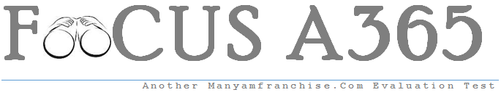

Gatitu Mixed Secondary School
Form 4 | Term 1 | 443 - Agriculture | 08-Jan-16 | Opener
- State four characteristics of desirable eggs for marketing (2MKS)
- Name two types of roughage (1MK)
- Give four disadvantages of inbreeding in livestock (2MKS)
- Give two reasons for docking in sheep rating (1MK)
- State four reasons for docking in sheep rearing (1MK)
- State four signs of fowl typhoid (2MKS)
- State four features on the animal which may predispose it to livestock diseases (2MKS)
- Give four preventive measures for livestock diseases (2MKS)
- State two functions of a queen in bee colony (1MK)
- State four maintenance practices carried out on a fish pond (2MKS)
- Describe the East Coast Fever under the following sub-headings
- Livestock affected; (1MK)
- Vector and causal organism; (2MKS)
- Signs of attack; (5MKS)
- Control measures; (2MKS)
B) Describe the activities that take place during digestion process in the rumen (5MKS)
C) Describe the management practices that ensure proper hygiene in a deep litter poultry house (5MKS)

- State five signs of external parasite infestation in livestock (5MKS)
Explain five factors that should be considered when sitting in a farm store (5MKS

