agriculture
443/2
TERM 1 2014

MWAKICAN JOINT EXAM TEAM (MJET)

PAPER 1
2 HOURS

INSTRUCTIONS TO CANDIDATES
- Write your name and index number at the top of the space given
- This paper has three sections
- Answers all question in section A and B and any 2 from section C
- Answer your questions in the spaces provided.

SECTION A (30MK) ANSWER ALL QUSTIONS
- Name the dairy cattle breed that provide milk with the highest butter fat content (1/2mks)

- State the name given to young ones of each of the following animals. (1 ^{1/2}mks)
- Rabbit

- Goat

- Pig

- Name the hormones that control milk let down (1mk)

- Name the most appropriate tool used in the following operations
- Cutting identification marks on ears of an animal (1/2mk)

- Removal of gases which cause bloat in ruminants (1/2mk)

- Trimming hedges and shrubs (1/2mk)

- Give three reasons why ewes disown lambs (1^{1/2}mk)

- List four disadvantages of live fences (2mk)

- Name four light breeds of poultry (2mk)

- State the functions of the following parts of an ox-drawn plough
- Landside (1/2mk)

- Land wheel (1/2mk)

- Share (1/2mk)

- Distinguish between randling and ringing as used in animal production (1mk)

- State 2 causes of bloat in ruminants animals (1mk)

- Diffreciate quarantine and isolation as used in livestock health. (1mk)

- Name three sources of water in animal’s body (1^{1/2} MK)

- Name any four water fish reared in farm ponds today (2mks)

- Give a fictional difference between a shoves and a spade (1mks)

- State the functions of a ring spanner (1mk)

- Give four methods of harnessing tractor power (2mks)

- (a)Give two maintaince practices of a milking equipment(1mk)

(b)Give two condition that may make a dairy cow withhold milk during milking(1mk)

- List four advantages of embryo transplant as used in livestock production (2mk)

- Give four ways in which famers can control cannibalism in poultry farming (2mk)

- Give four chacteristics of succulent roughages (2mk)

SECTION B (ANSWER ALL QUESTIONS IN THE SPACES PROVIDED)
- Below are two diagrams of youth chick m and n showing deficiency of certain nutrient

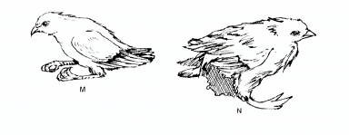

- Identify the nutrient the two chicks are lacking (1mk) _
M
N
- State two sources of nutrient chick N is lacking (2mk)

- State the condition chick N is suffering from (1mk)

- Other than the condition shown in chick B above give other symptoms of the deficiency (2mk)

- Study the illustration of the farm structure below and answer the questions that follow:

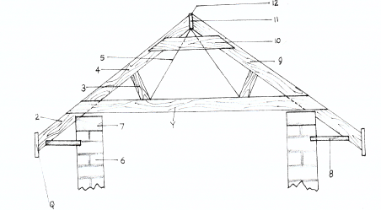 F

- Identify the parts labeled 5, 7, 9 and 10 (2mks)
5
7
9
10
- State one reason why it’s important to have structure labeled F at the edge of the rooting material.

- The diagram below is a cross section of part of cow’s udder.

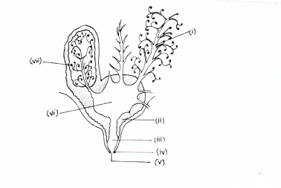

- Label the part’s numbered III, IV, VI, AND VII (2mks)
III
IV
VI
VII
- What is milk let down (1mk?)

- Give two characteristic of clean and high quality milk (2mks)

- The diagram below illustrate a disc plough study it carefully and answer the question thatfollow. 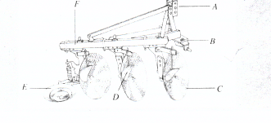

- Label the parts marked A,B and D. (3mk)
A
B
D

- Give the functions the parts marked C and F (2mks)

- State one reason why animals should be watered before dipping (1mk)

SECTION C
- Discuss milk fever under the following sub-heading
- Animals affected (1mk)

- Symptoms of attack (7mks)

- Discuss African swine fever under the following sub- heading
- Animal affected (1mk)

- Causal organism (1mk)

- Symptoms (6mk)

- A.Describe various care and maintenance of a tractor battery (6mk)

B. Outline the expected causes of the following faults of ignitions system of a tractor
- Sudden stopping (2mks)

- Continuous Engine running (3mks)

C)Discuss advantages of battery cage system in poutry rearing (9mks)

- A.Discuss digestion of food in poutry from crop to gizzard (10mks)

B. Give any 4 Harmful effects of Keds in livestock. (4mk)

C. Describe functions of the following parts of plunge dip (6mk)
- Jump (2mks)

- Drainage race (2mks)

- Roof (2mkS)

