Name___________________________________________Class______________Adm No:__________
Date__________________________________________Sign_______________

END OF TERM ONE EXAMINATION

FORM TWO

AGRICULTURE

TIME 2 HOURS
This paper has three section A, B and C.
Answer all questions in the section A, B and any two in section C.
All answers should be written in the spaces provided.

OFFICIAL USE ONLY
SECTION | QUESTION | MAX SCORE | CANDIDATE SCORE
A | 1 – 16 | 40
B | 17 – 19 | 20
C | 20 – 22 | 40
TOTAL |  | 100

SECTION A 40 MKS
Answer all question in this section
1. State three ways through which agriculture contribute to industrial development. (3mks)
………………………………………………………………………………………………………………………………………………………………………………………………………………………………………………………………………………………………………………………………………………………………………………………………………………………………
2. Name three factors that influence shifting cultivation. (3mks)
………………………………………………………………………………………………………………………………………………………………………………………………………………………………………………………………………………………………………………………………………………………………………………………………………………………………
3. State two categories of parasites that affect livestock production. (2mks)
………………………………………………………………………………………………………………………………………………………………………………………………………………………………………………………………………………………………………………………
4. List two maintenance practices carried out the following farm tools. (6mks)
a) Wheel barrow
………………………………………………………………………………………………………………………………………………………………………………………………………………………………………………………………………………………………………………………
b) Milking pail
………………………………………………………………………………………………………………………………………………………………………………………………………………………………………………………………………………………………………………………

c) Wool shears
………………………………………………………………………………………………………………………………………………………………………………………………………………………………………………………………………………………………………………………
5. State two reasons why a farmer should prepare land before planting. (2mks)
………………………………………………………………………………………………………………………………………………………………………………………………………………………………………………………………………………………………………………………
6. Name three methods a farmer can use when doing tertiary cultivation. (3mks)
………………………………………………………………………………………………………………………………………………………………………………………………………………………………………………………………………………………………………………………………………………………………………………………………………………………………
7. State two disadvantages of plastic pipes in water conveyance. (2mks)
………………………………………………………………………………………………………………………………………………………………………………………………………………………………………………………………………………………………………………………
8. State two importance of treating farm water before using it. (2mks)
………………………………………………………………………………………………………………………………………………………………………………………………………………………………………………………………………………………………………………………
9. List two methods of preparing compost manure. (2mks)
………………………………………………………………………………………………………………………………………………………………………………………………………………………………………………………………………………………………………………………
10. State two characteristics of a dairy cattle breed. (2mks)
………………………………………………………………………………………………………………………………………………………………………………………………………………

11. State two uses of farm records. (2mks)
………………………………………………………………………………………………………………………………………………………………………………………………………………………………………………………………………………………………………………………
12. What does the following initials represent in fertilizer description N.P.K. (3mks)
………………………………………………………………………………………………………………………………………………………………………………………………………………
13. Differentiate between the following terms.
a) Straight fertilizer and compound fertilizer. (2mks)
………………………………………………………………………………………………………………………………………………………………………………………………………………………………………………………………………………………………………………………………………………………………………………………………………………………………
14. A farmer was advised to apply 180 kg CAN/ha when top-dressing the maize crops. If the C.A.N. available in shops contain 21% N. Calculate the amount of nitrogen applied per hectare. (2mks)

15. State two advantage of using seeds as planting materials. (2mks)
………………………………………………………………………………………………………………………………………………………………………………………………………………………………………………………………………………………………………………………………………………………………………………………………………………………………

16. Name two methods a farmer can use to break seed dormancy. (2mks)
………………………………………………………………………………………………………………………………………………………………………………………………………………………………………………………………………………………………………………………………………………………………………………………………………………………………
SECTION B 20 MKS
Answer all questions in this section.
17a) Study the diagrams below and answer the questions that follow
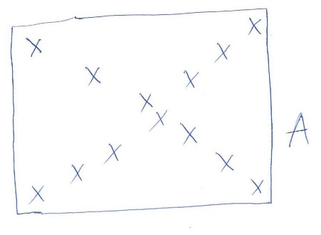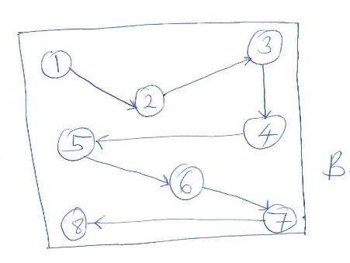

a) Identify the soil sampling methods shown above. (2mks)
A ………………………………………………………………………………….
B ………………………………………………………………………………….
b) State three types of information written on a soil sample before it’s taken to the laboratory for testing. (3mks)
………………………………………………………………………………………………………………………………………………………………………………………………………………………………………………………………………………………………………………………………………………………………………………………………………………………………
c) State four areas where soil samples should not be collected for sampling. (4mks)
………………………………………………………………………………………………………………………………………………………………………………………………………………………………………………………………………………………………………………………………………………………………………………………………………………………………
18. Study the diagram below and answer the questions
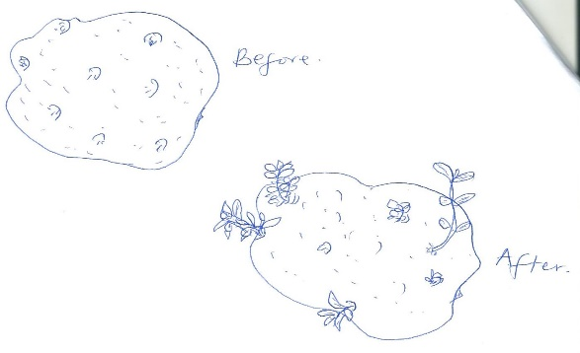

a) Name the practice above. (1mk)
………………………………………………………………………………………………………
b) State two advantages of the above practice on iris potatoes. (2mks)
………………………………………………………………………………………………………………………………………………………………………………………………………………………………………………………………………………………………………………………
c) Name two methods used when planting crops. (2mks)
………………………………………………………………………………………………………………………………………………………………………………………………………………9. Study the diagram below and answer the questions that follow. 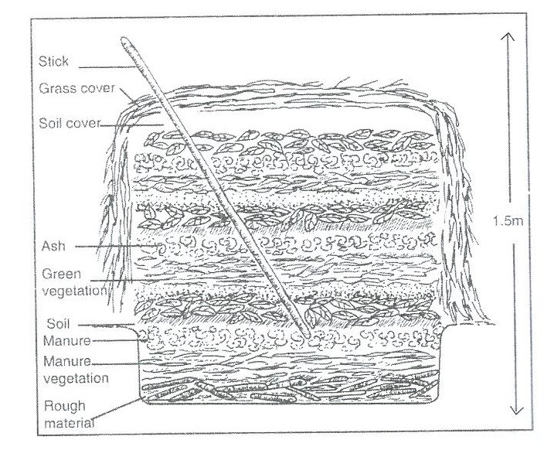
a) Identify manure preparation method above. (4mks)
i) Wood ash

ii) Rotten manure

iii) Stick

iv) Top soil

c) State one reason why manure heap should be turned at least every 3 to 4 weeks. (1mk)
………………………………………………………………………………………………………

SECTION C: 40 MKS
Answer any two questions in this section
20a) Explain five factors that determine the quality of farm yard manure. (10mks)
b) Discuss five importance of keeping livestock in Kenya today. (10mks)

21a) Explain five methods through which a soil loses its fertility. (10mks)
b) Describe five factors that affect the rooting of cuttings in vegetative propagation. (10mks)

22a) Explain five methods a farmer can use when applying fertilizer to crops. (10mks)
b) State and explain five reasons why farm tools should be maintained. (10mks)
………………………………………………………………………………………………………………………………………………………………………………………………………………………………………………………………………………………………………………………………………………………………………………………………………………………………………………………………………………………………………………………………………………………………………………………………………………………………………………………………………………………………………………………………………………………………………………………………………………………………………………………………………………………………………………………………………………………………………………………………………………………………………………………………………………………………………………………………………………………………………………………………………………………………………………………………………………………………………………………………………………………………………………………………………………………………………………………………………………………………………………………………………………………………………………………………………………………………………………………………………………………………………………………………………………………………………………………………………………………………………………………………………………………………………………………………………………………………………………………………………………………………………………………………………………………………………………………………………………………………………………………………………………………………………………………………………………………………………………………………………………………………………………………………………………………………………………………………………………………………………………………………………………………………………………………………………………………………………………………………………………………………………………………………………………………………………………………………………………………………………………………………………………………………………………………………………………………………………………………………………………………………………………………………………………………………………………………………………………………………………………………………………………………………………………………………………………………………………………………………………………………………………………………………………………………………………………………………………………………………………………………………………………………………………………………………………………………………………………………………………………………………………………………………………………………………………………………………………………………………………………………………………………………………………………………………………………………………………………………………………………………………………………………………………………………………………………………………………………………………………………………………………………………………………………………………………………………………………………………………………………………………………………………………………………………………………………………………………………………………………………………………………………………………………………………………………………………………………………………………………………………………………………………………………………………………………………………………………………………………………………………………………………………………………………………………………………………………………………………………………………………………………………………………………………………………………………………………………………………………………………………………………………………………………………………………………………………………………………………………………………………………………………………………………………
………………………………………………………………………………………………………

