FORM FOUR END OF TERM TWO EXAMINATION 2019
443/2 AGRICULTURE PAPER 2
TIME: 2 Hours
NAME: ____________________________________________________________________
INDEX NUMBER: __________________________ CLASS: ______________________
SIGNATURE: ______________________________ DATE: _______________________
Instructions to candidates
- write your name and index number in the spaces provided above.
- Sign and write the date of examination in the spaces provided above.
- This paper consists of three sections: A, B and C.
- Answer all the questions in sections A and B.
- Answer any two questions in section C.
- All answers should be written in the spaces provided in the Question paper.
- This paper consists of 12 printed pages.
- Candidates should check the question paper to ascertain that all the pages are printed as indicated and that no questions are missing.
- Candidates should answer all Questions in English.

For Examiner’s use only
Section | Question | Maximum  Score | Candidate’s  Score
A | 1-20 | 30
B | 21-24 | 20
C |  | 20
 |  | 20
Total Score |  | 90

Section A (30MKS) (Answer ALL the questions in this section

1. Name two livestock tools that are used together as a pair. (1mk)

2. Name three sources of water in animals body. (1½mk)

3. State two signs of lambing in sheep. (1mk)

4. List two ways through which a vaccine can be administered to poultry. (1mk)

5. Identify the main use of a queen excluder in a Kenyan top bar hire. (1mk)

6. State two factors that may predispose dairy cattle to mastitis. (1mk)

7. State the importance of the following parts an egg.
a) Chalaza (1mk)

b) Air space (1mk)

8. Name three maintenance practices carried out on a tractor battery. (1½mk)

9. State two advantages of using animals’ power in a farm. (2mks)

10. Name four farm structures used for handling livestock. (2mks)

11. Distinguish between mothering ability and prolificacy. (2mks)

12. Name four tools that are sued when laying concrete blocks during construction of a wall. (2mks)

13. Give four factors that may lead to a farmer culling dairy cattle. (2mks)

14. Mention four physical characteristics of exotic beef cattle breeds. (2mks)

15. State four factors considered when siting a fish pond in a farm. (2mks)

16. State four causes of cannibalism in poultry production. (2mks)

17. Name two hormones that control milk let down in a dairy cow. (1mk)

18. Give two reasons why walls of dairy shed should be white washed instead of painting with oil paints. (1mk)

19. List two functions of proteins in livestock. (1mk)

20. Gives two uses of litter in a poultry house. (1mk)

SECTION B (20 marks)
Answer ALL the questions in the section in this section in the spaces provided.

21. The diagram below shows a livestock parasite.
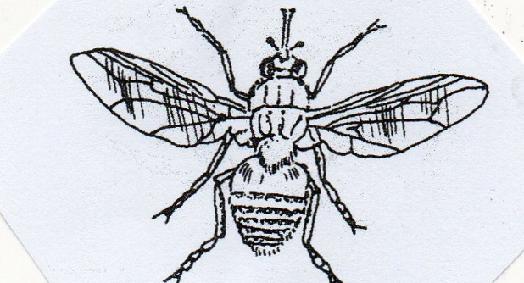

a) Identify the parasite shown above. (1mk)

b) State two harmful effects of the above parasite on livestock. (1mk)

c) Explain any two methods used in the control of the above parasite. (2mks)

22. The diagram below represents the structure of a quarter of the cow’s udder. Study it and answer the questions that follow.

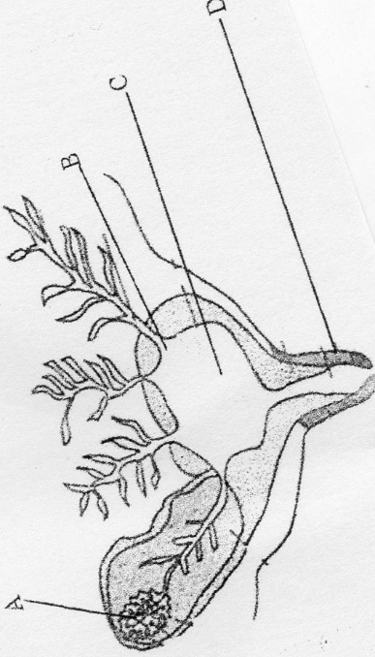

a) Name the parts labelled B and C. (2mks)
B –

C –

b) Name the process that takes place in the part labelled A and the hormone that controls it

Process –

Hormone –

c) State the function of the part labelled D. (1mk)

23. Below is a farm implement. Study it keenly and answer the questions that follow.

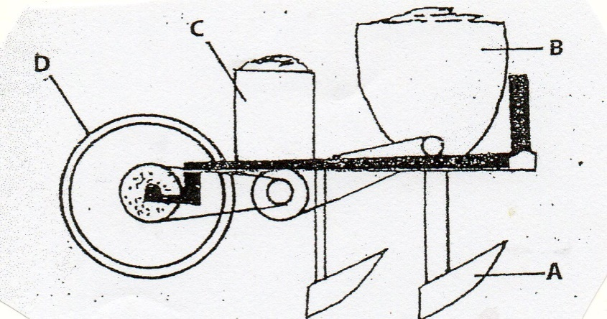

a) Name the farm implement drawn above. (1mk)

b) Identify the parts labelled A, B, C and D (2mks) A
B
C
D
c) State two maintenance practices carried out on the implement (2mks)

24. The diagram below shows a routine practice being carried out on an animals. Study it and answer questions that follow.

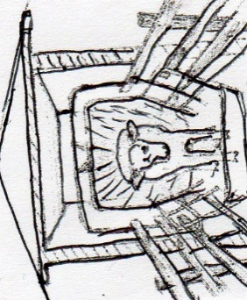

..

a) Identify the practice. (1mk)

b) Name the structure in which the practice is being carried out. 1mk)

c) Give three advantages of using the above structure instead of a plunge dip.
(3mks)

SECTION C (40 MARKS)
Answer ANY two questions from this section in the spaces provided after question 27

25. a) State and explain five reasons why farmers should keep livestock healthy. (10mks)

b) Discuss four factors that influence the dairy feed requirement of an animal. (8mks)

c) Name two methods used to compute livestock feeds. (2mks)

26. a) Describe Anthrax under the following subheadings.
i) Causal organism. (1mk)
ii) Signs of infection/symptoms. (6mks)
iii) Control measures. (3mks)

B) i) State and explain condition necessary for artificial incubation. (8mks)

ii) State two advantages of artificial incubation. (2mks)

27. a) State the differences between digestion in ruminants and non-ruminants. (5mks)

b) Describe the artificial rearing of layers chick from one day up to the end of brooding.
(10mks)
c) Explain the procedure of establishing wire fence. (5mks)

--------------------------------------------------------------------------------------------------------------------------
--------------------------------------------------------------------------------------------------------------------------
--------------------------------------------------------------------------------------------------------------------------
--------------------------------------------------------------------------------------------------------------------------
--------------------------------------------------------------------------------------------------------------------------
--------------------------------------------------------------------------------------------------------------------------
--------------------------------------------------------------------------------------------------------------------------
--------------------------------------------------------------------------------------------------------------------------
--------------------------------------------------------------------------------------------------------------------------
--------------------------------------------------------------------------------------------------------------------------
--------------------------------------------------------------------------------------------------------------------------
--------------------------------------------------------------------------------------------------------------------------
--------------------------------------------------------------------------------------------------------------------------
--------------------------------------------------------------------------------------------------------------------------
--------------------------------------------------------------------------------------------------------------------------
--------------------------------------------------------------------------------------------------------------------------
--------------------------------------------------------------------------------------------------------------------------
--------------------------------------------------------------------------------------------------------------------------
--------------------------------------------------------------------------------------------------------------------------
--------------------------------------------------------------------------------------------------------------------------
--------------------------------------------------------------------------------------------------------------------------
--------------------------------------------------------------------------------------------------------------------------
--------------------------------------------------------------------------------------------------------------------------
--------------------------------------------------------------------------------------------------------------------------
--------------------------------------------------------------------------------------------------------------------------
--------------------------------------------------------------------------------------------------------------------------
--------------------------------------------------------------------------------------------------------------------------
--------------------------------------------------------------------------------------------------------------------------
--------------------------------------------------------------------------------------------------------------------------
--------------------------------------------------------------------------------------------------------------------------
--------------------------------------------------------------------------------------------------------------------------
--------------------------------------------------------------------------------------------------------------------------
--------------------------------------------------------------------------------------------------------------------------
--------------------------------------------------------------------------------------------------------------------------
--------------------------------------------------------------------------------------------------------------------------
--------------------------------------------------------------------------------------------------------------------------
--------------------------------------------------------------------------------------------------------------------------
--------------------------------------------------------------------------------------------------------------------------
--------------------------------------------------------------------------------------------------------------------------
--------------------------------------------------------------------------------------------------------------------------
--------------------------------------------------------------------------------------------------------------------------
--------------------------------------------------------------------------------------------------------------------------
--------------------------------------------------------------------------------------------------------------------------
--------------------------------------------------------------------------------------------------------------------------
--------------------------------------------------------------------------------------------------------------------------
--------------------------------------------------------------------------------------------------------------------------
--------------------------------------------------------------------------------------------------------------------------
--------------------------------------------------------------------------------------------------------------------------
--------------------------------------------------------------------------------------------------------------------------
--------------------------------------------------------------------------------------------------------------------------
--------------------------------------------------------------------------------------------------------------------------
--------------------------------------------------------------------------------------------------------------------------
--------------------------------------------------------------------------------------------------------------------------
--------------------------------------------------------------------------------------------------------------------------
--------------------------------------------------------------------------------------------------------------------------
--------------------------------------------------------------------------------------------------------------------------
--------------------------------------------------------------------------------------------------------------------------
--------------------------------------------------------------------------------------------------------------------------
--------------------------------------------------------------------------------------------------------------------------
--------------------------------------------------------------------------------------------------------------------------
--------------------------------------------------------------------------------------------------------------------------
--------------------------------------------------------------------------------------------------------------------------
--------------------------------------------------------------------------------------------------------------------------
--------------------------------------------------------------------------------------------------------------------------
--------------------------------------------------------------------------------------------------------------------------
--------------------------------------------------------------------------------------------------------------------------
--------------------------------------------------------------------------------------------------------------------------
--------------------------------------------------------------------------------------------------------------------------
--------------------------------------------------------------------------------------------------------------------------
--------------------------------------------------------------------------------------------------------------------------
--------------------------------------------------------------------------------------------------------------------------
--------------------------------------------------------------------------------------------------------------------------
--------------------------------------------------------------------------------------------------------------------------
--------------------------------------------------------------------------------------------------------------------------
--------------------------------------------------------------------------------------------------------------------------
--------------------------------------------------------------------------------------------------------------------------
--------------------------------------------------------------------------------------------------------------------------
--------------------------------------------------------------------------------------------------------------------------
--------------------------------------------------------------------------------------------------------------------------
--------------------------------------------------------------------------------------------------------------------------
--------------------------------------------------------------------------------------------------------------------------
--------------------------------------------------------------------------------------------------------------------------
--------------------------------------------------------------------------------------------------------------------------
--------------------------------------------------------------------------------------------------------------------------
--------------------------------------------------------------------------------------------------------------------------
--------------------------------------------------------------------------------------------------------------------------
--------------------------------------------------------------------------------------------------------------------------
--------------------------------------------------------------------------------------------------------------------------
--------------------------------------------------------------------------------------------------------------------------
--------------------------------------------------------------------------------------------------------------------------

