Name: …………………………………………………………Index No: ……………………..……………
Candidate’s Signature:……………………………….
Date: ……………….……………….…

443/1
AGRICULTURE
PAPER 1
JULY/AUGUST 2014
TIME: 2 HOURS

Kenya Certificate of Secondary Education

443/1
Agriculture
Paper 1
2 hours

INSTRUCTIONS TO CANDIDATES:
- This paper contains three sections A, B and C
- Answer ALL the questions in section A amd B
- Answer any Two questions from section C
- All answers should be written in the spaces provided.

FOR EXAMINERS USE ONLY
SECTION | QUESTIONS | MAX SCORE | CANDIDATES SCORE
A | - 17 | 30
B |  | 20
 |  | 20
 |  | 20
TOTAL |  | 90

This paper consists of 8 printed pages. Candidates should check to ascertain that all pages are printed as indicated and that no questions are missing.
SECTION A (30 MARKS)
Answer ALL the questions in this section in the spaces provided
- List two benefits of a deep soil. (2mks)
……………………………………………………………………………………………………..
……………………………………………………………………………………………………..
- Under which conditions do farmers use high seed rate. (2mks)
……………………………………………………………………………………………………..
……………………………………………………………………………………………………..
- Name two factors that dictate a method of fertilizer application. ( 3mks)
……………………………………………………………………………………………………..
……………………………………………………………………………………………………..
- Differentiate between nutrient fixation and nutrient toxicity. (2mks)
……………………………………………………………………………………………………..
……………………………………………………………………………………………………..
- What is pricking out as used in vegetable crop nursery management. ( 1mk)
……………………………………………………………………………………………………..
……………………………………………………………………………………………………..
- State two practices of hardening off in vegetable crop nursery. (2mks)
……………………………………………………………………………………………………..
……………………………………………………………………………………………………..
- Differentiate between seed inoculation and seed dressing. (2mks)
……………………………………………………………………………………………………..
……………………………………………………………………………………………………..
- Give two characteristics of certified seeds. (2mks)
……………………………………………………………………………………………………..
……………………………………………………………………………………………………..
- Distinguish between concession and tenancy forms of land tenure. (2mks)
……………………………………………………………………………………………………..
……………………………………………………………………………………………………..
- Name two areas where cut-off drain discharges its water. ( 1 ½ mks)
……………………………………………………………………………………………………..
……………………………………………………………………………………………………..
- Name three methods of harvesting agro forestry crops. ( 1 ½ mks)
……………………………………………………………………………………………………..
……………………………………………………………………………………………………..
……………………………………………………………………………………………………..
- Name a crop that require the following training
- Propping ( ½ mk)
……………………………………………………………………………………………………..
- Tralishing ( ½ mk)
……………………………………………………………………………………………………..
- Staking ( ½ mk)
……………………………………………………………………………………………………..
- How can agriculture promote industrial growth. (1mk)
……………………………………………………………………………………………………..
……………………………………………………………………………………………………..
- How does the following practices control crop pests.
(a) close season (1mk)
……………………………………………………………………………………………………..
……………………………………………………………………………………………………..
(b) Use of flood water (1mk)
……………………………………………………………………………………………………..
……………………………………………………………………………………………………..
15 How would each of these methods help the farmer conserve soil and water
- Mulching (1mk)
……………………………………………………………………………………………………..
……………………………………………………………………………………………………..
- Bunds (1mk)
……………………………………………………………………………………………………..
……………………………………………………………………………………………………..
- What is the negative effects of these weeds in the named enterprises.
(a) Black Jack in merino sheep farm. ( ½mk)
……………………………………………………………………………………………………..
……………………………………………………………………………………………………..
- Maxican marigold in a dairy farm. (1mk)
……………………………………………………………………………………………………..
……………………………………………………………………………………………………..
- Name three types of elasticities of demand in agricultural economics. (1mk)
……………………………………………………………………………………………………..
……………………………………………………………………………………………………..
……………………………………………………………………………………………………..

SECTION B (20MARKS)
Answer ALL Questions in this section
- Below is a diagram on a method of soil sampling. Study it and answer the questions that follow.
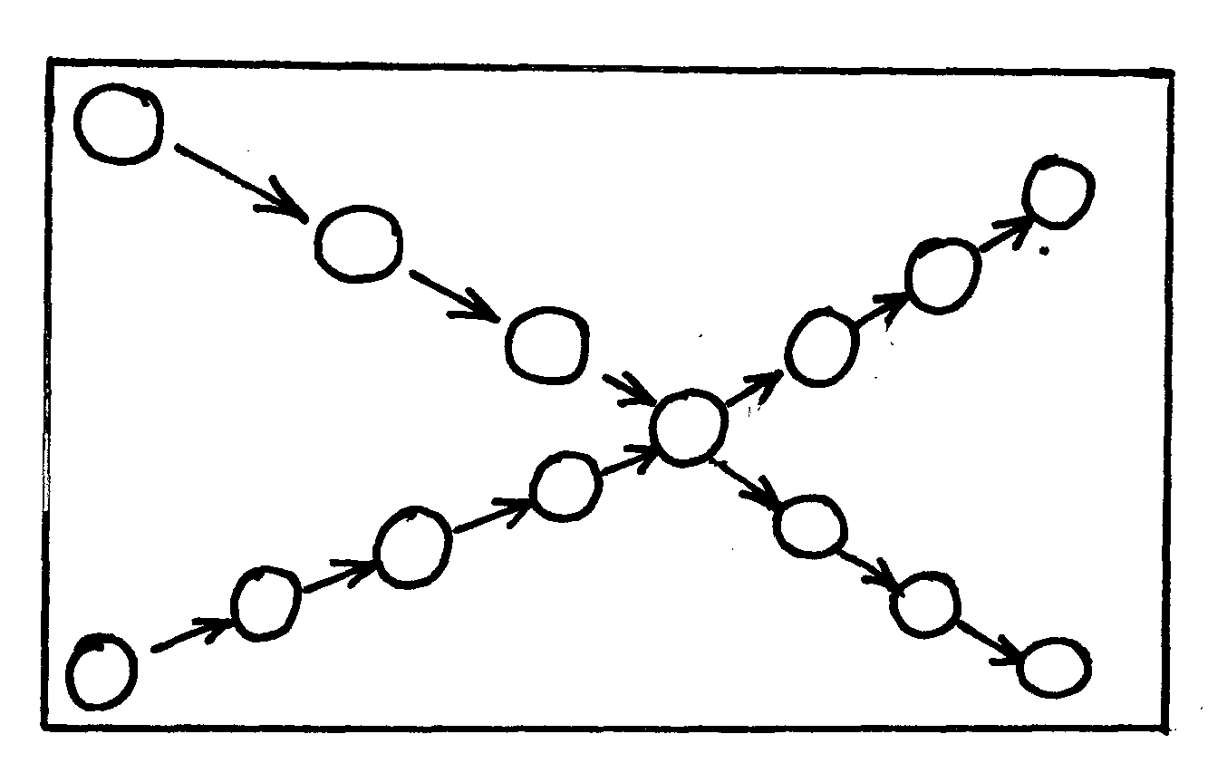
1
1
3
2
2
3
11
4
10
5
8
9
7
6

(a) Identify the method shown above. (1mk)
……………………………………………………………………………………………………..
……………………………………………………………………………………………………..
(b) State foursteps to be followed when sampling soil. (2mks)
……………………………………………………………………………………………………..
……………………………………………………………………………………………………..
B
A
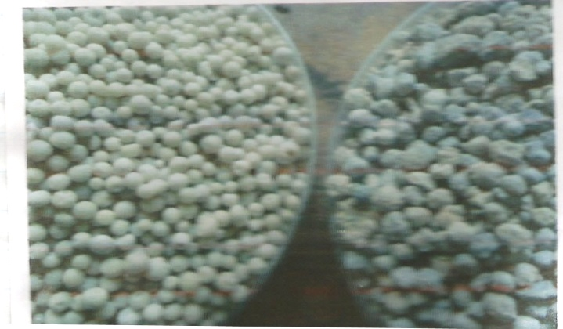
(c)

(i) Identify the fertilizers illustrated above (2mks)
A……………………………………………..…………
B…………………………………………………………
(ii) Give two reasons why fertilizer A is not applied during planting. (2mks)
……………………………………………………………………………………………………..
……………………………………………………………………………………………………..

- The diagram below illustrates materials and a method of vegetative propagation. Study it and answer the questions that follow.
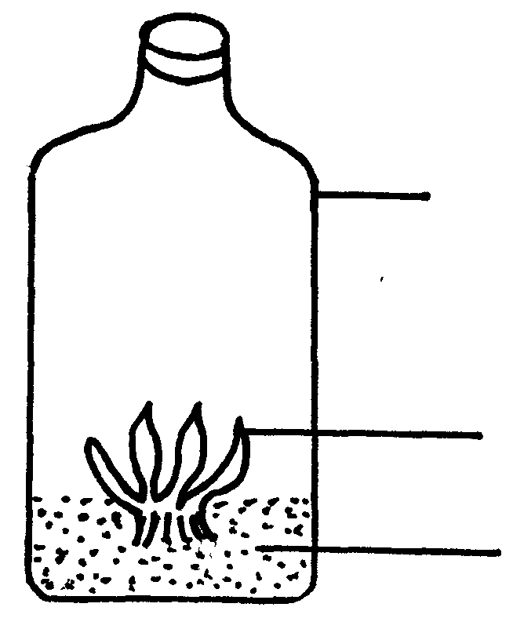

Glass container

Plantlets

Growth medium

- Identify the methods of propagation illustrated above (1mk)
……………………………………………………………………………………………………..
……………………………………………………………………………………………………..
- Give one advantage associated with the above method of propagation. (1mk)
……………………………………………………………………………………………………..
……………………………………………………………………………………………………..

- State one reason why the above method is rarely practiced by farmers. (1mk)
……………………………………………………………………………………………………..
……………………………………………………………………………………………………..
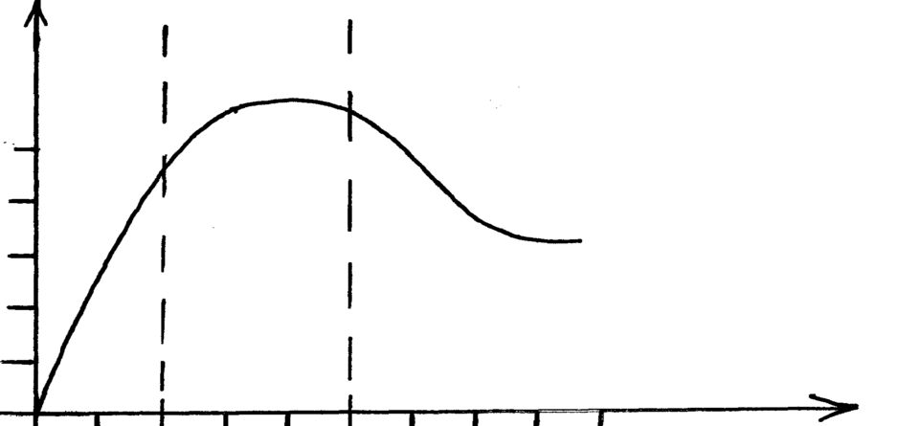
- Below is a graphical representation of the law of diminishing return.

Zone ZoneZone
I II III

50

40

30

20

10

1 2 3 4 5 6 7 8 9
- Explain what happens in each of the zoneslabelled I,II, and III (3mks)
……………………………………………………………………………………………………..
……………………………………………………………………………………………………..
- Which of the three is arationalzone of production. (1mk)
……………………………………………………………………………………………………..
……………………………………………………………………………………………………..
- What is journal as use din farm accounts. (1mk)
……………………………………………………………………………………………………..
……………………………………………………………………………………………………..
- The diagram below shows some common weeds found in arable land. Study them and answer questions that follow.
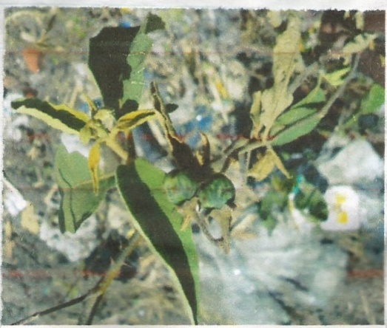
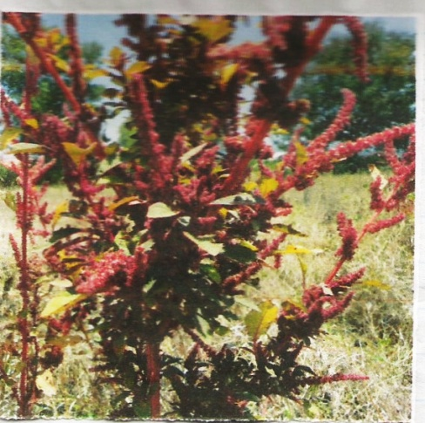

- (i) Identify the weeds D and E (1mk)
D……………………………………………..
E……………………………………………….
(ii) Give one difficulty encountered when controlling each of the weed. (1mk)
……………………………………………………………………………………………………..
……………………………………………………………………………………………………..
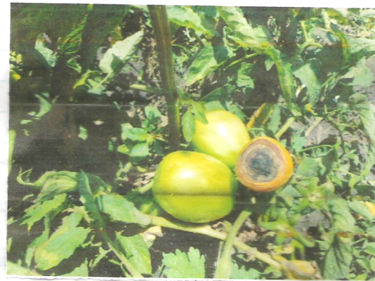
(b)

- Identify the disease above. (1mk)
……………………………………………………………………………………………………..
……………………………………………………………………………………………………..
- State two causes the above disease. (2mks)
……………………………………………………………………………………………………..
……………………………………………………………………………………………………..

SECTION C (40MARKS)
Answer any two Questions in this section
- (a) State five ways of improving productivity of a framlabour. (5mks)
(b) Identify seven ways of adjusting t o risks and uncertainitiesi in the farm. (7mks)
(c) Outline eight effects of land fragmentation (8mks)

- (a) Describe maize production under the following headigns
- Land preparation (3mks)
- Planting (4mks)
- Field management practices (3mks)
(b) State and explain five factors that influence crop rotation. (10mks)

- (a) Outline qualities of a good farm manager (5mks)
(b) Outline six activities that may be undertaken in organic farming. (6mks)
(c) (i) give five reasons for pruning. (5mks)
(ii) describefour disadvantages of chemical pest control. (4mks)
……………………………………………………………………………………………………..
……………………………………………………………………………………………………..
……………………………………………………………………………………………………..
……………………………………………………………………………………………………..
……………………………………………………………………………………………………..
……………………………………………………………………………………………………..
……………………………………………………………………………………………………..
……………………………………………………………………………………………………..
……………………………………………………………………………………………………..
……………………………………………………………………………………………………..
……………………………………………………………………………………………………..
……………………………………………………………………………………………………..
……………………………………………………………………………………………………..
……………………………………………………………………………………………………..
……………………………………………………………………………………………………..
……………………………………………………………………………………………………..
……………………………………………………………………………………………………..
……………………………………………………………………………………………………..
……………………………………………………………………………………………………..
……………………………………………………………………………………………………..
……………………………………………………………………………………………………..
……………………………………………………………………………………………………..
……………………………………………………………………………………………………..
……………………………………………………………………………………………………..
……………………………………………………………………………………………………..
……………………………………………………………………………………………………..
……………………………………………………………………………………………………..
……………………………………………………………………………………………………..
……………………………………………………………………………………………………..
……………………………………………………………………………………………………..
……………………………………………………………………………………………………..
……………………………………………………………………………………………………..
……………………………………………………………………………………………………..
……………………………………………………………………………………………………..
……………………………………………………………………………………………………..
……………………………………………………………………………………………………..
……………………………………………………………………………………………………..
……………………………………………………………………………………………………..
……………………………………………………………………………………………………..
……………………………………………………………………………………………………..
……………………………………………………………………………………………………..
……………………………………………………………………………………………………..
……………………………………………………………………………………………………..
……………………………………………………………………………………………………..
……………………………………………………………………………………………………..
……………………………………………………………………………………………………..
……………………………………………………………………………………………………..
……………………………………………………………………………………………………..
……………………………………………………………………………………………………..
……………………………………………………………………………………………………..
……………………………………………………………………………………………………..
……………………………………………………………………………………………………..
……………………………………………………………………………………………………..
……………………………………………………………………………………………………..
……………………………………………………………………………………………………..
……………………………………………………………………………………………………..

