Name: …………………………………………………………Index No: ……………………..……………
Candidate’s Signature:……………………………….
Date: ……………….……………….…

443/2
AGRICULTURE
PAPER 2
JULY/AUGUST 2014
TIME: 2 HOURS

Kenya Certificate of Secondary Education (K.C.S.E)

44//2
Agriculture 2
Paper 2
2 hours

INSTRUCTIONS TO CANDIDATES:
- Write your name and index number in the spaces provided.
- Sign and write the date of examination in the spaces provided
- This paper consists of three section A,B and C
- Answer all questions in section B and C
- Answer any two questions in section C
- All the questions should answered in the spaces provided
FOR EXAMINERS USE ONLY
SECTION | QUESTIONS | MAX SCORE | CANDIDATES SCORE
A |  | 30
B |  | 20
C  TOTAL |  | 20
 |  | 20
 |  | 90

This paper consists of 8 printed pages. Candidates should check to ascertain that all pages are printed as indicated and that no questions are missing.
SECTION A (30MARKS)
Answer all the questions in this section in the spaces provided
- State four categories of farm tools and equipment (2mks)
………………………………………………………………………………………………………….
………………………………………………………………………………………………………….
………………………………………………………………………………………………………….
………………………………………………………………………………………………………….

2.. Differentiate between breed and breed type. (1mk)
………………………………………………………………………………………………………….
………………………………………………………………………………………………………….

- a) Define pre-disposing factors as used in livestock. (1mk)
………………………………………………………………………………………………………….
………………………………………………………………………………………………………….
b) State four pre-disposing factors that can lead to a cow contracting mastitis. (2mks)
………………………………………………………………………………………………………….
………………………………………………………………………………………………………….
………………………………………………………………………………………………………….
………………………………………………………………………………………………………….
4. Distinguish between mothering ability and prolificacy. (1mk)
………………………………………………………………………………………………………….
………………………………………………………………………………………………………….
5 (a) An animal ate polythene paper and some strings accidentally. Name the stomach chamber
where the materials will be found if slaughtered. (1mk)
………………………………………………………………………………………………………….
………………………………………………………………………………………………………….
(b) Other than retaining materials above, state the other function of the part of stomach
chamber name din (a) above. (1mk)
………………………………………………………………………………………………………….
………………………………………………………………………………………………………….
6 (a) Natural mating is amethod of service in livestock production. Name any other two methods
of service. (1mk)
………………………………………………………………………………………………………….
………………………………………………………………………………………………………….

(b) State fourdisadvantages of natural mating. (2mks)
………………………………………………………………………………………………………….
………………………………………………………………………………………………………….
………………………………………………………………………………………………………….
………………………………………………………………………………………………………….
7. Give three reasons for carrying out maintenance practices on a mower ( 1 ½ mks)
………………………………………………………………………………………………………….
………………………………………………………………………………………………………….
………………………………………………………………………………………………………….
………………………………………………………………………………………………………….
8. Name two diseases that affect female cattle. (1mk)

9. Why is drenching not a effective method of controlling intestinal parasites in livestock. (1 ½ mks)
………………………………………………………………………………………………………….
………………………………………………………………………………………………………….
………………………………………………………………………………………………………….
………………………………………………………………………………………………………….

10
11
12
13
14
15
16. Name any four tools used when laying concrete blocks when constructing a calf pen.
………………………………………………………………………………………………………….
………………………………………………………………………………………………………….
………………………………………………………………………………………………………….
………………………………………………………………………………………………………….
17. Name any four practices carried out on milk immediately after milking.
………………………………………………………………………………………………………….
………………………………………………………………………………………………………….
………………………………………………………………………………………………………….
………………………………………………………………………………………………………….

SECTION B (20 MARKS)
Answer all the questions in this section in the spaces provided.
18. The diagram below shows parts of a power transmission system of a tractor. Study and answer the
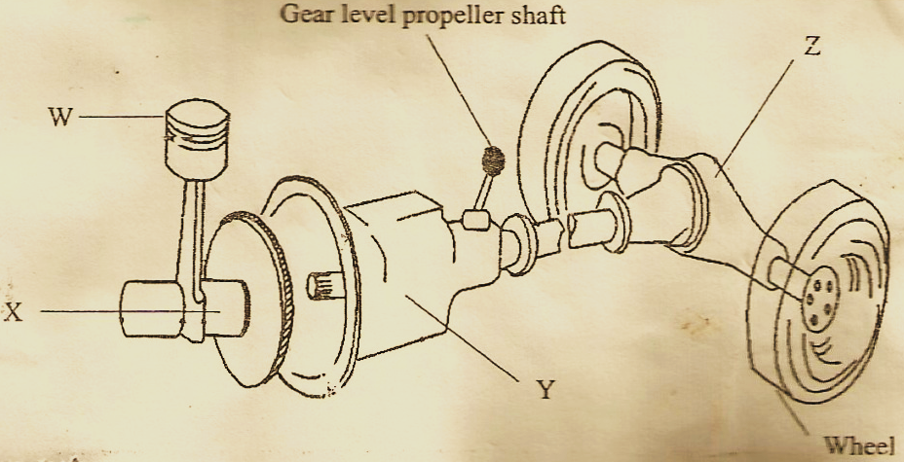
questions that follow.

(a) Name the parts labeled W,X,Y, and Z on the diagram. (2mks)
W………………………………………………………………………………
X………………………………………………………………………………
Y………………………………………………………………………………
Z………………………………………………………………………………
(b) State the function of the parts labeled W,Y, and Z ( 1 ½ mks)
W………………………………………………………………………………
Y………………………………………………………………………………
Z………………………………………………………………………………
(c) Name three ways in which the power is transmitted from the engine. ( 1 ½ mks)
………………………………………………………………………………………………………….
………………………………………………………………………………………………………….
………………………………………………………………………………………………………….
19. Diagrams G,Hand J illustrates some livestock parasites.
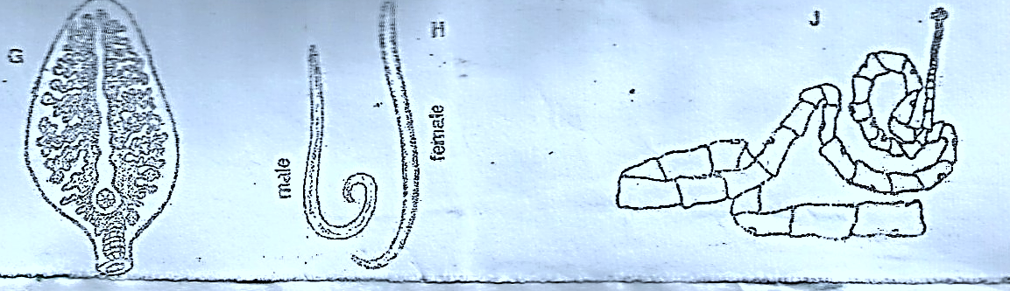

(a) Identify parasitesG,Hand J (3mks)
G…………………………………………………………………
H…………………………………………………………………
J…………………………………………………………………

(b) Name the parts of the host body when parasite G and H are found. (1mk)
G………………………………………………………….......
J…………………………………………………………………
(c) Name the intermediate host of parasite G and J (1mk)
G…………………………………………………………………
J…………………………………………………………………
20. Below is an illustration of astructure used for tick control in the farm. Study it carefully and answer
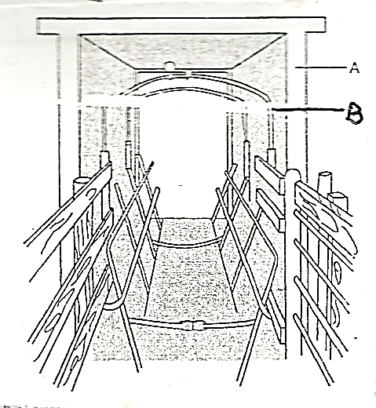
the questions that follow.

- Identify the structure. (1mk)
………………………………………………………………………………………………………….
………………………………………………………………………………………………………….
- Name the parts labeled A and B. (1mk)
A……………………………………………
B……………………………………………
- What is the function of the parts labeled (1mk)
A………………………………………………
B ………………………………………………

21. The diagram below shows a livestock production equipment .study it and answer the questions
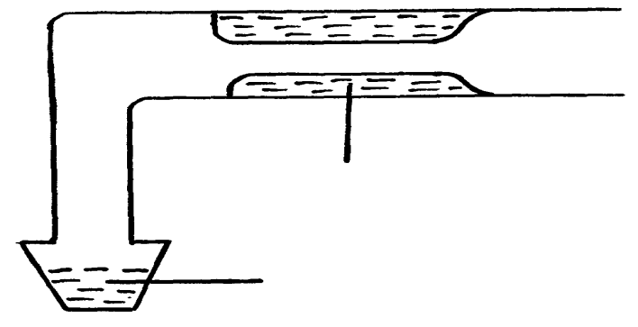
that follow.

Warm water

Collected semen

- Identify the equipment (1mk)
………………………………………………………………………………………………………….
………………………………………………………………………………………………………….
- What is the importance of warm water in the equipment. (1mk)
………………………………………………………………………………………………………….
………………………………………………………………………………………………………….

- Describe the procedure followed when using the equipment in collecting semen. (3mks)
………………………………………………………………………………………………………….
………………………………………………………………………………………………………….
………………………………………………………………………………………………………….
SECTION C 40 marks)
Answer any two questions in this section in the spaces provided after question 24.
22. (a) Discuss the life cycle of a three host tick (8mks)
(b) Discuss any four factors that may influence power output of a drought animal. (4mks)
(c) Discuss milk fever under the following headings
(i) cause (1mk)
(ii) symptoms of attack ( 5mks)
(iii) Control (2mks)

23. (a) Describe how a calf is trained to drink milk from abucket ( 6mks)
(b) Outline four advantages of artificial incubation ( 4mks)
(c) State four management practices that would unsure maximum harvest of fish from a fish pond. (4mks)
(d) givesix reasons for culling a boar in the farm. ( 6mks)

24. (a) State four observable features of poor layer in aflock of layers. (4mksm)
(b) Describe four structural requirements of a brooder. (4mks)
(c) State two factors considered when sourcing for chicks to be reared for egg production. (2mksm)
(d) Explain the requirements of a deep litter house for poultry rearing. (10mks)
………………………………………………………………………………………………………….
………………………………………………………………………………………………………….
………………………………………………………………………………………………………….
………………………………………………………………………………………………………….
………………………………………………………………………………………………………….
………………………………………………………………………………………………………….
………………………………………………………………………………………………………….
………………………………………………………………………………………………………….
………………………………………………………………………………………………………….
………………………………………………………………………………………………………….
………………………………………………………………………………………………………….
………………………………………………………………………………………………………….
………………………………………………………………………………………………………….
………………………………………………………………………………………………………….
………………………………………………………………………………………………………….
………………………………………………………………………………………………………….
………………………………………………………………………………………………………….
………………………………………………………………………………………………………….
………………………………………………………………………………………………………….
………………………………………………………………………………………………………….
………………………………………………………………………………………………………….
………………………………………………………………………………………………………….
………………………………………………………………………………………………………….
………………………………………………………………………………………………………….
………………………………………………………………………………………………………….
………………………………………………………………………………………………………….
………………………………………………………………………………………………………….
………………………………………………………………………………………………………….
………………………………………………………………………………………………………….
………………………………………………………………………………………………………….
………………………………………………………………………………………………………….
………………………………………………………………………………………………………….
………………………………………………………………………………………………………….
………………………………………………………………………………………………………….
………………………………………………………………………………………………………….
………………………………………………………………………………………………………….
………………………………………………………………………………………………………….
………………………………………………………………………………………………………….
………………………………………………………………………………………………………….
………………………………………………………………………………………………………….
………………………………………………………………………………………………………….
………………………………………………………………………………………………………….
………………………………………………………………………………………………………….
………………………………………………………………………………………………………….
………………………………………………………………………………………………………….
………………………………………………………………………………………………………….
………………………………………………………………………………………………………….
………………………………………………………………………………………………………….
………………………………………………………………………………………………………….
………………………………………………………………………………………………………….
………………………………………………………………………………………………………….
………………………………………………………………………………………………………….
………………………………………………………………………………………………………….
………………………………………………………………………………………………………….
………………………………………………………………………………………………………….
………………………………………………………………………………………………………….
………………………………………………………………………………………………………….
………………………………………………………………………………………………………….
………………………………………………………………………………………………………….
………………………………………………………………………………………………………….
………………………………………………………………………………………………………….
………………………………………………………………………………………………………….
………………………………………………………………………………………………………….
………………………………………………………………………………………………………….
………………………………………………………………………………………………………….
………………………………………………………………………………………………………….
………………………………………………………………………………………………………….
………………………………………………………………………………………………………….
………………………………………………………………………………………………………….
………………………………………………………………………………………………………….
………………………………………………………………………………………………………….
………………………………………………………………………………………………………….

