FORM FOUR END OF TERM TWO EXAMINATION 2019
443/1 AGRICULTURE PAPER 1
TIME: 2 Hours
NAME: ____________________________________________________________________
INDEX NUMBER: __________________________ CLASS: ______________________
SIGNATURE: ______________________________ DATE: _______________________
Instructions to candidates
- write your name and index number in the spaces provided above.
- Sign and write the date of examination in the spaces provided above.
- This paper consists of three sections: A, B and C.
- Answer all the questions in sections A and B.
- Answer any two questions in section C.
- All answers should be written in the spaces provided in the Question paper.
- This paper consists of 9 printed pages.
- Candidates should check the question paper to ascertain that all the pages are printed as indicated and that no questions are missing.
- Candidates should answer all Questions in English.

For Examiner’s use only
Section | Question | Maximum  Score | Candidate’s  Score
A | 1-15 | 30
B | 16-20 | 20
C |  | 20
 |  | 20
Total Score |  | 90

SECTION A (30 Marks)
Answer all Questions in the spaces provided.
- State four advantages of organic farming. (2marks)

- Give four factors that can increase seed rates in crop production. (2marks)

- State four roles of organic matter in sandy soils. (2marks)

- State four reasons for practicing minimum tillage. (2marks)

- What is meant by each of the following in crop production?
- Crop rotation (1mark)

- Mulching (1mark)

- Give four reasons for inverting soil (furrow) slices during primary cultivation. (2marks)

- State four cultural ways of controlling couch grass Digitaria scalarum. (2marks)

- a) Name three vegetative parts that can be used to propagate pineapples. (1½marks)

b) State three disadvantages of vegetatively propagating pineapples. (1½marks)

- Name three sources of underground water (1½marks)

- What is meant by each of the following in agro-forestry?
- Pollarding (1mark)

- Coppicing (1mark)

- Lopping (1mark)

- State the information included in a sales receipt when a farmer is selling eggs (2½marks)

- State two reasons for practicing agro-forestry on a;
- River bank (1mark)

- Steep slope (1 mark)

- State three disadvantages of using plastic pipes to convey water. (1½marks)

- State three causes of Blossom End Rot in tomatoes. (1½marks)

- What is meant by the term preference and choice as used in agricultural economics? (1mark)

SECTION B (20 Marks)
Answer all the Questions in the spaces provided.
- a) Distinguish between straight and compound fertilizers. (1 mark)

b) A farmer applied 200kg of CAN (20% N) per hectare on his five hectares maize crop. Calculate the amount of nitrogen the farmer applied on his crop. Show your working. (4 marks)

- The diagram below illustrates a type of soil erosion.

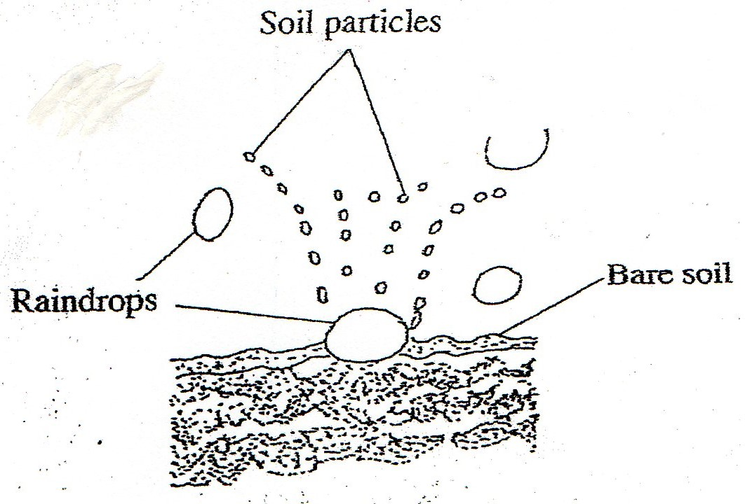
- Identify the type of soil erosion (1 mark)

- How does the type of erosion shown above occur? (2marks)

- How does cover cropping help to control the type of erosion shown above? (2marks)

- The table below shows the population and gross domestic products of countries A and B
Country | Gross Domestic Product  (million Ksh) | Population  (million)
A | 1800 | 36
B | 1200 | 15
- Calculate the per capita income for each country. Show your working. (2marks)

- Which of the two countries is more developed economically? (1mark)

- Give a reason for your answer in (b) above. (1mark)

- How can agriculture increase the gross domestic product of an economy? (1mark)

- The diagrams below show weeds A and B.
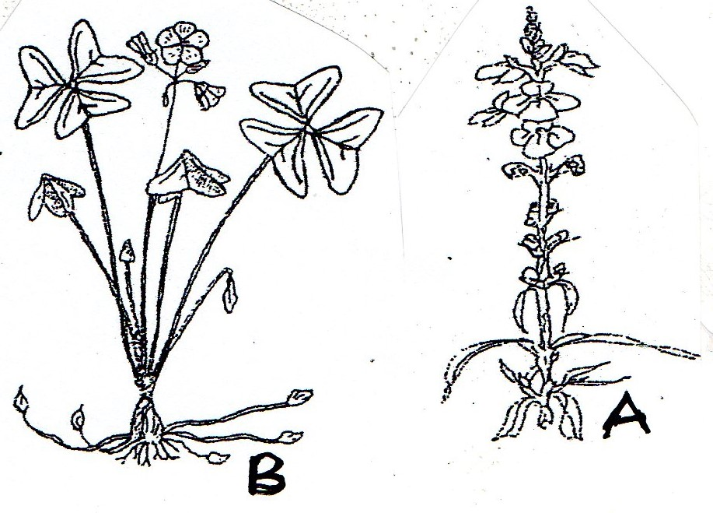
- Identify weed A (1mark)

- State one reason why weed A is referred to as a parasitic weed. (1mark)

- Give a reason why it is difficult to control weed B. (1mark)

- Which category of herbicide will be most suitable for controlling weed B.?(1mark)
- Name a disease that weed B can transmit to cereal crops. (1mark)

SECTION C (40 marks)
Answer any two Questions from this section in the spaces provided after Question 22.
- a) Describe the various risks and uncertainties in crop farming. (10 marks)
b) State the functions of young farmers clubs in Kenya. (5 marks)
c) Give the reasons for land registration in Kenya. (5 marks)

- a) Explain five ways in which the Kenyan government can improve maize production to ensure food security in the country. (10 marks)
b) Why is pruning done in crop production? (10 marks)

- a) The table below gives information on the supply and demand schedules for tomatoes on a market.
Table 1: Prices and Quantities of tomatoes supplied.
Tomatoes (Kg) | Price per Kg (Ksh)
150 | 16.00
130 | 14.20
125 | 13.80
112 | 13.00
106 | 12.70
85 | 11.80
50 | 10.60
42 | 10.40
30 | 10.20
25 | 10.10
Table 2: Prices and Quantities of tomatoes demanded.
Tomatoes (Kg) | Price per Kg (Ksh)
80 | 18.00
87 | 16.70
101 | 15.50
119 | 14.10
135 | 13.20
155 | 12.40
171 | 11.80
185 | 11.30
191 | 11.10
205 | 10.84

- Using the above data, plot supply and demand curves on the same axes. The axes have been labelled for you. (7mks) 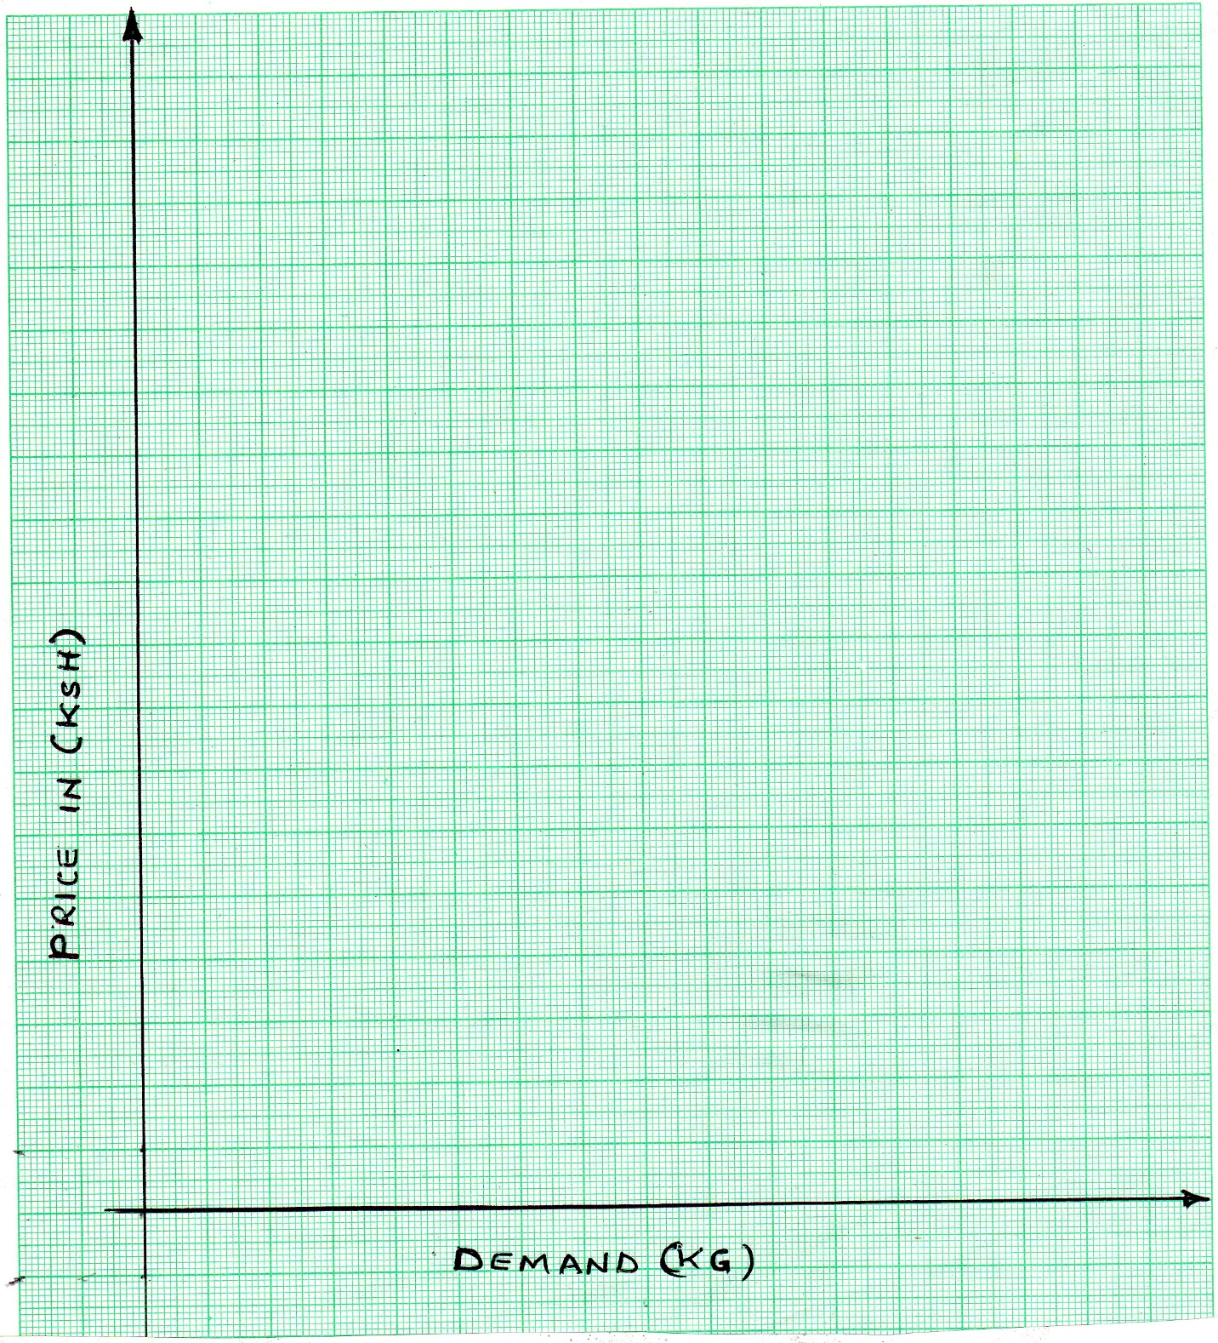

- Determine the price at which 120kg of tomatoes were supplied on the market. (1mark)

- How many kilograms of tomatoes were bought at the market price of Ksh13.00? (1mark)

- What was the equilibrium price for tomatoes on the market? (1mark)

b) Describe the production of maize under the following subheadings:
- Seedbed preparation (4marks)
- Planting (3marks)
- Harvesting (3marks)

