NAME:…………………………………………INDEX NO……………….
DATE:………………….

443/1
AGRICULTURE
FORM IV
PAPER I
TERM 1I, 2019
TIME: 2 HRS

MOKASA II PRE-MOCKS 2019

INSTRUCTIONS TO CANDIDATES
- Write your name and index number in the spaces provided
- This paper consist of three sections A, B and C
- Answer ALL questions in Section A, B and C
SECTION | MAXIMUM SCORE | CANDIDATE’S SCORE
A | 30
B | 20
C | 40
TOTAL | 90

This paper consist of 10 printed pages. candidates should check the questions paper to ascertain that all the pages are printed as indicated and that no questions are missing

SECTION A (30 MARKS)
Answer ALL the questions in this section in the spaces provided
1. List three characteristics of large scale farming system (1½ mks)

……………………………………………………………………………………………….…………………… …………………………………………………………………………………...……………………………….. ……………………………………………………………………………………………….……………………
…………………………………………………………………………………...………………………………..
- Differentiate between grafting and budding (lmk)
……………………………………………………………………………………………….……………………
…………………………………………………………………………………...………………………………..
- State three pieces of information contained in a land title deed (1½ mks)

……………………………………………………………………………………………….…………………… …………………………………………………………………………………...……………………………….. ……………………………………………………………………………………………….……………………
…………………………………………………………………………………...………………………………..
- Distinguish between each of the following pairs of terms
i)Pricking out and thinning (lmk)
……………………………………………………………………………………………….……………………
…………………………………………………………………………………...……………………………….. ii)Nursery bed and a seedling bed (lmk)
……………………………………………………………………………………………….……………………
…………………………………………………………………………………...………………………………..
- Give reasons for carrying out the following practices in a tomato nursery
i) Avoid excess application of nitrogen ( ½mk)
……………………………………………………………………………………………….……………………
…………………………………………………………………………………...……………………………….. ii) Sinking the nursery bed below the ground level (½ mk)
……………………………………………………………………………………………….……………………
…………………………………………………………………………………...………………………………..
iii) Hardening off ( ½mk)
……………………………………………………………………………………………….……………………
…………………………………………………………………………………...………………………………..
- Give two ways in which cut off drains control soil erosion (l mk)

……………………………………………………………………………………………….…………………… …………………………………………………………………………………...………………………………..

7. State six ways through which soil looses fertility (3mks)

……………………………………………………………………………………………….…………………… …………………………………………………………………………………...……………………………….. ……………………………………………………………………………………………….…………………… …………………………………………………………………………………...……………………………….. ……………………………………………………………………………………………….…………………… …………………………………………………………………………………...……………………………….. ……………………………………………………………………………………………….……………………
…………………………………………………………………………………...………………………………..
- Name two examples of potassic fertilizers (lmk)
……………………………………………………………………………………………….……………………
…………………………………………………………………………………...………………………………..
- State two diseases of leaf that attack sorghum. (lmk)
……………………………………………………………………………………………….……………………
…………………………………………………………………………………...………………………………..
10 .Give three reasons why a farmer needs to conserve forage . (1½ mks)

……………………………………………………………………………………………….…………………… …………………………………………………………………………………...……………………………….. ……………………………………………………………………………………………….……………………
…………………………………………………………………………………...………………………………..
- State two positive effects of high environmental temperatures on crop farming (lmk)
……………………………………………………………………………………………….……………………
…………………………………………………………………………………...………………………………..
- State four biological methods of soil erosion control (2mks)

……………………………………………………………………………………………….…………………… …………………………………………………………………………………...……………………………….. ……………………………………………………………………………………………….…………………… …………………………………………………………………………………...………………………………..
……………………………………………………………………………………………….…………………… 13. Name two types of labour records (lmk) ……………………………………………………………………………………………….…………………… …………………………………………………………………………………...………………………………..
……………………………………………………………………………………………….……………………
14. State four physical methods of pest control (lmk)

……………………………………………………………………………………………….…………………… …………………………………………………………………………………...……………………………….. ……………………………………………………………………………………………….……………………
…………………………………………………………………………………...………………………………..

15. Outline three reasons of top dressing a pasture land (1½ mks)

……………………………………………………………………………………………….…………………… …………………………………………………………………………………...……………………………….. ……………………………………………………………………………………………….……………………
…………………………………………………………………………………...………………………………..
16. State three symptoms of bacterial attack in crop production (1½ mks)

……………………………………………………………………………………………….…………………… …………………………………………………………………………………...……………………………….. ……………………………………………………………………………………………….……………………
…………………………………………………………………………………...………………………………..
17. State four factors which affect the quality of a silage. (2mks)

……………………………………………………………………………………………….…………………… …………………………………………………………………………………...……………………………….. ……………………………………………………………………………………………….……………………
…………………………………………………………………………………...………………………………..
- State two conditions under which opportunity cost is zero in a farming enterprise. (lmk)
……………………………………………………………………………………………….……………………
…………………………………………………………………………………...………………………………..
- Give four reasons of using certified seeds for planting . (2mks)

……………………………………………………………………………………………….…………………… …………………………………………………………………………………...……………………………….. ……………………………………………………………………………………………….……………………
…………………………………………………………………………………...………………………………..
20. State four factors that affect rooting of cuttings. (2mks)

……………………………………………………………………………………………….…………………… …………………………………………………………………………………...……………………………….. ……………………………………………………………………………………………….……………………
…………………………………………………………………………………...………………………………..

SECTION B (20MARKS)
Answer ALL Questions in this section
- Below is a record format kept in the farm
Sow No……………  Breed………………… | Sire No……..………  Breed……………….. | Date of service | Date of farrowing |  | Remarks
Sow1…….…………  ………………………  Sow 2 |  |  | Expected | Actual
  - Identify record format illustrated above (lmk)
……………………………………………………………………………………………….……………………
…………………………………………………………………………………...………………………………..
  - State two importance of a farmer keeping the type of records identified above (2mks)
……………………………………………………………………………………………….…………………… …………………………………………………………………………………...……………………………….. ……………………………………………………………………………………………….……………………
…………………………………………………………………………………...………………………………..
  - Why do institutions loaning money (credit) to farmers insist on seeing farm records of
the loan applicant? (lmk)
……………………………………………………………………………………………….……………………
…………………………………………………………………………………...………………………………..
- The diagrams labeled A and B are illustrations of coffee established using two different formative pruning systems. Study them and answer the questions that follow.

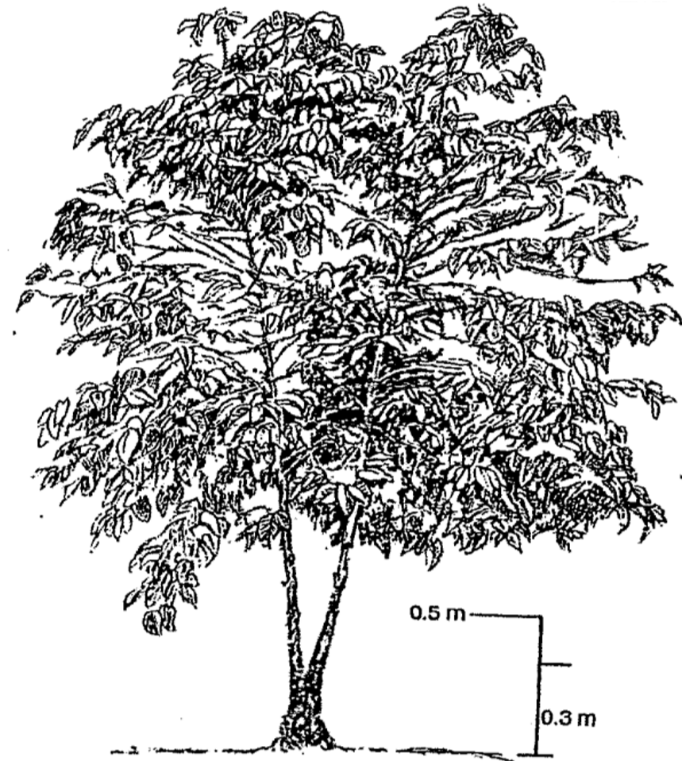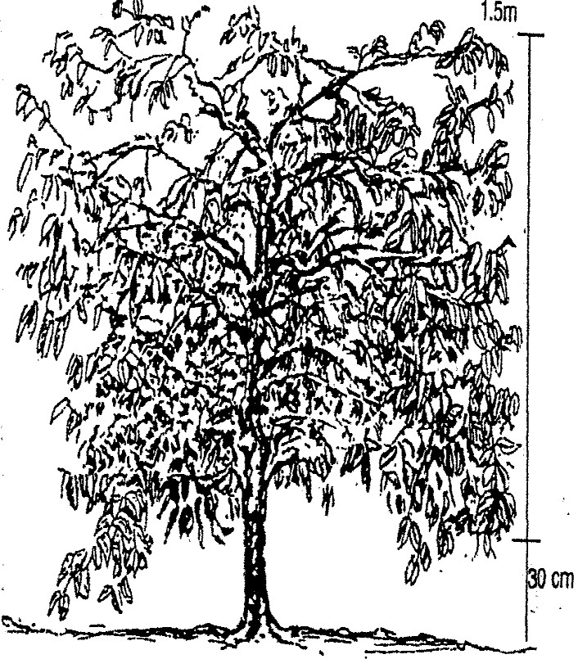

A

B

a)Name the system of pruning illustrated in diagram A and B above. (2mks)

……………………………………………………………………………………………….…………………… …………………………………………………………………………………...……………………………….. ……………………………………………………………………………………………….……………………
…………………………………………………………………………………...………………………………..
b) Outline the procedure of how the pruning illustrated in diagram B is carried out. (3mks)

……………………………………………………………………………………………….…………………… …………………………………………………………………………………...……………………………….. ……………………………………………………………………………………………….…………………… …………………………………………………………………………………...………………………………..
23. The diagrams below show common weeds on arable land

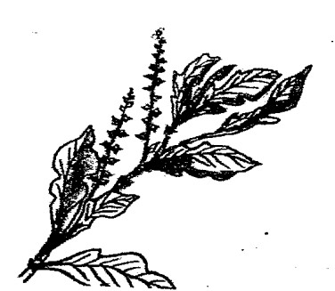
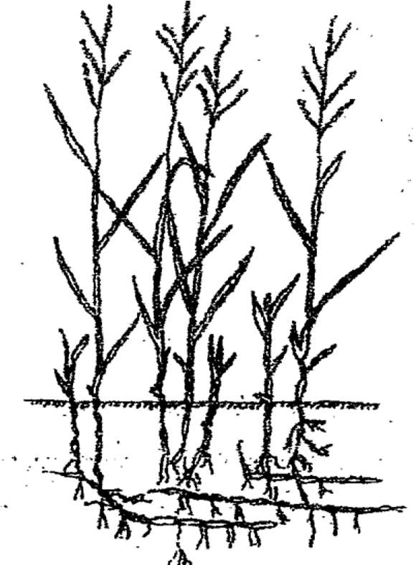
C D

i) Identify the weeds(2 mks)
C………………………………………………………………………
D………………………………………………………………………..
ii) Why is it difficult to control weed C (lmk)
……………………………………………………………………………………………….……………………
…………………………………………………………………………………...……………………………….. iii) Name three chemicals used to control weed C in a field of coffee (3mks)

……………………………………………………………………………………………….…………………… …………………………………………………………………………………...……………………………….. ……………………………………………………………………………………………….……………………
…………………………………………………………………………………...……………………………….. iv) State two harmful effects of weed D (2mks)

……………………………………………………………………………………………….…………………… …………………………………………………………………………………...………………………………..
…………………………………………………………………………………...………………………………..
24. The diagram below illustrates an experiment carried out by a form one boy. Study it carefully and answer the that
follow
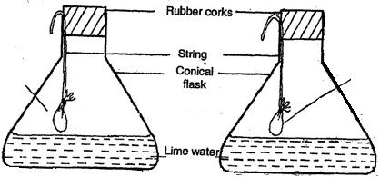

Strongly heated
garden soil

Fresh

garden soil

E
1

E
2

The set ups were allowed to stand for five hours.
a) State the aim of the experiment. (lmk)

…………………………………………………………………………………...……………………………….. …………………………………………………………………………………...………………………………..

b) Explain the results expected in
i)Set up E₁ (lmk)
…………………………………………………………………………………...………………………………..
…………………………………………………………………………………...……………………………….. ii) Set up E₂ (lmk)
…………………………………………………………………………………...………………………………..
…………………………………………………………………………………...………………………………..

SECTION C (40MARKS)
Answer ALL questions from this section
25 a) Explain five ways in which trees help in soil conservation. (5mks)
b) State five uses of water on the farm. (5mks)
c) Describe the process of treating water for domestic use using chemical treatment system. (l0mks)

26.
a) Describe transplanting of onions in the field. (l0mks)
b) Explain the various factors that influence spacing in crops. (5mks)
c) Describe the various types of farm records kept by a dairy farmer. (5mks)
…………………………………………………………………………………...………………………………..
…………………………………………………………………………………...………………………………..
…………………………………………………………………………………...………………………………..
…………………………………………………………………………………...………………………………..
…………………………………………………………………………………...………………………………..
…………………………………………………………………………………...………………………………..
…………………………………………………………………………………...………………………………..
…………………………………………………………………………………...………………………………..
…………………………………………………………………………………...………………………………..
…………………………………………………………………………………...………………………………..
…………………………………………………………………………………...………………………………..
…………………………………………………………………………………...………………………………..
…………………………………………………………………………………...………………………………..
…………………………………………………………………………………...………………………………..
…………………………………………………………………………………...………………………………..

