2019 FORM FOUR
Kenya Certificate of Secondary Education Trial 2

443/1 AGRICULTUR
PAPER ONE
TIME: 2HRS
INSTRUCTIONS
This paper consists of three sections A, B and C; Candidate to answer ALL questions in section A and B and answers any TWO questions only in section C
CANDIDATE SCORE
 | QUESTIONS | MAXIMUM SCORE | CAND.SCORE
A | 1-20 | 30
B | 21-25 | 20
C | 26 | 20
 | 27 | 20
 | 28 | 20
 | TOTAL | 90

SECTION A (30MKS)
Answer all questions in this section on spaces provided.
- Name two field management that are carried out to obtain optimum plant population in a crop field (1mk)
i)………………………………………………………………………………………………………………………………………
ii)…………………………………………………………………………………………………………………………………….
- Give two factors which characterize small scale farming (1mk)
i)………………………………………………………………………………………………………………………………………
ii)…………………………………………………………………………………………………………………………………….
- Give one examples of each of the following categories of water pipes
- Metal pipes (½mk)
………………………………………………………………………………………………………………………………..
- Horse pipes (½mk)
……………………………………………………………………………………………………………………………....
- Name three forms of horticulture practiced in Kenya (1½mk)
i)………………………………………………………………………………………………………………………………………
ii)…………………………………………………………………………………………………………………………………….
iii)……………………………………………………………………………………………………………………………………
- State four disadvantages of growing one type of crop on piece of land continuously(2mks)
i)………………………………………………………………………………………………………………………………………
ii)…………………………………………………………………………………………………………………………………….
iii)……………………………………………………………………………………………………………………………………
iv)……………………………………………………………………………………………………………………………………
- Outline four qualities of a mother plant from which vegetative propagation material should be obtained (2mks)
i)………………………………………………………………………………………………………………………………………
ii)…………………………………………………………………………………………………………………………………….
iii)……………………………………………………………………………………………………………………………………
iv)……………………………………………………………………………………………………………………………………
- State two ways in which crop rotation controls weeds (1mk)
i)………………………………………………………………………………………………………………………………………
ii)…………………………………………………………………………………………………………………………………….

- Give two reasons for imposing quarantine on imported planting materials (1mk)
i)………………………………………………………………………………………………………………………………………
ii)…………………………………………………………………………………………………………………………………….
- State two mechanical methods of separating soil particles according to sizes during soil analysis (1mk)
i)………………………………………………………………………………………………………………………………………
ii)…………………………………………………………………………………………………………………………………….
- Name four settlement schemes that the Kenyan government started as a result of the success of the million Acre scheme (2mks)
i)………………………………………………………………………………………………………………………………………
ii)…………………………………………………………………………………………………………………………………….
iii)……………………………………………………………………………………………………………………………………
iv)……………………………………………………………………………………………………………………………………
- State three practices which encourage soil erosion (1½mks)
i)………………………………………………………………………………………………………………………………………
ii)…………………………………………………………………………………………………………………………………….
iii)……………………………………………………………………………………………………………………………………
- State four characteristics of a good vegetable seedling (2mks)
i)………………………………………………………………………………………………………………………………………
ii)…………………………………………………………………………………………………………………………………….
iii)……………………………………………………………………………………………………………………………………
iv)……………………………………………………………………………………………………………………………………
- List four pose-harvest practices that are carried out in maize production (2mks)
i)………………………………………………………………………………………………………………………………………
ii)…………………………………………………………………………………………………………………………………….
iii)……………………………………………………………………………………………………………………………………
iv)……………………………………………………………………………………………………………………………………
- List four environmental factors that affect crop production in Kenya (2mks)
i)………………………………………………………………………………………………………………………………………
ii)…………………………………………………………………………………………………………………………………….
iii)……………………………………………………………………………………………………………………………………
iv)……………………………………………………………………………………………………………………………………

- Give four reasons for seed selection in crop production (2mks)
i)………………………………………………………………………………………………………………………………………
ii)…………………………………………………………………………………………………………………………………….
iii)……………………………………………………………………………………………………………………………………
iv)……………………………………………………………………………………………………………………………………
- Give two benefits of top-dressing in management of grass pasture (1mk)
i)………………………………………………………………………………………………………………………………………
ii)…………………………………………………………………………………………………………………………………….
iii)……………………………………………………………………………………………………………………………………
iv)……………………………………………………………………………………………………………………………………
- State four disadvantages of communal land tenure system (2mks)
i)………………………………………………………………………………………………………………………………………
ii)…………………………………………………………………………………………………………………………………….
iii)……………………………………………………………………………………………………………………………………
iv)……………………………………………………………………………………………………………………………………
- State any two benefits a farmer would get by having correct plant population in the production of annual crops (1mk)
i)………………………………………………………………………………………………………………………………………
ii)…………………………………………………………………………………………………………………………………….
- Define the term opportunity cost as used in economic (1mk)
…………………………………………………………………………………………………………………………………………………………………………………………………………………………………………………………………………………..
- State four pieces of information contained on a land title deed. (2mks)
i)………………………………………………………………………………………………………………………………………
ii)…………………………………………………………………………………………………………………………………….
iii)……………………………………………………………………………………………………………………………………
iv)……………………………………………………………………………………………………………………………………

SECTION B (20MKS)
Answer all questions in this section
- The table below shows PH value of different soil samples. Study it and answer the questions that follow.

Soil sample PH value
S₁ 3
S₂ 4
S₃ 5
S₄ 6
S₅ 7
S₆ 8
S₇ 9
S₈ 10
- Which soil sample has the highest acidity (1mk)
…………………………………………………………………………………………………………………………………..
- Which soil sample has the lowest alkalinity (1mk)
……………………………………………………………………………………………………………………………………
- State two ways in which the PHvalue of sample 3 can be raised (2mks)
i)………………………………………………………………………………………………………………………………
ii)………………………………………………………………………………………………………………………………
- Which of the above soil sample is suitable for growing maize (1mk)
…………………………………………………………………………………………………………………………………..
- The diagram below illustrates a seed potato prepared for planting. Study it carefully and answer the questions that follow.

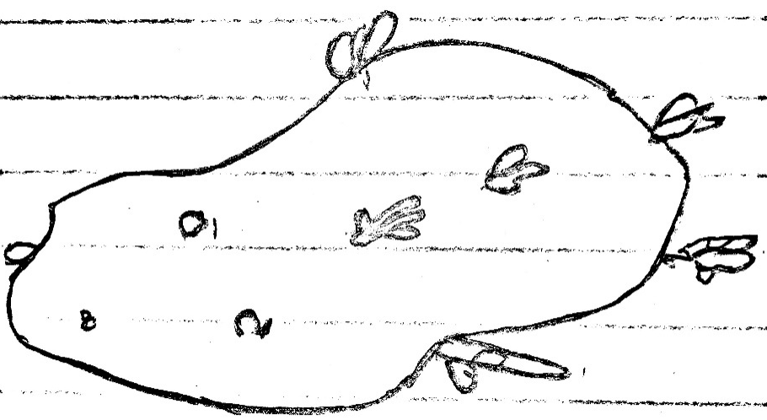

- Name the practice used in preparing the seed potato above for planting (1mk)
………………………………………………………………………………………………………………………………..
- Describe the procedure followed in preparing seed potatoes for planting. (8mks)
………………………………………………………………………………………………………………………………………………………………………………………………………………………………………………………………………………………………………………………………………………………………………………………………………………………………………………………………………………………………………………………………………………………………………………………………………………………………………………………………………………………………………………………………………………………………………………………………………………………………………………………………………………………………………………………………………………………………………………………………………………………………………………………………………………………………………………………………………………………………………………………………………………………………………………………………………………………………………………………………………………………………………………………………………………………………………………………………………………………………………………………..
- Below are diagrams of common weeds found in a crop field, study them carefully and answer questions that follow.
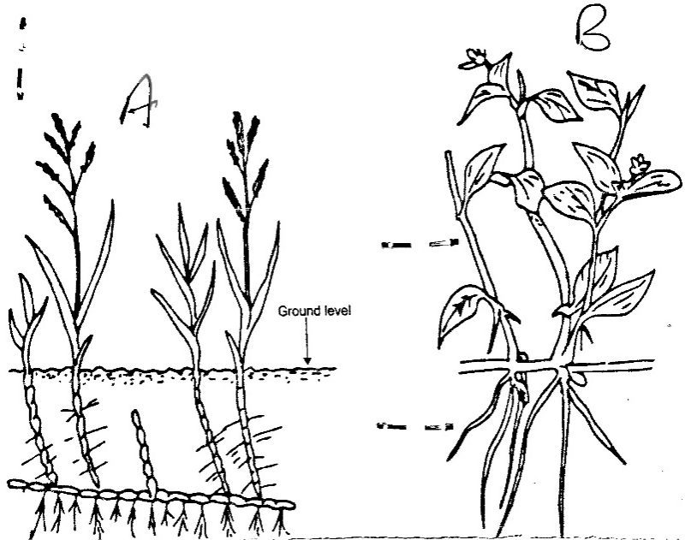
C
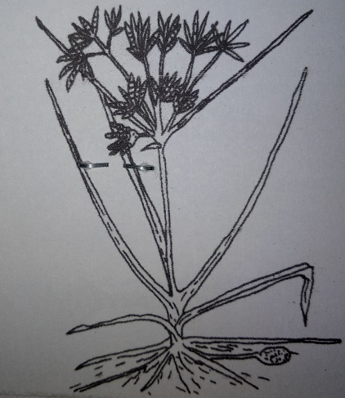

- Identify the weeds (3mks)
Weed A ……………………………………………….
Weed B ……………………………………………….
Weed C ……………………………………………….
- State one reason why weed A is difficult to control (1mk)
……………………………………………………………………………………………………………………………………
- State one economic use of weed B (1mk)
…………………………………………………………………………………………………………………………………
- Below is a method used in pasture management. Study it carefully and answer questions that follow.
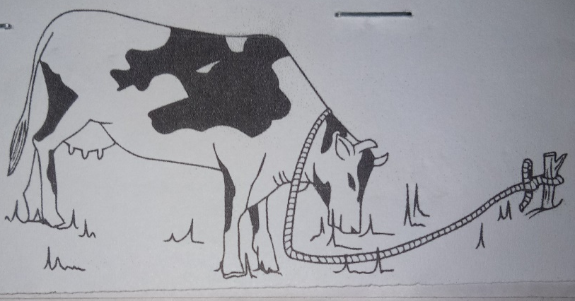

- Identify the type of grazing shown above (1mk)
……………………………………………………………………………………………………………………………………
- State two limiting of the practice above (2mks)
i)…………………………………………………………………………………………………………………………………
ii)………………………………………………………………………………………………………………………………..
- Below is a diagram of common pest found in the field. Study it carefully and answer questions that follows
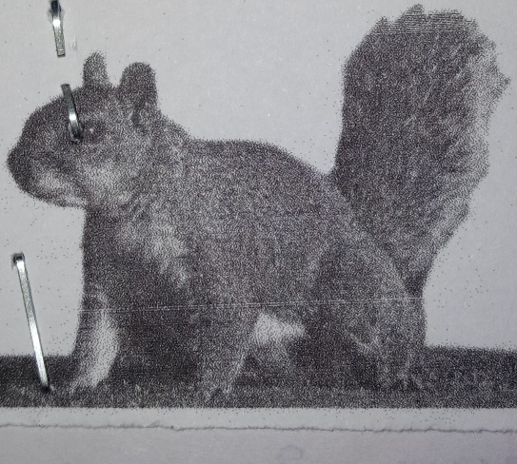

- Identify the pest (1mk)
……………………………………………………………………………………………………………………………………
- State the stage at which the pest attack maize (1mk)
……………………………………………………………………………………………………………………………………
- State one effect of the pest on crop production (1mk)
…………………………………………………………………………………………………………………………………
SECTION C (40MKS)
Answer any two questions only from this section
- a) Explain five ways in which biotic factors influence crop production in Agriculture (10mks)
b) Explain four ways in which Government policy improves agricultural production (4mks)
c) Describes the properties of Nitrogenous fertilizer (6mks)
- a) Describe the effects of pests on Beans in the field (4mks)
b) Describe the production of cabbage under the following seed headings.
- Seed bed preparation (3mks)
- Transplanting of seedlings (4mks)
c) Describe various nursery management practices carried out on cabbage seeding in the nursery (5mks)
d) Describe how water is treated to remove solid impurities (4mks)
- a) Describe five ways in which a grass cover help to conserve soil (5mks
b) Describe maize production under following sub-headings.
- Land preparation (3mks)
- Planting (6mks)
- Field management practices (6mks)

