443/1 - AGRICULTURE - Paper 1

January/February 2021
𝟐𝒉𝒐𝒖𝒓𝒔

Name ……………………………………………… Index Number ………………………...

School.…………………………………………… Class ……………………….................

Candidates Signature……………………………. Date ……………………………………

INSTRUCTIONS TO THE CANDIDATES:-

- Write your name and index number in the space provided at the top of this page.
- Sign and write the date of the examination in the space provided above
- This paper consist of three section A, B, and C
- Answer all questions in section A and B
- Answer any two questions in section C
- All answers should be written in the spaces provided
- Candidate should check the question paper to ascertain that all pages are printed as indicated and that no question is missing.
- Candidate should answer the question in English
FOR EXAMINERS USE ONLY
SECTION | QUESTION | MAXIMUM  SCORE | CANDIDATE  SCORE
A | 1-16 | 30
B | 17-20 | 20
C |  | 20
 |  | 20
 | TOTAL  SCORE | 90

SECTION A (30marks)
Answer all questions in this section in the spaces provided
- List four reasons for early land preparation.
(2mks)

- State four disadvantages of clean weeding in a maize field. (2mks)

- State four factors that determine the choice of a method of irrigation used in a farm.
(2mks)

- Name two sources of credit for a group of farmers registered as a cooperative. (1mk)

- State four characteristics of well decomposed farm yard manure. (2mks)

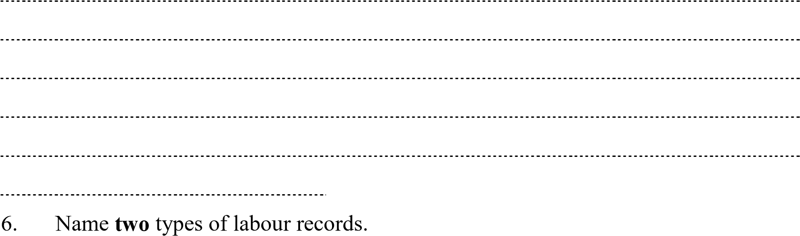
(1mk)

7. State two uses of a sales book.
(1mk)

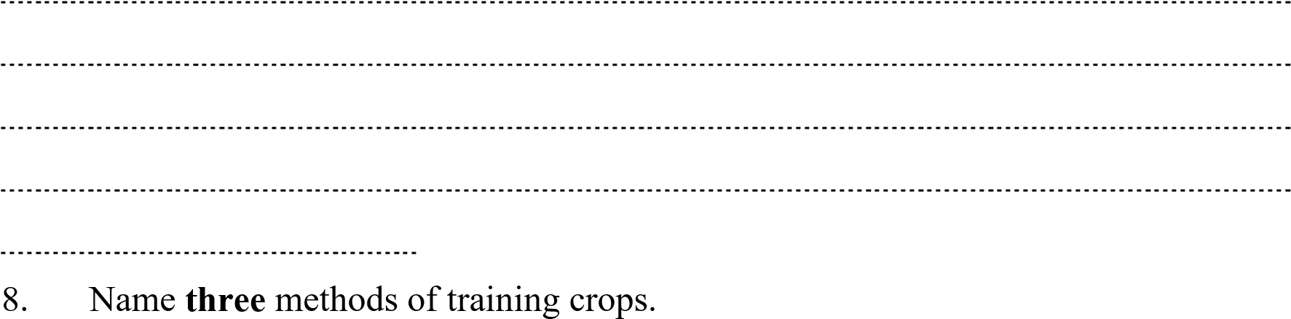
(1½mks)

- Name three diseases that affect tomatoes in the field.
(1½mks)

- State four reasons for resettlement and settlement in Kenya.
(2mks)

- State four aspects of biological weed control.
(2mks)

- State four symptoms of attack by the bean fly in bean production.
(2mks)

- Give three reasons for flooding when growing paddy rice.
(1½mks)

- State four precautions observed when harvesting cotton.
(2mks)

- (a) State two disadvantages of tractor hire services.
(2mks)

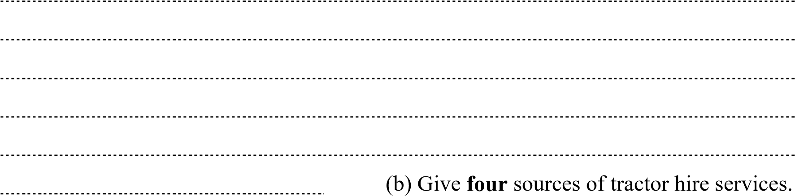
(2mks)

- State four functions of the National Agricultural Commodity Association.
(2mks)

- (a) What is meant by the term Agroforestry?
(½mk)

(b) State four management practices carried out during intensive hedgerow agroforestry.
(2mks)

SECTION B (20marks)
Attempt all questions in this section
- Identify the following methods of propagation. (1½marks)

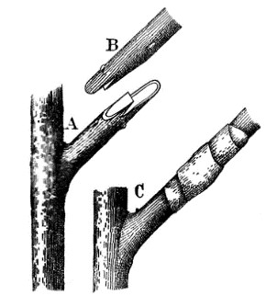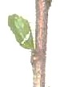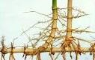

C

U

S…………………………… T……………………………
V……………………………
a) State three factors contribute to the success of method S?
(1½mk)

(1mk)
B
C
- State two importance of the method of propagation in diagram labelled T?
(1mk)

- Name two crops propagated by use of method V.
(1mk)

19. Maina’s farm requires the following items on credit from Kenya farmers association on 30th March 2020
10bags of Unga feeds Bran
18bags of DSP Chapa meli
24kg of Rose Coco Bean seeds simlaw seed
KFA sells the items as follows
Item no | Item | Company | Price | Quantity in store
1 | Bran 90kgs/bag | Brookhouse farm supplies | Kshs. 1000/bag | 200 bags
2 | Bran 90kgs/bag | Unga feeds Bran | Kshs. 1200/bag | 150 bags
3 | Bran 90kgs/bag | EA MAIZE Millers | Kshs. 1230/bag | 400 bags
4 | DSP 50kgs each | Chapa meli | Kshs. 1500/bag | 120 bags
5 | DSP 50kgs each | Nauru international | Kshs, 1500/bag | 140 bags
6 | DSP 50kgs each | Boatmil industries | Kshs. 1500/bag | 150 bags
7 | Bean seeds Rose coco | Kenya Seed | Ksh330 / 2kgs packets | 100 -  packets | 2kgs
8 | Bean seeds Rose coco | Western Seed | Ksh290 / 2kgs packets | 400 -  packets | 2kgs
9 | Bean seeds Rose coco | Simlaw Seed | Ksh300 /2kgs packets | 120 -  packets | 2kgs

a) Prepare a purchase order that KFA made to Maina’s farm.
(3mks)

- Below is an illustration of a method of frame formation in tea. Answer the questions that follow.
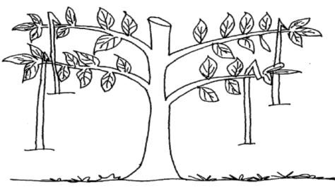
  - Identify the above method.
(1mk)

  - Describe the procedure followed in (a) above
(4mks)

  - Apart from the above method name one other method of frame formation
(1mk)

- Give a reason why the following practises are important when making silage
  - Wilting crop for 6-12 hours
(1mk)

  - Compacting the ensiled materials every 10cm-12cm
(1mk)

  - Checking the temperature regularly
(1mk)

  - Ensuring that the soil over the silo maintains a hump shape after covering
(1mk)

SECTION C (40 marks)
Answer any two questions from this section in the spaces provided after question 22.
22. A farmer in Rongai division wishes to change from arable farming to dairy goat production. In arable farming he has been spending kshs.400 on weeding maize and Ksh 200 on weeding cabbages. He spends Ksh 500 and Ksh 300 on harvesting maize and cabbages respectively. He buys the following inputs; DAP fertilizer at Ksh.1000, cabbage seeds for Ksh 400, maize seeds for Ksh 600. Pesticides cost ksh800. He also spends Ksh. 300 on shelling of maize.
The change in enterprise will have the following implications; He will buy 5 dairy goats at ksh.2, 000 each; pay milk man ksh.3, 000; control diseases at a cost of ksh.1500. Fencing of the farm will be done at a cost of ksh.1, 500 .The revenue he gets when growing maize is ksh.10, 000 and cabbages is ksh.4, 000. In dairy goat production, he will get Ksh 20,000 from sale of milk and Ksh 1000 from sale of manure.
- Prepare a partial budget and advise the farmer whether the change is worthwhile or
not. (12mks)

- Explain four factors that determine the choice of a farming enterprise (8
mks)
…………………………………………………………………………………………
………………………………………………………………………………………… ………………………………………………………………………………………… …………………………………………………………………………………………
…………………………………………………………………………………………
…………………………………………………………………………………………
…………………………………………………………………………………………
…………………………………………………………………………………………
………………………………………………………………………………………… ………………………………………………………………………………………… …………………………………………………………………………………………
…………………………………………………………………………………………
…………………………………………………………………………………………
…………………………………………………………………………………………
…………………………………………………………………………………………
………………………………………………………………………………………… …………………………………………………………………………………………
………………………………
23 a) Explain five roles of Agricultural based women self-help groups in Kenya. (5 mks)

………………………………………………………………………………………………
………………………………………………………………………………………………
………………………………………………………………………………………………
………………………………………………………………………………………………
………………………………………………………………………………………………
………………………………………………………………………………………………
……………………………………………………………………………………………… ……………………………………………………………………………………………… ………………………………………………………………………………………………
………………………………………………………………………………………………
………………………………………………………………………………………………
………………………………………………………………………………………………
………………………………………………………………………………………………
……………………………………………………………………………………………… ……………………………………………………………………………………………… ………………………………………………………………………………………………
………………………………………………………………………………………………
………………………………………………………………………………………………
………………………………………………………………………………………………
………………………………………………………………………………………………
……………………………………………………………………………………………… ……………………………………………………………………………………………… ………………………………………………………………………………………………
………………………………………………………………………………………………
………………………………………………………………………………………………
………………………………………………………………………………………………
………………………………………………………………………………………………
……………………………………………………………………………………………… ………………………………………………………………………………………………
…………………………

b) The inventory of Awilo’s Farm as at 31st December 2020 was as follows In Ksh:
Cash in hand 5,000
Layers 27,000
Dairy cattle 125,000
Maize in store 6,000
Calves 29,000
Buildings 70,000
Land 200,000
Machinery 75,000
On the same day, the following information was obtained from the sales record.
Bank loan 160,000
Egg sale on credit 20,000
Milk sales on credit 25,000
Vegetable sales on credit 10,000
Fertilizer purchased on credit 15,000
Wages payable 8,200
Taxes payable 8000
Interest payable on loan 4,000
- Prepare a balance sheet (8mks)

- State with a reason if Awilo’s farm solvent or insolvent
(1mk)
…………………………………………………………………………………………………
………………………………………………………………………………………………… …………………………………………………………………………………………………
……………………………………………
c) State five ways through which agricultural practices pollute water bodies.
(5mks)
…………………………………………………………………………………………………
…………………………………………………………………………………………………
…………………………………………………………………………………………………
…………………………………………………………………………………………………
………………………………………………………………………………………………… ………………………………………………………………………………………………… …………………………………………………………………………………………………
…………………………………………………………………………………………………
…………………………………………………………………………………………………
…………………………………………………………………………………………………
…………………………………………………………………………………………………
…………………………………………………………………………………………………
…………………………………………………………………………………………………
…………………………………………………………………………………………………
…………………………………………………………………………………………………
…………………………………………………………………………………………………
…………………………………………………………………………………………………
………………………………………………………………………………………………… ………………………………………………………………………………………………… …………………………………………………………………………………………………
…………………………………………………………………………………………………
…………………………………………………………………………………………………
…………………………………………………………………………………………………
…………………………………………………………………………………………………
…………………………………………………………………………………………………
……………………………………………………………………………………………
25. The tables below show the weekly demand and supply for wheat.

Price (Ksh.) | Quantity demand (kg) |  | Price (Ksh.) | Quantity supplied  (kg)
200 | 250 |  | 200 | 2500
180 | 350 |  | 180 | 2250
160 | 550 |  | 160 | 2000
140 | 900 |  | 140 | 1700
120 | 1300 |  | 120 | 1300
100 | 1850 |  | 100 | 800
80 | 2500 |  | 80 | 100

a. (i) Draw a demand and supply curve on the graph attached
(7 mks)

- Determine the equilibrium price for the wheat
(1mk) …………………………………………………………………………………………………
………………………………………………………………………

- Calculate the elasticity of demand for
- Price fall from ksh.20 to ksh.18 per kg. (2mks)

- (i) If the price increased from kshs.20 to kshs.22 and elasticity of demand is 6.
(2mks)

(ii) Find the quantity demanded at higher price.
(2mks)

- Explain two factors that affect the demand of tomatoes other than price.
(2mks)

…………………………………………………………………………………………………
…………………………………………………………………………………………………
…………………………………………………………………………………………………
…………………………………………………………………………………………………
…………………………………………………………………………………………………
………………………………………………………………………………………………… ………………………………………………………………………………………………… …………………………………………………………………………………………………
………………………………………………………………………………………………… …………………………………………………………………………………………………
……………………………………

b) Describe four characteristics of variable inputs
(4mks)
…………………………………………………………………………………………………
…………………………………………………………………………………………………
…………………………………………………………………………………………………
…………………………………………………………………………………………………
…………………………………………………………………………………………………
………………………………………………………………………………………………… ………………………………………………………………………………………………… …………………………………………………………………………………………………
…………………………………………………………………………………………………
…………………………………………………………………………………………………
…………………………………………………………………………………………………
…………………………………………………………………………………………………
………………………………………………………………………………………………… ………………………………………………………………………………………………… …………………………………………………………………………………………………
…………………………………………………………………………………………………
…………………………………………………………………………………………………
…………………………………………………………………………………………………
…………………………………………………………………………………………………
…………………………………………………………………………………………………
…………………………………………………………………………

