Name ……………………………………………… Index Number ………………………...

School.…………………………………………… Class ……………………….................

Candidates Signature……………………………. Date ……………………………………

INSTRUCTIONS TO THE CANDIDATES:-

- Write your name and index number in the space provided at the top of this page.
- Sign and write the date of the examination in the space provided above.
- This paper consists of three sections A, B, and C.
- Answer all questions in section A and B.
- Answer any two questions in section C.
- All answers should be written in the spaces provided.
- Candidate should check the question paper to ascertain that all pages are printed as indicated and that no question is missing.
- Candidate should answer the question in English.

FOR EXAMINERS USE ONLY
SECTION | QUESTION | MAXIMUM  SCORE | CANDIDATE  SCORE
A | 1-16 | 30
B | 17-20 | 20
C |  | 20
 |  | 20
 | TOTAL SCORE | 90

SECTION A: (30MARKS)
Answer all questions from this section on the spaces provided.
1(a) Give two qualities of milk of the Friesian breed of cattle. (1 mark)

b) Name three components of a truss. (1½ marks)

2. Give two reasons why Jersey breed of cattle is well suited to semi-arid conditions. (1 mark)

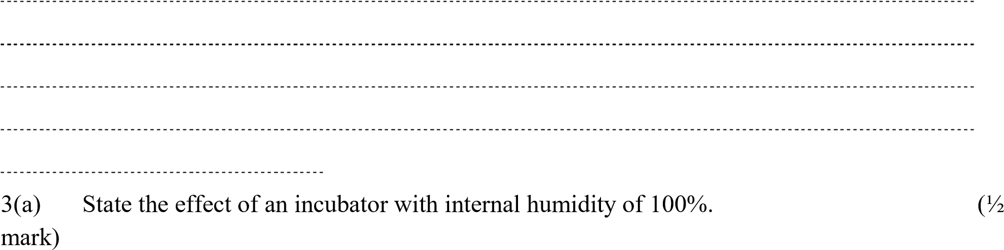

b) State the use soluble grit to layer birds? (½ mark)

- Give two uses of a wood float. (1 mark)

- Give three conditions may lead to culling of a breeding boar? (1½ marks)

- Identify two practices carried out during sap displacement in timber preservation.
(1 mark)

7(a) State three characteristics of the Galla goat (1½ marks)

b) Name the two breeds of camels. (1 mark)

8(a) List three sources of water to livestock. (1½ marks)

b) Maize germ, a livestock feed has a starch equivalent of 30%. Explain (1mark)

9(a) State four ways in which fleas cause economic losses to the farmer.
(2mark)

b) List three limitations of water as a source of power in the farm. (1½ marks)

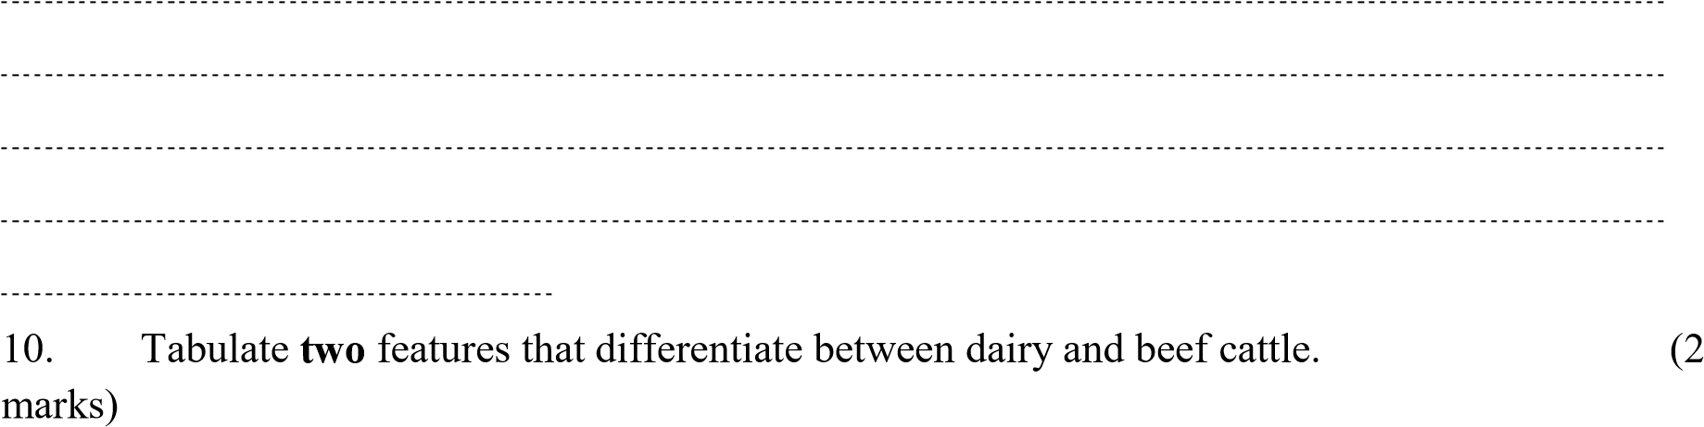

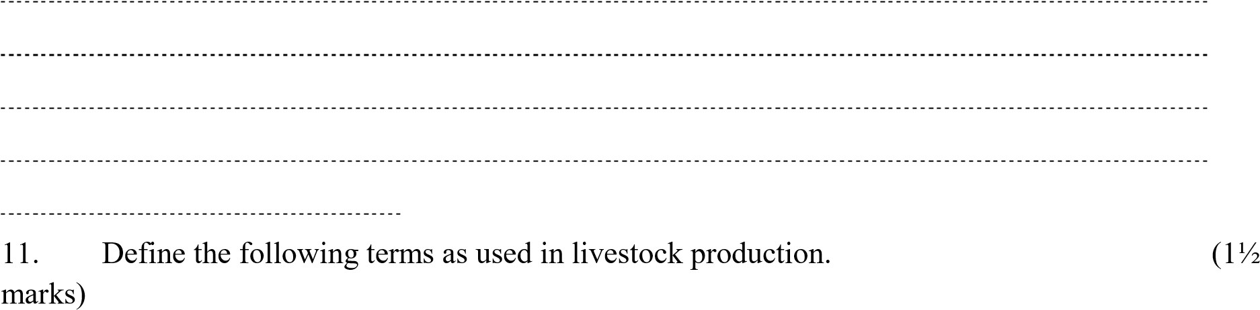
- Digestibility

- Prolificacy

- Malpresentation

- Give three methods of selecting livestock for breeding
(1½marks)

- Why should bees be fed on sugar syrup?
(1mark)

- State four conditions that would encourage hens to eat eggs in poultry production
(1½mark)

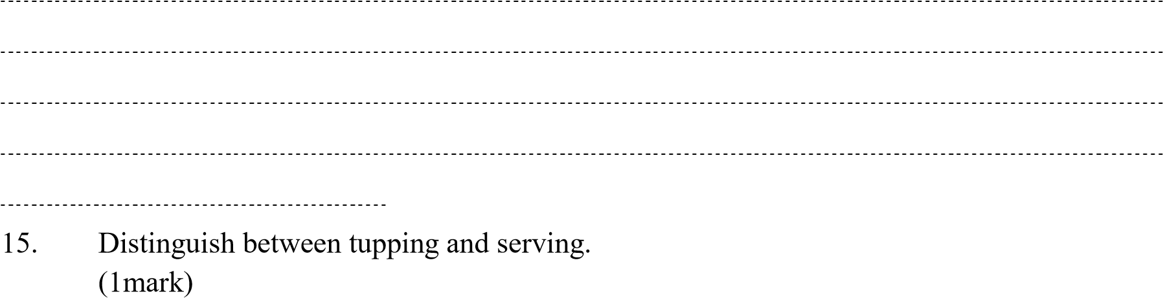

- What is the advantage of using forage harvesters compared to a mower?
(1mark)

- Give three maintenance practices of ox ploughs.
(1½marks)

- State four disadvantages of using live fence on the farm
(2marks)

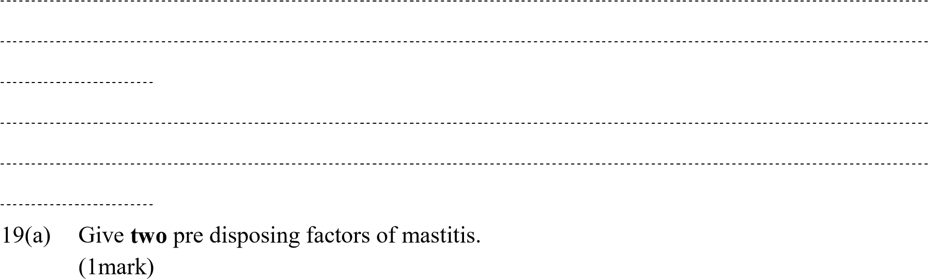

b) Using letter X identify three areas infested with a three- host tick in the picture below.
(1½marks)
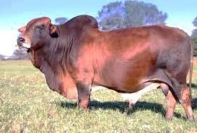

SECTION B: (20MARKS)
ANSWER ALL QUESTIONS FROM THIS SECTION ON SPACES
PROVIDED

20. Study the structure of a goat pen below and then answer the questions that follow.
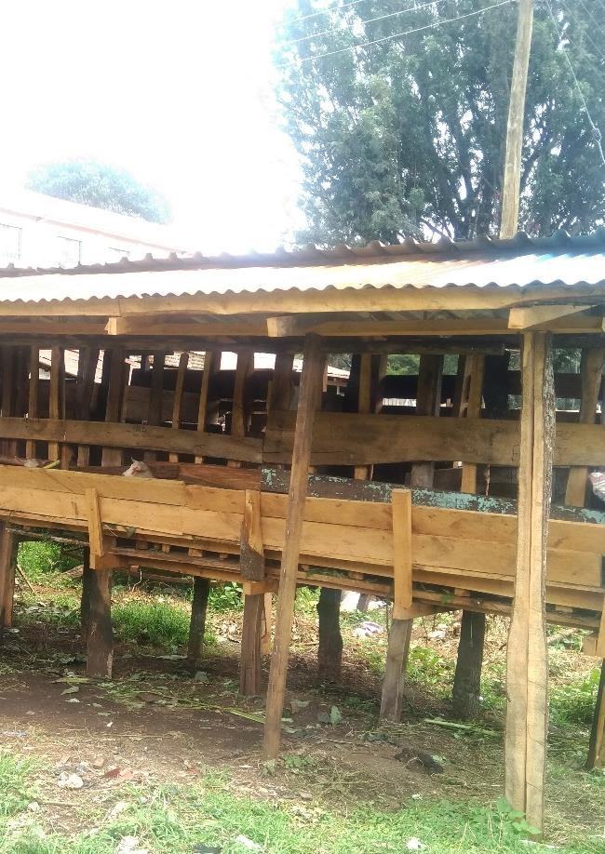

H

N

K

- Specify the measurements between H and N.
(½mark)

Give a reason for your answer in a) above.
(½mark)

- State the function of part K.
(1mark)

- Which type of floor is recommended for the pen shown in the picture above (½mark)

Give a reason for your answer in (c) above
(½mark)

- List two reasons for housing the calves singly.
(1mark)

21(a) Identify the equipment X and Y below.
(1mark) 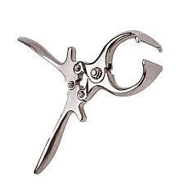
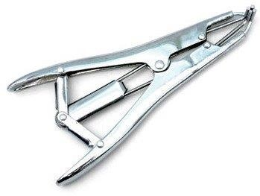

X Y
- State the functions of each of the equipment.
(2marks)

- i) Name the tool used to castrate a piglet.
(½mark)

ii) Give two reasons for castrating a male piglet.
(1mark)

22(a) Identify the parasites below.
(1mark)
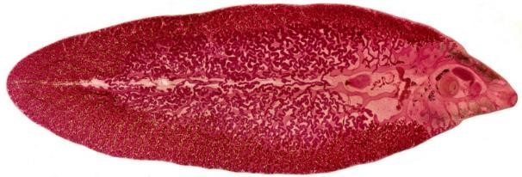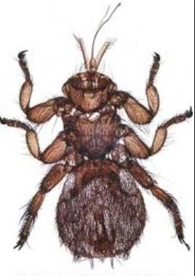

U W

- Name two species of parasite U.
(1mark)

- Why is it difficult to control parasite U?
(1mark)

- State the livestock commonly affected by parasite W?
(½mark)

e) | A farmer wanted to mix 270kg of livestock feed containing 30% DCP by using Sorghum meal
with | 12%DCP and Soya bean meal containing 36% DCP. Calculate the quantities of each feedstuff
he | would have in the ration.
 | (2marks)
23(a) | Using x draw the behaviour of the chicks expected in the following conditions in a
brooder.(2marks)

brooder

wall

H
eat
source

V

Draught wind Excess heat for heat source

- What is the role of the part labelled V? (½ mark)

- i) Identify the got breed below.
(1mark)

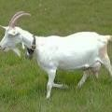

1

2

3

ii) On the diagram name parts 1-3. (1½ marks)
d) List two features that are used to identify the goat breed
(1mark)

SECTION C: (40MARKS)

Answer ANY TWO questions from this section on foolscaps provided.

24(a) Describe the procedure for honey harvesting in a Kenya Top Bar Hive.
(5marks)
- Name ten parts of an ox- drawn plough and state the function of each.
(10marks)
- Explain how physiological factors are used as a sign of ill or good health.
(5marks)

25(a) Describe the process of milk let down in a cow.
(6marks)
- Describe the procedure of embryo transplant in cattle.
(9marks)
- Describe cattle management during dipping
(5marks)

26(a) Outline the control measures of mastitis.
(5marks)
- Describe the marketing of eggs.
(10marks)
- Outline the general characteristics of chinchilla breed of rabbits.
(5marks)

