MWAKICAN EXAM FORM ONE END OF TERM THREE AGRICULTURE 2016.

Name…………………………………..

Date…………………………………….

TIME 2HRS

Instructions

1. Write your name in the space provided above

2. Write the date of the exam in the space provided above.

3. This paper consist of three sections A,B and C.

4. Answer all questions in section A,B and C.

5. All answers should be written in the spaces provided.

6. Check the paper to ascertain that all the pages are printed as indicated and that no question is missing.

SECTION A. 30MKS
1. Define the term agriculture 1mks

2. Give four factors that make agriculture to be termed as an art 2mks

3. Differentiate between entomology and crop pathology as used in agriculture 1mk

4. Define the following terms as used in agriculture
(a) Floriculture 1mk

(b) Olericulture 1mk

(c) Pomology 1mk

5. Name three forms in which soil water exist in the soil. 3mks

6. Give the functions of the following farm tools and equipments.
(a)Dibber 1mk

(b)Garden trowel 1mk

(c) Strip cup 1mk

(d) Troca and canula 1mk

(e)Stock and die 1mk

Pipe cutter 1mk

7. Give any four importance of primary cultivation 4mks

8. Give a functional difference between a bolus gun and a drenching gun. 1mk

9. State four factors to consider when making a choice of the type of irrigation to be used in the farm 2mks

10. Outline any two effects of high temperature on crop production 2mks

11. Give any four factors influencing soil formation 2mks

12 .Give any three factors determining the depth of ploughing 3mks

SECTION B (30MKS)
13. Below are diagram of spanners. Use them to answer the question that follows

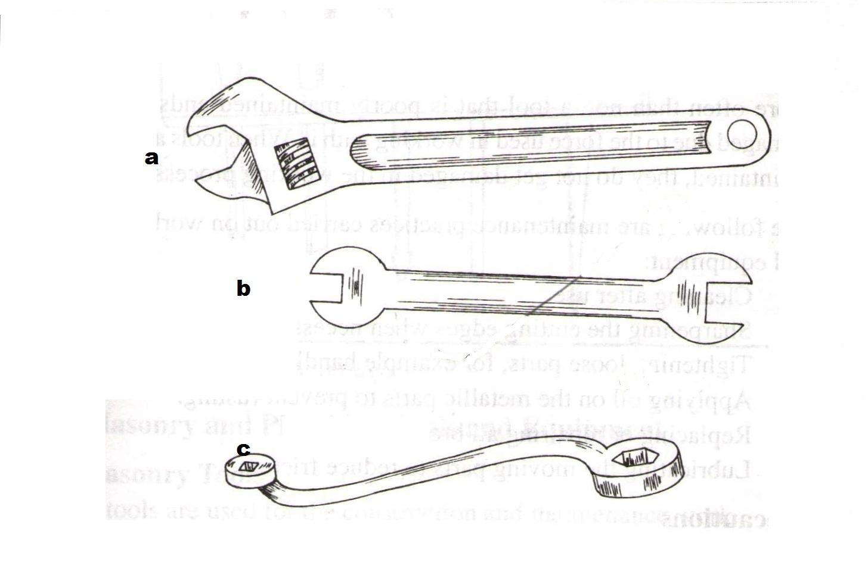

(a)Identify the type of spanner marked a-c. 3mks

(b)Give one advantage of a spanner a over spanner b 1mk

14. Below is a diagram of a knapsack sprayer .Use it to answer the questions that follow.

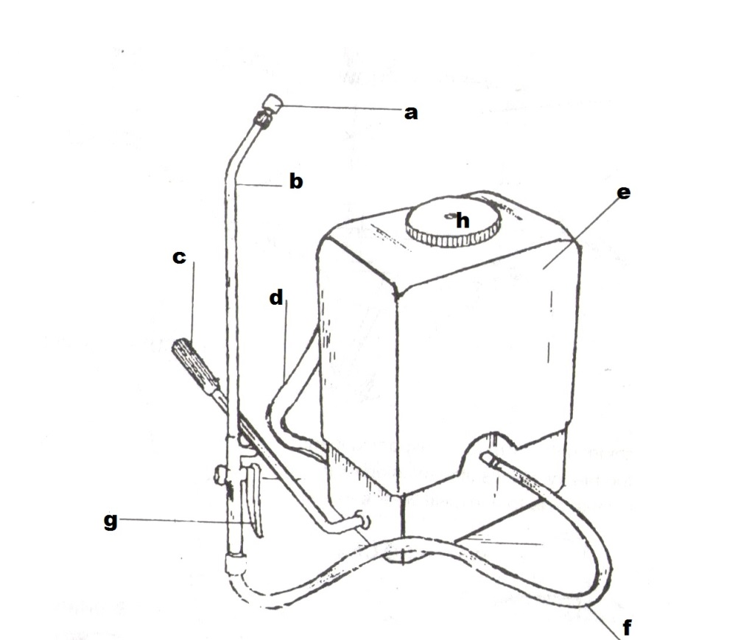

(a)Name the parts marked a-h 4mks

(b)Give any four maintenance practices of a knapsack sprayer 4mks

15. The structure drawn below is a tertiary operation done in land preparation .Use it to answer the questions that follows
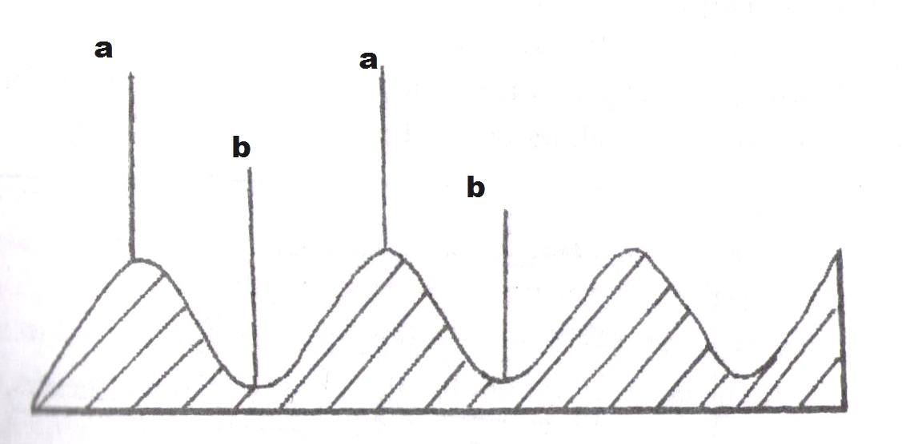

(a)Identify the parts marked a and b 2mks

(b)Give two advantages of using the above structures in growing of crops 2mks

16. State the six stages of water treatment process 6mks

17.(a). Identify the type of irrigation system drawn below1mks

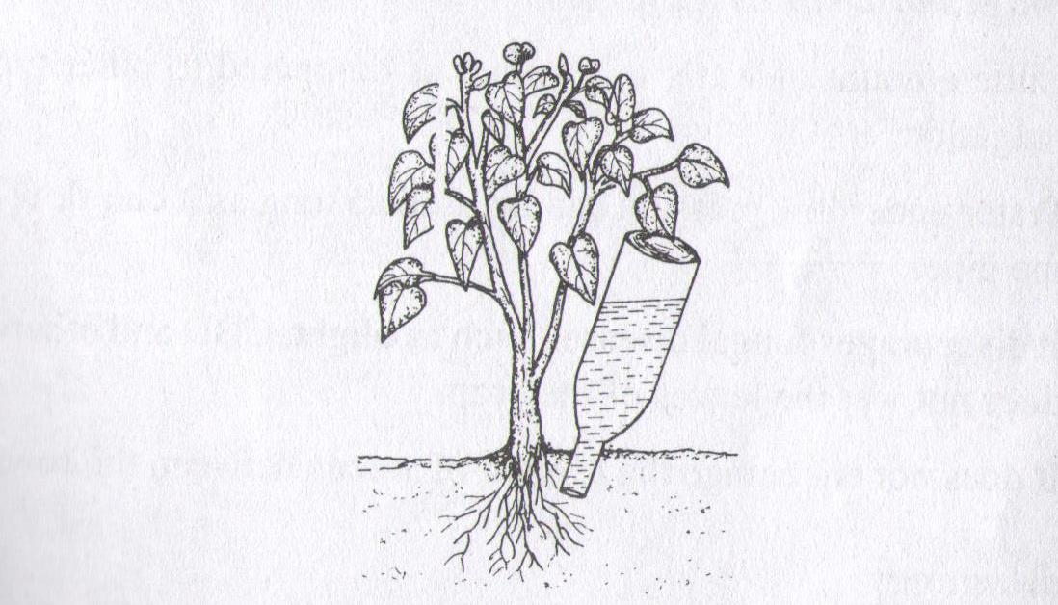

(b)Give any five advantages of using the irrigation system drawn above 5mks

18. State two aspects of rainfall that a farmer may consider when deciding on what crop to grow in an area 2mks

SECTIO N C
19. (a)State and explain any five importance of agriculture to our economy 10mks

(b)Outline five maintenance practices carried out on workshop tools and equipment 10mks

20. State any five types of soil structures. 5mks

(b) Outline five general uses of water in the farm. (5x2=10mks)

(C)State five effects of high level of education and technology to agricultural production 5mks

