NAME…………………………………………….ADMISSION NUMBER………………………
AGRICULTURE
TIME:2 HOURS
MWAKICAN FORM 1 JOINT EXAMINATION 2019
AGRICULTURE
TERM 3
INSTRUCTIONS TO CANDIDATES.
- Write your name and admission number in the spaces provided.
- Answer all questions in the spaces provided.
- This question paper consists of three sections A, B and C.
- Answer all the questions in sections A, B and C.
- Answers should be written in the spaces provided.
For Examiner’s use only
Section | Question | Maximum score | Candidate’s score
A | 1-19 | 40
B | 20-23 | 20
C | 24 | 20
 | 25 | 20
 |  | 100

Candidates should check the question paper to ascertain that all the pages are printed as indicate and no questions are missing.

SECTION A (4O MARKS
1. Give three ways through which HIV/AIDS affect agriculture. (3mks)

2 (a) Give three advantages of drip irrigation. (3mks)

b. State two surface water sources on the farm (1mk)

3. Differentiate between the terms soil texture and soil structure (1mk)

4. Name four types of pumps used in lifting water from its source on the farm (2mks)

5Differentiate between olericulture and pomoculture as used in crop production. (1mrk)

6. Outline four ways in which optimum soil temperature is beneficial to crops (2mks)

7. Give four importance of secondary cultivation in crop production (2mks)

8. Name four factors influencing soil formation. (2mks)

9. List the physical weathering agents in soil formation process (3mrks)

1O. Define the term drainage. (1mk)

11. Give any three tertiary operations carried out during land preparation. (3mks)
12. State two conditions under which shifting cultivation is favourable. (lmk)

13.In farming under what conditions is opportunity cost zero. (1mk)

14. State four reasons of treating water in the farm. (2mks

15. State four advantages of overhead irrigation. (2mks)

16. State three ways of conveying water in the firm. (3mks)

17. Give four method of farming (2mrks)

18. Give three reasons why agriculture is defined as a science. (3mks)

19. Name four dairy cattle breeds reared in Kenya. (2mks

SECTION B (2O MARKS)
2O.The diagram below illustrates the general shape of a cattle breed. Study it carefully and answer the questions that follow.
a)Identify the type of breed illustrated by the above shape (1mk)

b)Give example of a breed in (a) above ( 1mk)

c)State threephysical characteristics of the type of breed identified in (a) above (3mks)

21. The diagram below shows an experiment set up using soil types G H and J to investigate a certain property of soil.
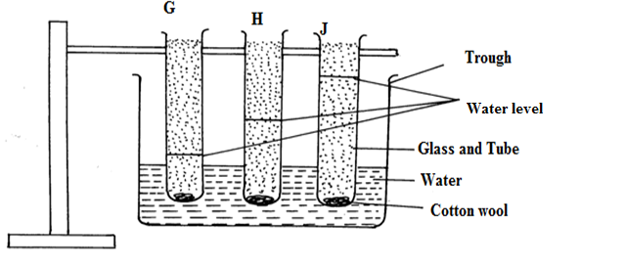

a. a.Identify the property being investigated (1mk)

b. Name the three types of soil represented by (3mks
G ____
H ____
J______

- What conclusion can be made from the experiment (2mks)

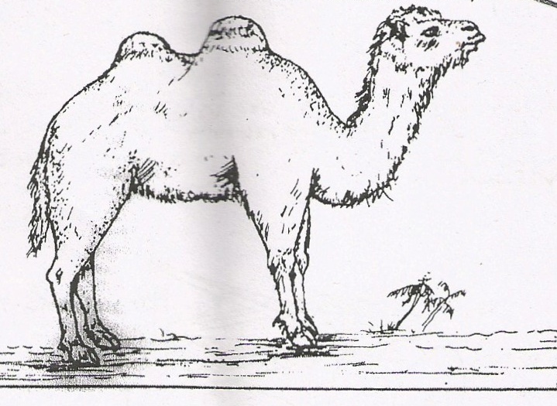

22.(a) Identify the camel species (1mk

(b) Give three reasons why the camel species illustrated above is able to survive in the natural habitat 3mks

23.Below are illustrations of farm tools and equipment.
A

B

C

- Identify the tool labelled A and C
A (1 mk)

C (1 mk)

- State the advantage of tool B over tool C (1 mk)

- State two maintenance practices carried out on tool labelled B. (2 mks)

SECTION C 4O MARKS
24.(a)Outline five benefits for practicing minimum tillage. (5 marks)

b)Outline four benefits of primary cultivation. (4 marks)

C.Explain eight ways in which soil fertility can be maintained (8mrks)

d. Give three advantages of shifting cultivation. (3mks)

25.a.Outline four characteristics of green manure crops (4mks

b.State four reasons as to why is green manure is not commonly used (4mks

c.Write down five uses of farm records (5mks

d.Write down five reasons for maintaining farm tools and equipment (5mks

e. Outline four characteristics of clay soil (2mks)

