443
AGRICULTURE

MWACKAN EXAM FORM 2

END OF TERM 1

2016

INSTRUCTIONS
- Write your name in the space provided above
- This paper consult of three sections A.B,C
- Answer all the questions in section A and B
- Answer all the questions in section C

SECTION
A | 1-17 | 30 MKS
B | 18-22 | 30MKS
C | 23-24 | 40MKS
TOTAL 100MKS

SECTION A
30MKS
- State the meaning of the following terms as used in Agriculture
- Entomology 1mk

- Floriculture 1mk

- Give four symptoms of potassium deficiency in plants 2mks
4× ½ =2mks

- State four disadvantages of shifting cultivation 4× ½ mks
2mks

- What is Agroforestry 1mk

- List four factors influencing soil formation 2mks

- Name three aspect of light that affect crop production 3× ½ =1 ½ mks

- State two forms in which Nitrogen can be absorbed by a plant 1mk

- List three disadvantages of row planting 1 ½ mk

- Give four general characteristics of Romney Marsh Dual purpose breed of sheep.
4× ½ mks

- State the function of the following farm tools and equipments
- Robbot plane 1mk

- Strip cup 1mk

- Trocar and canula 1mk

- State two instances where opportunity cost is said to be zero 1mk

- State four importances of primary cultivation 2mks

- Mention three light breeds of poultry 1 ½ mks

- Give four reason why burning of bushes as a method of land clearing should be discouraged 2mks

- Name three types of surface irrigation 1 ½ mks

- Distinguish between a seedling bed and a nursery bed 1mk

- Give reasons for carrying out the following operations in crop production
- Earthing up 1mk

- Leveling 1mk

- Rolling 1mk

SECTION B 30 MKS
- Study the following diagrams of soil sampling and answer the questions that follows.
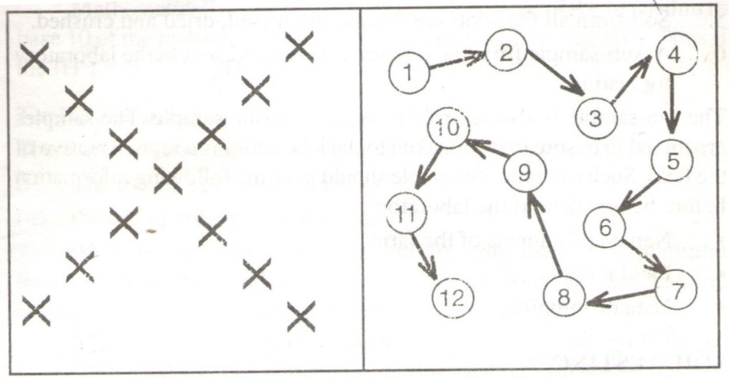
A B
- Identify the sampling method labeled
A 1mk

B 1mk

- Describe the procedures followed during soil sampling process 3mks

- State the information contained in a composite sample of soil before being taken to the laboratory 3mks

- The diagram below illustrate an investigation on a property of soil using soil samples labeled J,K and L.
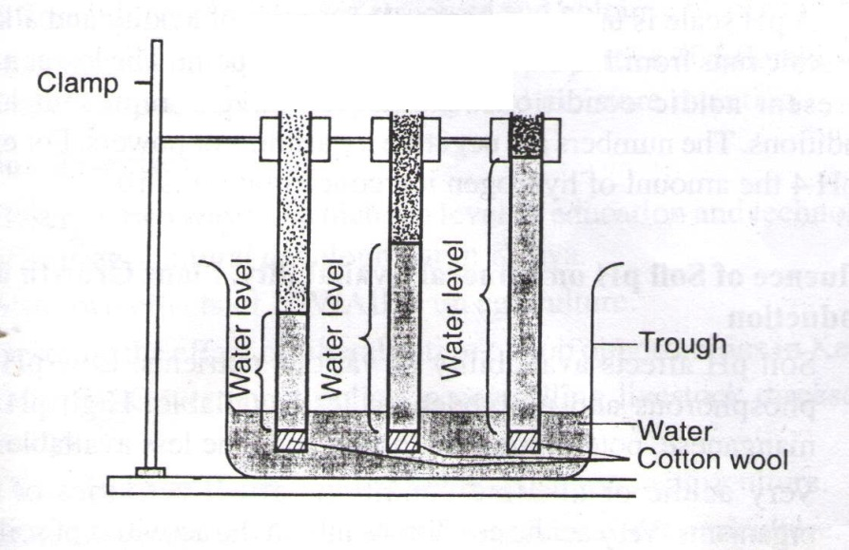
J K L
Dry soil

- If the level of water shown in the diagram were observed after 3 hours, name these property of soil being investigated 1mk

- What is this relationship between soil property named in (a) above and the size of the soil particles 1mk

- Which soli sample would be suitable for growing paddy rice 1mk

- Study the diagram below and answer the questions that follows:
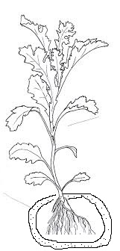

Crop being fertilized
Fertilizer particles
- Identify the method of fertilizer application shown above 1mk

- Name any other four methods of fertilizer application apart from the one demonstrated above 4mk

- (a)Define the term drainage 1mk

(b)State four importance of drainage as a land reclamation method 4mk

(c)Give four methods of drainage 4mks
- (a) Identify the method of irrigation drawn below.1mks
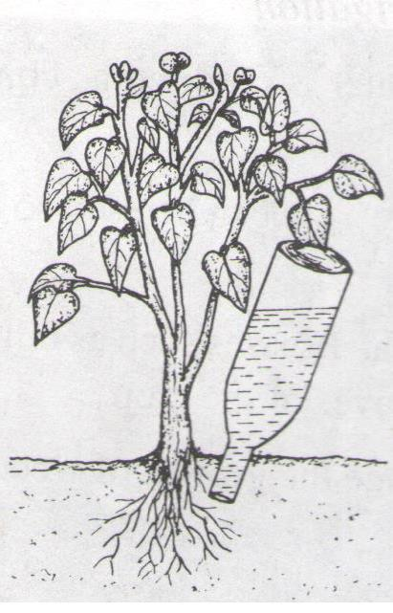
Bottle of water
(b)Give advantages of the method of irrigation drawn above 4mks

SECTION C
- (a)State and explain various factors determining spacing of crops 7×2=14 mks

(b)Explain factors considered when selecting a nursery site 6mks

- (a)State and explain various practices carried out in the nursery while the seedlings are growing 7×2=14 mks

(b)Discuss various roles of agriculture to our economy 6mks

