Name ……………………………………………………… ADM NUMBER……………...
CANDIDATE’S SIGN………….
DATE ………………………….
443/2
AGRICULTURE
PAPER 2

Time 2 Hours

MWAKICAN END OF TERM ONE 2016
Kenya Certificate of Secondary Education (K.C.S.E)
INSTRUCTIONS TO CANDIDATES
- Write your name and index number in the spaces provided
- Sign and write the date of examination in the spaces provided
- This paper consists of three sections A, B and C.
- Answer all questions in section A and B.
- Answer any two questions in section C
- All the questions should be answered in the spaces provided
- Candidates should check to ascertain that all pages are printed as indicated and that no questions are missing.
FOR EXAMINER’S USE ONLY
Section | Question | Max Score | Candidates Score
A | 1-17 | 30
B | 18-21 | 20
C | 22 | 20
 | 23 | 20
 | 24 | 20
 | Total

SECTION A (30MKS)
- Name the two types of bees (1mk)

- Define the following terms as used in livestock production (1 ½ mks)
- Dehorning

- Culling

- Parturition

- State four reasons why a farmer should strive to keep livestock healthy (2mks)

- Outline the effects of parasites on their hosts (3mks)

- Give two importances of water in an animal’s body (1mk)

- Give two examples of equipments that a livestock farmer can use in administering oral antihelminthes (1mk)

- Differentiate between flushing and steaming up. (1mk)

- (a) Name a dual purpose cattle breed reared in Kenya (½mk )

(b) Outline four general characteristics of indigenous cattle breed (2mks)

- Name four breeds of dairy goats (2mks)

- State four ways of controlling tse tse flies (2mks)

- List the methods of selection in livestock (1½ mks)

- Give three types of bees found in a colony (1½ mks)

- List three advantages of hoof trimming in sheep production (1½ mks)

- State two uses of a foot bath in cattle dip (1mk)

- State six routes through which disease causing organisms can enter into an animal’s body
(3mks)

- (a) State three characteristics of succulent roughages (1½ mks)

(b) Name two types of concentrates (1mk)

- State, four features of a good calf-pen (2mks)

SECTION B (30MKS)

- (a) Below are farm tools, study them and answer the questions that follows:-
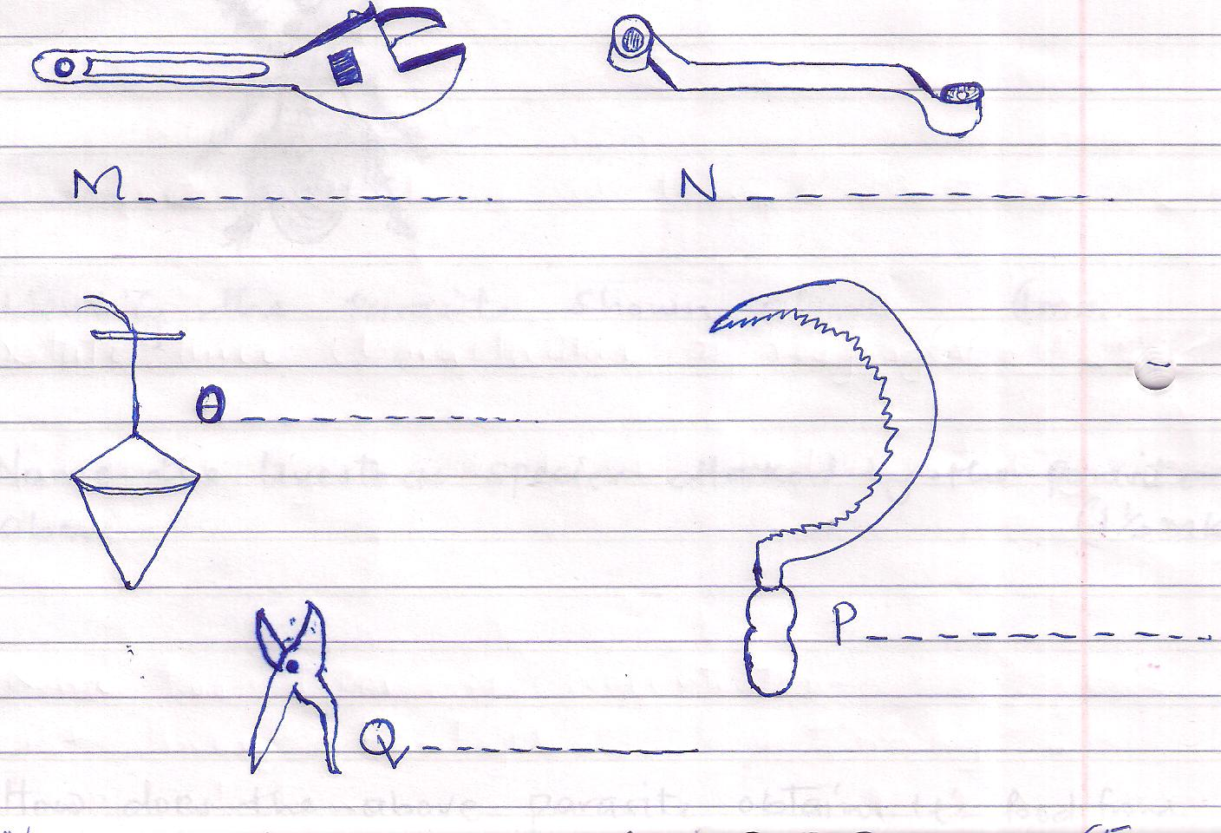

- Name the tools labeled M, N, O, P Q (212mks)

- Give one functional advantage of tool M over N (1mk)

- State the uses of each tool named in (i) above (2½ mks)
M -
N -
O -
P -
Q -

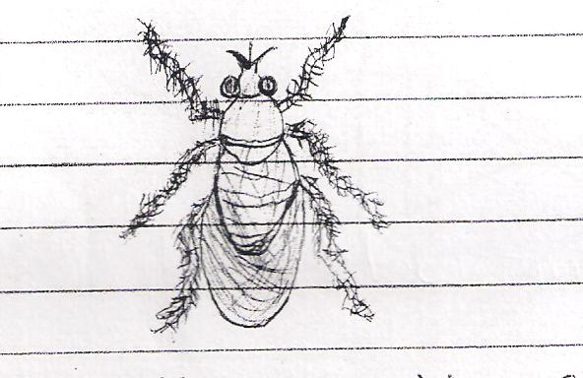
- Study the diagram below and then answer the questions that follows:-

- Identify the parasite shown above (1mk)

- Name the livestock species attacked by the parasite above (1½ mks)

- How does the above parasite obtain it’s food from the host? (1mk)

- What are the harmful effects of the parasite you have mentioned in (a) above?
(2mks)

- How would a farmer control the above parasite (2mks)

- Study the illustrations of a farm structure below and answer the questions that follows:
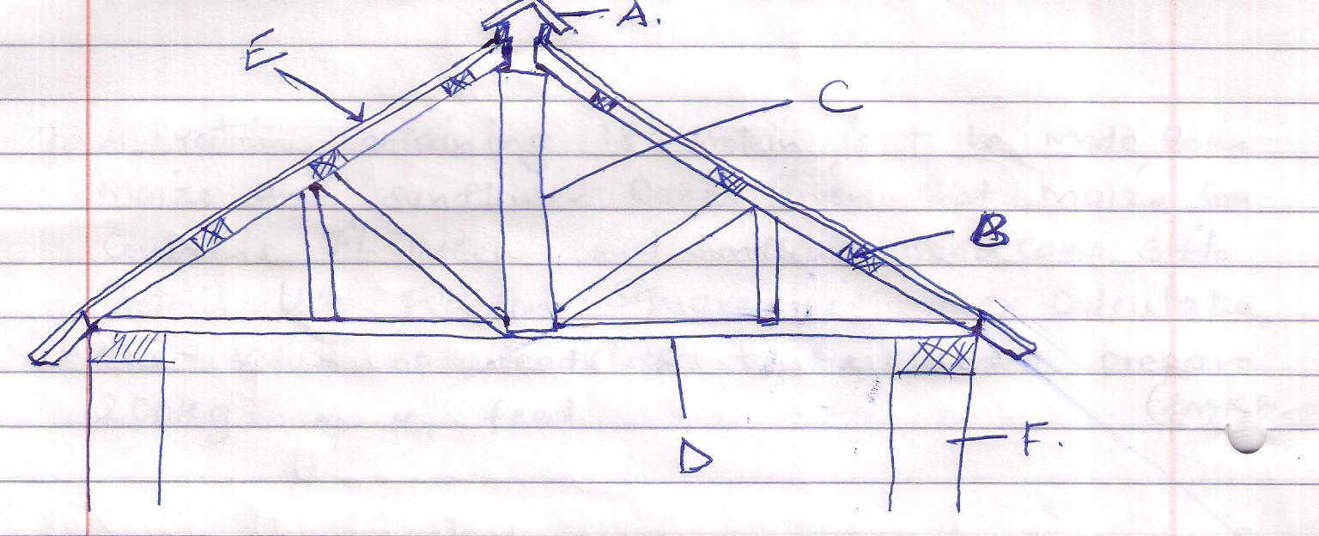
(i) Name the parts labeled A, B, C, D (4mks)
A -
B -
C -
D -
(ii) State the function of the part labeled E (1mk)

(iii) State three maintenance practices carried out on the roof of a farm structure (3mks)

SECTION C (40MKS)
- (a) Outline the importances of fences in the farm. (10mks)

(b) Give two methods used for ration computation (2mks)

(c) A ration containing 18% protein is to be made from maize and sunflower cake. Given that maize contains 7% protein, and sunflower seed cake 34% protein. Use pearson square method to calculate the value of feedstuffs to be used to prepare 200Kgs of the feed. (3mks

d Give five differences between digestion of a ruminant and a non-ruminant animal

- (a) Outline the life cycle of a three host tick (10mks)

(b) State five effects of tick to livestocks (5mks)

(c) Howe can a farmer control ticks in livestock production? (5mks)

- (a) Explain five factors considered when selecting a breeding stock (10mk

(b) With a well labeled diagram, describe egg formation in a hen (10mks)

