MWAKICAN (MJET)
END OF TERM 1 EXAM 2016
NAME…………………………………….………………………………….... ADM …………………..
AGRICULTURE FORM THREE
PAPER 2
SECTION A (30MKS)
- Name two species of camels. (1mk)

- Differentiate between a drenching gun and a bolus gun. (2mks)

- State four reasons why it’s important to maintain farm tools and equipment. (2mks)

- State four importance of keeping livestock healthy. (2mks)

- State four advantages of castration in livestock. (2mk)

- Name two dual purpose breeds of cattle. (1mk)

- State four differences between large white and landrace breeds of pigs. (2mks)

- Give two examples of feed addictives in livestock feeding. (2mks)

- (a) Highlight four differences between ruminants and non-ruminants. (2mks)

(b) State four functions of proteins in the body of an animal. (2mks)

10. (a) Differentiate between flushing and steaming up. (2mks)

(b) Give four reasons why an animal may be culled. (2mks)

11. Name four rabbit breeds. (2mks)

12. State six requirements of a calf pen. (3mks)

13. Indicate six livestock management practices carried out in a crush. (3mks)

SECTION B (20MKS)
14. The following is a diagram of the oviduct of a hen. Study it carefully and answer the questions that follows.
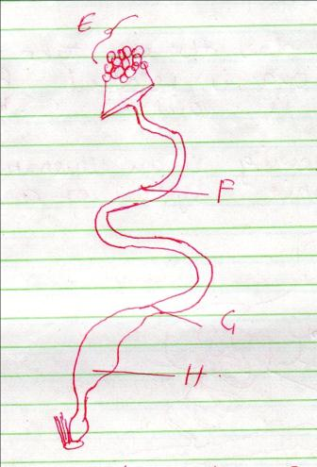

- Name parts labelled E, F, G and H. (2mks)
E

F

G

H

- State one constituent added to the egg in each of the following parts.
F

G

H

- State two processes that take place in the infundibulum. (1mk)

- How long does the egg take from the time the ova is released from E to the time its laid? (1mk)

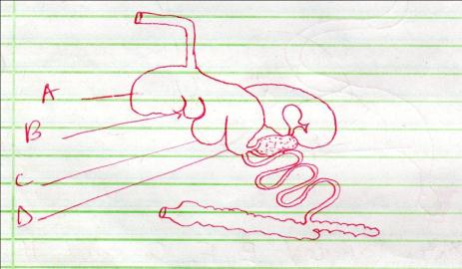
15. The following is an illustration of the digestive system of a ruminant.

- Name the parts labelled A to D.
A

B

C

D (2mks)

- Name the parts illustrated where microbial activities takes place. (1mk)

- State two microbial activities that take place in part named in (b) above. (2mks)

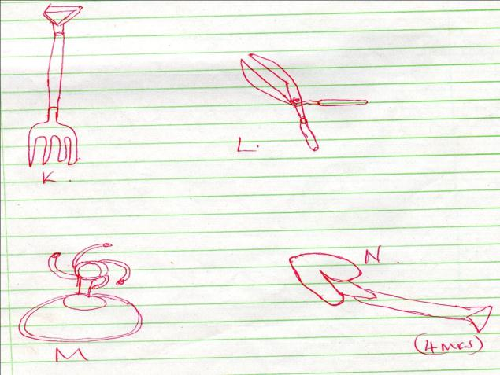
16. (a) Identify the tools J K L M and N. (4 MKS)

(b) Give one use of each of the tools named in (a) above. (2mks)

(c) State the maintenance practices carried out on tool K and L. (2mks)

SECTION C (40 mks)
17(a) State five factors to consider in selecting construction materials. (6mks)

(b) Explain the factors to consider in citing farm structures. (9mks)

(c) What is the importance of farm buildings. (5mks)

18(a) Explain the importance of fencing in the farm. (8mks)

(b) Describe the procedure followed when constructing a barbed wire fence. (8mks)

(c) State the maintenance practices carried out on a barbed wire fence. (4mks)

19(a) State six effects of parasites in livestock. (6mks)

(b) Describe the life cycle of Taenia solium species of tapeworm. (10mks)

(c) State four control measures of tapeworm. (4mks)

