Name: ……………………………………………... Index no ……..…......................................

School: …………………………………………….. Candidate’s sign …………………….......

Class………………………………………….…..… Adm No…………………...……………...

AGRICULTURE 443/2
JULY 2019
TIME: 2 HOURS
FORM FOUR MOKASA II MOCK
Kenya Certificate of Secondary Education (K.C.S.E.)
Agriculture
Paper 2

INSTRUCTIONS TO CANDIDATES:
- Write your name and index number in the spaces provided above.
- Sign and write the date of examination in the spaces provided above.
- This paper consists of three sections A, B and C.
- Answer all the questions in section A and B.
- Answer any two questions in section C.
- All answers should be written in the spaces provided.
- This paper consists of 11 printed pages.
- Candidates should check the question paper to ascertain that all the pages are printed as indicated and that no questions are missing.
- Candidates should answer all the questions in English.
For Examiner’s Use Only:
SECTION | QUESTIONS | MAXIMUM SCORE | CANDIDATES SCORE
A | 1-19 | 30
B | 20-23 | 20
C |  | 20
 |  | 20
 | TOTAL SCORE | 90

SECTION A (30 MARKS)
- Give the meaning of the following terms as used in livestock health. (1mk)
- Incubation period
………………………………………………………………………………………………………………………………………………………………………………………………
- Mortality rate.
………………………………………………………………………………………………………………………………………………………………………………………………
- State four physical characteristics of a dairy cow. (2mks)
………………………………………………………………………………………………..…………………………………………………………………………………………………..…………………………………………………………………………………………………..…………………………………………………………………………………………………..……………………………………………………………………………………………………..
- Name the two different types of rabbit houses. (1mk)
……………………………………………………………………………………………………………………………………………………………………………………………………
- What is the role of a footbath in a poultry house? $(\frac{1}{2}mk)$
……………………………………………………………………………………………………………………………………………………………………………………………………
- State four care and maintenance practices carried out on a tractor water cooling system.
(2mks)
……………………………………………………………………………………………………………………………………………………………………………………………………………………………………………………………………………………………………………………………………………………………………………………………………………………………………………………………………………………………………………
- State four factors that affect the digestibility of a feed. (2mks)
………………………………………………………………………………………………………………………………………………………………………………………………………………………………………………………………………………………………………………………………………………………………………………………………………

- Give four factors that should be considered when siting a beehive on the farm. (2mks)
……………………………………………………………………………………………………………………………………………………………………………………………………………………………………………………………………………………………………………………………………………………………………………………………………………………………………………………………………………………………………………
- Name the complementary tool for each of the tools named below: (2mks)
- Trochar ……………………………………………………………………………………..
- Hand drill…………………………………………………………………………………...
- Elastrator……………………………………………………………………………………
- Bull ring…………………………………………………………………………………….
- State four advantages of embryo transplant when breeding livestock. (2mks)
…………………………………………………………………………………………………………………………………………………………………………………………………………………………………………………………………………………………………………………………………………………………………………………………………………
- Give two reasons why sows may eat piglets immediately after farrowing. (1mk)
………………………………………………………………………………………………………………………………………………………………………………………………………………………………………………………………………………………………………
- State three reasons for docking in rams. $(1\frac{1}{2}mks)$
………………………………………………………………………………………………………………………………………………………………………………………………………………………………………………………………………………………………………
- Name four components of a building truss. (2mks)
………………………………………………………………………………………………..…………………………………………………………………………………………………..…………………………………………………………………………………………………..……………………………………………………………………………………………………..
- Differentiate between strategic and tactical treatment as used in the control of endoparasites.
(1mk)
………………………………………………………………………………………………………………………………………………………………………………………………………………………………………………………………………………………………………
- Name four diseases in poultry that are controlled by vaccination. (2mks)
………………………………………………………………………………………………..…………………………………………………………………………………………………..…………………………………………………………………………………………………..……………………………………………………………………………………………………..
- List four vices that may be developed by birds kept under total confinement. (2mks)
…………………………………………………………………………………………………………………………………………………………………………………………………………………………………………………………………………………………………………………………………………………………………………………………………………
- Give three reasons for steaming up an in-calf heifer. $(1\frac{1}{2}mks)$
………………………………………………………………………………………………..…………………………………………………………………………………………………..……………………………………………………………………………………………………..
- State four factors that influence the respiration rate in livestock. (2mks)
…………………………………………………………………………………………………………………………………………………………………………………………………………………………………………………………………………………………………………………………………………………………………………………………………………
- Name three dual purpose breeds of sheep. $(1\frac{1}{2}mks)$
………………………………………………………………………………………………………………………………………………………………………………………………………………………………………………………………………………………………………
- Give two reasons why proper nutrition is important in livestock health. (1mk)
………………………………………………………………………………………………………………………………………………………………………………………………………………………………………………………………………………………………………

SECTION B (20MARKS)
- The diagrams below illustrate ectoparasites.Study them and answer the questions that follow.
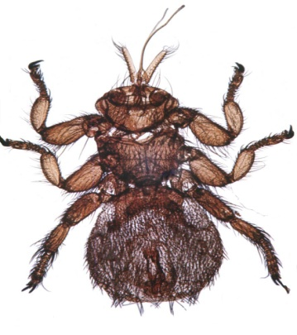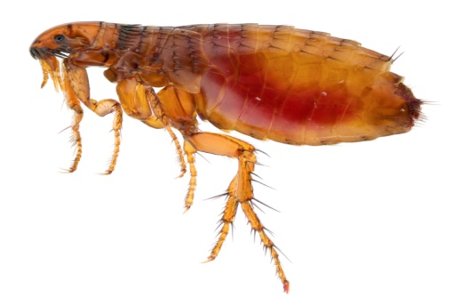
A B
- Identify the parasites labelled A and B. (1mk)
A……………………………………………………………………………………………
B……………………………………………………………………………………………
- Name the livestock affected by the parasite labelled A. (1mk)
………………………………………………………………………………………………
- State two harmful effects of parasites A and B in livestock production. (2mks)
………………………………………………………………………………………………………………………………………………………………………………………………
- Below is a diagram of the power transmission system of a tractor engine. Study it and answer the questions that follow.
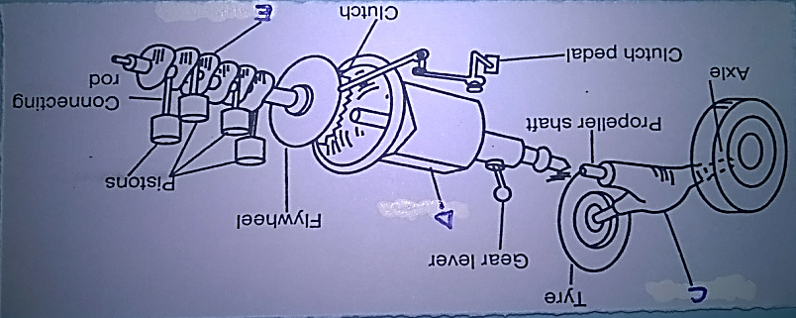
- Name the parts labelled C, D and E. (3mks)
C…………………………………………………………………………………………….
D………………………………………………………………………………………….....
E…………………………………………………………………………………………….
- State the functions of parts C, D and E. (3mks)
C…………………………………………………………………………………………….
D………………………………………………………………………………………….....
E…………………………………………………………………………………………….
- a) Outline the procedure of castrating a male piglet. (4mks)
………………………………………………………………………………………………..…………………………………………………………………………………………………..…………………………………………………………………………………………………..…………………………………………………………………………………………………..…………………………………………………………………………………………………..…………………………………………………………………………………………………..…………………………………………………………………………………………………..……………………………………………………………………………………………………..
b) At what age should the male piglet be castrated? (1mk)
…………………………………………………………………………………………………
- Study the tools below and answer the questions that follow.
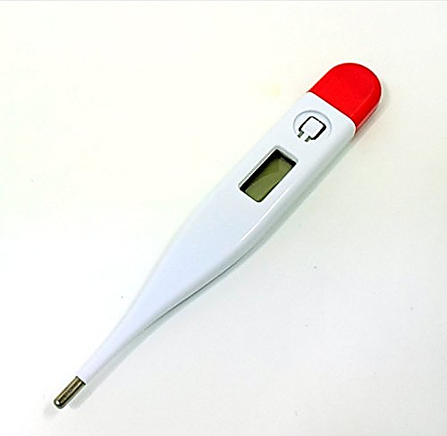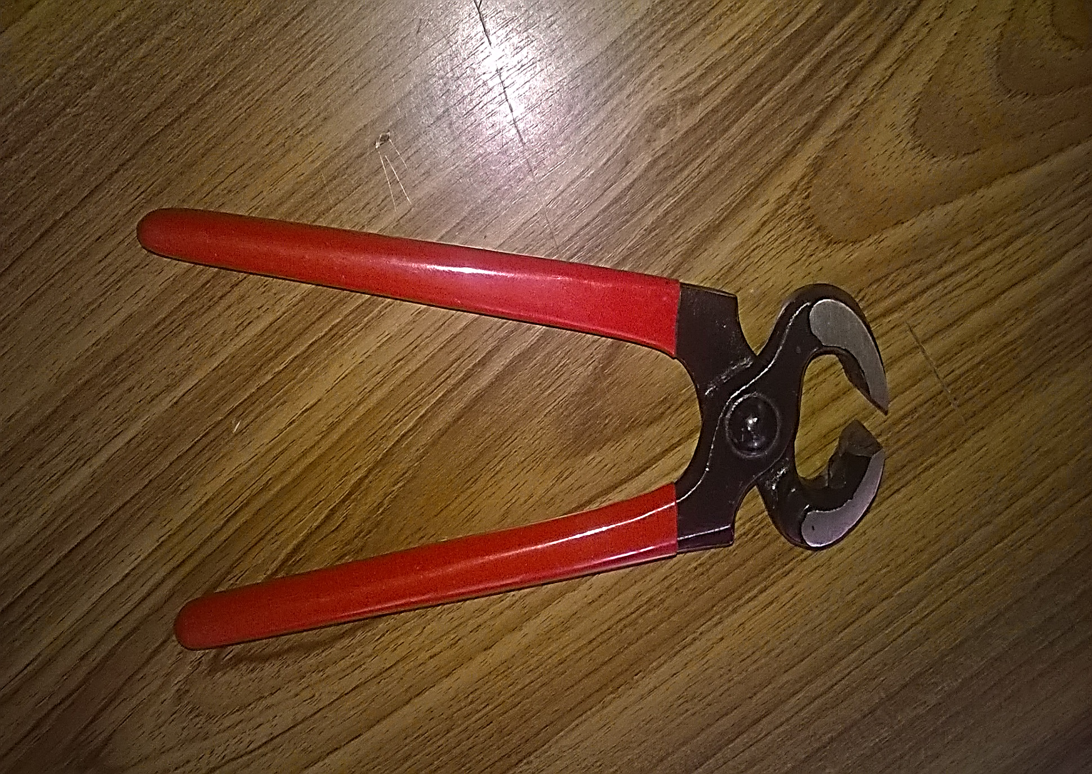
F G
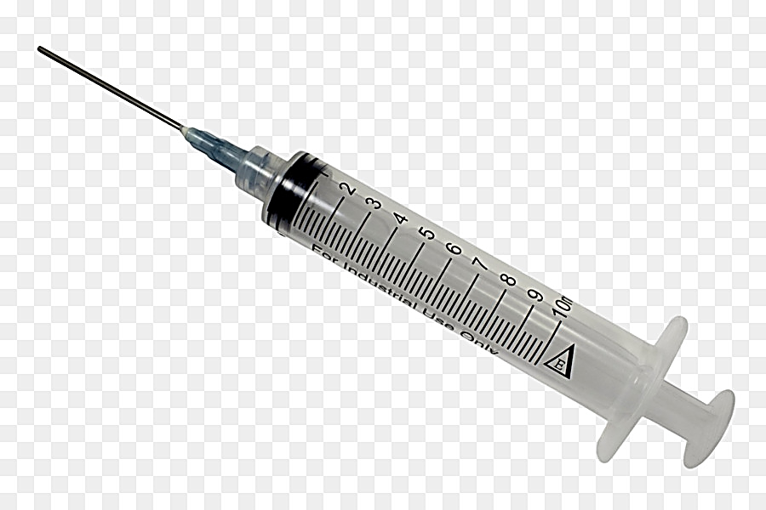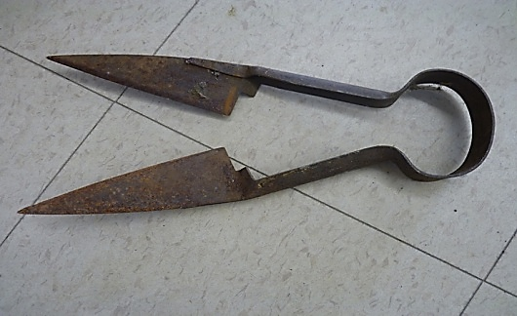
H I
- Identify the tools labelled F, G, H and I. (2mks)
F……………………………………………………………………………………………
G……………………………………………………………………………………………
H……………………………………………………………………………………………
I……………………………………………………………………………………………..
- Give the uses of each of the tools labelled H and I. (2mks)
H……………………………………………………………………………………………
I…………………………………………………………………………………………..…
- Name the part of the animal where tool F is placed when in use. (1mk)
………………………………………………………………………………………………
SECTION C (40MARKS)
- a) Explain the management practices that a farmer should carry out to improve milk production in a low dairy herd. (10mks)
b) Describe the rearing of one day old chicks to 8 weeks. (10mks)

- a) Describe coccidiosis disease under the following sub-headings:
- Causal organism (1mk)
- Pre-disposing factors. (3mks)
- Symptoms. (4mks)
- Control measures. (2mks)
b) Describe five parts of a piggery unit. (10mks)

- a) Give five functions of water in livestock. (5mks)
b) State and explain five essentials of clean milk production. (10mks)
c) Give five operational differences between a disc pough and a mouldboard plough. (5mks)
………………………………………………………………………………………………..…………………………………………………………………………………………………..…………………………………………………………………………………………………..…………………………………………………………………………………………………..…………………………………………………………………………………………………..…………………………………………………………………………………………………..……………………………………………………………………………………………………..
………………………………………………………………………………………………..…………………………………………………………………………………………………..…………………………………………………………………………………………………..…………………………………………………………………………………………………..…………………………………………………………………………………………………..…………………………………………………………………………………………………..…………………………………………………………………………………………………..…………………………………………………………………………………………………..…………………………………………………………………………………………………..…………………………………………………………………………………………………..…………………………………………………………………………………………………..…………………………………………………………………………………………………..…………………………………………………………………………………………………..…………………………………………………………………………………………………..…………………………………………………………………………………………………..…………………………………………………………………………………………………..…………………………………………………………………………………………………..…………………………………………………………………………………………………..…………………………………………………………………………………………………..…………………………………………………………………………………………………..……………………………………………………………………………………………………..
………………………………………………………………………………………………..…………………………………………………………………………………………………..…………………………………………………………………………………………………..…………………………………………………………………………………………………..…………………………………………………………………………………………………..…………………………………………………………………………………………………..…………………………………………………………………………………………………..…………………………………………………………………………………………………..…………………………………………………………………………………………………..…………………………………………………………………………………………………..…………………………………………………………………………………………………..…………………………………………………………………………………………………..…………………………………………………………………………………………………..…………………………………………………………………………………………………..…………………………………………………………………………………………………..…………………………………………………………………………………………………..…………………………………………………………………………………………………..…………………………………………………………………………………………………..…………………………………………………………………………………………………..…………………………………………………………………………………………………..……………………………………………………………………………………………………..
………………………………………………………………………………………………..…………………………………………………………………………………………………..…………………………………………………………………………………………………..…………………………………………………………………………………………………..…………………………………………………………………………………………………..…………………………………………………………………………………………………..…………………………………………………………………………………………………..…………………………………………………………………………………………………..…………………………………………………………………………………………………..…………………………………………………………………………………………………..…………………………………………………………………………………………………..…………………………………………………………………………………………………..…………………………………………………………………………………………………..…………………………………………………………………………………………………..…………………………………………………………………………………………………..…………………………………………………………………………………………………..…………………………………………………………………………………………………..…………………………………………………………………………………………………..…………………………………………………………………………………………………..…………………………………………………………………………………………………..……………………………………………………………………………………………………..
………………………………………………………………………………………………..…………………………………………………………………………………………………..…………………………………………………………………………………………………..…………………………………………………………………………………………………..…………………………………………………………………………………………………..…………………………………………………………………………………………………..…………………………………………………………………………………………………..…………………………………………………………………………………………………..…………………………………………………………………………………………………..…………………………………………………………………………………………………..…………………………………………………………………………………………………..…………………………………………………………………………………………………..…………………………………………………………………………………………………..…………………………………………………………………………………………………..…………………………………………………………………………………………………..…………………………………………………………………………………………………..…………………………………………………………………………………………………..…………………………………………………………………………………………………..…………………………………………………………………………………………………..…………………………………………………………………………………………………..…………………………………………………………………………………………………..…………………………………………………………………………………………………..……………………………………………………………………………………………………..
………………………………………………………………………………………………..…………………………………………………………………………………………………..…………………………………………………………………………………………………......
………………………………………………………………………………………………..…………………………………………………………………………………………………..…………………………………………………………………………………………………..…………………………………………………………………………………………………..…………………………………………………………………………………………………..…………………………………………………………………………………………………..…………………………………………………………………………………………………..…………………………………………………………………………………………………..…………………………………………………………………………………………………..…………………………………………………………………………………………………..…………………………………………………………………………………………………..…………………………………………………………………………………………………..…………………………………………………………………………………………………..…………………………………………………………………………………………………..…………………………………………………………………………………………………..…………………………………………………………………………………………………..…………………………………………………………………………………………………..………………………………………………………………………………………………..…..………………………………………………………………………………………………..…..…………………………………………………………………………………………………
..………………………………………………………………………………………………..…..………………………………………………………………………………………………..…..……………………………………………………………………………………………..
..………………………………………………………………………………………………..…..………………………………………………………………………………………………..…..………………………………………………………………………………………………….…………………………………………………………………………………………………..…………………………………………………………………………………………………..…………………………………………………………………………………………………..…………………………………………………………………………………………………..…………………………………………………………………………………………………..…………………………………………………………………………………………………..……………………………………………………………………………………………………………………………………………………………………………………………………..…………………………………………………………………………………………………..…………………………………………………………………………………………………..…………………………………………………………………………………………………..…………………………………………………………………………………………………..…………………………………………………………………………………………………..…………………………………………………………………………………………………..…………………………………………………………………………………………………..…………………………………………………………………………………………………..…………………………………………………………………………………………………..…………………………………………………………………………………………………..…………………………………………………………………………………………………..............................................................................................................................................

