Kenya Certificate of Secondary Education 2019
443/ 1 Agriculture Paper 1
END TERM 1Time -2 hours

Name …………………………………………….……… Index Number…………………………..

Candidate’s Signature ………………….…...……….. Date ……………………………………

INSTRUCTIONS TO CANDIDATES
- Write your name and index number in the spaces provided above.
- The paper consists of three sections A , B and C.
- Answer all questions in section A and B in the spaces provided
- Answer any two questions from section C on foolscaps provided

FOR EXAMINER’S USE ONLY

 | Section | Question | Maximum score | Candidate’s score
 | A | 1−16 | 30
B |  | 17  18  19  20 | 20
c |  | 21-23 | 40
 |  | Total | 90

Turn over

SECTION A. (30 MARKS)
Answer all questions in this section in the spaces provided.

- List four methods of farming (2marks)
…………………………………………………………………………………………………………….
…………………………………………………………………………………………………………….
…………………………………………………………………………………………………………….
…………………………………………………………………………………………………………….
2. Give two characteristics of small scale farming. (1mark)
…………………………………………………………………………………………………………….
…………………………………………………………………………………………………………….

3. Outline four qualities of a mother plant that should be considered when selecting vegetative materials for planting (2mks)
………………………………………………………………………………………………………………………………………………………………………………………………………………….…….
4. Name four sources of agricultural credit in Kenya (2mks)
…………………………………………………………………………………………………………………
…………………………………………………………………………………………………………………
…………………………………………………………………………………………………………………
…………………………………………………………………………………………………………………

5. State two benefits of optimum soil temperature in crop production. (2 mk)
……………….………………………………………………………………………………………………………………………………………………………………………………………………………………………………………………………………………………………………………………………………………
6. Give four soil factors that influence soil productivity. (2mks)
………………………………………………………………………………………………………………………………………………………………………………………………………………………………………………………………………………………………………………………………………………………………………………………………………………………………………………………………………………………………………………………………………

7. Give two reasons why root pruning is done in the nursery management in agro forestry. (2 mks)
(1 mark)

…………………………………………………………………………………………………………………………………………………….………

…………………………………………………………………………………………………………………………………………………………….

…………………………………………………………………………………………………………………………………………………………..

8. State four sources of nitrogen in the soil. (4 marks)

…………………………………………………………………………………………………………………………………………………………….

……………………………………………………………………………………………………………………………………………………………

…………………………………………………………………………………………………………………………………………………………….

…………………………………………………………………………………………………………………………………………………………….

9. State four factors that affect the rooting of cuttings in tea and sugar cane. (2 mks)
…………………………………………………………………………………………………………….
…………………………………………………………………………………………………………….
…………………………………………………………………………………………………………….
10. Outline four factors that determine the choice of a weed control measure to use in a crop field. (2mks)
……………….……………………………………………………………………………………………………………………………………………………………………………………………………………………………………………………………………………………………………………………………………………………………………………………………………………………………………………………………………………………………………………………………………………………………………………

11. List four types of terraces (2mks)
…………………………………………………………………………………………………………….
…………………………………………………………………………………………………………….
…………………………………………………………………………………………………………….
…………………………………………………………………………………………………………….

12. State two ways by which organic mulches help to conserve moisture in the soil. (2mks)
…………………………………………………………………………………………………………….
…………………………………………………………………………………………………………….
13. Differentiate between under-sowing and over-sowing as used in forage Production. (2mks)
………………………………………………………………………………………………………………………………………………………………………………………………………………………………………………………………………………………………………………………………………………
14. Outline two activities carried out by the Young Farmers Club of Kenya (2mk)
…………………………………………………………………………………………………………….
…………………………………………………………………………………………………………….
15. State three ways of reclaiming water logged land (3 mks)
................................................................................................................................................................................................................................................................................................................................................ ............................................................................................................................ ..........................................

SECTION B (20 MARKS)
Answer All the questions in this section in the spaces provided
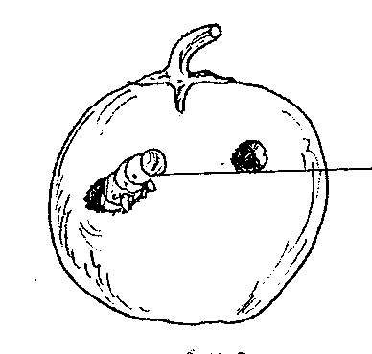
16. The diagram below shows a tomato fruit affected by a pest. Study it carefully then answer the questions that follow.
P

- Identify the pest labeled P (1mk)
…………………………………………………………………………………………………………………………………………………………………………………………………………………….
- State one method used to control the pest. (1mk)
…………………………………………………………………………………………………………………………………………………………………………………………………………………..
- State any two factors to consider when selecting tomato fruits for marketing. (2mks)
…………………………………………………………………………………………………………………………………………………………………………………………………………………..
……………………………………………………………………………………………………………………………………………………………………………………………………………………

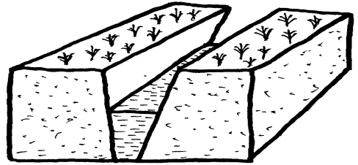
17. Below is a diagram showing a method of land reclamation. Study it carefully then answer questions that follow.
Planted crops
Water

- Identify the method of drainage illustrated above (1mk)
………………………………………………………………………………………………………………….
- State two reasons for carrying out drainage. (2mks)
……………………………………………………………………………………………………………………………………………………………………………………………………………….…….
…………………………………………………………………………………………………………………………………………………………………………………………………………………….
18. (a) Money maker variety of tomatoes are spaced at 100cm by 60cm. Calculate the number of
plants which would accommodate half an hectare of land. (3mks)
………………………………………………………………………………………………………………………………………………………………………………………………………………..….
…………………………………………………………………………………………………………………………………………………………………………………………………………………..
…………………………………………………………………………………………………………………………………………………………………………………………………………………….
……………………………………………………………………………………………………………………………………………………………………………………………………………………
(b) Give two importance of suitable plant population (2mks)
……………………………………………………………………………………………………………………………………………………………………………………………………………………..
…………………………………………………………………………………………………………

19. The diagram below illustrates a feature observed after digging the soil several meters deep. Study the diagram carefully and answer the questions that follow
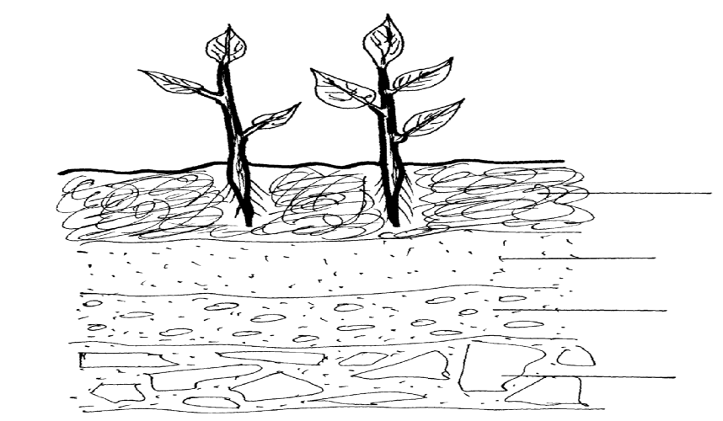

A

B
C

D

- Identify the feature that the diagram above represents (1 ½ ) mk)
……………………………………………………………………………………………………………………………………………………………………………………………………………………………………

- Name the parts of the diagram labeled B,C and D (1½ mk)
B…………………………………………………………………………
C……………………………………………………………………….
D……………………………………………………………………….
- Outline three characteristics of the part labeled A (3mks)
…………………………………………………………………………………………………………………………………………………………………………………………………………………………
…………………………………………………………………………………………………………….

SECTION C (40 MARKS)
Answer any two questions from this section in the space provided after question .

20. a) i)State the problems experienced by farmers and agricultural industries while marketing their
Produce. (8marks)
ii) Give any five solutions to the problems stated in (a) (i) above. (5marks)
b) Describe the general functions of Agricultural marketing boards in Kenya. (7marks)

21. a) State six advantages of a mixed pasture. (6 mks)
(b) Explain five roles of trees in soil and water conservation. (10 mks)
(c) State four conditions that should be observed when harvesting to ensure that cotton picked is of high quality. (4 mks)
22. a). Describe the effects of liberalization of agricultural markets to farming in Kenya (10mks)
b). Explain how price is determined in a free market situation. (3mks)
c). with examples explain how government policies affect agricultural production (7mks)
………………………………………………………………………………………………………………………………………………………………………………………………………………………………………………………………………………………………………………………………………………………………………………………………………………………………………………………………………………………………………………………………………
……………………………………………………………………………………………………………………………………………………………………………………………………………………………………………………………………………………………………………………………………………………………………………………………………………………………………………………………………………………………………………………………………..
………………………………………………………………………………………………………………………………………………………………………………………………………………………………………………………………………………………………………………………………………………………………………………………………………………………………
………………………………………………………………………………………………………………………………………………………………………………………………………………………………………………………………………………………………………………………………………………………………………………………………………………………………
………………………………………………………………………………………………………………………………………………………………………………………………………………………………………………………………………………………………………………………………………………………………………………………………………………………………

