Name…………………………………………….Adm. no……………………
School……………………………………..Date………………………………
Class…………………………….
443/2
AGRICULTURE
PAPER 2
TIME:2HOURS
2020 FORM 4 TERM 1 END TERM EXAMS
INSTRUCTIONS TO CANDIDATES:
1. This paper consists of sections A,B,andC
2. Answer all questions in sections A and B
3. Answer any two questions in section C
For Examiners use only
SECTION | QUESTON | MAXIMUM SCORE | CANDIDATE’S SCORE
A | 1-17 | 30
B | 18-21 | 20
C | 22-24 | 40
 | TOTAL | 90

Section A (30MKS)
1. Name four methods of dehorning in cattle (2mks)
……………………………………………………………………………………………………..
……………………………………………………………………………………………………..
……………………………………………………………………………………………………..
……………………………………………………………………………………………………..
2. State the function of the following parts of a poultry digestive system(1mk)
Crop-………………………………………………………………………………………………………….
Gizzard-……………………………………………………………………………………………………..

3. State two functions of protein in animal nutrition (1mk)
……………………………………………………………………………………………………..
……………………………………………………………………………………………………..
4. Name four bacterial diseases 2mks
…………………………………………………………………………………………………….
……………………………………………………………………………………………………
…………………………………………………………………………………………………………………………………………………………………………………………………………………………….
5. Name two meat breeds of goat …1mks ……………………………………………………………………………………………………..
……………………………………………………………………………………………………..
6. Give four characteristics of a large white breed of pig (2mk)
..........................................................................................................................................................
.........................................................................................................................................................
7. State four ways of restraining cattle during routine management (2mks)
........................................................................................................................................................
.......................................................................................................................................................
.......................................................................................................................................................
8. What is meant by the following terms as used in livestock health?
(a) Incubation period (1mk)
.......................................................................................................................................................
....................................................................................................................................................
(b) Mortality rate (1mk)
......................................................................................................................................................
9. Define the following terms as used in livestock rearing………..2mks
(a)pullet……………………………………………………………………………………………………………………………
b.cockrel…………………………………………………………………………………………………………………………..
c.piglet……………………………………………………………………………………………………………………………
c.sow………………………………………………………………………………………………………………………………..
10. What is creep feeding? (1mk)
……………………………………………………………………………………………………………………………………………………………………………………………………………………………………………………..………………………………………………………………
11.State two meat breeds of sheep 2mks

12. Give microbial activities that takes place in the rumen..2mks

13. (a) State 2 functions of cobalt in animal’s body 1MKS

(b)Name two classes of feedstuff 1mks

14. Give 4 mechanical method of tick control 2mks

15. State structural requirements of a pig house 2mks

16. State 4 disadvantages of using spray race over cattle dip 2mks

17. Give the uses of the following farm tools and equipments 2mks
i) strip cup
ii) milk strainer
Iii) Hacksaw
iv) Centre punch

Section B 20mks
18. Diagram G,H and J illustrates some livestock parasites
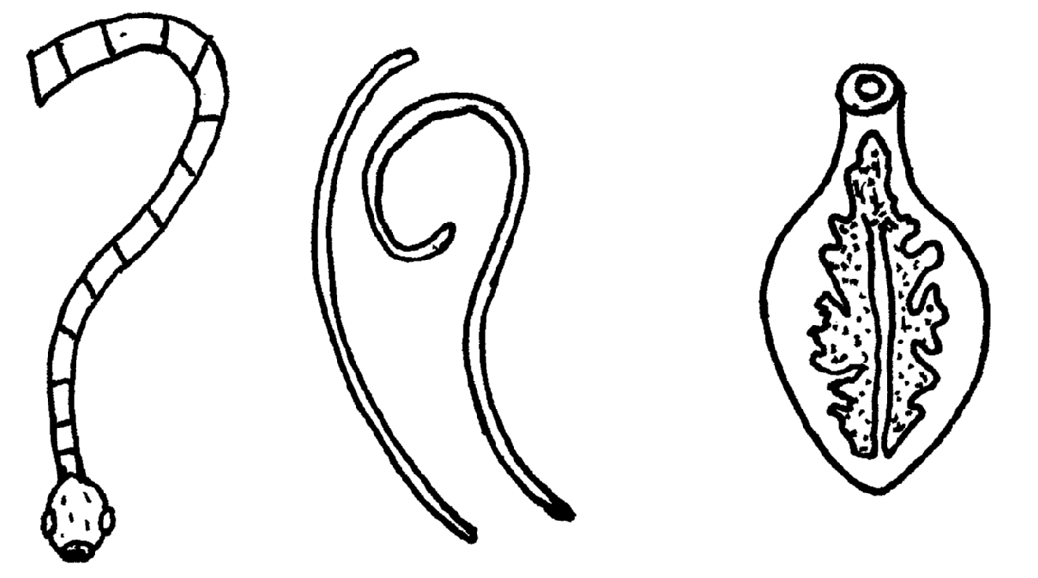

(a) Identify parasites G,H and J (3 mk
G……………………………………….
H……………………………………….
J………………………………………..
(b) Name the parts of the host body where parasites G and J are found (1mk)
……………………………………………………………………………………………………..
(c) Name the intermediate host of parasites G and J (2mk)
G……………………………………………………………………………………………………..
J……………………………………………………………………………………………………..

(d) Outline four symptoms of attack in livestock by parasite J (2mks)
……………………………………………………………………………………………………..
……………………………………………………………………………………………………..
……………………………………………………………………………………………………..
19. The diagram below illustrates a hoof of a sheep. Study it carefully and answer the questions that follow
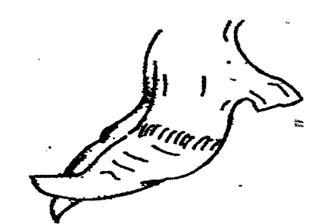

(a) Name the routine management practice that should be carried out on the hoof illustrated above(1mk)
...........................................................................................................................................................
(b) State two reasons for carrying out the management practice in (a) above (2mks)
...........................................................................................................................................................
...........................................................................................................................................................

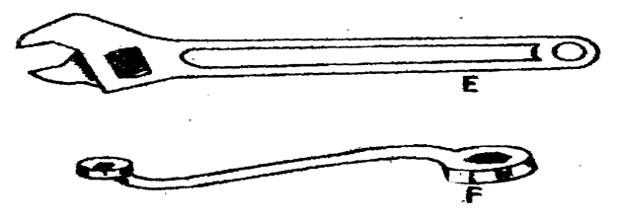
20. Study the diagrams of workshop tools shown below

(a) Identify the tools labeled E and F (2mk)
E........................................................
F.........................................................
(b) What functional advantage does tool E have over tool F? (1mk)
.........................................................................................................................................................
.........................................................................................................................................................
(c) Below is a diagram of a farm structure for storing grains. Study it carefully and answer the question that follows
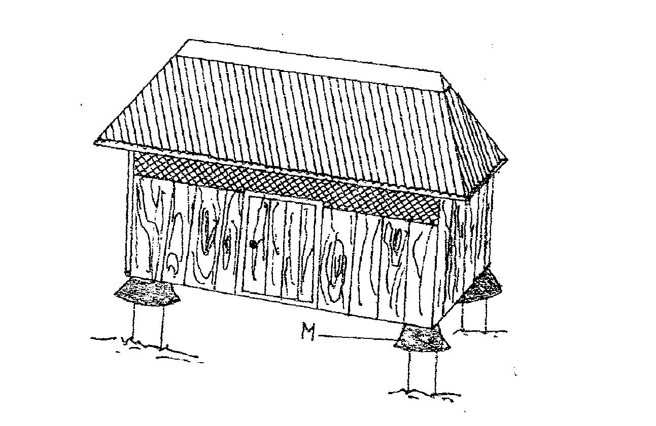
(i) Identify the farm structure illustrated above ( 1mk)
.........................................................................................................................................................
(ii) State the function of the part labeled M ( 1mk)
.......................................................................................................................................................

(iii) State two maintenance practices that should be carried out on the farm structure illustrated above in readiness for grain storage 2mks

21.Give four functions of a worker bee 2mks

Section c (40mks)
Attempt any two questions

22(a) i) Describe seven signs of ill-health in livestock 7mks
……………………………………………………………………………………………………………………………………………………………………………………………………………………………………………………………………………………………………………………………………………………….………………………………………………………………………………………………………………………………………………………………………………………………………………………………………………………………………………………………………………………………………………………………………………………………………………………………………………………………………………………………………………………………………………………………………………………………………………………………………………………………………………………………………………………………………………………………………………………………………………………………………………………………………………………………………………………………………………………………………………………………………………………………………………………………………………………………………………………………………………………………………………………………………………………………………………………………………………………………………………………………………………………………………………………………………………………………………………………………………………………………………………………………………………………………………………………………………………………………………………………………………………………………………………………………………………
(ii) Outline five uses of a crush in livestock rearing5mks
………………………………………………………………………………………………………………………………………………………………………………………………………………………………………………………………………………………………………………………………………………………………………………………………………………………………………………………………………………………………………………………………………………………………………………………………………………………………………………………………………………………………………………………………………………………………………………………………………………………………………………………………………………………………………………………………

(b) (i) Name the causal organism of coccidiosis in poultry. (1mk)
…………………………………………………………………………………………………………………………………………………………………
(ii) Apart from poultry name two other animals affected by the disease above. (2mks)
……………………………………………………………………………………………………………………………………………………………………………………………………………………………………………………………………………………………………………………………………
(iii) Give five symptoms of the disease in poultry. (5mks)
……………………………………………………………………………………………………………………………………………………………………………………………………………………………………………………………………………………………………………………………………………………………………………………………………………………………………………………………………………………………………………………………………………………………………………………………………………………………………………………………………………………………………………………………………………………………………………………………………………………………………………………………………………………………………………………………………………………………………………………………………………………………………………………………………………………………………………………………………………………………………………………………………………………………………………………………………………………………………………………………………………………………………………………………………………………………………………………………………………………………………………………………………………………………………………………………………………………………………………………………………………………………………………………………………………………………………………………………………………………………………………………………

23. (a) Describe the procedure of processing honey wax (8mks
………………………………………………………………………………………………………………………………………………………………………………………………………………………………………………………………………………………………………………………………………………………………………………………………………………………………………………………………………………………………………………………………………………………………………………………………………………………………………………………………………………………………………………………………………………………………………………………………………………………………………………………………………………………………………………………………………………………………………………………………………………………………………………………………………………………………………………………………………………………………………………………………………………………………………………………………………………………………………………………………………………………………………………………………………………………………………………………………………………………………………………………………………………………………………………………………………………………………………………………………………………………………………………………………………………

(b) Outline FOUR harmful effects of lice in livestock ( 4MKS )
………………………………………………………………………………………………………………………………………………………………………………………………………………………………………………………………………………………………………………………………………………………………………………………………………………………………………………………………………………………………………………………………………………………………………………………………………………………………………………

(c) State five advantages of the top bar beehive (5mks)
………………………………………………………………………………………………………………………………………………………………………………………………………………………………………………………………………………………………………………………………………………………………………………………………………………………………………………………………………………………………………………………………………………………………………………………………………………………………………………

d). Give three signs of heat in pigs (3mks)

24. A) Explain six advantages of artificial insemination (A.I) in livestock breeding. (6mks)
………………………………………………………………………………………………………………………………………………………………………………………………………………………………………………………………………………………………………………………………………………………………………………………………………………………………………………………………………………………………………………………………………………………………………………………………………………………………………………………………………………………………………………………………………………………………………………………………………………………………………………………………………………………………………………………………………………………………………………………………………………………………………………………………………………………………………………………………………………………………………………………………………………………………………………………………………………………………

(b) Give 5 categories of farm tools and equipment (5mks)
………………………………………………………………………………………………………………………………………………………………………………………………………………………………………………………………………………………………………………………………………………………………………………………………………………………………………………………………………………………………………………………………………………………………………………………………………………………………………………

c)outline five characteristics corriedale breed of sheep (5mks)
……………………………………………………………………………………………………………………………………………………………………………………………………………………………………………………………………………………………………………………………………………………………………………………………………………………………………………………………………………………………………………………………………………………………………………………………………………………………………………
d)discuss 4 practices carried out on fish before preservations. 4mks
………………………………………………………………………………………………………………………………………………………………………………………………………………………………………………………………………………………………………………………………………………………………………………………………………………………………………………………………………………………………………………………………………………………………………………………………………………………………………………

