Kenya Certificate of Secondary Education 2019
443/ 2 Agriculture Paper 2
END TERM 1 2019 Time 2hours

Name …………………………………………….……… Index Number…………………………..
Candidate’s Signature ………………….…...……….. Date ……………………………………

INSTRUCTIONS TO CANDIDATES
- Write your name and index number in the spaces provided above.

2019
- The paper consists of three sections A, B and C.
- Answer all questions in section A and B in the spaces provided
- Answer any two questions from section C on foolscaps provided
FOR EXAMINER’S USE ONLY
Section | Question | Maximum score | Candidate’s score
A | 1−15 | 30
B | 16 | 20
 | 17
 | 18
c | 25-27 | 40
 | Total | 90

©

Turn over

1. Name three methods of selection in livestock. (1 ½ mks)

…………………………………………………………………………………………
…………………………………………………………………………………………
…………………………………………………………………………………………
2. a) Name the causal organism of fowl typhoid. (1/2 mk)
…………………………………………………………………………………………
b) List three signs on a carcass which shows that an animal died of anthrax. (1 ½ mks)
…………………………………………………………………………………………
…………………………………………………………………………………………
…………………………………………………………………………………………
3. Differentiate between cropping and harvesting in fish farming. (1 mark)
…………………………………………………………………………………………
…………………………………………………………………………………………
…………………………………………………………………………………………
4. Name four methods of dehorning in cattle rearing. (2 marks)
…………………………………………………………………………………………
…………………………………………………………………………………………
…………………………………………………………………………………………
5. State four structural requirements of a calf pen. (2 marks)
…………………………………………………………………………………………
…………………………………………………………………………………………
…………………………………………………………………………………………
6. Give four characteristics of a good site for a bee hive. (2 marks)
…………………………………………………………………………………………
…………………………………………………………………………………………
…………………………………………………………………………………………

7. State two functions of an egg shell. (1 mark)

…………………………………………………………………………………………
…………………………………………………………………………………………
8. State four factors that can affect maintenance requirement of an animal. (2 marks)
…………………………………………………………………………………………
…………………………………………………………………………………………
…………………………………………………………………………………………
9. Name four parts of a roof on a farm building. (2 marks)
…………………………………………………………………………………………
…………………………………………………………………………………………
…………………………………………………………………………………………
10. State four disadvantages of nomadic pastoralism system of rearing livestock. (2 marks)
…………………………………………………………………………………………
…………………………………………………………………………………………
…………………………………………………………………………………………
11. State four signs of heat in cows. (2 marks)
…………………………………………………………………………………………
…………………………………………………………………………………………
…………………………………………………………………………………………
12. Name two methods of acaricide application onto cattle. (1 mark)
…………………………………………………………………………………………
…………………………………………………………………………………………
…………………………………………………………………………………………

13. Distinguish between inbreeding and line breeding as used in livestock production. (1 mark)
…………………………………………………………………………………………
…………………………………………………………………………………………
…………………………………………………………………………………………
14. State four maintenance requirements of a jack plane. (2 marks)
…………………………………………………………………………………………
…………………………………………………………………………………………
…………………………………………………………………………………………
15. State four practices that a farmer should carry out to reduce egg eating in poultry. (2 marks)
…………………………………………………………………………………………
…………………………………………………………………………………………
…………………………………………………………………………………………
16. a) Give two features of a good laying nets. (1 mark)

…………………………………………………………………………………………
…………………………………………………………………………………………
b) Give three reasons why a young calf must be fed on colostrums during the first few days of birth. (1 ½ mk)
…………………………………………………………………………………………
…………………………………………………………………………………………
…………………………………………………………………………………………
17. State two reasons why calcium and phosphorus are important in the diet of young livestock. (1 mark)
…………………………………………………………………………………………
…………………………………………………………………………………………
18. Name two kinds of livestock which can be castrated using a rubber ring. (1 mark)
…………………………………………………………………………………………
…………………………………………………………………………………………
…………………………………………………………………………………………

SECTION B (20 marks)
Answer all the questions in this section in the spaces provided.
19 A dairyfarmer is required to prepare 100 kg of dairy meal containing 20% Digestible Crude
Protein (D.C.P.). Using the Pearson's Square Method, calculate the quantity of soya bean (40% D.C.P.) and rice (16% D.C.P.) the farmer requires for the dairy meal. (4 marks)

20 Below is an illustration of a camel. Study it and answer the questions that follow.
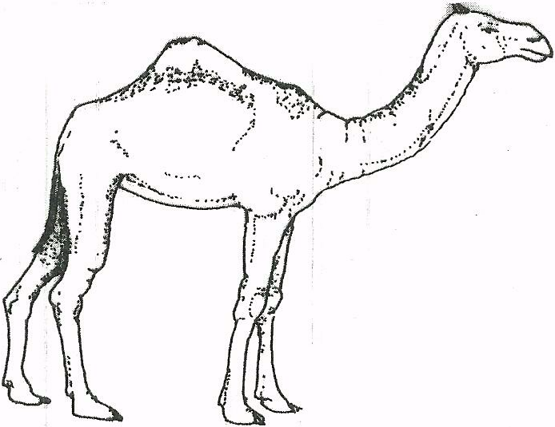

(a) Identify the'camel species illustrated above.

………………………………………………………………………………………………………

(b) Name three products that farmers obtain from the camel species illustrated above. (1 marks)

……………………………………………………………………………………………………………………………………………………………………………………………………………………………………………………………………………………………………………………………..........…………

(c) Give two reasons why the camel species illustrated above is able to survive in itsnatural habitat. (2 marks)

………………………………………………………………………………………………………………………………………………………………………………………………………………………………………………………..........………………………………………………………………………………
.....................................................................................................................................................................
21 The diagram below represents farm tools and equipment. Study them and answer the questions that follow.

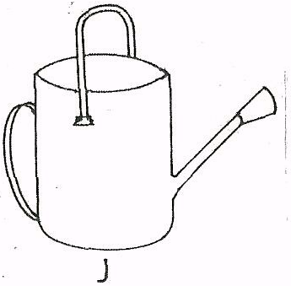
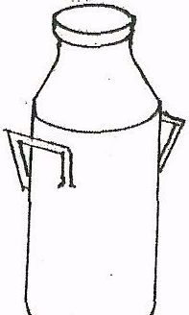

K

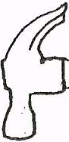
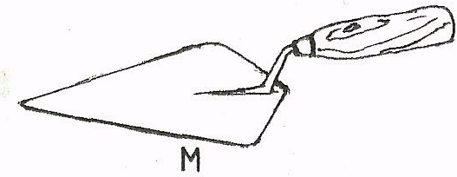
J
L

(a) Identify the tool equipment labelled J, K and M.

J………………………………………………………………………..........…………
K……………………………………………………………………..........…………
L……………………………………………………………………..........…………
(b) State one use for each of the tool / equipment labelled K and L.
……………………………………………………………………..........…………
(c) Give two maintenance practices for the equipment labelled K. (1 mark)

………………………………………………………………………………………………………………………………………………………………………………………………………………………………………………………..........………………………………………………………………………
.....................................................................................................................................................................

22 The illustration below shows a practice carried out to prevent mastitis infection in a dairy cow.

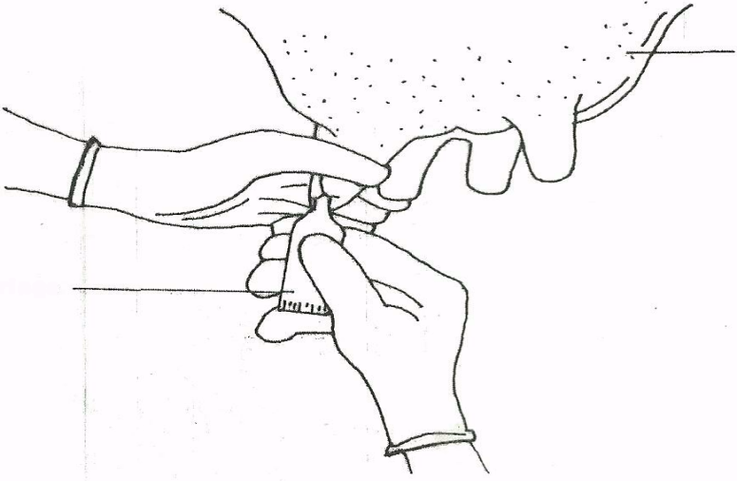

(a) Identify the practice. (1 mark)
…………………………………………………………………………………………………………………………………………..........…………………………………………………………………………
(b) At what stage is the practice carried out? (1 mark)
…………………………………………………………………………………………………………………………………………..........…………………………………………………………………………
(c) State two other practices that are carried out on the udder to prevent mastitis infection.
(2 marks)

…………………………………………………………………………………………………………………………………………..........…………………………………………………………………………

23 The diagram below shows the digestive system of cattle. Study it and answer the questions that follow.

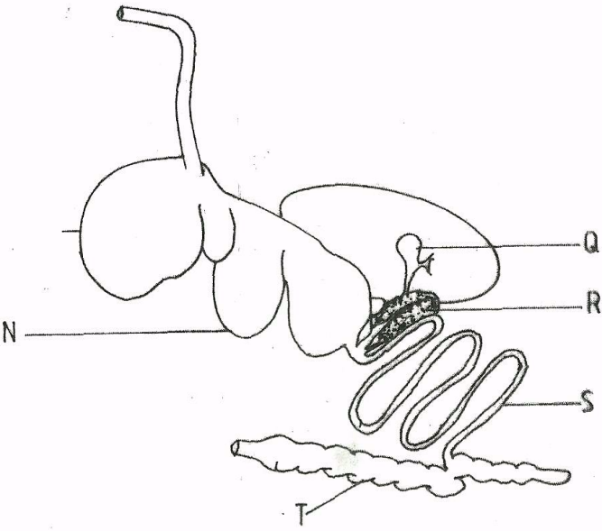

(a) Name the parts labelled N, I and Q. (3 marks)
N.............................................................................................................................
I.............................................................................................................................
Q.........................................................................................................................

(b) State one function for each of the parts labelled S and T. : (1 mark)
…………………………………………………………………………………………………………………………………………..........…………………………………………………………………………
(c) Give one enzyme produced by each of the parts labelled R and S. (1 mark)

…………………………………………………………………………………………………………………………………………..........…………………………………………………………………………
…………………………………………………………………………………………………………………………………………..........…………………………………………………………………………
SECTION C (40 MARKS)
Answer only two questions from this section in the spaces provided
24.. a) Describe the features of ideal calf pen. (10marks)
b) Distinguish between cropping and harvesting as used in fish farming (2marks)
c) Describe the maintenance practices on a fish pond or describe management practices that would ensure maximum fish harvest from a fish pond. (8marks)
- a) Discuss coccidiosis disease under the following headings
- Causal organism (1mark)
- Livestock species attacked (4marks)
- Symptoms of attack (4marks)
- Control measures. (3marks)
b) Describe the procedure of obtaining clean milk from a cow (10marks)
26.a)
i) Describe the life cycle of a two host tick (6marks)
- Describe digestion in a rumen of ruminant (8marks)
- Explain three methods of acaricide application (6marks)

