Name: …………………………………………………………Index No: ……………………..……………
Candidate’s Signature:……………………………….
Date: ……………….……………….…

443/2
AGRICULTURE
PAPER 2
JULY/AUGUST 2014
TIME: 2 HOURS

Kenya Certificate of Secondary Education (K.C.S.E)

443/2
Agriculture
Paper 2
2 hours

INSTRUCTIONS TO CANDIDATES:
- Write your name and index number in the spaces provided.
- Sign and write the date of examination in the spaces provided
- This paper consists of three section A,B and C
- Answer all questions in section A and B
- Answer any two questions in section C
- All the questions should answered in the spaces provided

FOR EXAMINERS USE ONLY

SECTION | QUESTIONS | MAX SCORE | CANDIDATES SCORE
A | 1-17 | 30
B | 18-21 | 20
C  TOTAL | 22-24 | 20
 |  | 20
 |  | 90

This paper consists of 8 printed pages. Candidates should check to ascertain that all pages are printed as indicated and that no questions are missing.

SECTION A (30 MARKS)
Answer all questions from this section in the spaces provided.
- Mention two examples of meat goats in Kenya (1mk)
…………………………………………………..………………………………………………………
…………………………………………………..………………………………………………………
- Give the functions of the following parts in the male reproductive system of a goat
- Testes (1mk)
…………………………………………………..………………………………………………………
- Urethra (1mk)
…………………………………………………..………………………………………………………
- State three factors that affect digestibility of a feed in dairy animals (1 ½ mks)
…………………………………………………..………………………………………………………
…………………………………………………..………………………………………………………
…………………………………………………..………………………………………………………
- State three factors to consider when selecting eggs for sale (1 ½ mks)
…………………………………………………..………………………………………………………
…………………………………………………..………………………………………………………
…………………………………………………..………………………………………………………
- Give two uses of a gear box in a tractor (2mks)
…………………………………………………..………………………………………………………
…………………………………………………..………………………………………………………
- Differentiate between outcrossing and cross breeding as used in livestock production (2mks)
…………………………………………………..………………………………………………………
…………………………………………………..………………………………………………………
…………………………………………………..………………………………………………………
- State three reasons for weighing livestock at weaning stage (1 ½ mks)
…………………………………………………..………………………………………………………
…………………………………………………..………………………………………………………
…………………………………………………..………………………………………………………
- State four functions of vitamins (2mks)
…………………………………………………..………………………………………………………
…………………………………………………..………………………………………………………
…………………………………………………..………………………………………………………
…………………………………………………..………………………………………………………

- State two advantages of using wood as a construction material (2mks)
…………………………………………………..………………………………………………………
…………………………………………………..………………………………………………………
…………………………………………………..………………………………………………………
- Mention four safety precautionary measures when using electric power in the farm (2mks)
…………………………………………………..………………………………………………………
…………………………………………………..………………………………………………………
…………………………………………………..………………………………………………………
- Name two tractor drawn implements that are attached to the draw bar (1mk)
…………………………………………………..………………………………………………………
…………………………………………………..………………………………………………………
- Give two uses of footbath in a plunge dip (2mks)
…………………………………………………..………………………………………………………
…………………………………………………..………………………………………………………
- State two possible channels through which Kenya farmers can market their livestock (2mks)
…………………………………………………..………………………………………………………
…………………………………………………..………………………………………………………
- State two disadvantages of using hurricane lamps and lanterns as providers of heat in a brooder (2mks)
…………………………………………………..………………………………………………………
…………………………………………………..………………………………………………………
- Give four ways of stimulating milk let down in a dairy cow (2mks)
…………………………………………………..………………………………………………………
…………………………………………………..………………………………………………………
…………………………………………………..………………………………………………………
…………………………………………………..………………………………………………………
- State two functions of addictives in silage making (2mks)
…………………………………………………..………………………………………………………
…………………………………………………..………………………………………………………
- State the uses of the following tools and equipments (1 ½ mks)
- Chipping harmer
…………………………………………………..………………………………………………………
- Tinsnip
…………………………………………………..………………………………………………………
- Router
…………………………………………………..………………………………………………………
SECTION B (20 MARKS)
Answer all the questions in this section in the spaces provided
- (a) Identify each of the parasites of livestock shown below, (2mks)
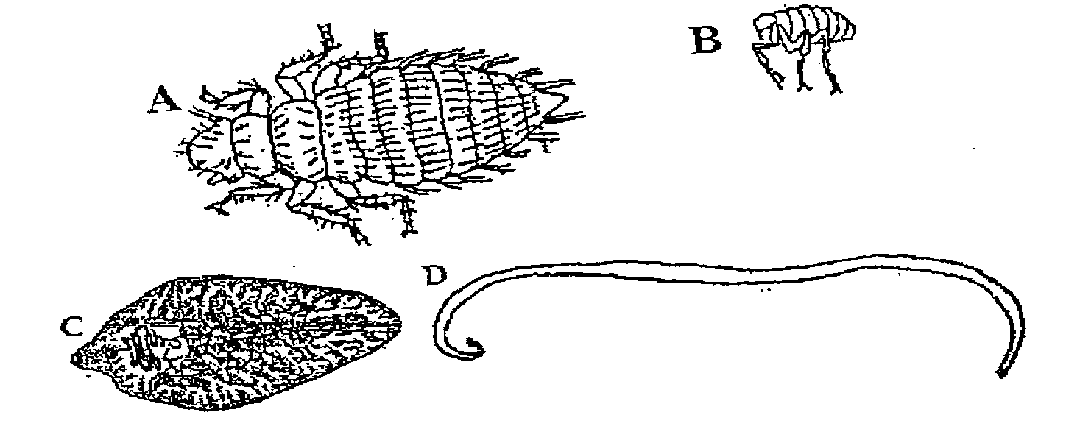

(b) What is the difference between parasites A and B and parasites C and D? (lmk)
A……………………………………………..
B……………………………………………..
C……………………………………………..
D……………………………………………..
(c) Suggest an effective control measure of the parasite labeled C (1 mk)
…………………………………………………..………………………………………………………
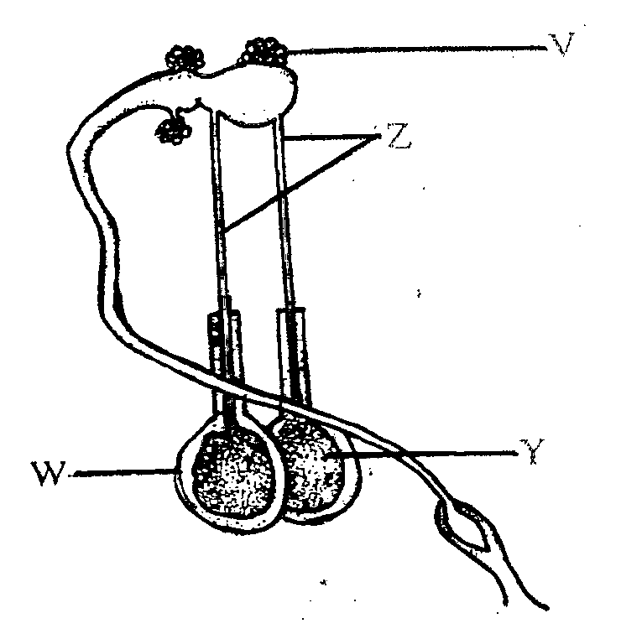
- The diagram below shows the male reproductive organ in cattle. Study it and answer the questions that follow

- Name the parts labeled Z and W (2mks)
Z ………………………………………………………………………………
W ………………………………………………………………………………
(b) State two functions of the part labeled Y (2mks)
…………………………………………………..………………………………………………………
…………………………………………………..………………………………………………………

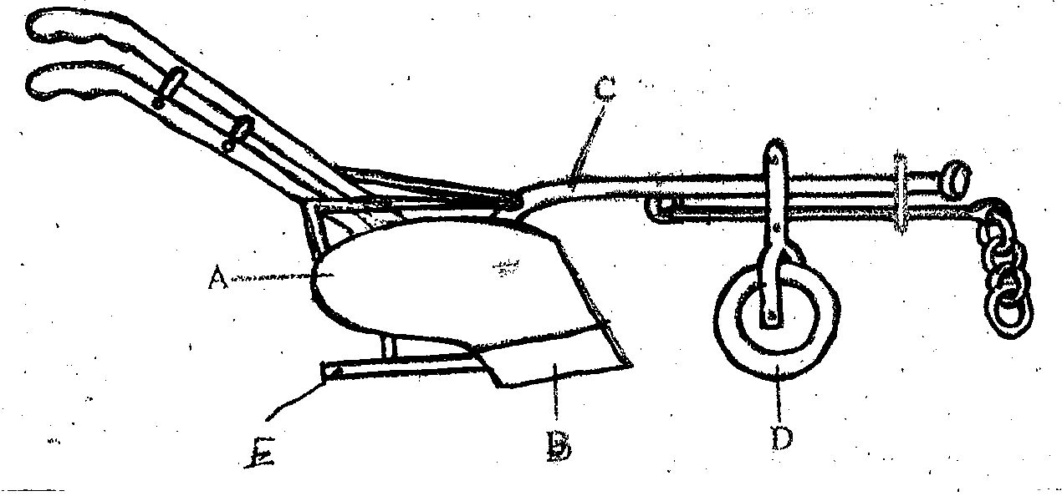
- Below is a diagram of a farm implement

A

E
B
D
- Identify the implement ( ½ mk)
…………………………………………………………………………………………
- Label the parts marked A,B,C,D and E (2 ½ mks)
A……………………………………………………
B……………………………………………………
C……………………………………………………
D……………………………………………………
E ……………………………………………………
- State the functions of the parts labeled C and E (2mks)
……………………………………………………………………………………………………………………………………………………………………………………………………………………
- A farmer wants to prepare a ration for layers containing 18% DCP using maize germ 20% DCP and wheat bran 10% DCP.
- Calculate using pearson’s square method the amount of each feed-stuff needed in order to prepare 100kg of feed (5mks)

- Name one other method the farmer can use to compute the ratio (1mk)
…………………………………………………………………………………………………………
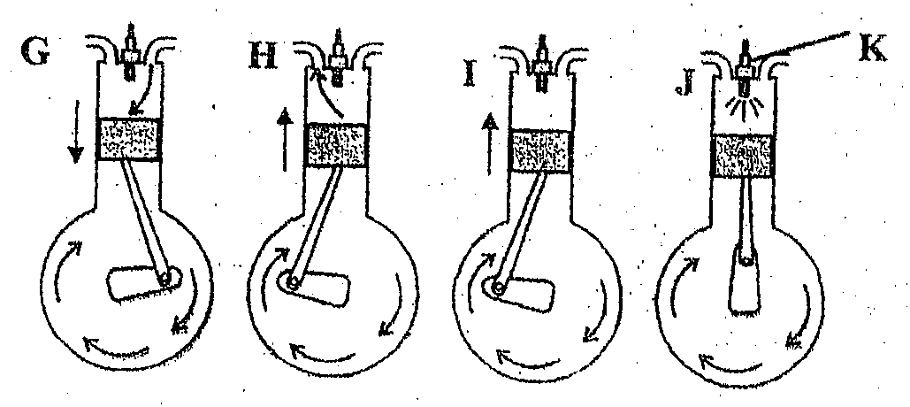
- The diagrams below illustrate a four stroke cycle engine system. Study it and answer the questions that follow

- State the four stages of the four stroke cycle engine G,H,I and J (2mks)
G……………………………………………………………………………………..
H……………………………………………………………………………………..
I………………………………………………………………………………………
J………………………………………………………………………………………
- Mention two disadvantages of a four stroke engine (2mks)
……………………………………………………………………………………………………………………………………………………………………………………………………………………
- What is the function of part K (1mk)
…………………………………………………………………………………………………………
SECTION C
Answer any two questions from this section in the spaces provided.
- (a) Discuss the importance of keeping livestock healthy (8mks)
(b) State the daily maintenance and servicing of a tractor (10mks)
(c) Explain two maintenance practices carried out in a fish pond (2mks)

- (a) Describe the structural requirements to be considered when constructing a calf pen (10mks)
- Describe mastitis disease in dairy cattle under the following subheadings;
- Two causal organisms (2mks)
- Predisposing factors (8mks)
- (a) Explain the factors to consider while siting farm structures (10mks)
- Describe the process of training a calf to drink milk from a bucket (5mks)
- Discuss the reasons that would make a farmer prefer a disc plough over a mouldboard
plough (5mks)
……………………………………………………………………………………………………………………………………………………………………………………………………………………
……………………………………………………………………………………………………………………………………………………………………………………………………………………
……………………………………………………………………………………………………………………………………………………………………………………………………………………
……………………………………………………………………………………………………………………………………………………………………………………………………………………
……………………………………………………………………………………………………………………………………………………………………………………………………………………
……………………………………………………………………………………………………………………………………………………………………………………………………………………
……………………………………………………………………………………………………………………………………………………………………………………………………………………
……………………………………………………………………………………………………………………………………………………………………………………………………………………
……………………………………………………………………………………………………………………………………………………………………………………………………………………
……………………………………………………………………………………………………………………………………………………………………………………………………………………
……………………………………………………………………………………………………………………………………………………………………………………………………………………
……………………………………………………………………………………………………………………………………………………………………………………………………………………
……………………………………………………………………………………………………………………………………………………………………………………………………………………
……………………………………………………………………………………………………………………………………………………………………………………………………………………
……………………………………………………………………………………………………………………………………………………………………………………………………………………
……………………………………………………………………………………………………………………………………………………………………………………………………………………
……………………………………………………………………………………………………………………………………………………………………………………………………………………
……………………………………………………………………………………………………………………………………………………………………………………………………………………
……………………………………………………………………………………………………………………………………………………………………………………………………………………
……………………………………………………………………………………………………………………………………………………………………………………………………………………
……………………………………………………………………………………………………………………………………………………………………………………………………………………
……………………………………………………………………………………………………………………………………………………………………………………………………………………
……………………………………………………………………………………………………………………………………………………………………………………………………………………
……………………………………………………………………………………………………………………………………………………………………………………………………………………
……………………………………………………………………………………………………………………………………………………………………………………………………………………
……………………………………………………………………………………………………………………………………………………………………………………………………………………
……………………………………………………………………………………………………………………………………………………………………………………………………………………
……………………………………………………………………………………………………………………………………………………………………………………………………………………
……………………………………………………………………………………………………………………………………………………………………………………………………………………
……………………………………………………………………………………………………………………………………………………………………………………………………………………
……………………………………………………………………………………………………………………………………………………………………………………………………………………
……………………………………………………………………………………………………………………………………………………………………………………………………………………
……………………………………………………………………………………………………………………………………………………………………………………………………………………
……………………………………………………………………………………………………………………………………………………………………………………………………………………
……………………………………………………………………………………………………………………………………………………………………………………………………………………
……………………………………………………………………………………………………………………………………………………………………………………………………………………
……………………………………………………………………………………………………………………………………………………………………………………………………………………
……………………………………………………………………………………………………………………………………………………………………………………………………………………
……………………………………………………………………………………………………………………………………………………………………………………………………………………
……………………………………………………………………………………………………………………………………………………………………………………………………………………

