GATITU MIXED SECONDARY SCHOOL
FORM 2 JUNE MIDTERM EXAM 2014
PHYSICS
INSTRUCTIONS
Answer all questions provided.
- State the basic law of magnetism 1mk
- The figure below shows two magnets subjected to a soft iron ring;

S
N

Draw the resultant magnetic fields (2mks)

- a)Name the figures below( 1mk)
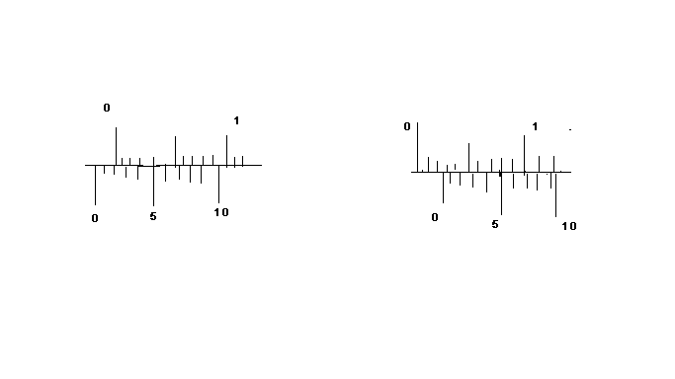

b) The figure I is used to measure the diameter of a cylindrical object of height 10cm and recorded 3.05cm while the figure ii is used to measure the diameter of a sphere object and recorded 3.25cm. Calculate the correct volumes of this objects in m³(Take π=3.142) 4mks

4. Write down each one of the following in standard form
a) 1000kg

b) 0.00078kg

c) 320694

d)63

5. (a) Define the following terms;
i) Moment of force

II) Principle of moments

b) The hammer below is applied a force of 320N on the handle. Assuming the force applied to the nail is vertical, how large is the force applied to the nail? Take the lengths x=0.8cm and y=10cm (3mks)
320N F Hammer
Nail

y x

6. Explain the states of equilibrium, diagrams for explanations (6mks)

7. (i) state the principle of reversibility of light (1mk)

(ii) The figure below shows a ray of light striking a concave mirror from object o;
Concave mirror

C O F

Complete the diagram to show the reflection (4mks)

