NAME _______________________________________ ADM NO__________CLASS__________

MWAKICAN JOINT EXAMINATION (MJET)
AGRICULTURE FORM 1
END OF TERM 1 2014.

Answer all the questions in the spaces provided.

SECTION A (75 MARKS)
- Define the term agriculture correctly.( 1 mk)

- Give four practices that show that agriculture is an art.( 4 mks)

- State four area of study that shows that agriculture is a science.( 4 mks)

- State two ways in which agriculture contributes to development of industries in Kenya.(2 mks)

- State three ways by which agriculture contributes to national development. (3 mks)

- List five branches of agriculture. (5 mks)

- State four factors considered when identifying a farming system in an area.( 4mks)

- State four characteristics of large scale farming system.( 4mks)

- State two reasons which make small scale farming common to majority of he farmers in Kenya.( 2 mks)

- Define the term pomology as used in crop production (1 mk)

- State two reasons why nomads move with their livestock from place to place.( 2mks)

- State four climatic factors that influence agricultural production in Kenya.( 4mks)

- What is agroforestry.( 1mk)

- State four problems associated with shifting cultivation.( 4mks)

- State two effects of HIV/AIDs) in agriculture.(2 mks)

- State three ways how agriculture as an occupation provide employment.( 3mks)

- State four aspects of rainfall important to a farmer ( 4mks)

- State five biotic Factors that affect agricultural production.( 5mks)

- State four advantages of mixed farming.( 4mks)

- a) Give three effects of low temperature in crop production.( 3mks)

b) State four harmful effects of wind in crop production. (3 mks)

- Name two categories of crops on the basis of photosynthetic light requirement.( 2mks)

SECTION B( 25 MKS)
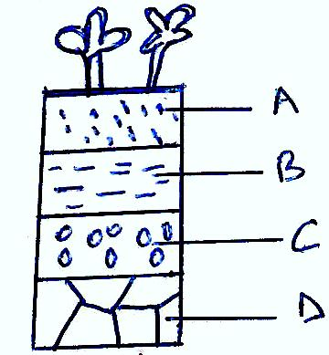
- Below is a diagram illustrating a soil profile study it carefully and answer the questions that follow.

- Name parts labeled A,B,C and D above( 4mks)
A____________
B___________
C_________
D____________

- State three properties of the part labeled A above.( 3mks)

- State four factors that influence soil formation ( 4mks)

23. The diagram below shows an experiment set up using different soil type A,B and C.
The observation was made after 24 hours.

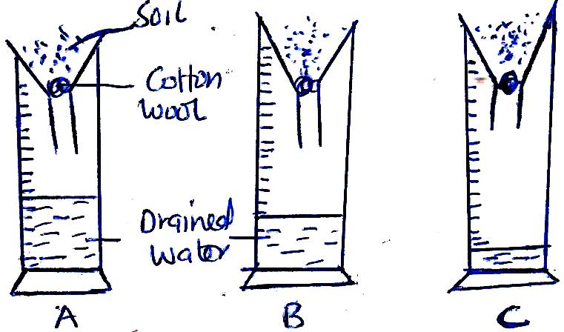

- State what the experiment was designed to study.( 1mk)

- Name the soil type labeled A,B,C ( 3mks)
A________
B________
C_______
- State three ways in which soil structure influences crop production.( 3mks)

- Distinguish between soil structure and soil texture. ( 2mks)

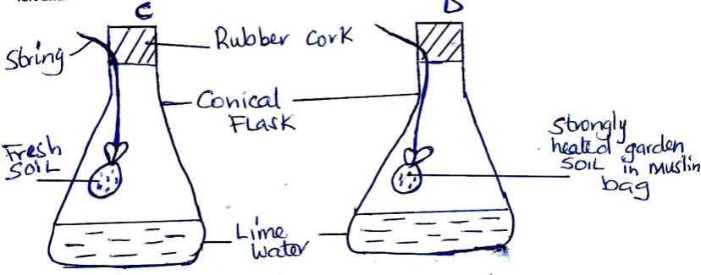
24. The diagrams below show a set up of an experiment to study an aspect of soil. The set up was 6

- What was the aim of the experiment (1mk)

- State one observation that was made in each of the flasks labeled C and D
C_____________________( 1mk).

D_____________________(1 m k)

- Give a reason for each of your answers in(b) above (1 mk)
C________________(1 mk)
D_______________(1 mk)

