CHEMISTRY
THEORY
PAPER 1
FORM III END OF TERM 1 2014
Name: ………………………………..class: ………..Adm no: …………….school:……………………….
- Name another gas which is used with oxygen in welding [1 Mk]

- a. write the electronic configuration of calcium (atomic number 20) and magnesium (atomic number 12)
Calcium…………………………………………………………………………………………………………………….. [½ Mk]

Magnesium……………………………………………………………………………………………………………….. [½ Mk]

b. Why is calcium more reactive than magnesium? [2 Mks]
……………………………………………………………………………………………………………………..……………………………………………………………………………………………………………………..……………………………………………………………………………………………………………………..……………………………………………………………………………………………………………………..……………………………………………………………………………………………………………………..……………………………………………………………………………………………………………………..…………………………………………………………………
- The table below shows the relative atomic masses and the percentage abundance of the isotopes T₁ and T₂ of element T
 | RAM | % abundance
T₁ | 62.93 | 69.09
T₂ | 64.93 | 30.91

Calculate the relative atomic mass of element T [3 mks]
……………………………………………………………………………………………………………………..……………………………………………………………………………………………………………………..……………………………………………………………………………………………………………………..……………………………………………………………………………………………………………………..……………………………………………………………………………………………………………………..……………………………………………………………………………………………………………………..…………………………………………………………………

- The diagram below is a set-up for the laboratory preparation of oxygen gas.
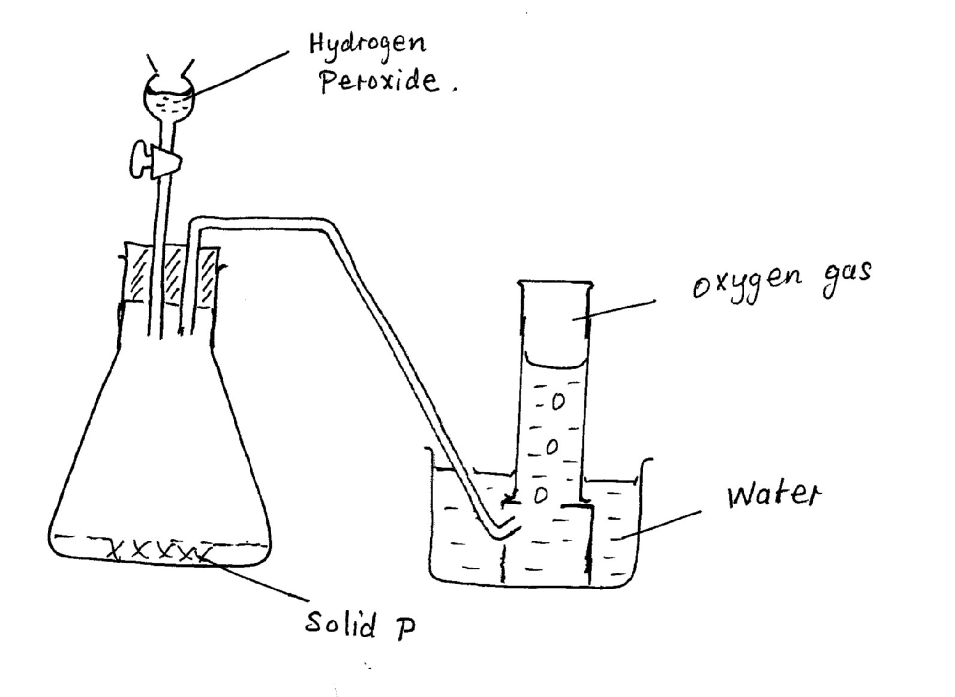
  - Name solid P. ………………………………………………………………………………………..…………………………………[1 mk]
  - Write an equation for the reaction that takes place in the conical flask
………………………………………………………………………………………..…………………………………[1 mk]

  - Give two commercial uses of oxygen [2 mks]

    - ………………………………………………………………………………………..……………………………………….

    - ………………………………………………………………………………………..………………………………………
- State two reasons why hydrogen is not commonly used as a fuel [2 mks]
    - ………………………………………………………………………………………..………………………………………

    - ………………………………………………………………………………………..………………………………………

- The figure shows a set-up by a form three student to prepare a certain gas
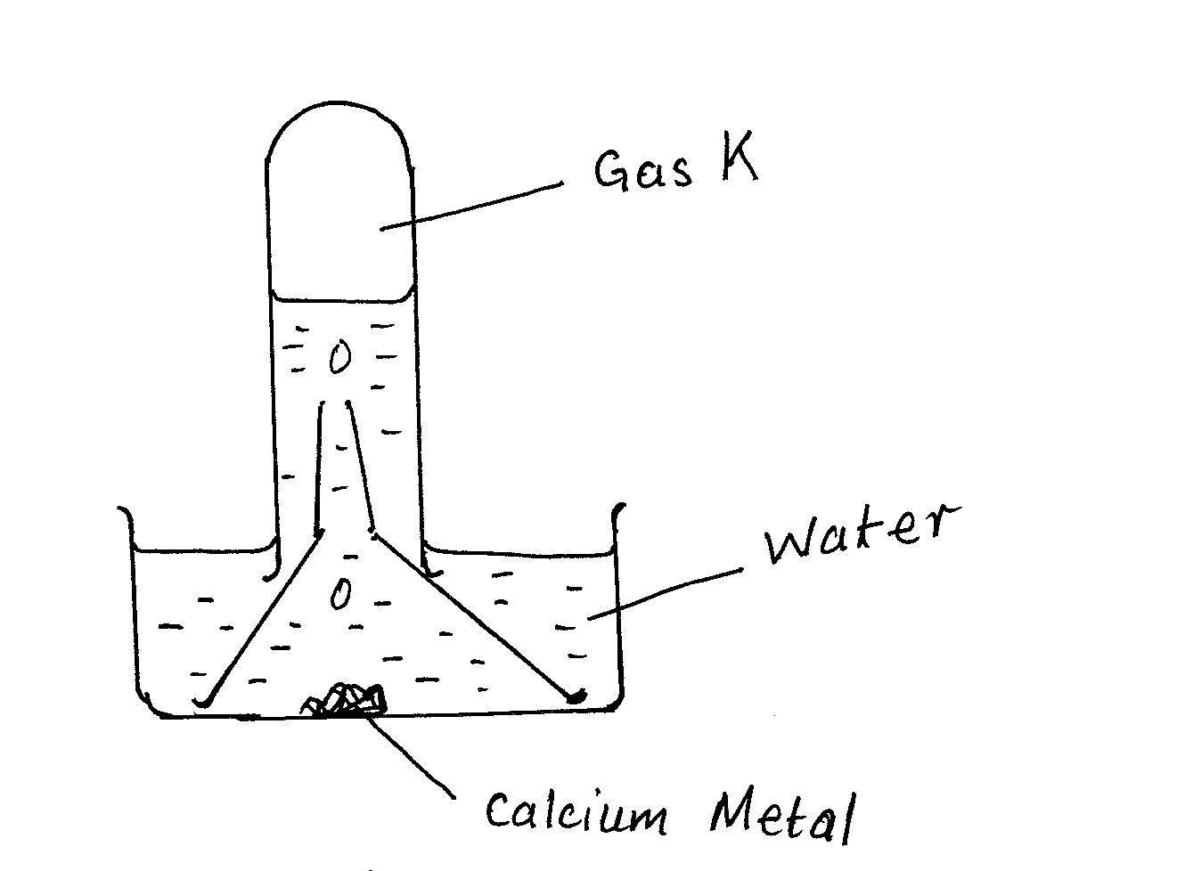

  - Write an equation for the formation of gas K [1 mk]

………………………………………………………………………………………..………………………………………

  - Give one use of gas K in the industries [1 mk]

………………………………………………………………………………………..………………………………………
  - Give one use of the resulting solution after the metal has reacted [1 mk]

………………………………………………………………………………………..………………………………………
- Draw a dot and cross diagram showing the bonding in a molecule of calcium oxide. Name the type of bond. [3 mks]

- When 0.288g of an oxide of metal M was reduced using suitable reducing agent, 0.256 of pure metal was formed. Determine the empirical formula of the oxide of the metal M. [M=64 O=16]
[4 mks]
……………………………………………………………………………………………………………………..……………………………………………………………………………………………………………………..…………………………………………………………………………
- X+ is an ion with electronic configuration 2,8,8. Identify element X [1 mk] ……………………………………………………………………………………………………………………..………………………………

- 20g of solid sodium hydroxide were dissolved in distilled water and made to 400cm³. 30 cm³ of this solution required 27 cm³ of dilute sulphuric (iv) acid for complete reaction. [Na=23 O=16 H=1]

Determine
    - Moles of sodium hydroxide contained in 30 cm³ of solution [2 mks]
……………………………………………………………………………………………………………………..……………………………………………………………………………………………………………………..………………………………………………………………………………………………………………………………………………………………………………………………..……………………
    - Moles of sulphuric (iv) acid that reacted [2 mks]
……………………………………………………………………………………………………………………..……………………………………………………………………………………………………………………..………………………………………………………………………………………………………………………………………………………………………………………………..…………………………………..
……………………………………………………………………………………………………………………..……………………………………Concentration of the sulphuric (iv) acid in moles per litre [2 mks]
……………………………………………………………………………………………………………………..……………………………………………………………………………………………………………………..………………………………………………………………………………………………………………………………………………………………………………………………..…………………………………..
- The diagram shows the structures of two allotropes of carbon. Study them and answer the questions that follow.
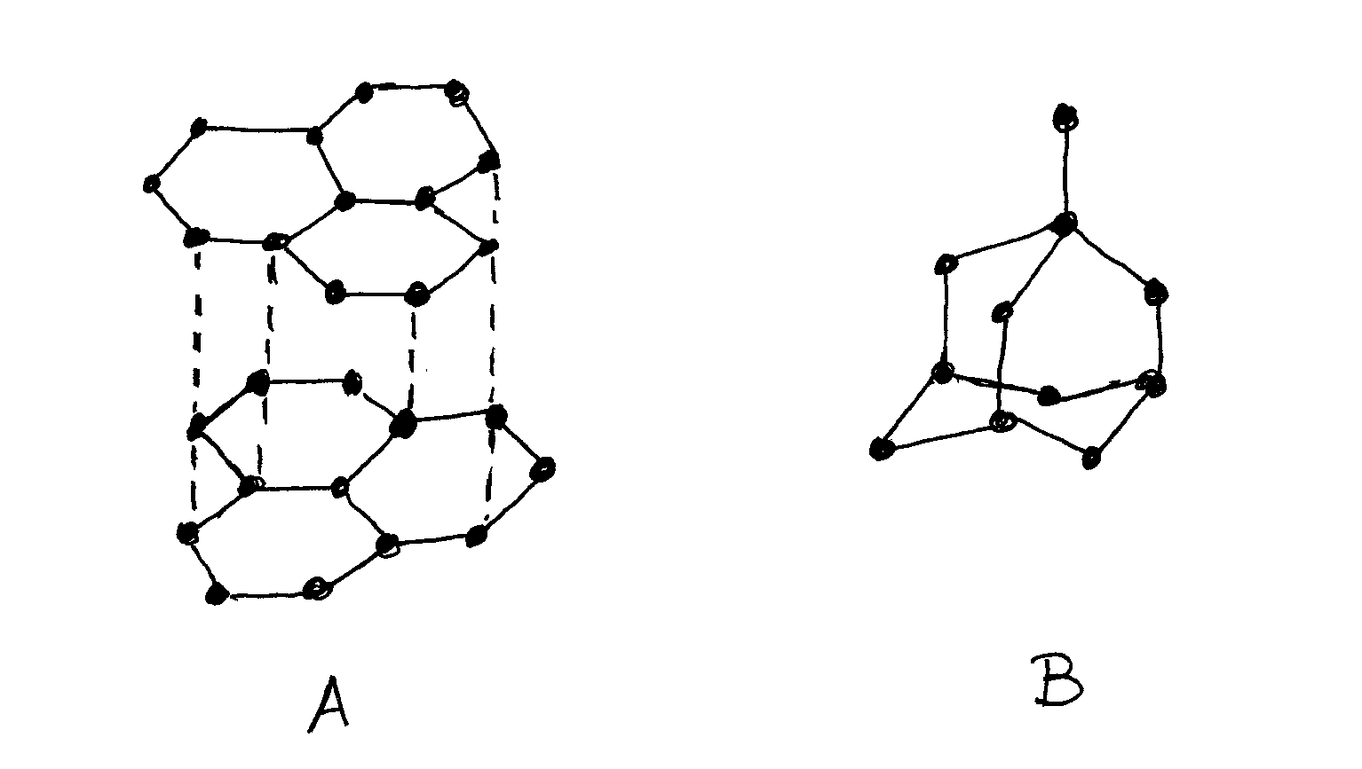

  - Name allotrope A and B [2 mks]
A…………………………………………………………………………………..

B……………………………………………………………………………………

  - Give two uses of allotrope B [2 mks]
    - ……………………………………………………………………………
    - ……………………………………………………………………………
  - Which allotrope conducts electricity? Explain. [2 mks]
……………………………………………………………………………………………………………………..…………………………………..
……………………………………………………………………………………………………………………..……………………………………………………………………………………………………………………..………………………………………………………………………………………………………………………………………………………………………………………………..……………………………………

- An oxide of element F has the formulaF₂O₅
  - Determine the oxidation state of F. [1 mk]
……………………………………………………………………………………………………………………………………….
  - In which group of the periodic table is element F? [1 mk]
……………………………………………………………………………………………………………………………………….

- Explain how you would obtain solid sodium carbonate from a mixture of lead II carbonate and sodium carbonate. [3 mks]
……………………………………………………………………………………………………………………..…………………………………..
……………………………………………………………………………………………………………………..……………………………………………………………………………………………………………………..………………………………………………………………………………………………………………………………………………………………………………………………..……………………………………
- Give two properties of aluminum that makes it very suitable for making cooking utensils [2 mks]

    - ……………………………………………………………………………………………………………………..………………………

    - ……………………………………………………………………………………………………………………..………………………

- Write down an ionic equation for the reaction between dilute hydrochloric acid and calcium carbonate [3 mks]
……………………………………………………………………………………………………………………..…………………………………..
……………………………………………………………………………………………………………………..……………………………………………………………………………………………………………………..………………………………………………………………………………………………………………………………………………………………………………………………..……………………………………
……………………………………………………………………………………………………………………..…………………………………..
……………………………………………………………………………………………………………………..……………………………………………………………………………………………………………………..…………………………………………………………………………
- The diagram shows electric current passing through dilute sulphuric (iv)acid
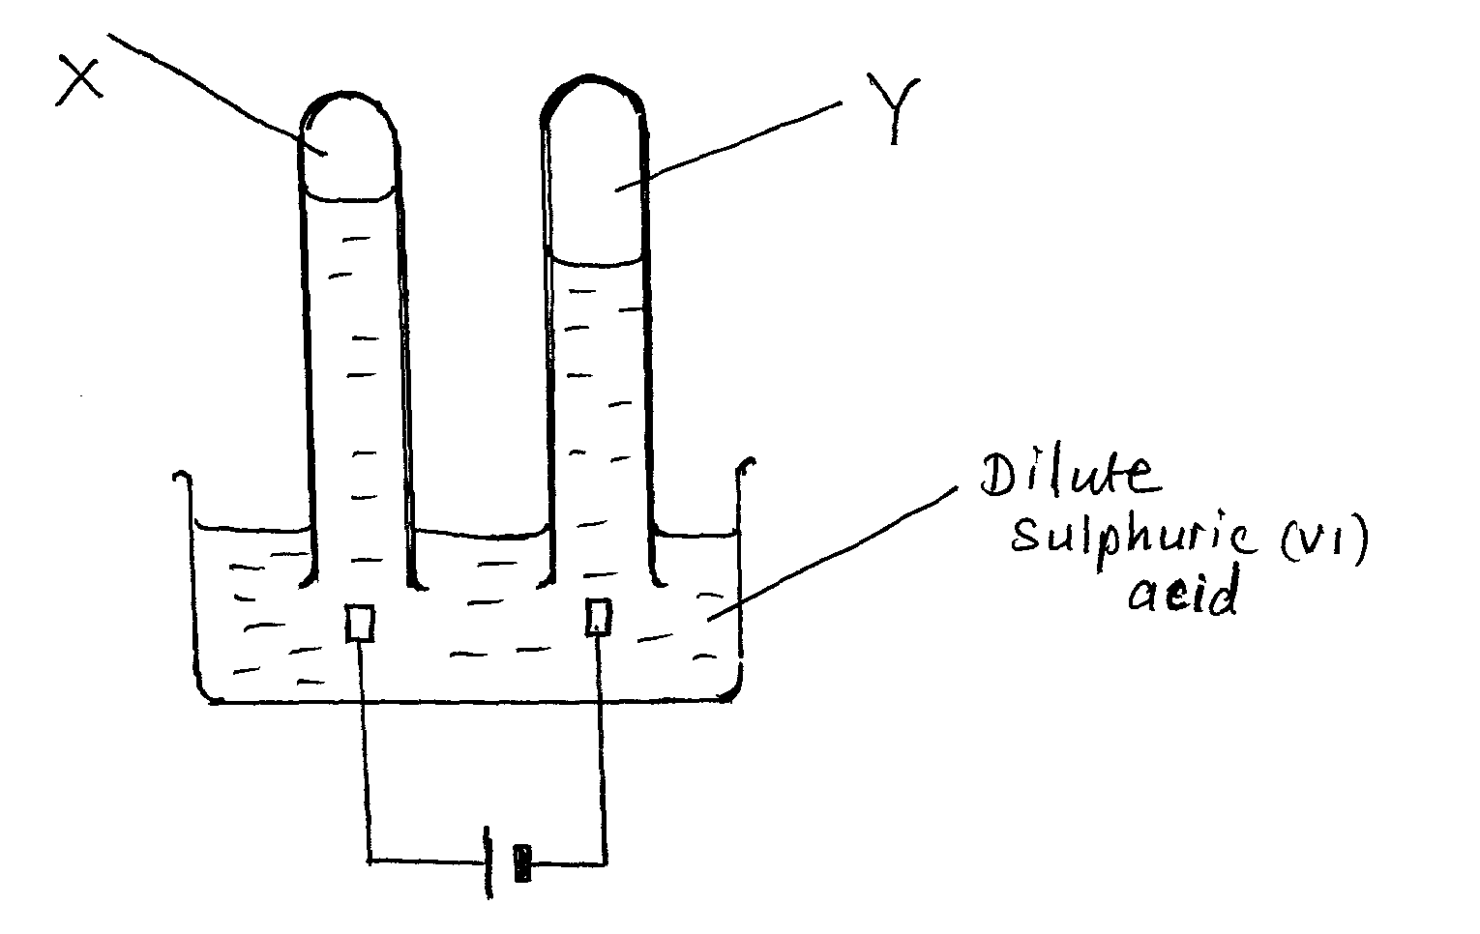
  - On the diagram identify the cathode and the anode [2 mks]

  - Identify substances X and Y [2 mks]
X ……………………………………………………………………………………………………………………[1 mk]

Y …………………………………………………………………………………………………………………….[1 mk]
- State and explain the change in mass that occur when following substances are separately heated in open crucibles [4 mks]
  - Copper metal……………………………………………………………………………………..………………………………………..
……………………………………………………………………………………………………………………..……………………………………………………………………………………………………………………..…………………………………………………………………………
  - Copper II nitrate……………………………………………………………………………..………………………………………..
……………………………………………………………………………………………………………………..……………………………………………………………………………………………………………………..………………………………………………………………………………………………………………………………………………………………………………………………..…………………………………..

- The diagram below represents a paper chromatograph for three brands of juices suspected to contain banned food colourings

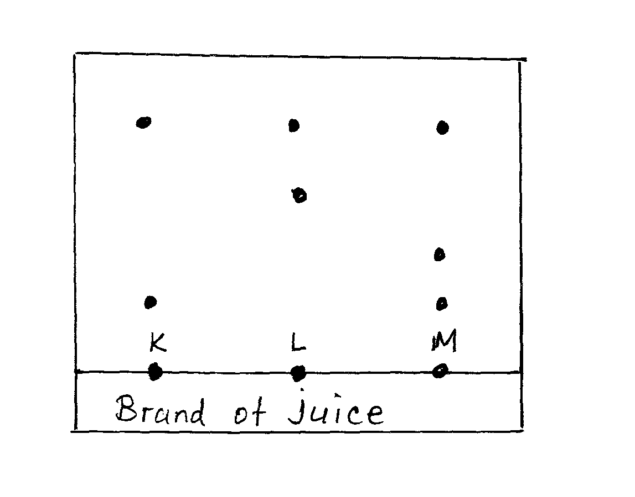

The result showed presence of banned food colourings in L and M only
  - On the diagram
    - Circle the spots which show the banned colourings [2 mks]
    - Show the solvent front [1 mk]
  - On the same diagram indicate and label the baseline [1 mk]
- Determine the number of sodium ions contained in 25cm³ of 0.5M sodium carbonate solution
[a=6.023 x 10²³] [3 mks]
……………………………………………………………………………………………………………………..……………………………………………………………………………………………………………………..………………………………………………………………………………………………………………………………………………………………………………………………..…………………………………..……………………………………………………………………………………………………………………..……………………………………………………………………………………………………………………..………………………………………………………………………………………………………………………………………………………………………………………………..…………………………………..

- The graph below shows a curve obtained when water at 20$℃$ was heated for 15 mins.
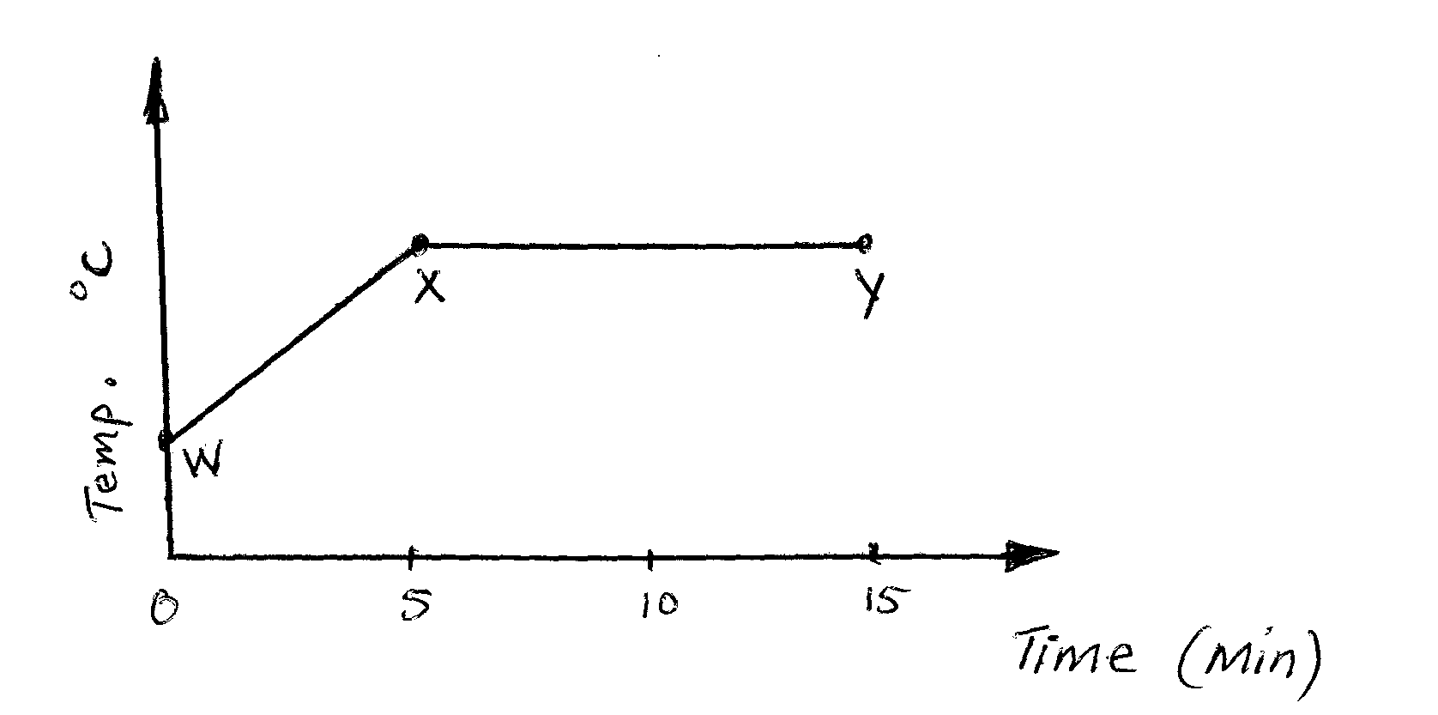
  - What happens to the water molecules between points W and X [1 mk]
…………………………………………………………………………………………………………………………………………..
……………………………………………………………………………………………..………………………………………………
  - In which part of the curve does a change of state occur? [1 mk]
…………………………………………………………………………………………………………………………………………..
……………………………………………………………………………………………..………………………………………………

  - Explain why the temperature does not rise between points X and Y [1 mk]
……………………………………………………………………………………………………………………..……………………………………………………………………………………………………………………..………………………………………………
- Write down the formula of the following compounds
    - Potassium manganate vii…………………………………………………………………[1mk]

    - Aluminium oxide …………………………………………………………………………….[1mk]

    - Iron III chloride ……………………………………………………………………………….[1mk]

- Write balanced equations for the following reactions
  - Reaction between sodium and excess oxygen [1mk]
…………………………………………………………………………………………………………………………………………..
……………………………………………………………………………………………..………………………………………………
  - [1mk]
…………………………………………………………………………………………………………………………………………..
……………………………………………………………………………………………..………………………………………………
- Reaction between Zinc and hydrochloric acid [1mk]
…………………………………………………………………………………………………………………………………………..
……………………………………………………………………………………………..………………………………………………

- The diagram shows PH values for several substances.
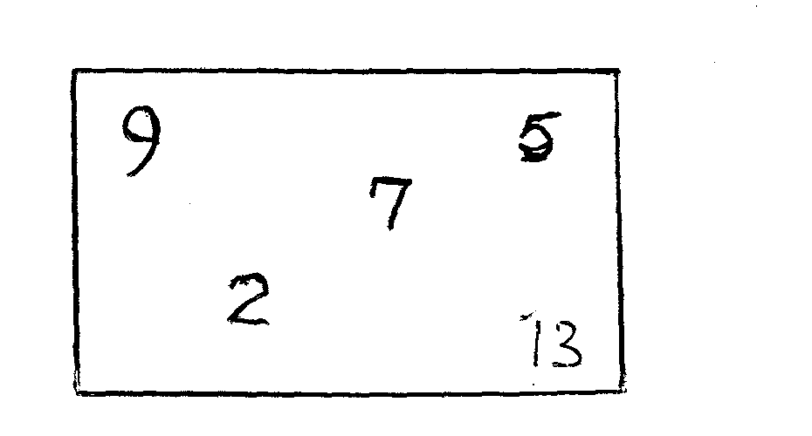
Choose the likely PH value for,
    - Dilute Hydrochloric acid…………………………………………………………………………………..[1mk]
    - Calcium hydroxide…………………………………………………………………………………………..[1mk]
    - Sodium hydroxide …………………………………………………………………………………………..[1mk]
    - Lemon juice……………………………………………………………………………………………………..[1mk]
- Briefly outline how you would obtain ethanol from a mixture of ethanol and water. [3mks]
…………………………………………………………………………………………………………………………………………..
……………………………………………………………………………………………..………………………………………………
…………………………………………………………………………………………………………………………………………..
……………………………………………………………………………………………..………………………………………………
…………………………………………………………………………………………………………………………………………..
……………………………………………………………………………………………..…………………………………………………………………………………………………………………………………………………………………………………………..
……………………………………………………………………………………………..………………………………………………
…………………………………………………………………………………………………………………………………………..
……………………………………………………………………………………………..………………………………………………
…………………………………………………………………………………………………………………………………………..
……………………………………………………………………………………………..………………………………………………
- (a) What is rust? [1mkl]
…………………………………………………………………………………………………………………………………………..
……………………………………………………………………………………………..………………………………………………
…………………………………………………………………………………………………………………………………………..
……………………………………………………………………………………………..………………………………………………

(b) Give two advantages of rusting.
(i) ………………………………………………………………………………………………………………………….[1mk]
(ii)………………………………………………………………………………………………………………………………[1mk]

