MWAKICAN JOINT EXAMINATION CHEMISTRY FORM 4 PAPER 2
MARKING SCHEME

- i) A,G ( ½ mk for each)
reason: Their ionic radius is bigger than their atomic radius (1mk)

ii) Ioning bonding (1mk)

iii) JA₂ (1mk)

iv) The oxide of G contains simple molecular (1mk) structure since both elements are non-metals while that of E is Grant ionic(1mk) structure since E is a metal while oxygen is a non metal.

v) D and A (1mkboth must be correct) D is the metal withlargest atomic rasius while A is the non metal with the smallest atomi radius (1mk)

vi) E (1mk) its oxide has the highest melting point (1mk)

- a) i) C₃H₈ - Alkanes ( ½ mk)
C₃H₆ - Alkanes ( ½ mk)
ii) C₃H₆ decolourises potassium manganate (1mk) VII/Bromine water while C₃H₈ does not (1mk)
b) a)i) Dehydration (1mk)
ii) Hydrogenation (1mk)

b) Sodalime (1mk)

c) Polythene ( ½ mk)
polymerization ( ½ mk)

d) Tetrachloromethane (1mk)
Cl
Cl= C - Cl (1mk)
Cl

(1mk)
e) n = 44800 = 1600 (1mk)
28
f) Hardening of oils into fat (1mk)

- a) Graph – labeling axis ( ½ mk for each )
ploting - 1mk if 5 points correctly plotted.
½ mk if 3-5 points correctly plotted.
shape of the graph - rise in temp then constant (1mk)
b) 7°C (1mk)

c) Zn + Cu2 + Cu Zn2+ (1mk)
(s) (aq) (s) (aq)

e) Heat change = mcθ
= - 50x 4.2 x 7 (1mk)
= - 1470J (1mk)
Penalize ½ mk for missing negative sign

f) i) 1mole 209KJ
1.47 KJ
1.47 = 0.00733Moles ( ½ mk)
209 (1mk)

ii) Molarity of CuSO4
volume - 50cm³
number of moles = 0.00733
0.00733 = 50 x m
1000
M = 0.00733 X 1000 = 7.33 = 0.1466 ( ½ mk)
50 (1mk) 50

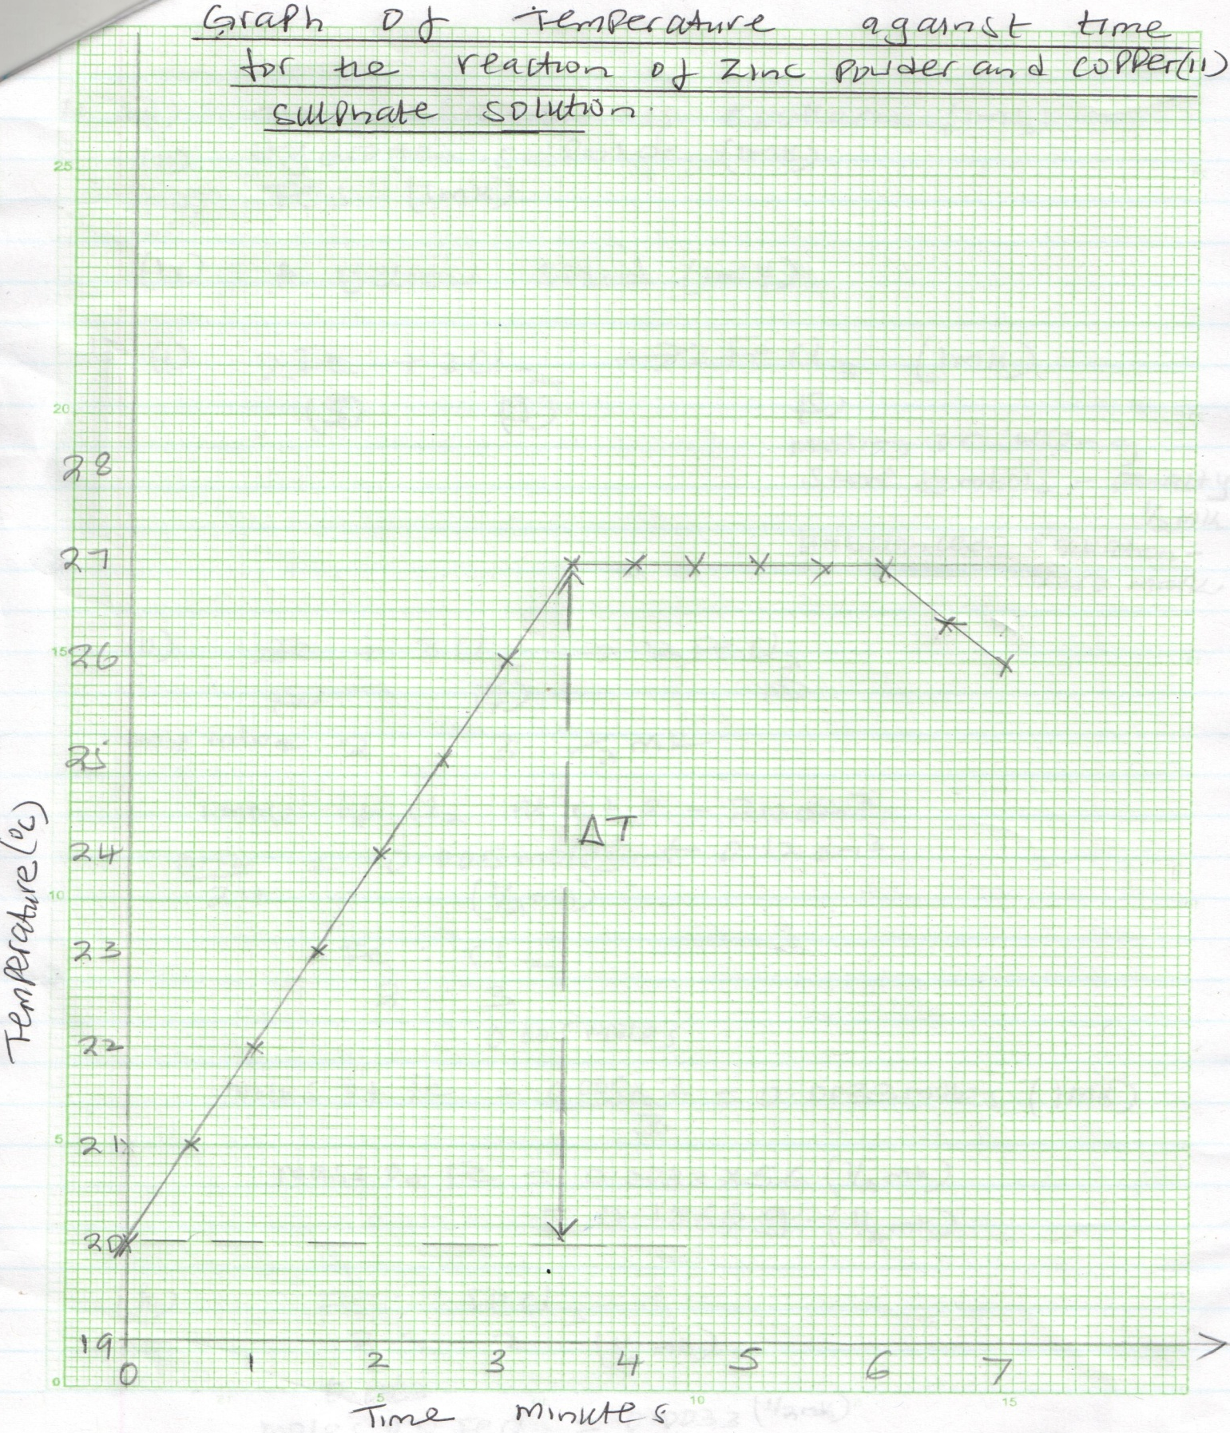

- a) i) The reaction is exothermic (1mk)
ii) Hydrogen sulphide (1mk)
Fes (1mk)
iv) A yellow solid (1mk)
b) i) 2Fe + 3Cl₂ 2FeCl₃ (1mk)
(s) (g) (s)
missing or wrong state symbols – penalty ( ½ mk)
unbalanced equation – zero mark
ii) 2Fe + 3Cl₂ 2FeCl₃
(s) (g) (s)
mole ration 2: 3 ( ½ mk)
1 mole of Cl2 at r.t.p - 24dm³
0.12 = 0.005 moles 0.12 dm³
24 ( ½ mk)
Fe : Cl
2 : 3
0.005moles
moles of Fe = 0.005 x2 = 0.0033 moles (1mk)
Mass of Fe = 0.0033 x 56 ( ½ mk)
= 0.1866g ( ½ mk)

iii) Fe : FeCl3
2 : 2 ( ½ mk)
0.0033
moles of FeCl3 = 0.0033 ( ½ mk)
R.F.M of FeCl3 = 162.5 g ( ½ mk)
mass of FeCl3 = 0.0033 x 162.5 g (1mk)
= 0.53625 g ( ½ mk)

- a) i) Oxygen gas (1mk)
ii) 4OH - -4e 2H₂O + O₂ (1mk)
(aq) (l) (g)
iii) Relights a flowing splint (1mk)
iv) Decreases (1mk) because of the increase in (1mk) concentration of H+ ions as the Cu²⁺ are discharged
b) Anode - Cu – ze Cu²⁺ (1mk)
(s) (aq)
Cathode - Cu²⁺ +ze Cu (1mk)
(aq) (s)
c) The blue colour fades (1mk) with time because as copper ions are discharged they are not replaced (1mk)

d) - Electroplating
- extraction of metals
- refining of metals ( any two 1mk each)
- a) i) Lead(ii) hydroxide or Pb (OH)₂ (1mk)
ii) Cl- or Chloride ion (1mk)
iii) Lead oxide r Pbo (1mk)
b) Pb² ⁺ + 2OH Pb (OH)₂
(aq) (aq) (s) (white ppt)
c) A white precipitate ( ½ mk) which does not dissolve ( ½ mk) in excess ammonia solution
d) i) The enthalpy change when one mole of a compound dissolves in water forming an infinitely dilute solution (1mk)
ii) a) H1 - Lattice energy (1mk)
H2 – Heat of solution (1mk)

b) H2 = H1 + H3
-(2237 + -2378) KJ (1mk)
= - 141KJ (1mk)

- a) i) X – Carbon(IV) Oxide (1mk)
Y – Calcium hydroxide (1mk)
ii) Ammonia ( ½ mk)
Carbon(iv) oxide ( ½ mk)
iii) S – Decomposition (1mk)
R - Filtration (1mk)
iv) Lowering melting point of NaCl during extraction of Na.
- As a drying agent (1mk for any one)
v) Q – NH₄OH + NaCl + CO₂ NH₄CL + NaHCO₃
(aq) (aq) (g) (aq) (aq) (1mk)

T - CaO + H₂O Ca(OH) ₂ (1mk)
(s) (l) (aq) (1mk)

b) Na₂CO₃ + Mg SO₄ MgCO₃ + Na₂SO₄
aq) (aq) (s) (aq) (1mk)
or Na₂CO₃ + Ca SO₄ CaCO₃ + Na₂SO₄
aq) (aq) (s) (aq)
(any one1mk)
c) -Manufacture of glass
- making soaps and detergents
-manufacture of paper
(any one -1mk)
d) i) Na₂Co₃ + 2HCl 2NaCl + CO₂ + H₂O (1mk)
(s) (aq) (aq) (g) (l)
ii) Mole ration 1: 2
1Mole of Co2 at s.t.p - 22.4dm³
moles of CO2 produced - 672
22400
moles of NaCo3 = 0.03 = 0.03 Moles ( ½ mk)

0.03 = 30x M ( ½ mk)
1000
M = 0.03 x 1000 = 3 = 1M (1mk)
30 3

iii) Value of x = 0.03 x 10

R.F.M of Na₂Co₃ = 3.18g
=106g x =3.18g

