**NAME………………………………………………INDEX NUMBER…………………………….…**

**DATE………………………………**

**121/1**

**MATHEMATICS**

**PAPER 1**

**APRIL, 2016**

**TIME: 2½ HOURS**

**MWAKICAN JOINT EXAMINATION (MJET) - 2016**

**Kenya Certificate of Secondary Education**

**MATHEMATICS**

**PAPER 1**

**TIME: 2½ HRS.**

**INSTRUCTION TO CANDIDATE’S:**

1. *Write your* ***name****,* ***index number*** *and* ***school*** *in the spaces provided above.*
2. *Write the* ***date*** *of examination in spaces provided.*
3. *This paper consists of* ***two*** *Sections; Section* ***I*** *and Section* ***II****.*
4. *Answer* ***ALL*** *the questions in Section* ***I*** *and any* ***five*** *questions from Section* ***II****.*
5. *All answers and working must be written on the question paper in the spaces provided below each question.*
6. *Show all the steps in your calculation, giving your answer at each stage in the spaces provided*

***below*** *each question.*

1. *Marks may be given for correct working even if the answer is wrong.*
2. *Non-programmable silent electronic calculators and KNEC Mathematical tables* ***may be*** *used,*

*except where stated otherwise.*

1. *Candidates should check the question paper to ascertain that all the pages are printed as indicated and that no questions are missing.*
2. ***Candidates should answer the questions in English.***

**FOR EXAMINER’S USE ONLY:**

**SECTION I**

|  |  |  |  |  |  |  |  |  |  |  |  |  |  |  |  |  |
| --- | --- | --- | --- | --- | --- | --- | --- | --- | --- | --- | --- | --- | --- | --- | --- | --- |
| 1 | 2 | 3 | 4 | 5 | 6 | 7 | 8 | 9 | 10 | 11 | 12 | 13 | 14 | 15 | 16 | TOTAL |
|  |  |  |  |  |  |  |  |  |  |  |  |  |  |  |  |  |

**SECTION II**

|  |  |  |  |  |  |  |  |  |
| --- | --- | --- | --- | --- | --- | --- | --- | --- |
| 17 | 18 | 19 | 20 | 21 | 22 | 23 | 24 | TOTAL |
|  |  |  |  |  |  |  |  |  |

|  |
| --- |
| GRAND TOTAL |
|  |

**SECTION I: (50 MARKS)**

Answer all the question in this section in the spaces provided:

1. Evaluate without using a calculator

¼ + 1/5 ÷ ½ of 1/3 (3mks)

½ of (4/5 – ¾ + ½)

1. Simplify completely.

3a2 + 5ab – 2b2  (3mk)

b2 – 9a2

1. The points A, B and C lie on a straight line. The position vectors of A and C are

2**i** + 3**j** + 9**k** and 5**i** – 3**j** + 4**k** respectively; B divides AC internally in the ration 2:1. Find

the

1. Position vector of B. **(2 mks)**
2. Distance of B from the origin. **(1 mk)**
3. Find the value of x in the equation  in the range listed below. 0o ≤ x ≤ 180o   **(3mks)**
4. A farmer has a piece of land measuring 840m by 396m. He divides it into square plots of equal size. Find the maximum area of one plot. **(3 mks)**
5. A liquid spray of mass 384g is packed in a cylindrical container of internal radius 3.2 cm. Given that the density of the liquid is 0.6g/cm3, calculate to 2dp the height of the liquid in the container. **(3 mks)**
6. (a) Find the inverse of the matrix $\left(\begin{matrix}4 & 3 \\ 3 & 5\end{matrix}\right)$**( 1 mark)**

(b) Hence solve the simultaneous equation using the matrix method **( 2 marks)**

4x +3y = 6

3x + 5y = 5

1. Use the tables of cube roots, squares, and reciprocals to evaluate the following correct to 4 s.f

3____ 2___ (4mks)

1/3

(0.0136) (3.72)2

1. The volumes of two similar solids are 800cm3 and 2700cm3. If the surface area of the larger one is 2160cm2, find the surface area of the smaller figure. (3mks)
2. Find the integral values that satisfy the simultaneous inequalities below. (3mks)





1. Find the area of the triangle below given that lines AB=25cm, BC = 15cm, AC = 14cm, BD = 28cm and  (4mks)

B



15cm

25cm

28cm

A

C

D

14cm

1. A straight line has the equation. Determine the acute angle which the line makes with the X-axis. (3mks)
2. The data below shows masses in grams of pieces of metal in a factory. If the mean mass is 3.3g, find the value of m. (3mks)

|  |  |  |  |  |  |  |
| --- | --- | --- | --- | --- | --- | --- |
| Mass (x) g | 1 | 2 | 3 | 4 | 5 | 6 |
| Frequency (f) | 4 | 7 | 2m | 2 | 5 | m |

1. A point (-5, 4) is mapped onto (-1, -1) by a translation T. Find the image of (-4, 5) under the same translation. (2 marks)

1. If (M + n) : (M – n) = 8: 3. Find the ratio M: n. (3 marks)
2. Solve the equation log (x+24) – 2log3 =log (9-2x) + 2 (4marks)
3. A bus left Mombasa and traveled towards Nairobi at an average speed of 60km/hr. after 2½ hours; a car left Mombasa and traveled along the same road at an average speed of 100km/ hr. If the distance between Mombasa and Nairobi is 500km, Determine
4. (i) The distance of the bus from Nairobi when the car took off

( 2 marks)

(ii) The distance the car travelled to catch up with the bus (4 marks)

(b) Immediately the car caught up with the bus, the car stopped for 25 minutes. Find the new average speed at which the car traveled in order to reach Nairobi at the same time as the bus. ( 4 marks)

1. The figure below is a model representing a rocket capsule. Themodel whose total height is 15cm is made up of a conical top; a hemispherical bottom and the middle part is cylindrical. The radius of the base of the cone and that of the hemisphere are each 3cm. Theheight of the cylindrical part is 8cm.

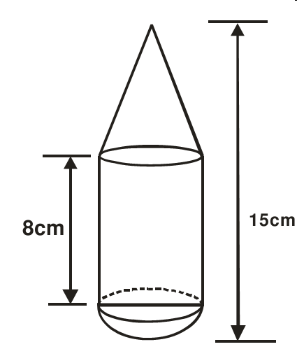

a) Calculate the external surface area of the model. (4mks)

b) The actual rocket has a total height of 6 metres. The outside ofthe actual rocket capsule is to be painted. Calculate the amount of paint required if an area of 20m requires 0.75 litres of the paint. (6mks)

1. The figure below shows a circle centre O PQRS is a cyclic quadrilateral and QOS is a straight line.

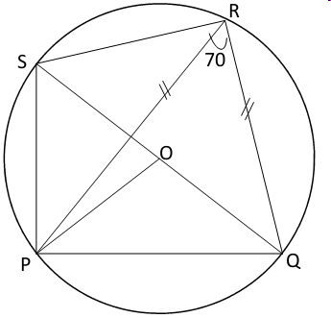

Giving reasons for your answers find the size of;

a) Angle PRS (3mks)

b) Angle POQ (2mks)

d) Angle PSR (2mks)

e) Reflex angle POS (3mks)

1. (a) Complete the table of the functions Y = 1+x -2x (2mks)

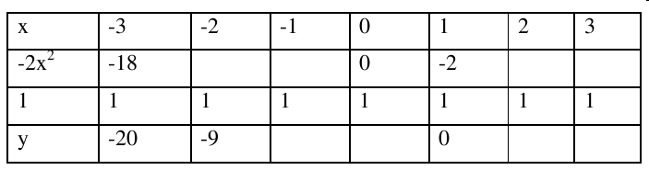

b) Draw the graph of the function Y = 1+x -2x on the graph paper provided. (4mks)

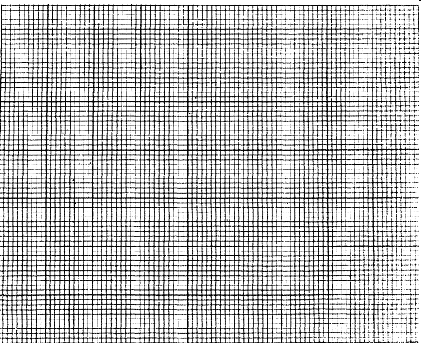

Use your graph to find the value for x in the equation 1 + x -2x=0

c) By drawing a suitable line graph on the same graph find the value for x which satisfies the

equation +5 + 2x -2x=0 (3mks)

d) State the maximum point of the function Y = 1+x -2x (1mk)

1. At 2.00 pm, a ship is at a position P from where a light house L is 12km away on a bearing of 320. At 4.00pm, the ship is at a position Q from where the lighthouse is now on a bearing of 035°. Given that the ship is traveling due West, find by calculation;

a)How far the lighthouse is from Q. (3mks)

b) The speed of the ship. (2mks)

c) The closest distance of the ship from the light house. (2mks)

d) The lighthouse, point Q and point P were noted to be along the circumference of a circular field. Find the distance of P from the centre of the field. (3mks)

1. (a) In the figure below O is the centre of a circle whose radius is 5 cm AB = 8 cm and AOB is obtuse.



Calculate the area of the major segment ( 7 marks)

1. A wheel rotates at 300 revolutions per minute. Calculate the angle in radians through which a point on the wheel turns in one second. (3mks)
2. A school planned to buy x calculators for a total cost of Kshs 16 200. The supplier agreed to offer a discount of Kshs 60 per calculator. The school was then able to get three extra calculators for the same amount of money.

a) Write an expression in terms of x, for the:

i) Original price of each calculator. (1 mk)

ii) Price of each calculator after the discount (1 mk)

b) Form an equation in x and hence determine the number of calculators the School bought. (5 mks)

c) Calculate the discount offered to the school as a percentage (3 mks)

1. The diagram below represents a conical vessel which stands vertically. The which stands vertically. The vessels contains water to a depth of 30cm. The radius of the surface in the vessel is 21cm. (Take  = ).

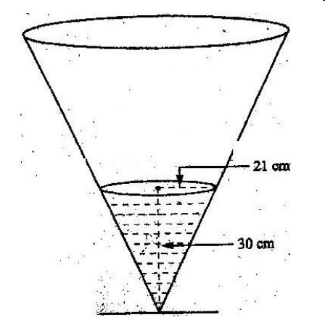

a) Calculate the volume of the water in the vessels in cm (2mks)

b) When a metal sphere is completely submerged in the water, the level of the water in the

vessels rises by 6cm.

Calculate:

1. The radius of the new water surface in the vessel; (2mrks)

(ii) The volume of the metal sphere in cm (3mks)

(iii) The radius of the sphere. (3mks)