MWAKICAN JOINT EXAMINATION TEAM
BIOLOGY PAPER 2
FORM 3

NAME ……………………………………………… ADM …………………………

CLASS …………………………..

Answer all the questions in section A in the spaces provided.
In section B answer question 6 (Compulsory) and either question 7 or 8 in the spaces provided
after question 8.

SECTION A (ANSWER ALL QUESTIONS)

1(i) The diagram below represents a plant cell.

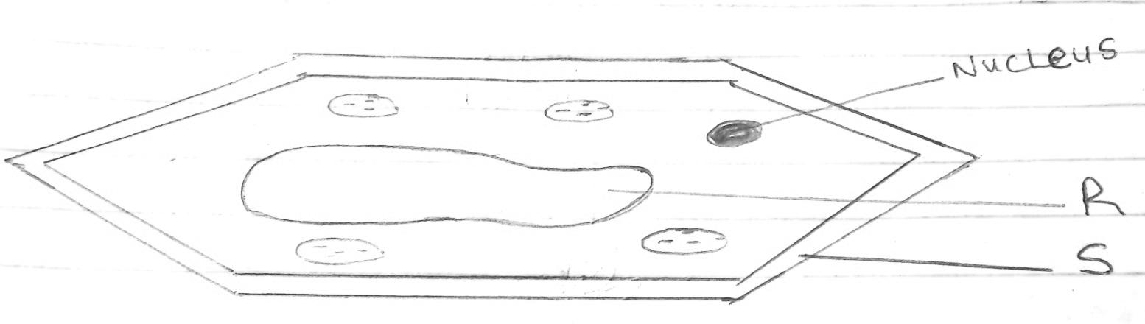

- Name a carbohydrate which forms part of the structure labelled S. (1mk)

- State two functions of the part labelled R (2mks)

- Name two structures present in the diagram but absent in an animal cell (2mks)

(ii) Name the organelles that perform each of the following functions (3mks)
- Excretion in amoeba

- Carries out digestion and destruction of worn out cell organelles

- Movement in paramecium

2(A) The diagram below represents a plant in the division Bryophyta.

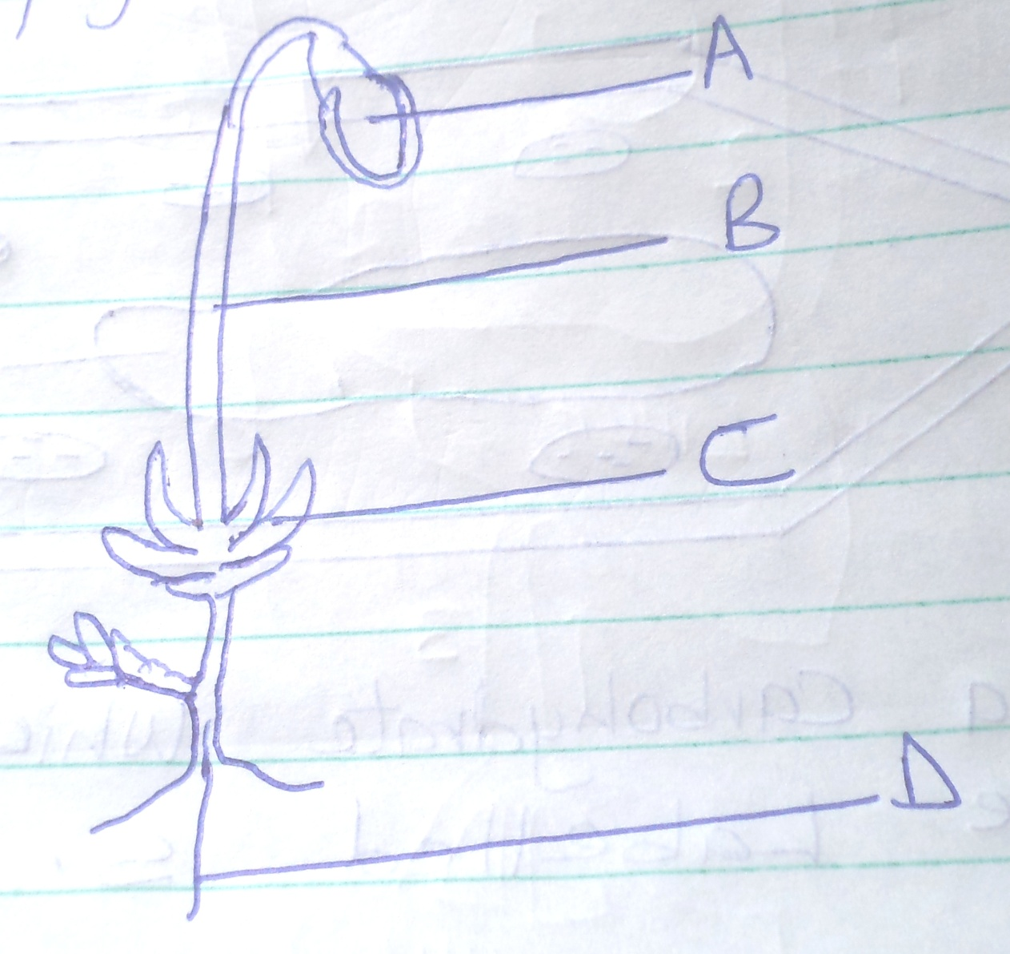

- Name the parts labeled B and D (2mks)

B -

D -

- State one function for each of the parts labelled A and C (2mks)

A -

B -

(B) (a)To which phylum and class does the following organism belong ?

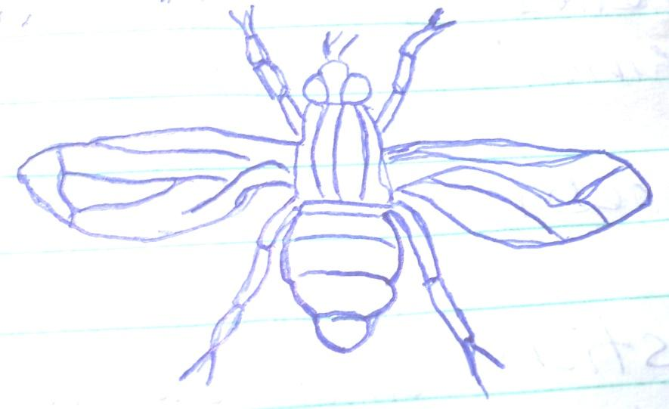

Phylum -

Class -

(b) Using observable features in the diagram, give two reasons for the phylum you have stated in (a) above

3. The figure below shows a transverse section of a monocot stem. Study it and answer the questions that follow.

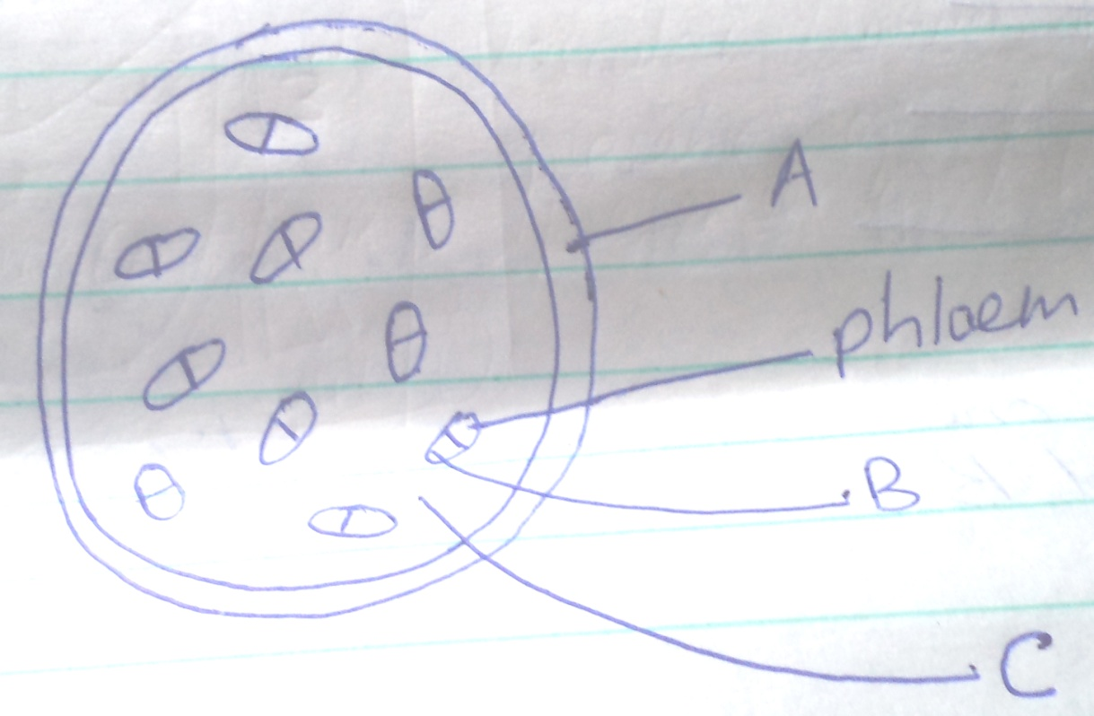

- Name the parts labeled A, B and C (3mks)

A -

B -

C -

- State the function of the part labelled C (2mks)

- State three differences between a monocot stem and a dicot stem (3mks)

4. The figure below illustrates a part of kidney nephron

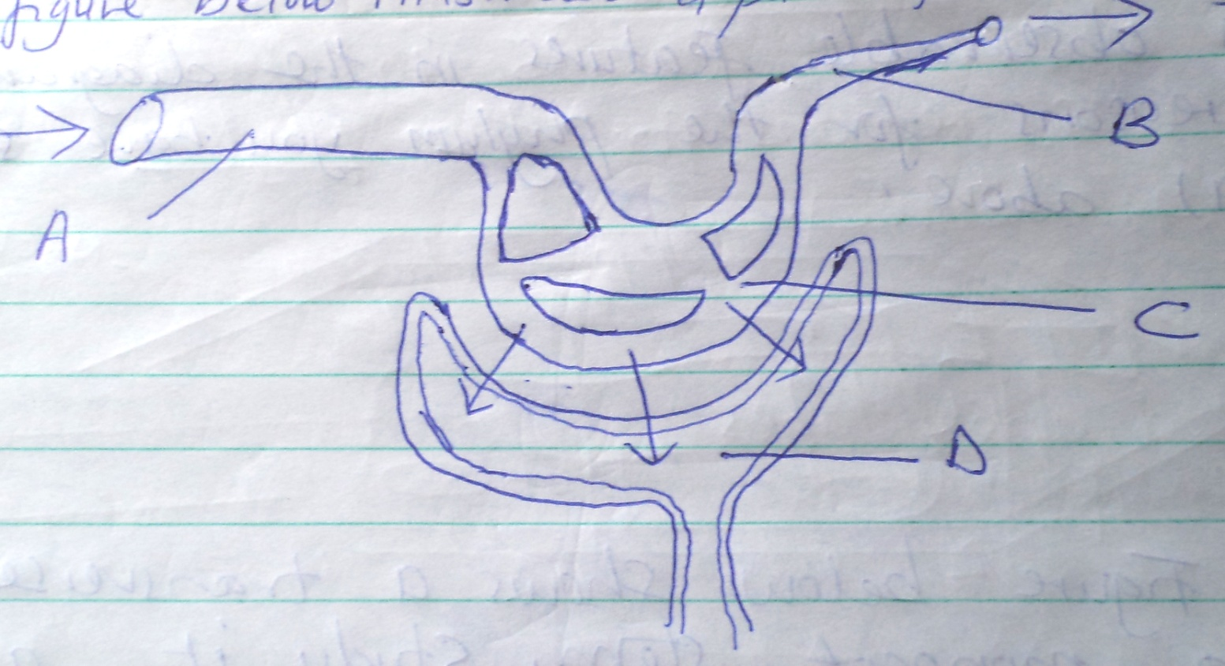

- Name the parts labeled A, B and D (3mks)

A -

B -

D -

- State one observable difference between part A and B

- Name the fluid that is found in part D (1mk)

5. Below is a sketch diagram showing the parts of a mammalian circulatory system.

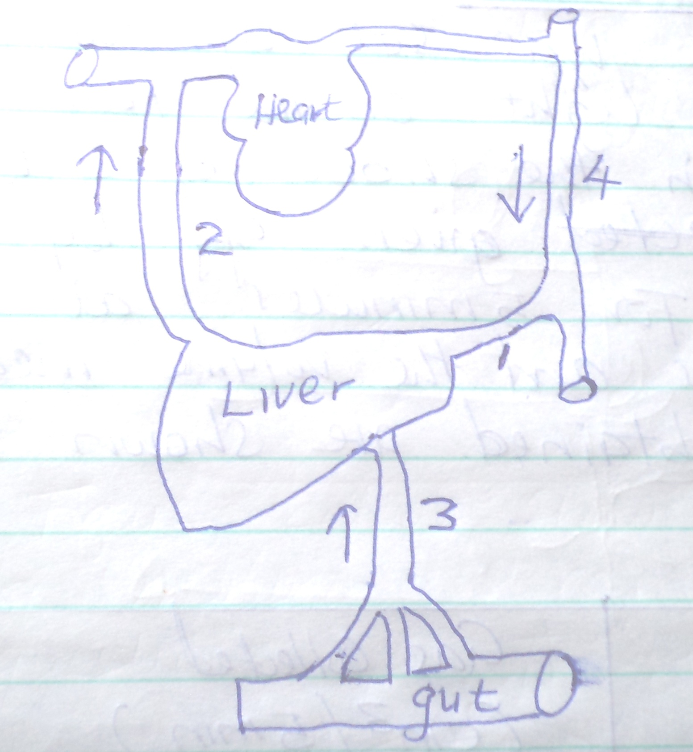

- Explain why the level of blood sugar in vessel 2 would be higher than that in vessel 3 during fasting (2mks)

- Name the vessel that has the highest concentration of urea among the vessels labelled 1,2 and 3
(1mk)

- How is vessel 3 structurally adapted to perform its functions. (3mks)

- Name the vessels labelled 2 and 4
2 -

4 -

SECTION B (40MKS)
6. An experiment was set up to investigate the effect of light on the rate of photosynthesis in the shoot of a water plant. The gas given off by the shoot was collected for 5 minutes at different light intensities and the volume measured. The results obtained are shown on the table below.

Light intensity (units | Gas collected (cm³ / 5min)
1 | 0.35
2 | 0.60
3 | 0.85
5 | 1.20
10 | 1.55
20 | 1.70
30 | 1.80
40 | 1.79
50 | 1.79

- Using the data given in the table, plot a graph of the volume of the gas collected against light intensity. (6mks)

- Account for the rate of gas production in the following intervals of light intensity.
- 1 - 10 (2mks)

- 30 – 50

- Write a word equation for the process of photosynthesis (2mks)

- State the products of the light stage of photosynthesis

- State the role of light in photosynthesis.

- Other than light intensity, name two other factors that affect the rate of photosynthesis.

7. Explain the economic importance of the organisms of each of the following kingdoms.

- Monera (10mks)

- Fungi (10mks)

8. Explain how abiotic factors (Environmental factors) affect plants. (20mks)

