BUSINESS STUDIES

FORM 4
PAPER 1
END OF TERM EXAMINATION

TERM 2 – 2019

TIME: 2hrs.

NAME:………………………………..…………… ADM:………… CLASS:………

LARI SUB – COUNTY

KIRENGA BOYS HIGH SCHOOL.
INSTRUCTION

1. Answer all the questions in the spaces provide.
2. Write your Name, ADM. No. and Class

- State four economic elements that influence business operation (4 mks)
- …………………………………………………………………………………………….
- ……………………………………………………………………………………………
- ……………………………………………………………………………………………
- ……………………………………………………………………………………………
- Highlight four indications of economic development in a country. (4 mks)
- ……………………………………………………………………………………………
- ……………………………………………………………………………………………
- ……………………………………………………………………………………………
- ……………………………………………………………………………………………
- State four essentials elements for a transport system to function efficiently (4 mks)
- ……………………………………………………………………………………………
- ……………………………………………………………………………………………
- ……………………………………………………………………………………………
- ……………………………………………………………………………………………
- Highlight four internal economies of scale that a firm may get when operating on a large scale (4 mks)
- ……………………………………………………………………………………………
- ……………………………………………………………………………………………
- ……………………………………………………………………………………………
- ……………………………………………………………………………………………
- The following information was extracted from the books of Mitei Traders on 31st July 2018.
Details shs.
Capital 90,000
Fixed assets 80,000
Cash in hand 20,000
Current liabilities 20,000
Stock 20,000
Net profit 15,000
Drawings 5,000

Calculate:-
- Capital owned (2 mks)

- Acid test ratio (2 mks)

- Apart from personal saving highlight four sources of capital for a sole proprietorship(4 mks)
- ……………………………………………………………………………………………
- ……………………………………………………………………………………………
- ……………………………………………………………………………………………
- ……………………………………………………………………………………………
- Give four differences between goods and services (4 mks)
 | GOODS |  | SERVICES
(i) |  | (i)
(ii) |  | (ii)
(iii) |  | (iii)
(iv) |  | (iv)

- Outline four problems encountered when computing national income using income approach. (4 mks)
- ……………………………………………………………………………………………
- ……………………………………………………………………………………………
- ……………………………………………………………………………………………
- ……………………………………………………………………………………………
- State four causes of demand pull inflation (4 mks)
- ……………………………………………………………………………………………
- ……………………………………………………………………………………………
- ……………………………………………………………………………………………
- ……………………………………………………………………………………………

- Outline four circumstances under which a correctly drawn cheque can be dishonoured(4 mks)
- ……………………………………………………………………………………………
- ……………………………………………………………………………………………
- ……………………………………………………………………………………………
- ……………………………………………………………………………………………
- The following are some of uses of office equipments. Indicate in the table below the most appropriate equipment one will use to perform the following functions
 | Use | Equipment
 | For trimming documents into required shapes and sizes
 | To make holes in papers to facilitate filing
 | To fold documents, place them in envelopes and seal the envelopes
 | For printing postage impression on envelopes

- Identify the ledgers in which the following accounts are kept (4mks)
 | ACCOUNT | LEDGER
1. | Pendo (debtor)
2. | Machinery
3. | Rent
4. | Capital

- Outline four ways an account holder benefit from using M-banking/E-banking (4 mks)
- ……………………………………………………………………………………………..
- ……………………………………………………………………………………………..
- ……………………………………………………………………………………………..
- ……………………………………………………………………………………………..
1
0
PRICE

QUANTITY
From the above diagram state the factors that factors that could have contributed to the shift. (4 mks)
- ……………………………………………………………………………………………..
- ……………………………………………………………………………………………..
- ……………………………………………………………………………………………..
- ……………………………………………………………………………………………..
- Identify four methods of trade restrictions in international trade (4 mks)
- ……………………………………………………………………………………………..
- ……………………………………………………………………………………………..
- ……………………………………………………………………………………………..
- ……………………………………………………………………………………………..
- Identify the source documents into which the information given in the table below would be recorded. (4 mks)
 | INFORMATION | SOURCE DOCUMENT
(i) | Payments received from debtors
(ii) | Purchases made on credit
(iii) | Validating payments made by the cashier
(iv) | Requesting for additional payments from a debtor

- State the line of communication involved in each of the following (4 mks)
- The Manager of ABC Company Ltd talking to the Manager of XYZ company Ltd.
………………………………………………………………………………………………
- A secretary asking for time off from her boss ………………………………………………
- The Production Manager giving instruction to the secretary of the Sales Manager
…………………………………………………………………………………………….
- The store keeper giving explanations to the Chief Accountant ……………………………
- If a house worth Kshs. 1,200,000 was insured against fire from Ksh. 900,000 under the “with average clause” Fire occurred and damaged the house causing a loss of Kshs. 500,000. Determine the value of compensation due to the insured. (4 mks)

- Outline features of monopoly market structure (4 mks)
- ……………………………………………………………………………………………..
- ……………………………………………………………………………………………..
- ……………………………………………………………………………………………..
- ……………………………………………………………………………………………..
- Label points a, b and c in the figure below (3 mks)
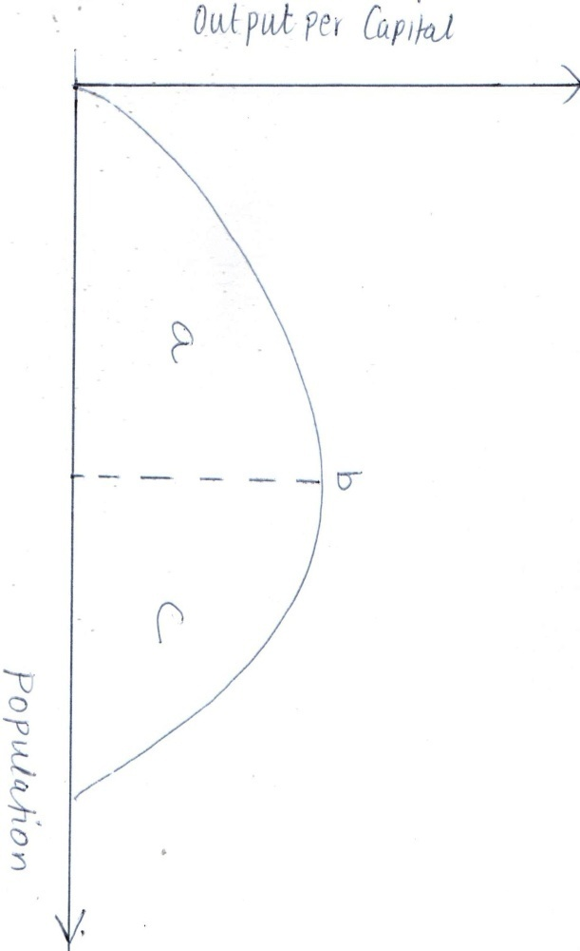
- The following balance sheet was incorrectly prepared. Prepare a current one
Bidii Traders
Balance Sheet
As at 31st Dec. 2017
ASSETS LIABILITIES .
Stock 80,000 Bank overdraft 80,000
Creditors 50,000 Debtors 35,000
Long-term loan 65,000 Land 120,000
Capital 130,000 Furniture 15,000
325,000 325,000

- Highlight four reasons why government levy taxes (4 mks)
- ……………………………………………………………………………………………..
- ……………………………………………………………………………………………..
- ……………………………………………………………………………………………..
- ……………………………………………………………………………………………..
- List four types of warehouses (4 mks)
- ……………………………………………………………………………………………..
- ……………………………………………………………………………………………..
- ……………………………………………………………………………………………..
- ……………………………………………………………………………………………..
- State ways in which the government get involved in business (4 mks)
- ……………………………………………………………………………………………..
- ……………………………………………………………………………………………..
- ……………………………………………………………………………………………..
- ……………………………………………………………………………………………..
- State the effects of the following transactions on the balance sheet totals. (4 mks)
- Bought a piece of land Ksh. 500,000 in cash ……………………………………………..
- Paid a creditor through a cheque Kshs. 50,000 …………………………………………….
- Sold a personal car Ksh. 300,000 and deposited the amount in the business bank account.
………………………………………………………………………
- Took Kshs. 10,000 to pay for his son’s school fees ……………………………………………

