PERFECT STEPS PUBLISHERS
0721745374/0721707626
Nairobi
END OF YEAR EXAMS 2015

BIOLOGY EXAMINATION FORM ONE MARKING SCHEME

1 Movement of molecules against concentration gradient; using energy
2 (a) breakdown /digest starch into maltose
(b) fatty acids and glycerol
3 (a) golgi bodies/ ribosome’s/ lysosomes (b) mitochondria / mitochondrion. 1mk
4 Flagella
5 A lower incisors
D canine
6 Genetics
7(a) Catalyse (b)Detoxification / Breakdown hydrogen peroxide to oxygen and water
8 Osmosis/ Water moved from low conc of water molecules. (beaker) to the high conc of water molecules. (visking tubing); 2mk
Diffusion; 1mk
9
Beam of electrons; 1mk

Diaphragm 1mk
Eye-piece/ objective lenses; 1mk
Coarse adjustment knob 1mk

9 i)Lion and maize Belong to different kingdoms;
ii) Lion and dog;
Belong to same order; rej. belong to same kingdom
Lipids are a source of metabolic water. When lipids are metabolized, they produce metabolic water which is an important source of water in desert animals such as camels.
Insulation. Fat deposited under the skin of animals forms adipose tissue which serves as an insulator against heat loss.
Lipids form part of cell structure for example, in plasma membrane where they are used as phospholipids.
Lipids offer physical protection to vital body organs. Lipids acts as shock absorber around the heart, kidney and eye balls.
Lipids are a medium of transport and storage for fat-soluble vitamins A, D, E and K in the body.
Some hormones such as sex hormones have lipids in their structure.
Under the influence of cholesterol which is a lipid, the body is able to synthesize bile and vitamin D. any 7 times 2 = 14

10 Study the diagram below and answer the questions that follow.
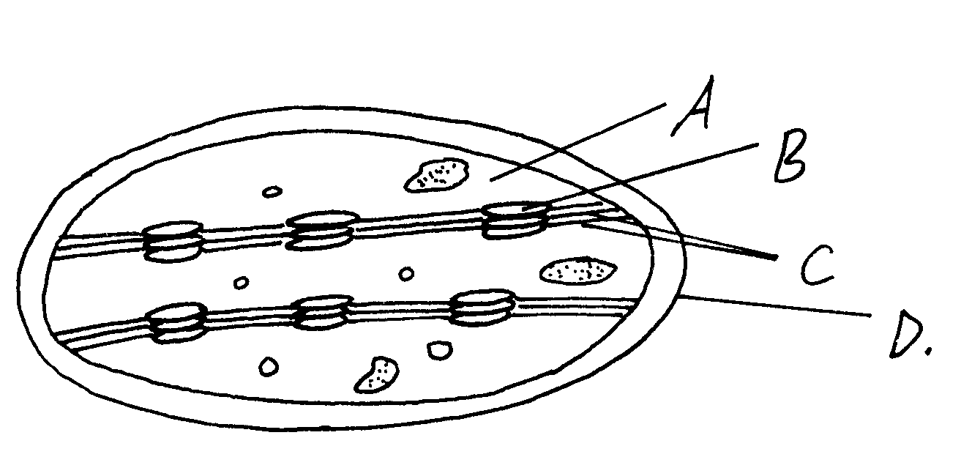

A Stroma

D Outer membrine 2mks

i) A 1mk
ii) B 1mk

Fig P- Small intestines/ ileum; 1mk
Fig Q- Large intestines/ colon; 1mk
Folding in the inner walls of P and not
c) i) Site for absorption of soluble/ digested food substances;
Site for completion of food digestion;

d) - Long to increase SA for absorption of digested foods;
Highly coiled to slow down movement of food and thus allow more time for digestion and absorption
Presence of Villi and microvilli to increase SA for absorption of digested foods
Thin layer of cells/ thin inner walls for faster diffusion of soluble products
Presence of dense network of blood capillaries in villi into which soluble products of digestion/ amino acids, sugars, vitamins, mineral salts are absorbed;
Presence of lacteals in villi for absorption of fatty acids and glycerol; Any 4 =4 mks
e) - Absorption of water from undigested and indigestible food material

(a) Oxygen ;
(b) 6CO₂ + 6H₂O ———— O₆ H ₁₂ O₆ + 6O ₂ + Energy;
C Chloroplast;
(d) To provide carbon (IV) Oxide gas for photosynthesis ; Rej. Carbon dioxide
A -Stomach; B - Pancreas;
(ii) (Stomach wall) is made of thick circular and longitudinal layers of muscles; which contract and relax producing movements that mix contents of stomach/ churning;
(b) (i) Cholecystokinin
(ii) Cholecystokinin – It stimulates the secretion of bile from the gall bladder; bile contains bile salts/ sodium glycocholate and sodium taurocholate; emulsify fats into tiny fat droplets;

2 (a) Aquatic;
. (i) To allow light pass through the section (1mk) *UG*
(ii) Maintain structure of specimen or (1) to make specimen hard enough for thin sections to be cut

1
- Starch

PRINTED AND COMPILED BY
PERFECT STEPS PUBLISHERS
0721 745374/ 0721 707626 NAIROBI

