FORM ONE BIOLOGY
1. State the function of the following parts of a light microscope. (2mks)
a) Objective lens
……………………………………………………………………………………………………………….
b) Diaphragm
……………………………………………………………………………………………………………….
2. What are the functions of the following cell organelles. (2mks)
a) Ribosomes
……………………………………………………………………………………………………………….
b) Lysosomes
……………………………………………………………………………………………………………….
3. a) Distinguish between diffusion and active transport. (2mks)
………………………………………………………………………………………………………………………………………………………………………………………………………………………………………………………………………………………………………………………………………………………………………………………………………………………………………………………………..
b) State one role played by osmosis in:
i) Plants. (1mk)
………………………………………………………………………………………………………………
ii) Animals. (1mk)
……………………………………………………………………………………………………………...
4. Explain how the following factors determine the daily energy requirement in humans.
a) Age (1mk)
………………………………………………………………………………………………………………

b) Occupation. (1mk)
……………………………………………………………………………………………………….
c) Sex. (1mk)
………………………………………………………………………………………………………..
5. Below is a diagram of an organelle that is involved in respiration

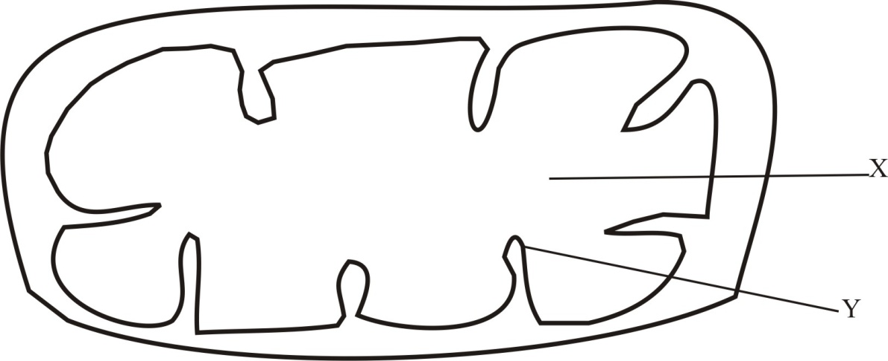

- Name t he organelle ……………………………………………………………........ ( 1mk)

- Name the part labeled X………………………………………………………… (1 mk)

- What is the purpose of the part labeled Y (1 mk)

………………………………………………………………………………………..
6. Plant cells do not burst when immersed in distilled water. Explain. (2mks)
………………………………………………………………………………………………………………………………………………………………………………………………………………………………………………………………………………………………………………………7. State three functions of Golgi apparatus. (3mks)
………………………………………………………………………………………………………………………………………………………………………………………………………………………………………………………………………………………………………………………
8. Name the disease caused by deficiency of
a) Iodine (1mk)
…………………………………………………………………………………………………..
b) Vitamin B₂ (1mk)
……………………………………………………………………………………………………
9 a). Identify the following apparatus and state its functions.

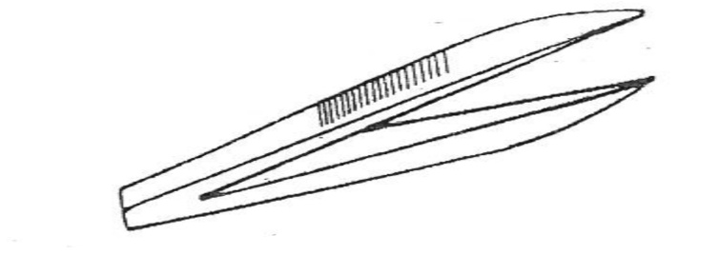
- Name…………………………………………………………………(1mk)

- Function ………………………………………………… ………. (1mk)

b) A student measured the length of a mitochondrion on a photomicrograph whose magnification was X 40000 and found it to be 1mm. Calculate the actual size of the mitochondrion. (3 mks)

……………………………………………………………………………………………………………………………………………………………………………………………………………………………………………………………………………………………………………………..
c) An experiment was set up as shown below
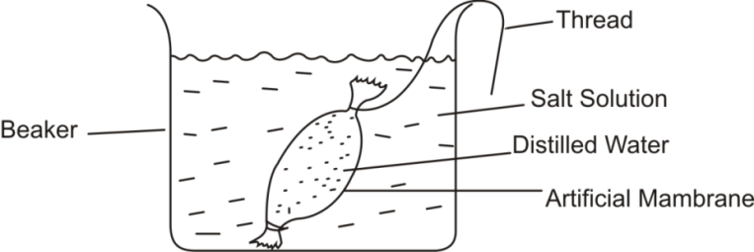

The set up was left for 30 mins.
- What was the aim of the experiment (1mk)
……………………………………………………………………………………………………………………………………………………………………………………………………………………
- State and explain what would be observed after 30 minutes. (3mks)
…………………………………………………………………………………………………………………………………………………………………………………………………………………………………………………………………………………………………………………………........
10. State two adaptations of leaves that maximize efficiency in trapping sunlight for photosynthesis. (2mks)
………………………………………………………………………………………………………………………………………………………………………………………………………………………………………………………………………………………………………………………………………………………………………………………………………………………………………..
11. Name one organelle found in the actively respiring tissues. (1mk)
……………………………………………………………………………………………………….
12. a) What is meant by the term symbiosis? (1mk)
……………………………………………………………………………………………………………………………………………………………………………………………………………………
b) i) What are the final products of digestion of fats? (1mk)
…………………………………………………………………………………………………………
ii) Under which conditions will the body use proteins as a source of energy . (1mk)
…………………………………………………………………………………………………………
iii) Name one nutrient that does not require digestion before it is absorbed. (1mk)
………………………………………………………………………………………………………..
13. Study the diagram of the mammalian tooth below and answer the questions that follow.
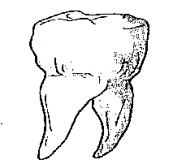

(a) Identify the tooth. (1mk)
.....................................................................................................................................................
(b) Give a reason for your answer in (a) above. (1mk)
…………………………………………………………………………………………………
(c) State one adaptation of the tooth to its function. (1mk)
……………………………………………………………………………………………………………………….………………………………………………………………………………………………………………………………………………………………………………

14. .(i) Identify the mode of feeding of the animal whose dental formula is shown below.(1mk)
I O C O PM 3 M 3
3 O 3 3
…………………………………………………………………………………………….
(ii) Give reasons for your answer in 14(i) above (2mks)
……………………………………………………………………………………………………………………………………………………………………………………………………………………………………………………………………………………………………….
15. a) State two factors that denature enzymes. (2mks)
………………………………………………………………………………………………………………………………………………………………………………………………………………
b) Give two functions of the large intestines in human beings. (2mks)
……………………………………………………………………………………………………………………………………………………………………………………………………………..
16. State the role of the following parts of the mammalian intestine.
a) Goblet cells. (1mk)
…………………………………………………………………………………………………….
b) Lacteals in the villi. (1mk)
……………………………………………………………………………………………………..
17. Distinguish between hypertonic and hypotonic solutions. (2mks)
………………………………………………………………………………………………………………………………………………………………………………………………………………………………………………………………………………………………………………………
18. A form one student obtained the results below in an experiment
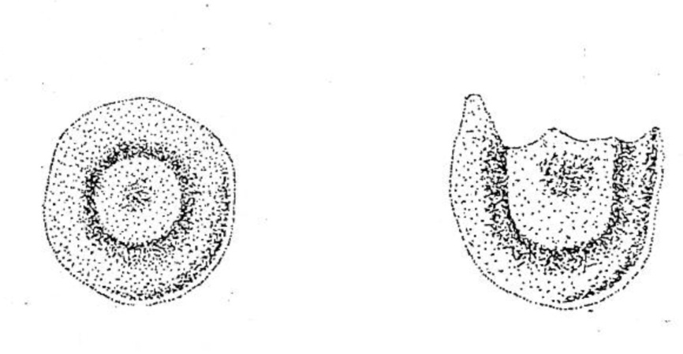
Red blood cell
At start of experiment

Red blood cell
At end of experiment

- Identify the physiological process under investigation. (1mk)

………………………………………………………………………………………

- Account for the result obtained (3mks)
……………………………………………………………………………………………………………………………………………………………………………………………………………………………………………………………………………………………………………………………………………………………………….
19. Below is a diagram of an organelle.

- State the function of the organelle drawn above. (1mk)
………………………………………………………………………………………………….
- Name the parts of the organelle where :
  - Oxygen gas is produced as a by product. (1mk)
…………………………..………………………………………………………………
  - Carbon (IV) oxide is utilized. (1mk)
…………………………………………………………………………………………………..

20. Name the organelle that:
a)Manufacture and transport lipids and steroids in a cell. (1mk)

…………………………………………………………………………………………………….
b) Control enzymes that are capable of destroying old damaged cells. (1mk)

…………………………………………………………………………………………………….
c) Control all the processes in a cell (1mk)

……………………………………………………………………………………………………..
d) Form cilia and flagella in cells that have them. (1mk)

…………………………………………………………………………………………………….
21. State the branch of biology that deals with the study of: (2mks)
i) Insects
……………………………………………………………………………………………………….
ii) The relationship between organisms and their environment

………………………………………………………………………………………………………
22. Name the field of science that specializes in the study of cells. (1mk)

……………………………………………………………………………………………………
23. The scientific name for beans is Phosedus vulgaris.
a) What taxon does the term phosedus represent. (1mk)

………………………………………………………………………………………………………
b) State two rules that are followed when giving a scientific name to an organism. (2mks)

………………………………………………………………………………………………………………………………………………………………………………………………………………………………..
24. Compare the structure of plant and animal cells. (4mks)
……………………………………………………………………………………………………………………………………………………………………………………………………………………………………………………………………………………………………………………………………………………………………………………………………………………………………………………………….
25. List seven characteristics that must be shown by all living organisms. (7mks)
………………………………………………………………………………………………………………………………………………………………………………………………………………………………………………………………………………………………………………………………………………………………………………………………………………………………………………………………………………………………………………………………………………………………………………………………………………………………………………………………………………………….......
26. a) The diagram below shows chemical reactions I and II which are controlled by enzymes.
Glucose + Glucose

Reaction II Reaction I
Enzyme B Enzyme A

Maltose + Water

- Into which class of carbohydrates is maltose (1mk)
……………………………………………………………………………………………..
- Name reaction I and enzyme A (2mks)
Reaction I …………………………………………………………………………….
Enzyme A …………………………………………………………………………….

b) The word equation below shows a biological process.
Water Hydrogen atom + oxygen
i) Name the process. (1 mk)
……………………………………………………………………………………………………..
ii) Where does the process named in a) above take place? (1 mk)
……………………………………………………………………………………………………………………………………………………………………………………………………………………
iii) State two conditions necessary for the process to occur. (2 mks)
……………………………………………………………………………………………………………………………………………………………………………………………………………………
27. List the seven major taxonomic units of classification of living things. In ascending order. (7mks)
……………………………………………………………………………………………………………..……………………………………………………………………………………………………………………………………………………………………………………………………………………………………………………………………………………………………………………………
28. Classify the following organisms into their kingdoms. (4mks)
Organisms Kingdom
- Maize,Beans ………………………………………….
- Mushroom,Yeast …………………………………………
- Protozoa,algae …………………………………………
- Bacteria …………………………………………
29. . How is support brought about in herbaceous plants? (3 mks)
……………………………………………………………………………………………………………………………………………………………………………………………………………………………………………………………………………………………………………………………………………………………………………………………………………………………………………………………………………………………………………………………………………………

END.

