GATITU MIXED SECONDARY SCHOOL
ARISE & SHINE
FORM 1 BIOLOGY_MIDTERM EXAM TERM 3 2014
NAME………………………………………………………… ADM.NO…………………

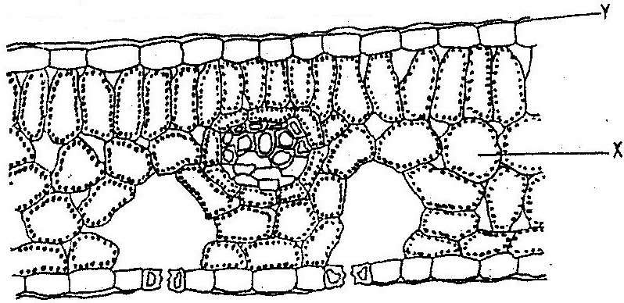
- The diagram below represents a section of a leaf.

Name the parts labeled X, and Y(2mks)

2.State the function of the organelles:
  - Cell membrane (1mks)

  - Golgi apparatus (1mks)

3. a)What is diffusion (2mks)

b) how do the following factors affect the rate of diffusion?
i) Diffusion gradient (1mk)

ii) Surface area volume ratio (1mk)

iii) Temperature (1mk)

c) Outline three roles of active transport in the human body (3mks)

4.a)State the functions of cristae in mitochondria.(1mk)

b) The diagram below represents a cell organelle.
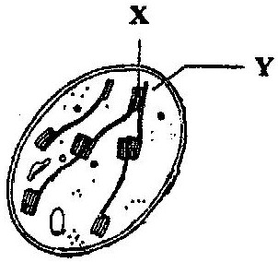

(i) Name the part labeled Y. (1mk)

(ii) State the functions of the part labeled X. (1mk)

5. Distinguish between the terms autotrophism and heterotrophism. (2mk)

6. (a) What is meant by the term binomial nomenclature ( 1 mark)

(b) Give two reasons why classification is important ( 2 marks)

7 (a) What is the formula for calculating linear magnification of a specimen
when using a hand lens? ( 1 mark)

8. Plant cells do not burst when immersed in distilled water. Explain ( 2 marks)

9. State two functions of centrioles (2marks)

10.Describe what happens during the light stage of photosynthesis ( 2 marks)

11.The diagrams below show a red blood cell that was subjected to a certain
Treatment

At start At the end of experiment
(a) Account for shape of the cell at the end of the experiment ( 2mks)

(b)Draw a diagram to illustrate how a plant cell would appear if subjected to
the same treatment ( 1 mk)

12.State the function of:
- Ribosomes (1 mark)

- Lysosomes (1 marks)

13. Distinguish between haemolysis and plasmolysis(2mks)

14. . State one use for each of the following apparatus in the study of living organisms.(2mks)
(a) Pooter

b)sweepnet

15. State two functions of the following parts of a light microscope. (3mks)
Stage

Condenser

Mirror

16. Give three functions of cuticle.(3mks)

17.What is carbon iv oxide fixation ?..Write the equation involved in this process (2mks)

18.list two factors that affect the rate of photosynthesis (2mks)

19.State the part of chloroplast that the following stages occur
a) light stage
b) dark stage (2mks)
20. Name two tissues in animals (2mks)

21. State two differences between plant and animal cell (2mks)

22. Describe five adaptation of leaves to its photosynthetic function (10mks)

All the best.- Ms. Muturi.

