MUKINDURI MIXED DAY SECONDARY SCHOOL
MIDTERM EXAM TERM 2 2017
BIOLOGY FORM 3
NAME……………………………………………………..ADM……………

ANSWER ALL THE QUESTIONS IN THE SPACES PROVIDED .

- a)Distinguish between autotrophic and heterotrophic nutrition. (2mks)

b) An organism was found to have the dental formula.
I¹/₁ , C ⁰/₀ , pm ³/₂ , m ⁴/₄
- calculate the total number of teeth in the organism. (2mks)

- giving a reason, suggest the mode of feeding of the organism. (2mks)

- Explain three characteristics of a population. (3mks)

- Describe four adaptations of xerophytes. (4mks)

- The diagram below shows the roots of a dicotyledonous plant.

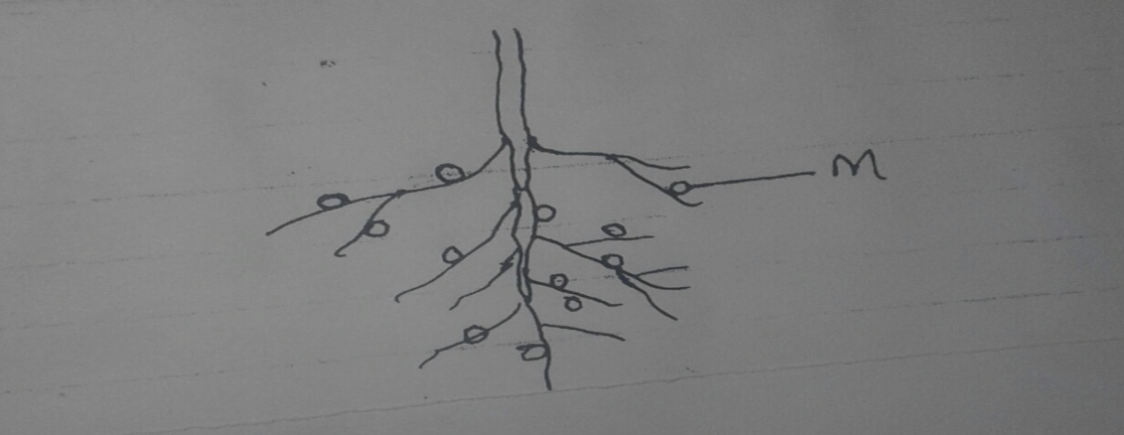

- Name the structures labeled m (1mk)

- Identify the organism found in structure m. (1mk)

- Explain the importance of the organism identified in (b) above to the plant. (2mks)

- Name the type of relationship between the above named organism and the plant. (1mk)

- The flow chart above shows a food web in a terrestrial ecosystem.

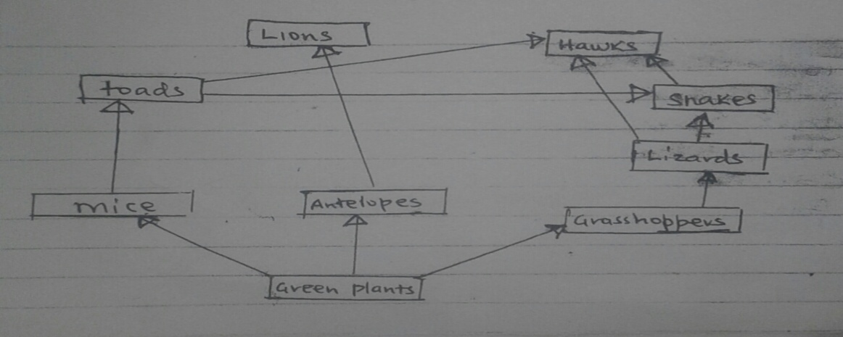

- From the food web construct a food chain with the hawk as
i)a tertiary consumer (1mk)

- a quartenary consumer (1mk)

- Name the trophic level occupied by the toads (1mk)

- What would happen if leopards were introduced into the ecosystem. (3mks)

- To estimate the population of crabs in a lagoon traps were laid at random. 400 crabs were caught, marked and released into the lagoon. Four days later , traps were laid again and 374 crabs were caught. Out of the 374 crabs, 80 were found to have been marked.
a)calculate the population of the crabs in the lagoon using the formula: (2mks)
P = $\frac{FM x SC}{MR}$

b) What is the name given to this method of estimating population? (1mk)

- State three assumptions made during the investigation. (3mks)

- State the main nitrogenous waste product excreted by each of the following types of
Animals. (3mks)

Animal Nitrogenous Waste
Birds
Fresh water fish
Mammals

- State three adaptations of respiratory surfaces. (3mks)

- a) Describe how you would carry out test for reducing sugar. (3mks)

b) Name two types of polysaccharides. (2mks)

- a) Name the organ in the body that produces (2mks)
i)bile

ii)gastric juice

b)Name the end product of digestion of the following types of foods. (3mks)
i)Proteins

ii)Starch

iii)Lipids

- What are the causative agents of the following diseases? (2mks)
i)Cholera
ii)Malaria

- In a study of Acacia tree, the following numbers of organisms were obtained at each trophic level.

Trophic Level Number of organisms
Producer 1
Primary consumer 2600
Secondary consumer 40
Tertiary consumer 3
- Draw a pyramid of numbers to represent the information. (2mks)

- Give a reason for the large differences in numbers of primary and secondary consumers. (1mk)

- a) State three causes of
- Land pollution (3mks)

- Water pollution (3mks)

- Air pollution

b)State three methods used to control water pollution. (3mks)

