MIDTERM EXAMS biology
Form 3

NAME__________________________________ADM NO. _____________

Answer all questions in the spaces provided.
- a) State 3 characteristics of respiratory surface. (3mks)
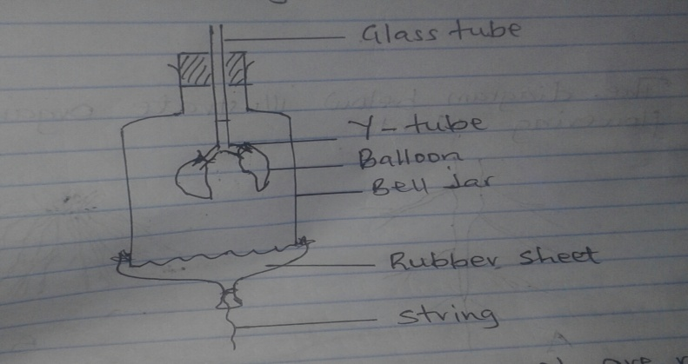
b) The diagram below represents a model of the chest cavity.

What structure in a mammal are represented by:
- glass tube (1mk)

- Y- tube (1mk)

- Rubber sheet (1mk)

- Ballons (1mk)

c)Explain how the structure represented by the ballon is adopted to its function. (3mks)

2. The diagram below illustrate organs of some flowering plants.
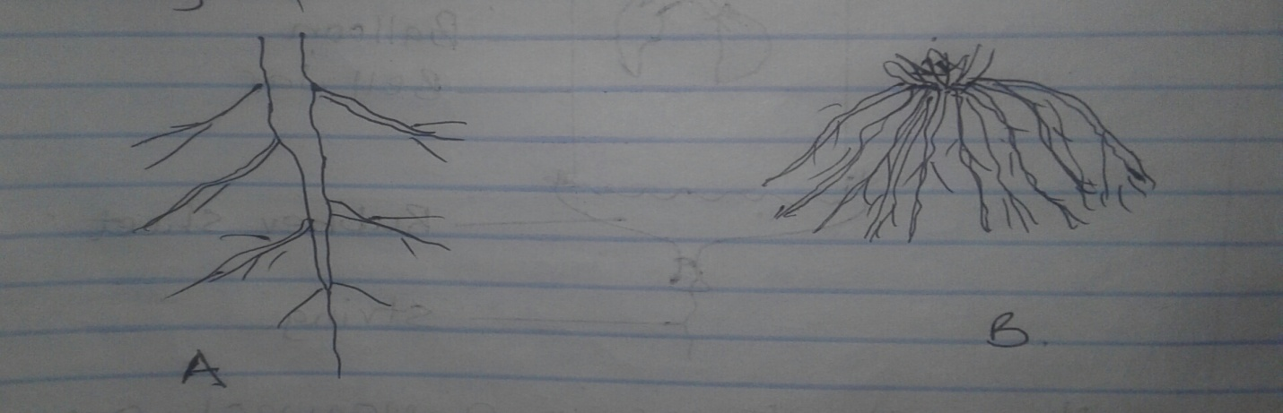
- Name the organs illustrated. (1mk)

b) State the class of plants to which each belong (2mks)

- a) Name the phylum to which birds, snakes and human beings belong. (1mk)

- List 3 classes found in the phylum mentioned in 3(a) above. (3mks)

4. A student placed a drop of pond water in a cavity slide and observed it under the microscope.
The student observed many moving organisms, one of which is represented in the diagram
Below. 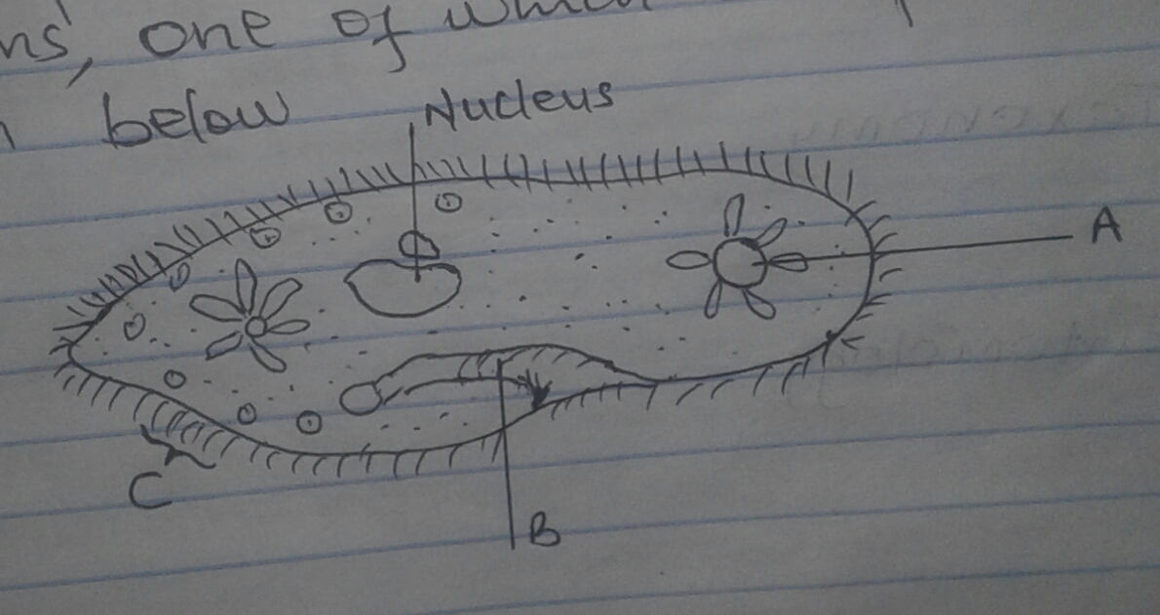

- Name the organism (1mk)

- i)To which kingdom does it belong? (1mk)

ii)Give a reason for your answer in (b)i) above(1mk)

(c)Name the structure labeled A,B and C (3mks)

- State 2 observable features that enable the organism to move fast. (2mks)

5. Explain the meaning of the following terms
i) Zoology (1mk)

ii) Taxonomy (1mk)

iii)Entomology (1mk)

6. study the diagrams of leaves from different plants.

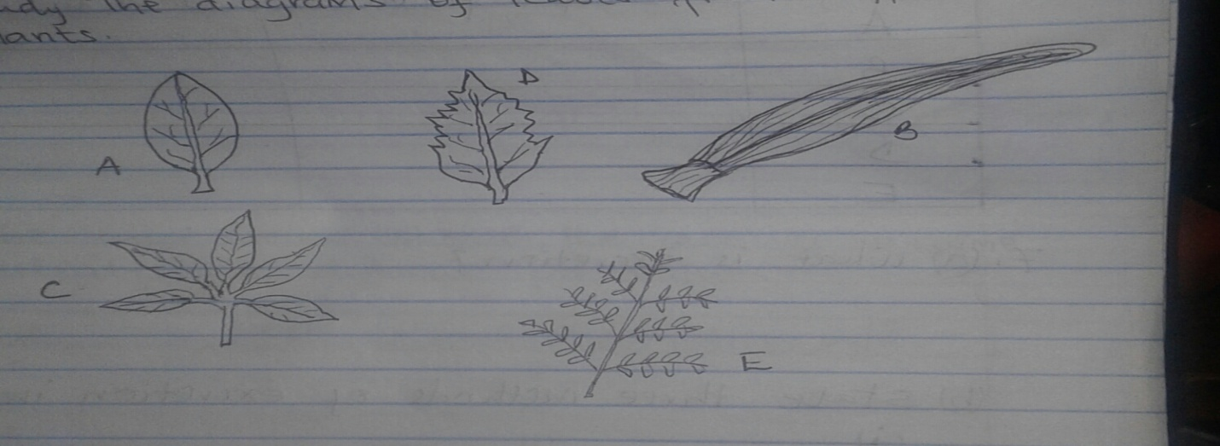
Use the key provided below to identify the plants from which the leaves were obtained.
Key
1a) simple leaf----------------------------------------------------------- go to 2
b) compound leaf ---------------------------------------------------- go to 4
2a) leaf with parallel veins ------------------------------------------ maize
b) leaf with network veins ---------------------------------------- go to 3
3a)leaf margin smooth ---------------------------------------------- bougainvillea
b) leaf margin rough ----------------------------------------------- hibiscus
4a)leaflets palmate --------------------------------------------------- bombax
b)leaflets bipinnate ------------------------------------------------- Acacia
in each case give the sequence of steps in the key which you follow to arrive at the identity. (10mks)
leaf | Steps followed | identity

7(a) What is excretion ? (1mk)

(b)State 3 methods of excretion in plants (3mks)

(c)List 2 excretory products in plants and state their economic importance. (4mks)

8. a) A given food substance is suspected to contain proteins.
i) Name the reagents you would use to test for presence of proteins. (2mks)

ii) Describe the procedure you would use and write the expected results. (2mks)
9. the table below shows the rate of enzyme activity at different PH values.
PH | Rate of product formation mg/hr
1  2  3  4  5  6  7  8  9  10 | 8  10  10  6  3.3  2  1  0.3  0  0

- using a suitable scale, draw a graph of the rate of product formation (vertical axis) against PH (horizontal axis) (6mks)

- from the graph, what was the optimum value for this enzyme? (1mk)

- suppose this enzyme is a digestive enzyme, in which part of the alimentary canal would it be located? Give reason. (2mks)

- Name one digestive enzyme that works in acidic conditions. (1mk)

