MWAKICAN JOINT EXAMINATIONS TEAM(MJET)
FORM THREE
BIOLOGY PAPER 1:231/1
TIME: 2 HRS
NAME:............................................................ ADM.NO:....................
Instructions: Answer all the questions in the spaces provided.
1. What is the role of the following organelles? (2mks)
(a) Ribosomes

(b) Secretory vesicle

2 Give a reason why the coarse adjustment knob should not be used together with the high power objective lens. (1mk)

3 What are the structural differences between mitochondria and chloroplasts? (2mks)

4 Which processes of living organisms depend on diffusion? (2mks)

5 During a biological experiments, some form one students peeled a medium sized potato and bored a hole on top. They then boiled the potato for 10 minutes then set up the experiment as shown below.
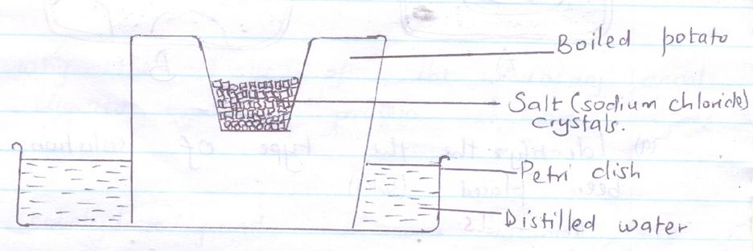(a) Which physiological process was being investigated? (1MK)

(b)(i) State the expected results after 30 minutes. (1mk)

(ii) Give a reason for the results obtained in (b)(i) above. (2mks)

6(a) What is wilting? (1mk)

(b) State how temporary wilting can be advantageous to plants. (1mk)
7 Epidermal cells of onion bulb were placed in three liquids A,B and C of different concentrations. Sections were then placed on a glass slide and observed under the medium power of the microscope.
The appearance of each is shown in the diagram A,B and C
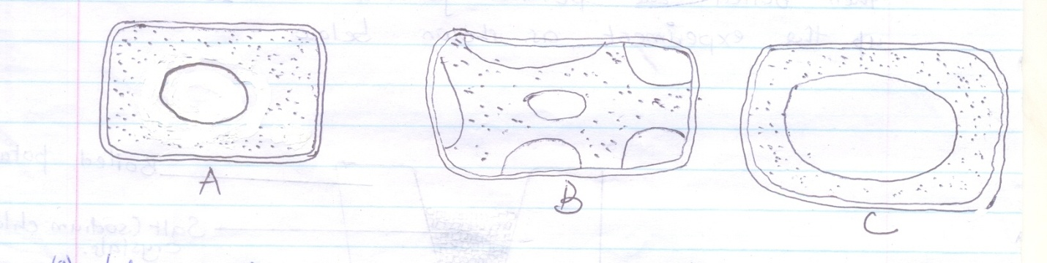
(a) Identify the type of solution each cell had been placed. (3mks)
A -
B -
C -

(b) State the physiological term applied to the epidermal cell labeled B. (1mk)

8. How are the following parts of a leaf adapted to their functions.
(a) cuticle and epidermis (1mk)

(b) palisade mesophyll layer (1mk)

(c) Lamina (1mk)

9(a) What are enzyme inhibitors (1mk)

(b) Give three possible ways of terminating an enzyme – catalyzed reaction. (3mks)

10(a) What is the function of bile salts? (1mk)

(b) Explain why the walls of the alimentary canal are not digested by the protein digestive enzymes. (1mk)

(c) Name one carbohydrate found in a balanced diet, that enhances the process of peristalsis. (1mk)

11(a) Which apparatus is used to measure the rate of transpiration. (1mk)

(b) State two precautions which should be taken when setting up the apparatus you have named in 11(a) above, (2mks)

12(a) Give two reasons as to why clotting of blood is important. (2mks)

(b) What is the role of platelets in the process of blood clotting. (1mk)

(c) Name two enzymes required in the process of blood clotting. (2mks)

13 Using relevant examples distinguish between single and double circulatory systems. (2mks)

14 What is the role of vascular bundles in plant nutrition? (3mks)
15 What characteristics do mammalian lungs and the gills of bony fish have in common that enables them to exchange gases efficiently? (3mks)

16 The table below shows the percentage composition by volume of inhaled and exhaled air:-
Gas | Inhaled air (%) | Exhaled air (%)
Oxygen | 21 | 16
Carbon IV oxide | 0.03 | 4.0
Nitrogen | 79 | 79

(a) By what percentage is the carbon (iv) oxide concentration in exhaled air higher than inhaled air? (1mk)

(b) Explain the difference in the composition of the gases between inhaled and exhaled air.(2mks)

17 The equation below shows what happens in cellular respiration.
C₁₈H₃₆O₂ + 26 O₂ 18CO₂ + H₂O + ATP
(a) What do you understand by the term Respiratory Quotient? (1mk)

(b)(i) Work out the RQ for the above substance. (2mks)

(ii) Identify the substance being oxidized. (1mk)

(iii) Which type of respiration is taking place? (1mk)

18(a) Explain what is meant by the term osmoregulation. (1mk)

(b) State two ways in which glomerular filtrate is different from urine. (2mks)

(c) Which gland secretes antidiuretic hormone? (1mk)

(d) What causes diabetes mellitus? (1mk)

19 The table provided shows the concentration of sodium and iodine in sea water and cell sap of a plant.
 | Sodium ion concentration | Iodine ion concentration
Sea water | 250 | 35
Cell sap | 100 | 550

(a)(i) Name the process through which the plant cells take up sodium ions. (1mk)

(ii) Give a reason for your answer in (a)(i) above. (1mk)

(b) If the plant was sprayed with a chemical that inhibits respiration
(i) Which of the two ions uptake will be affected? (1mk)

(ii) Give a reason for your answer in (b)(i) above (1mk)

20 The figure below represents an organism.
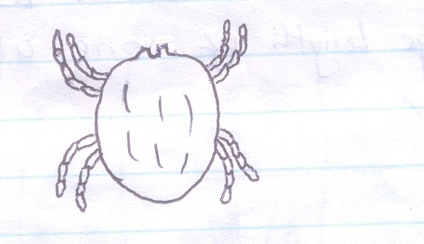

(a) Name the phylum and the class to which the organism belongs. (2mks)
Phylum

Class

(b) State two observable features that are used to place the organism in class (a) above. (2mks)

21 The diagram below shows how gaseous exchange occurs across the gills of fish.
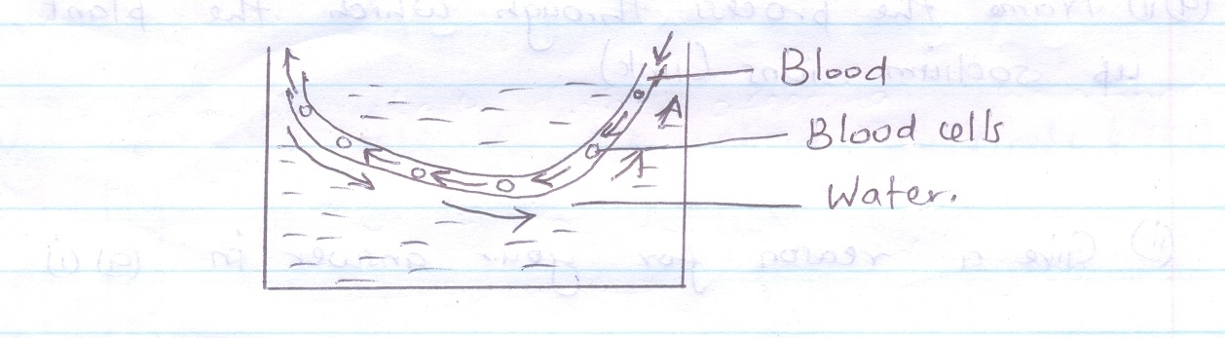
(a) What is the term used to describe the type of flow displayed above? (1mk)

(b) What is the advantage of this flow system? (1mk)

c) Name an organ in human beings which display this flow system. (1mk)

22 Using a microscope, a student counted 55 cells across a field of view whose diameter was 6000$µm.$ Calculate the average length of one Cell. Show your working. (1mk)

23 The figure below shows the nuclear of a diploid cell during the early stages of cell division
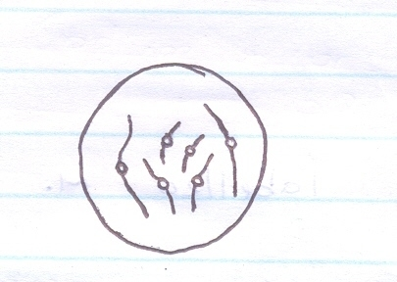

a) How many pairs of chromosomes does it have? (1mk)

b) Draw a diagram to show how the nucleus of the daughter cell would look like after
(i) Mitosis (1mk)

(ii) Meiosis (1mk)

24 The diagram below represents a stage during cell division
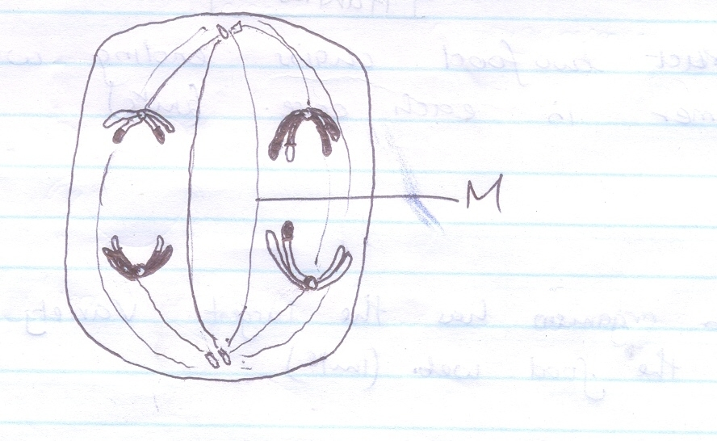
(a)(I) Identify the stage of cell division. (1mk)

(ii) Give three reasons for your answer in (a)(i) above.

(b) Name the structures labeled M. (1mk)
25 The following chart shows a feeding relationship in an ecosystem.

Green plants

Grass hopper Mice

Lizards Domestic cat

Snakes Wild cat

Hawks
(a) Construct two food chains ending with tertiary consumer in each case. (2mks)

(b) Which organism has the largest variety of predator in the food web. (1mk)

(c) Suggest three ways in which the ecosystem would be affected if there was prolonged drought. (3mks)

