MWAKICAN JOINT EXAM TEAM

FORM 3 BIOLOGY PP 2 MARKING SCHEME
END OF TERM 2 – 2015

1(a)(i) A - Nucleus
C - Cell wall

(ii) - Maintain the shape of the cell;
- Providing support to herbaceous plants; (any 1)
- Stores sugar and salts;

(b) Hypotonic solution / dilute solution / dilute sugar / salt solution.

(c) The potato cell sap was lowly concentrated than the surrounding solution; hence lost
water molecules by osmosis (through semi-permeable membrane) to become plasmolysed.

(d) - Opening and closing of stomata.
- Absorption of water by root hairs.
- Absorption of water in intestines.
- Reabsorption of water in kidney nephron. (any 2)
- Feeding in insectivorous plants.
- Movement of water from cell to cell.
- Osmoregulation.

2(a) Cartepillars
- Aphids
Mice each (1/2 mk)
Slugs

- Primary consumers

(b)(i) Plants Cartepillars Insectivorous hawks ;
Birds

(ii) Plants Slugs Frogs Snakes Hawks (any 1)

Plants Aphids Beetles Insectivorous Hawks
Plants

(c)(i) Largest Biomass - plants
Directly obtain energy from the sun.

(ii) Least biomass - Hawks
- Loss of energy in form of heat, respiration, defaceation, excretion.

- Sun / solar energy.

3(a) A - Villus
B - Lacteal

(b) A - Increases surface area for maximum digestion and absorption.
B - Absorption of fatty acids and glycerol.

(c) - Final digestion of food.
- Absorption of soluble products of digestion.

(d) Produces bile juice which contain bile salts that emulsify fats; and neutralizes the acidic chyme from the stomach;

4(a) Deamination

(b) Liver

(c) - Removal of excess amino acids.
- Availing of energy in the body. (any 1)
- Formation of glycogen / fats for storage.
(award any one)
(d) Urea

(e) It is transported to the kidney where it is excreted.

(f) (i) Diabetes inspidus

(ii) Antidiuretic Hormone / Vasopressin

(iii) Pituitary gland.

5(a) To remove / expel dissolved air from the glucose solution.

(b) To prevent entry of oxygen into the yeast – glucose solution.

(c) Anaerobic respiration.

(d) Becomes white precipitate.

(e) High temperature kills the yeast cells; hence the reaction stops;

(f) - Making of beer / Brewing / Ethanol / Alcohol.
- Baking industry / Raising of the dough. (any 2)
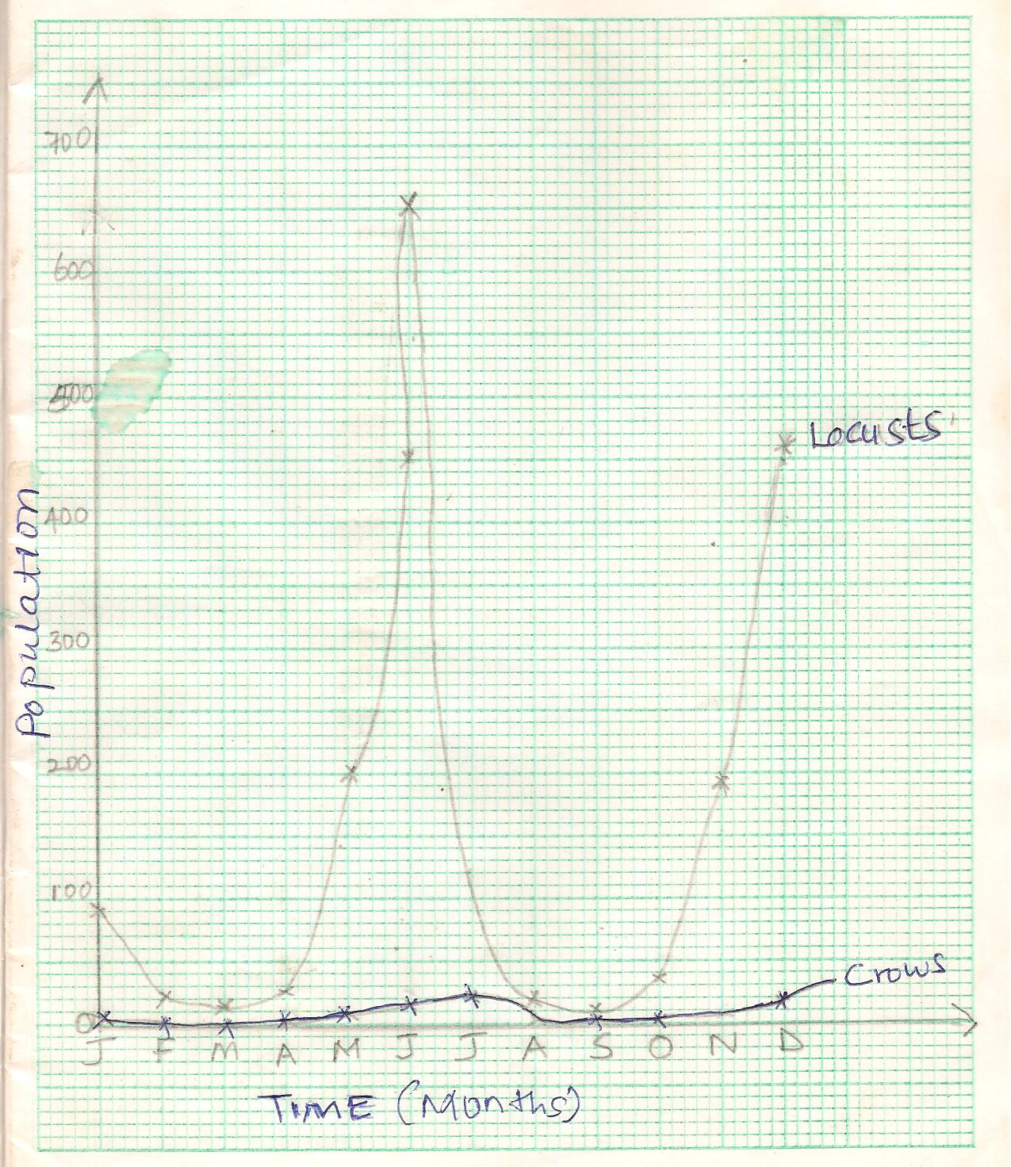
6(a)

- Axes labelling (2mks)
Scale (x and y – axis) (2mks)
Curve plotting - each (1mk) total 2mks
Curve labeling - each (1mk) total 2mks

(b)(i)The population of locusts increase with increase in the amount of rainfall.

(ii)Increased amount of food;
Improved breeding conditions;

- The population of both decreases;
Less food availability to locusts and crows.

- Capture – Recapture method.

- (i) Locust – Primary consumers

Crows – Secondary consumers

(ii) Grass Locusts Crows

- Grass would increase
crows would reduce

- (i) Biomass – The total dry weight of organisms at a particular trophic level.

- Ecosystem – A natural unit composed of abiotic and biotic factors whose
interactions lead to a self-sustaining system.

- Xerophytes
- Have thick cuticle to prevent cuticular transpiration.
- Have reduced stomata on lower leaf surface to lower transpiration.
- Fold or curl leaves in dry weather to protect stomata from direct sunlight.
- Have reversed stomatal opening rhythm where they open at night to reduce water loss.
- Have succulent stems and leaves to store water for use in dry season.
- Some have superficial roots to absorb light showers of rain.
- Some are deep rooted to absorb water from water table.
- Shedding of leaves during dry season.
- Some have short life cycles and survive as underground perennating structures or seeds during drought.
- Hairy leaves.
- Sunken stomata 1 x 10 = 10mks.

Hydrophytes
- Submerged plants have dissected leaves to increase surface area for maximum light absorption.
- Emerged plants have broad leaves with stomata on upper surface to increase transpiration.
- Have aerenchyma tissue to increase buoyancy and for gaseous exchange.
- Floating water plants have raised flower for pollination.
- Poorly developed roots that lack root hairs to reduce absorption of water.
- Some submerged plants have sensitive chloroplasts that photosynthesise in low light intensities. 5 x 2 = 10mks

- High body temperature above normal:
- Sweat glands; Produce sweat; water in the sweat evaporates / sweat evaporates; absorbing latent heat of vaporization producing a cooling effect;
- Hairs lie flat; due to relaxation of erector pilli muscles; no / little air is trapped; hence increased heat loss from the body;
- Blood vessels / arterioles; vasodilate / dilate; more blood flow to the skin hence loss of heat from the body, by radiation and convection;
When body temperature is low below normal:
- Sweat glands produce less / no sweat; no latent heat is absorbed; more heat retained in the body;
- The hairs stand upright / erect; to trap air between them; that insulate the body against heat loss; more heat retained in the body.
- Blood vessels / arterioles vasoconstrict / constrict;
Less blood flow to the skin; reduces heat loss / more heat is retained in the body;

(20mks)

(;) means a marking point.

