Name: . …………………………………………………..............................

Candidate’s Signature……………………………

Date: ……………………………………

ST.CLAIRE GIRLS HIGH SCHOOL

231/1
BIOLOGY
PAPER 1
FORM 3
TIME: 2 HOURS

QuestionS | Maximum Score | Candidate’s Score
1 - 29 | 70

SECTION A

1. The scientific name for French bean is Pharseolus vulgaris
(a) What taxon does the term Phaseolus represents? (1 mark)
…………………………………………………………………………………………………………
(b) State two rules that are followed when giving a scientific name to an organism. (2 marks)
…………………………………………………………………………………………………………
…………………………………………………………………………………………………………
2. a) What is the function of the mirror in the microscope? (1 mark)
…………………………………………………………………………………………………………
b) Which organelle would be abundant in:
Skeletal muscle cell (1 mark)
…………………………………………………………………………………………………………
Palisade cell (1 mark)
…………………………………………………………………………………………………………

3 State two advantages of breathing through the nose than through the mouth. (2 marks)

4 Name two mineral elements required in the synthesis of chlorophyll. (2 marks)
…………………………………………………………………………………………………………
…………………………………………………………………………………………………………

5 a) State the function of amylase in human body. (1 mark)
…………………………………………………………………………………………………………
…………………………………………………………………………………………………………
b) Name two parts of the alimentary canal where amylase is secreted. (2 marks)
…………………………………………………………………………………………………………
…………………………………………………………………………………………………………

6 Give the function of melanin pigment produced in the skin of man. (1 mark)
…………………………………………………………………………………………………………

7 A student while carrying out an experiment observed 8 cells across the field of view of light microscope. If the diameter of the field of view is 5 mm, calculate the average length of each cell in micrometers. (2 marks)

8 Differentiate between respiration and respiratory surface. (2 marks)
…………………………………………………………………………………………………………
…………………………………………………………………………………………………………

9 State two adaptations of skin of the frog to gaseous exchange. (2 marks)
…………………………………………………………………………………………………………
…………………………………………………………………………………………………………

10 a) Name two structures of gaseous exchange in aquatic plants. (2 marks)
…………………………………………………………………………………………………………
…………………………………………………………………………………………………………
b) What is the effect of contraction of the diaphragm muscles during breathing in mammals? (2 marks)

11 The diagram below represents part of the mammalian blood circulatory system and some associated glands.
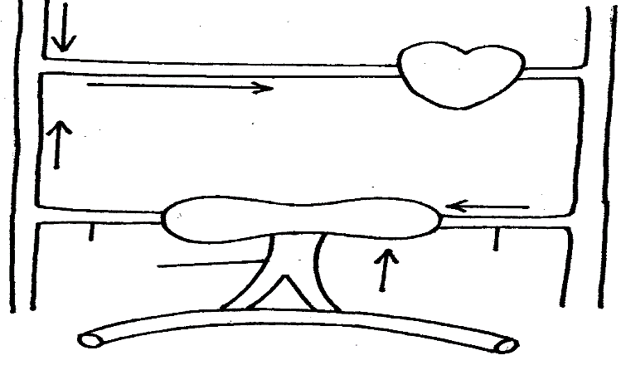

- Name the blood vessels A and B (2 marks)
………………………………………………………………………………………………………….…………………………………………………………………………………………………………..
(b) State two structural differences between the blood vessels labeled A and C (2 marks)

12 a) Name the disease caused by H.I.V (1 mark)
…………………………………………………………………………………………………………
b) Give two reason why it is difficult to cure the disease named above. (2 marks)
…………………………………………………………………………………………………………
…………………………………………………………………………………………………………
c) Give one preventive measure of the named disease. (1 mark)
.…………………………………………………………………………………………………………………………………………………………………………………………………………..

13 State two roles played by the bark in plants (2 marks)
…………………………………………………………………………………………………………………………………………………………………………………………………
.………………………………………………………………………………………………………………………………………………………………………………………………….
…………………………………………………………………………………………………………………………………………………………………………………………………….

14 A student mashed a piece of ripe banana and made it into paste by adding water, place the paste in a visking tubing and suspended it in a beaker containing iodine solution as shown below. The set up was left for 40 minutes.
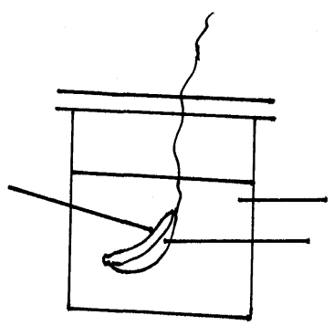

a) State the physiological process under investigation. (1 mark)
……………………………………………………………………………………………………………………………………………………………………………………………………………………
b) Account for the result obtained in the table. (2 marks)
………………………………………………………………………………………………………………………………………………………………………………………………
……………………………………………………………………………………………………………………………………………………………………………………………………
…………………………………………………………………………………………………………………………………………………………………………………………………
………………………………………………………………………………………………………………………………………………………………………………………………….
15 During oxidation of certain foods substances the respiratory quotient was found to be 0.718.
i) Name the type of food substance being oxidized. (1 mark)

……………………………………………………………………………………………………………………………………………………………………………………………………………………
ii) State two advantages of using the food substances named. (2 marks)

…………………………………………………………………………………………………………………………………………………………………………………………………………………

- 16 Name the tissues whose cells are thickened with:
    - Cellulose and pectin. (1mk)
………………………………………………………………………….
    - Lignin. (1mk)
………………………………………………………………………….
17. a) Define the term immunity. (1mk)
…………………………………………………………………………………………………
……………………………………………………………………………………………………………………………………………………………………………………………
b) Distinguish between natural immunity and acquired immunity. (1mk)
………………………………………………………………………………………………………………………………………………………………………………………………………………………………………………………………………………………………………………………………………………………………………………………………

c) Identify one immunizable disease in Kenya. (1mk)
…………………………………………………………………………………………….
18. State three differences between osmosis and active transport. (3mk)
…………………………………………………………………………………………………………………
………………………………………………………………………………………………………………
……………………………………………………………………………………………………………
………………………………………………………………………………………………………………
………………………………………………………………………………………………..
19 What is meant by the following biological terms?
- Crenation (1mk)
………………………………………………………………………………………………
……………………………………………………………………………………………….

ii) Haemolysis (1mk)
…………………………………………………………………………………………….
…………………………………………………………………………………………….

iii) Plasmolysis (1mk)
………………………………………………………………………………………………
………………………………………………………………………………………………

20. a) State the major factor in the ‘Global warming’ experienced in the world today. (1mk)

……………………………………………………………………………………………..
b) Suggest two ways of reducing the Global warming. (2mk)
………………………………………………………………………………………………
………………………………………………………………………………………………
………………………………………………………………………………………………
21 a) Name a protein and vitamin involved in blood clotting.
i) Protein. (1mk)

………………………………………………………………………………………………
ii) Vitamin (1mk)

………………………………………………………………………………………………
b) Explain why blood is not normally used for transfusion after one month. (1mk)
……………………………………………………………………………………………..
……………………………………………………………………………………………..
……………………………………………………………………………………………..
22. The diagram below represents an experimental set up to investigate a certain scientific concept. The potted plant was first destarched by keeping it in dark for four days.
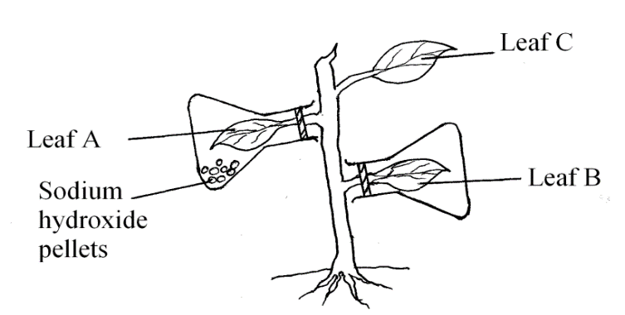
The set up was then placed in sunlight for five hours and leaves were tested for starch.
a) What scientific concept was being investigated? (1mk)
b) i) Give the results likely to be obtained after starch test for A and B.
A ………………………………………………………………………… (1mk)
B ………………………………………………………………………… (1mk)
ii) Account for the results in leaf A in b (i) above. (1mk)
…………………………………………………………………………………..
……………………………………………………………………………………
…………………………………………………………………………………
c) Why was leaf C included in the set-up? (1mk)
………………………………………………………………………………………

23a) Explain the importance of transport in plants. (1mk)

b) What is the role of root hairs in plants? (1mk)

24. Study the reaction below and answer the questions that follow.
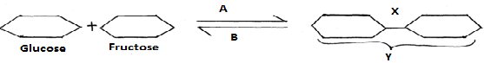

a) What biological processes are represented by A and B? (2mk)

A ................................................................................................................................

B .............................................................................................................................
b) Identify the product Y. (1mk)
................................................................................................................................................

c) State the bond represented by X. (1mk)
................................................................................................................................................

25. Explain the events of the light stage of photosynthesis. (3mk)

MARCH/APRIL 2016
BIOLOGY PAPER 1
MARKING SCHEME

1. a) genus
b) – the genus name should be in capital letter and the species name with a small letter:
- should be printed in italic or when ad written should be underlined as separate words:
2 – should be Latinized i.e. made to sound like Latin words: (2 correct responses 1x 2mks)
a) Reflects light through the source through the condenser to the stage: (1)
b) - Mitochondria
- Chloroplasts

3 - Air is cleaned cilia.
- Amount of air taken in is controlled. (2 marls)
- Any smell in the air is detected
4 - Magnesium
- Nitrogen:
- Iron. Acc. Magnesium ion/ iron rej symbols of elements

5 a) Digests starch to maltase
b) - Mouth
- Duodenum:
6. - Screen or protects against ultra violet rays from the sun (1 mk)
7 Average length of one cell = field diameter/ no. of cells
5mm/8t: 0.625mm
0.625 x 1000 = 625 micrometers (2mk)
8. - Respiration is the chemical breakdown of glucose to release energy
- Respiratory surface is the surface across which respiratory gases exchange
9. Moist for gases to dissolve efficient diffusion;
- Large to provide a large surface area over which gaseous exchange takes place;
- Highly vasculatrized for fast transport of gases in and out of the ski;
- Thin epithelium for fast diffusion of gases; (3 correct response 1 x 3)
10. a) -Pneumatophores
- Aeronchyma tissues
- Cuticle
b) - Eternal intercostals muscles relax while internal intercostals muscles contract; moving the rib cage
Downwards and inwards: The diaphragm muscles relax making it dome shape;
- The volume of the thoracic cavity decreases while its pressure increases pushing air outside due to low atmospheric pressure; (4 mks)
11. a) A- Hepatic portal vein; B – Hepatic vein
b)
Hepatic portal veins | Hepatic artery
- Wide/ large lumen | -Narrow lumen
- Presence of valves | - Absence of valves
Thinner walls/ less muscular walls | - Thick walls/ muscular walls
;
12. a) Acquire Immuno – deficiency Syndrome/ AIDS
b) It destroys the immune system virus replicates rapidly
Virus is obligate intracellular
- - Screen blood for HIV before transfusions;
- Avoid multiple sexual partner
- Sterilize surgical implements before use
- HIV positive mothers should avoid breast feeding mark one
13 – Insulation against fire;
- Protects against infection by fungi;
- Prevents damage by insects
- Prevents loss of water; (3 correct responses (3 mks))
14. a) Diffusion (1 mark)
b) Iodine molecules from the beaker moved into the visking tubing by diffusion since they were small in size; (iodine reacted with starch to form blue- black colour). Colour of iodine solution outside remain brown as starch molecule were too large to pass through the visking tubing. (2marks)

15. (i) Fats/ lipids – accumulated ions
(ii) Release large amount of energy per molecule on complete oxidation; √ produces a lot of water on oxidation; √ (use for other metabolic activities)

16 Name the tissues whose cells are thickened with:
    - Cellulose and pectin. (1mk)
Collenchyma;
    - Lignin. (1mk)
Sclerenchyma
17. a) Define the term immunity. (1mk)
Ability of the body to identify/ recognize foreign antigens and develop mechanisms of destroying them / ability to resist infection;
b) Distinguish between natural immunity and acquired immunity. (1mk)
Natural immunity is inborn /inherited /passed from parents to offspring while acquired immunity is obtained in life;
c) Identify one immunizable disease in Kenya. (1mk)
Tuberculosis; poliomyelitis; diphtheria; whooping cough; measles;
18 State three differences between osmosis and active transport. (3mk)
Osmosis involves movement of water /solvent molecules, active transport involves movement of solute molecules; osmosis does not require energy, active transport requires energy; in osmosis molecules move along a concentration gradient, in active transport molecules move against a concentration gradient;
19.What is meant by the following biological terms?
- Crenation Shrinking of red blood cells/ animal cells as a result of water loss by osmosis (when placed in hypertonic solution); (1mk)
ii) Haemolysis (1mk)
Bursting of red blood cells as a result of uptake of water by osmosis (when placed in hypotonic solution);
iii) Plasmolysis (1mk)
Shrinking and pulling away of the cell membrane from the cell wall of
plant as a result of water loss by osmosis;
20.a) State the major factor in the ‘Global warming’ experienced in the world today. (1mk)
Carbon (IV) Oxide; rej.Carbon (iv) Oxide
b) Suggest two ways of reducing the Global warming. (2mk)
Reducing use wood / fossil fuels; planting more trees / afforestation or re-afforestation;
21.a) Name a protein and vitamin involved in blood clotting.
i) Protein. (1mk)
Fibrinogen;
ii) Vitamin (1mk)
(Vitamin) K;
b) Explain why blood is not normally used for transfusion after one month. (1mk)
Most of the red blood cells will have died;
22. The diagram below represents an experimental set up to investigate a certain scientific concept. The potted plant was first destarched by keeping it in dark for four days.
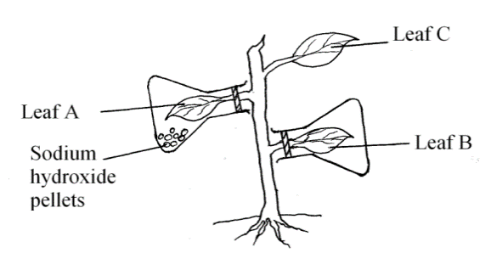
The set up was then placed in sunlight for five hours and leaves were tested for starch.
a) What scientific concept was being investigated? (1mk)
Photosynthesis;
b) i) Give the results likely to be obtained after starch test for A and B.
A – Negative test / starch absent; (1mk)
B – Positive test / starch present; (1mk)
ii) Account for the results in leaf A in b (i) above. (1mk)
Sodium hydroxide absorbed all the Carbon (IV) Oxide hence no photosynthesis;
c) Why was leaf C included in the set-up? (1mk)
Control experiment;

23.a) Explain the importance of transport in plants. (2mk)
Supplies water and mineral ions to the (photosynthetic) cells; conduct products of photosynthesis / nutrients to all parts of the plant / translocation;
b) What is the role of root hairs in plants? (1mk
Absorption of water and mineral ions from the soil;
24. Study the reaction below and answer the questions that follow.
a) What biological processes are represented by A and B? (2mk)
A – Condensation; B – Hydrolysis;
b) Identify the product Y. (1mk)
Sucrose;
c) State the bond represented by X. Glycosidic; (1mk)
25 .Explain the events of the light stage of photosynthesis. (3mk)
Light energy is s absorbed by chlorophyll molecules; used to split water molecule into oxygen and hydrogen atoms/ ions; light energy is converted into chemical energy (ATP) and stored;

