Gatitu Mixed Secondary School
Form 3 | Term 1 | 231 - Biology | 06-Jan-16 | Opener
1. a) Explain how mammalian lungs are adapted for gaseous exchange (8mks)

b) Name two structures used for gaseous exchange in plants. (2mks)

2. Why are gills in fish highly vascularized? (2mks)
3. Describe the process of inhalation in mammals. (10 mks)

4. The diagram below represents a part of the rib cage.
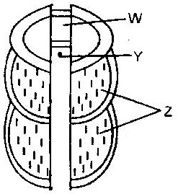

a) Label parts labeled W, Y and Z (3mks)
b) How does the part labeled Z facilitates breathing in? (2mks)

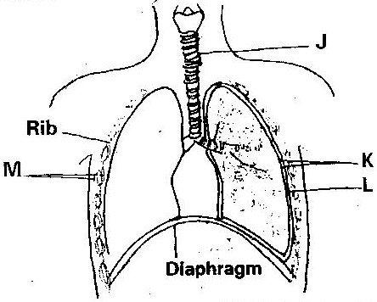
- The diagram below represents some gaseous exchange structures in humans.

a) Label parts K, L and M in the diagram above (3mks)

b) How is the structure labeled J suited to its functions? (3mks)

c) Name the process by which inhaled air moves from the structure labeled L into blood capillaries (1mk)

d) Give the scientific name of the organism that causes tuberculosis in humans. (2mks)

6. Name the main site of gaseous exchange in
a) Mammals
b) Fish
c) Leaves
d) Amoeba (4mks)

7. The diagram below shows a set up that was used to demonstrate fermentation.
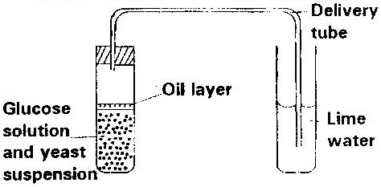

Glucose solution was boiled and oil added on top of it. The glucose solution was then allowed to cool before adding the yeast suspension.
a) Why was the glucose solution boiled before adding the yeast suspension? (1mk)

b) What was the importance of cooling the glucose solution before adding the yeast suspension? (2mks)

c) What was the use of the oil in the experiment? (1mk)

d) What observation would be made in test tube B at the end of the experiment (1mk)

e) Suggest a control for this experiment (1mk)

8. Give two reasons why accumulation of lactic acid during vigorous exercise lead to an increase in heartbeat. (2mks)

9. A process that occurs in plants is represented by the equation below.
C₆H₁₂O₆ 2C₂ H₅OH + 2CO₂+ Energy
Glucose Ethanol Carbon Dioxide
a) Name the process (1mk)
b) State the economic importance of process name in (a) above. (1mk)

