GATITU GIRLS SECONDARY
BIOLOGY TUNE-UP TERM 1 2017
FORM 2
- Differentiate the following
- osmosis and diffusion [2mks]
osmosis is the movement of solvent molecules from a lowly concentrated solution to a highly concentrated solution through a semi permeable membrane
Diffusion is the movement of particles from a highly conc region to a region of low conc region

- Heterotrophism and autotrophism [2mks]
Heterotrophism is the mode of nutrition whereby an organism feeds on already made food
autotrophism is the mode of nutrition where organisms manufacture their own food

- Intracellular enzyme and extracellular enzyme [2mks]

Intracellular enzymes are secreted and used within the cells that produce them
Extracellullar enzymesare produced with in the cell and but used outside the cell

- Explain how thickness of membrane and tissue affects diffusion [2mks]

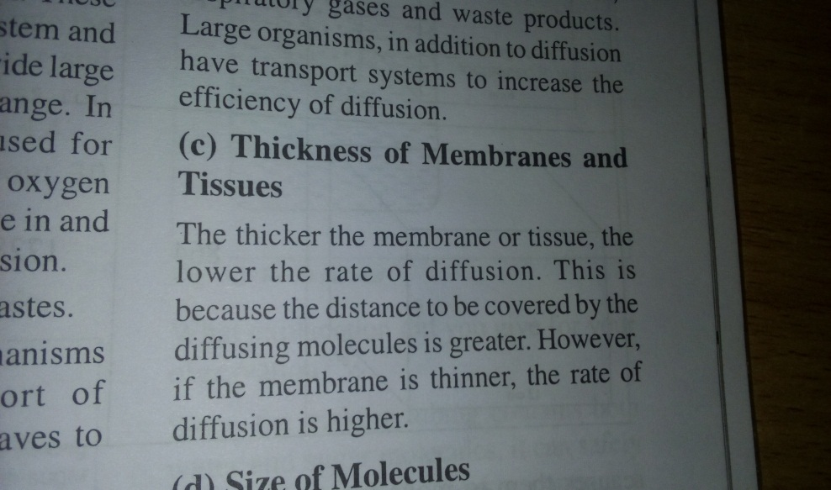

- State 4 adaptations of the leaf to photosynthesis [4mks]

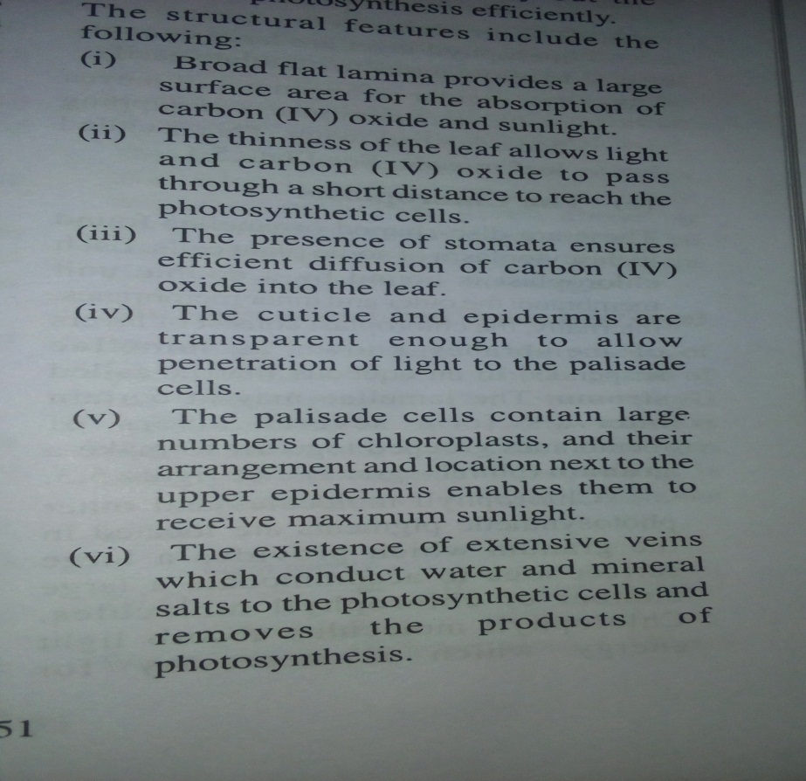

b)Define photosynthesis [2mks]
this is the process by which green plants combine oxygen and carbon dioxide in the presence of light energy and chlorophyll to produce simple carbohydrates and releasing oxygen

- With the aid of a graph explain how temperature affects the rate of photosynthesis [4mks]

`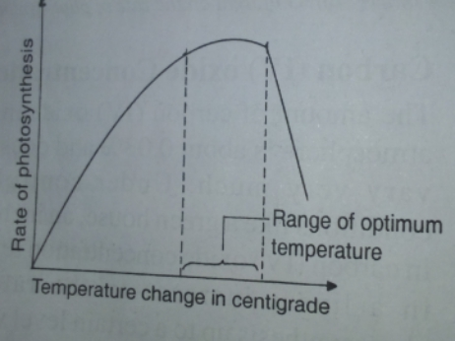
At low temps the rate of photosynthesis is low
At high temps the rate of photosynthesis increases but up to a certain temp of 40⁰c beyond this temp the rate of photosynthesis decreases sharply and finally stops due to the fact that enzymes are destroyed by high heat

- Explain what happens during light stage in photosynthesis [3mks]

It occurs in the grana.
The light energy absorbed by chlorophyll is used to split water molecules into oxygen and hydrogen atoms.
The H atom enters the dark stage and the oxygen is released to the atmosphere or used in respiration. Some light energy is absorbed and used in the formation of ATP

- State 3 roles of active transport [3mks]

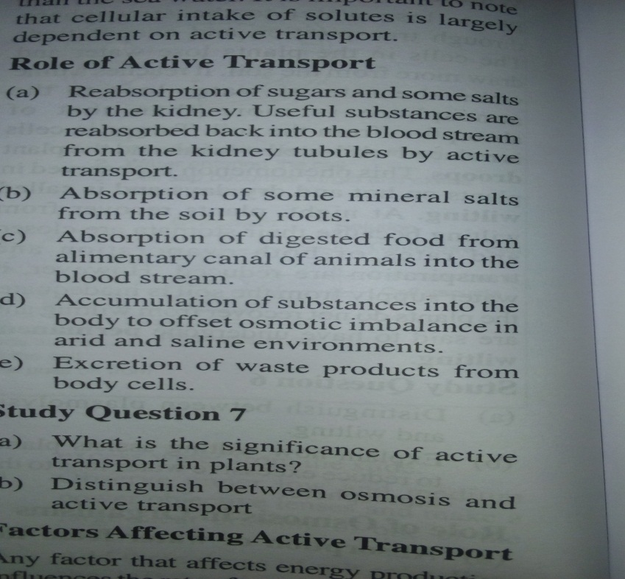

- With the aid of a diagram explain plasmolysis [3mks]

This whereby a plant cell is placed in a hypertonic solution and water molecules move out of the celland into the solution through osmosis. As the water moves out the cell starts to shrink and the plasma membrane pulls away from the cell wall towards the centre.
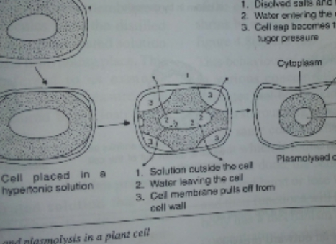
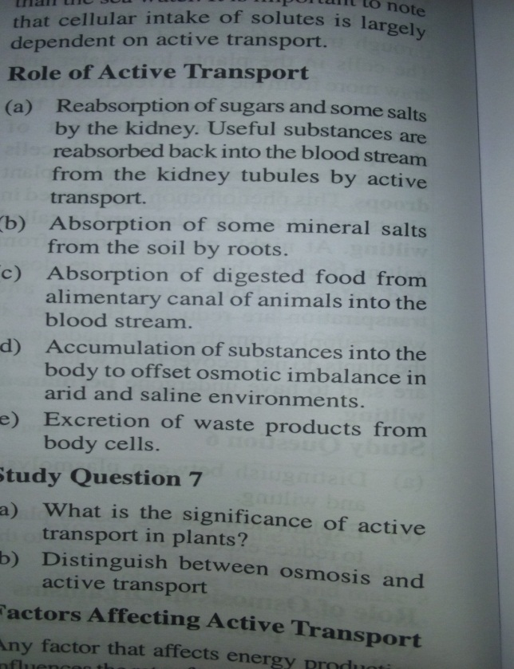

- State 3 functions of lipids [3mks]
Source of energy
Source of metabolic water
Structural compounds
Heat insulation
protection

GATITU GIRLS SECONDARY
AGRICULTURE TUNE-UP TERM 1 2017
FORM 2
- State the 2 categories of cattle breeds based on origin [2mks]

EXOTIC
INDIGENOUS

b) State 4 general characteristics of dairy cattle breeds [4mks]

c) State 2 breeds of dairy goat [2mks]
SAANEN
TOGGENBURG
British alpine

- State 3 characteristics of a fertile soil [3mks]
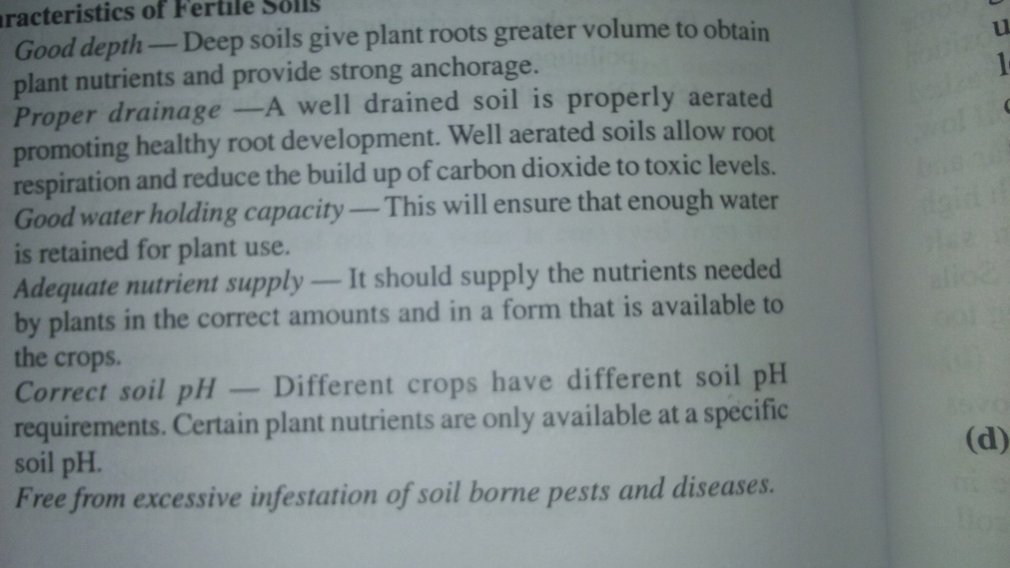

- Explain how burning vegetation cover leads to lose of fertility [2mks]

b) Give 2 disadvantages of burning vegetation cover [2mks]

- State 3 limitations of the use of manure [3mks]
They are bulky
Laborious in application and transport
They spread diseases,pests and weeds
Loss of nutrients
If used when not fully decomposed crop do not benefit

- State 2 factors considered when choosing the type of irrigation to use [2mks]

- State 4 effect of HIV/AIDS and ill health affect agriculture [ 4mks ]
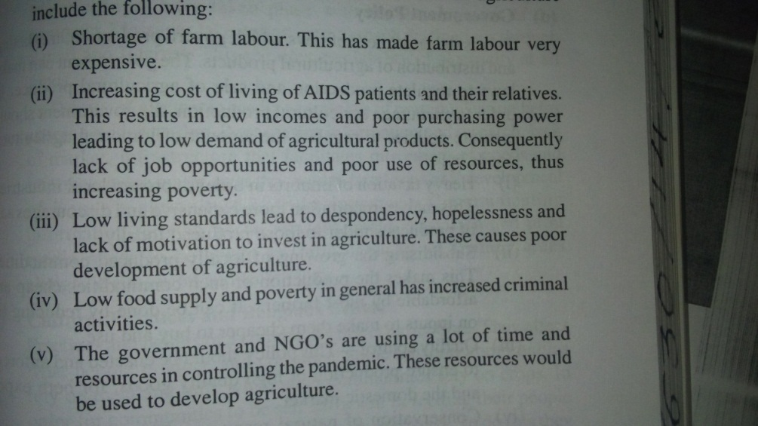

- List 3 forms of water [3mks]
Superfluous water
Capillary water
hygroscopic

- State 2 ways of determining soil texture [2mks]
Mechanical
chemical
- Define the term soil [1mk]
This the topmost layer on the earth surface that supports growth of crops

GATITU GIRLS SECONDARY
AGRICULTURE TUNE-UP TERM 1 2017
FORM 3
- State 4 advantages of broadcasting method of planting [4mks]
It is easier
It is quicker
It is cheaper
Does not require skilled labor
Its not time consuming

- State 2 microbial activities that take place in the rumen of polygastric animals [2mks]
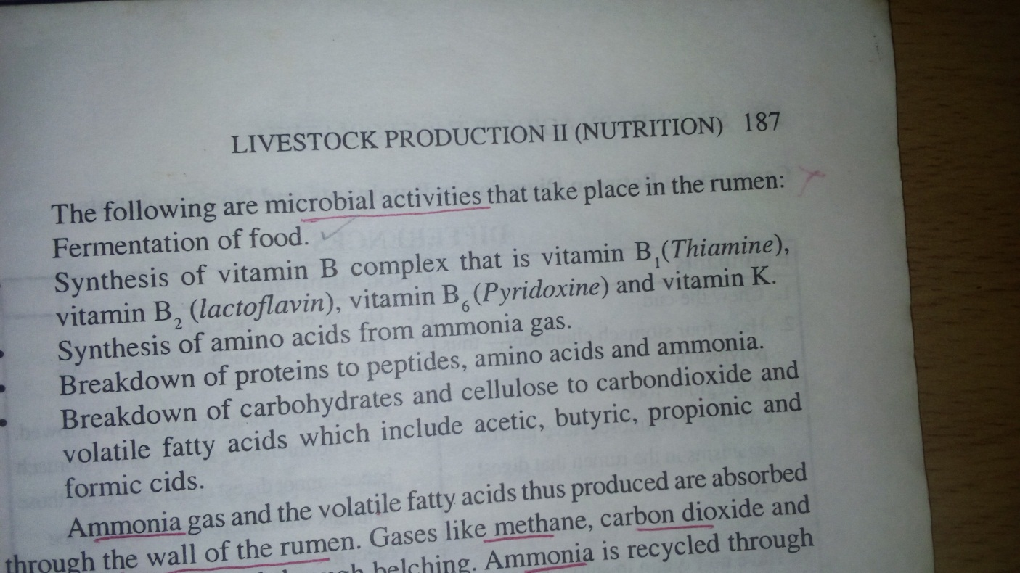

- State 2 functions of the reticulum [2mks]
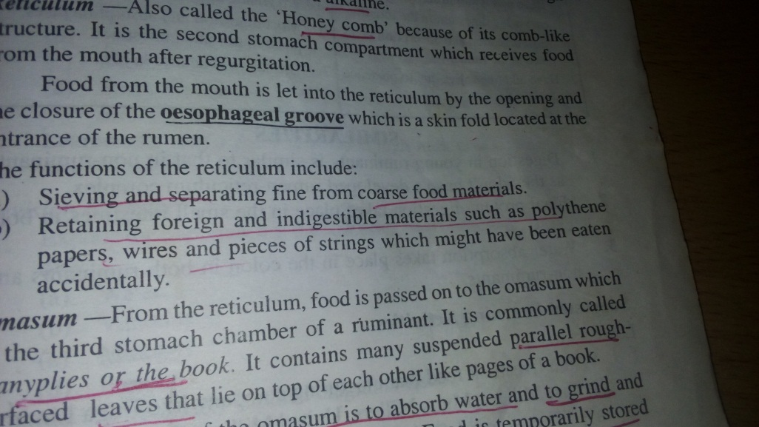

- List 4 factors affecting digestibility [4mks]

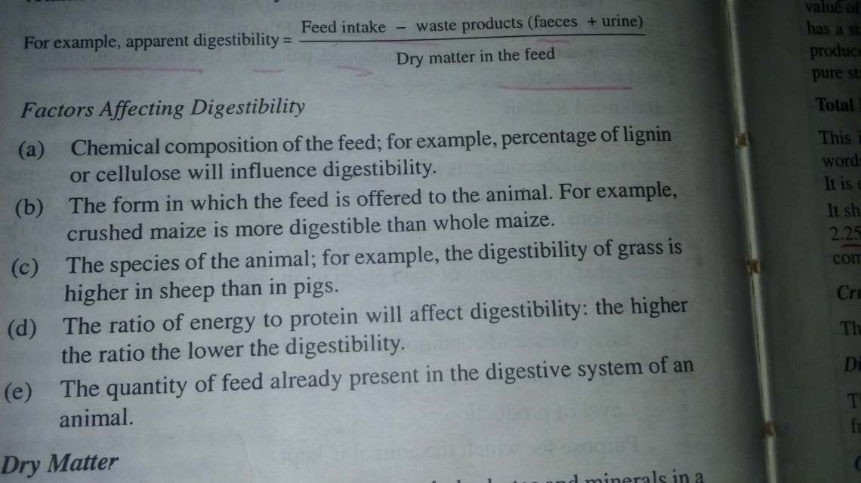

- Explain the life cycle of a three- host tick [3mks]
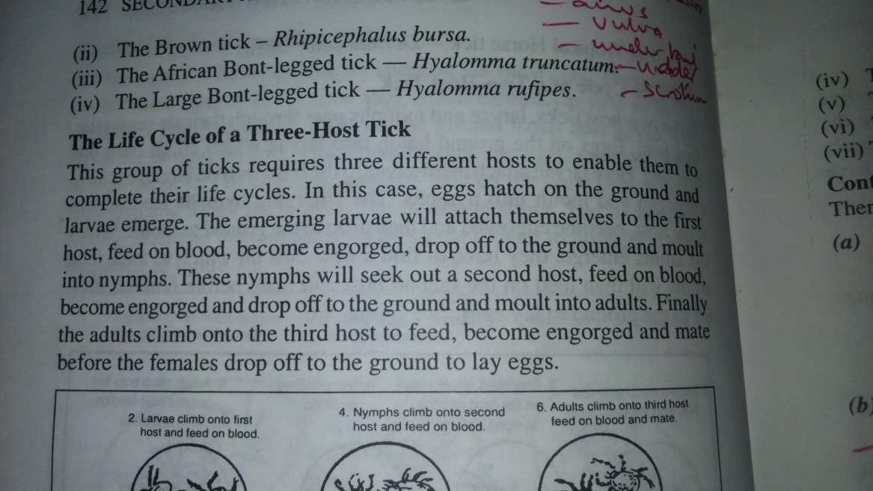

- Give examples of 2- host tick [2mks]
Red legged tick
Brown tick
African bont legged tick
Large bont tick
- Give 3 tapeworm attack symptoms in animals [3mks]

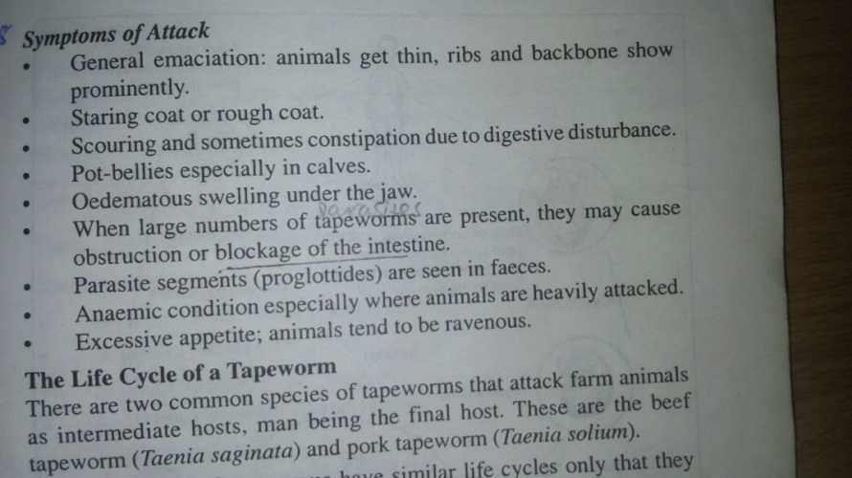

- State 3 characteristics of exotic cattle breeds [3mks]

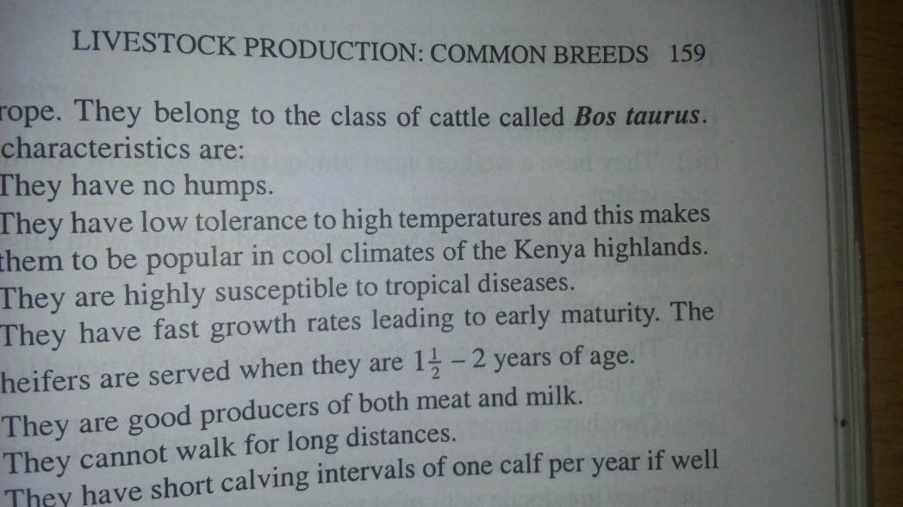

- Differentiate between a pullet and cockerel as used in poultry breeds [2mks]
Pullet - young female bird from 8 weeks to point of lay
Cockerel - - young male bird from 8 weeks to point of lay

- List 2 beef cattle breeds [2mks]
Aberdeen angus
Galloway
Hereford
Beef shorthorns
charolais
7. Define the following terms as used in agricultural economics
a) Field operations
record accounts of all activities taking place in the field

b) Health records
shows health condition of an animal

c) Breeding records
shows breeding activities and programs for different animals in the farm

GATITU GIRLS SECONDARY
BIOLOGY TUNE-UP TERM 1 2017
FORM 4
SECTION A
- Explain why a person could die when he/she inhales gas from burning charcoal in poorly ventilated room [2mks]
The gas produced is carbon monoxide which readily combines with haemoglobin to form a compound that does not readily dissociate with haemoglobin therefore reducing the capacity of haemoglobin to transport oxygen to tissues.

- Explain what happens during the exponential phase on a normal growth curve [3mks]
There is rapid growth and its at its maximum.This rapid growth is due to ;
- There is an increase in the number of cells dividing
- Cells have already adjusted to the new environment
- Food and other factors are not limiting hence the cells are not competing for resources
- Rate of cell increase is higher than the cell death.

- State 3 adaptive characteristics of Ascaris lumbricoides to its parasitic mode of life [3mks]
- It has 2 (pig and humans) hosts and this ensures that it has a ready host for survival
- It lays many eggs to increase chances of survival
- The eggs have a protective shell to survive harsh environmental conditions
- It has a thick elastic cuticle which protects it against digestive enzymes of the alimentary canal
- It has tissues that can can tolerate low oxygen conc in the gut
- It has a musculay pharynx through which it sucks digested food in the hosts intestines

- Explain what happens during light stage of photosynthesis [2mks]
It occurs in the grana.
The light energy absorbed by chlorophyll is used to split water molecules into oxygen and hydrogen atoms.
The H atom enters the dark stage and the oxygen is released to the atmosphere or used in respiration. Some light energy is absorbed and used in the formation of ATP

b) With the aid of a graph explain how temperature affects the rate of photosynthesis [2mks]
`
At low temps the rate of photosynthesis is low
At high temps the rate of photosynthesis increases but up to a certain temp of 40⁰c beyond this temp the rate of photosynthesis decreases sharply and finally stops due to the fact that enzymes are destroyed by high heat

- Give 3 adaptation of the red blood cells to their function [3mks]
- They are bi concave in shape hence increasing their surface area for gaseous exchange
- Thy can change their shape hence they can squeeze through narrow capillaries
- They have haemoglobin which readily combines with oxygen and carbon dioxide
- They do not have a nucleus hence providing room for haemoglobin for carrying more oxygen

b) State the differences between artery and veins [3mks]
ARTERIES | VEINS
Walls are thick muscular and elastic | Walls are thin (less elastic and muscular
Have novalves apart at the base of large arteries | Have valves at intervals
Blood flows rapidly and in pulses | Blood flows slowly under low pressure
Narrow lumen | Wider lumen

- Explain oxygen debt [1mk]
This is the extra oxygen required to get rid of the accumulated lactic acid in the body after a vigorous exercise
b) State 4 factors that affect rate of respiration [4mks]
- Oxygen conc
- Subtrates conc
- Hormones
- Sex
- Age
- occupation

- Give 3 adaptations of the proximal convoluted tubule to its function [3mks]
- cells lining the tubule have numerous mitochondria which provide energy
- cells have microvilli which increases the surface area
- tubule is long and highly coiled to provide a large surface area
- the coiling of the tubule reduces the speed of flow thereby giving more time for efficient reabsorption
- the tubule is well supplied with blood capillaries

- Name 2 nitrifying bacteria in the nitrogen cycle [2mks]
Nitrosomonas
Nitrococcus
Nitrobacter

SECTION B
10) State 5 significance of transpiration [5mks]
- Serves to replace water lost through the leaves
- Uptake and transport of mineral salts and water
- Cools the plant
- Removes excess water
- Responsible of turgor pressure

b) State 3 characteristics of the xylem vessel [3mks]
The walls of the vesselsare strengthened by lignin which prevent collapsing
They are long and hollow to allow continuous flow of water
They have borded pits to allow passage of water in and out of lumen in to neighboring cells

c) Define photosynthesis [2mks]
this is the process by which green plants combine oxygen and carbon dioxide in the presence of light energy and chlorophyll to produce simple carbohydrates and releasing oxygen

- State 5 structural factors that affect transpiration rate [10mks]

Cuticle : plants growing in arid habitats they usually have a thick waxy cuticle which acts as a water proof material hence reducing rate of respiration
Plants growing in areas that have plenty of water they have thin cuticles hence allowing transpiration to occur to get rid of the excess water

Leaf size and shape: Broad leaves expose a large surface area to the environment hence high rate of transpiration. Narrow or needle like leaves expose a small surface area to the environment hence low rate of transpiration

Stomata: some plants close their stomata on a hot day to reduce transpiration
Some have reversed stomatal rhythm ( closing stomata during the day and opening during the night to reduce transpiration

Leaf fall: some plants shed their leaves to reduce the surface area for water loss

Hairy leaves: These hairs trap the layer of still moist air on the surface of the leaves hence reducing transpiration

