GATITU MIXED SECONDARY SCHOOL
FORM 4 BIOLOGY AUGUST HOME ASSIGNMENT
INSTRUCTIONS: All questions and answers should be written at the back of the exercise book. (No question should be left unanswered)
- State one structural and one functional differences between motor and sensory neurons
Structural differences
Functional differences ( 2 marks)
- The table below shows two mammalian hormones. For each hormone, state the site of production and its function in the body.

Hormone | Site of production | Function
Oestrogen
Aldosterone

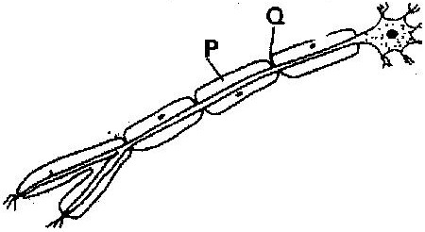

(i) With an arrow, indicate on the diagram the direction of the impulse through the neurone ( 1 mark)
(ii) State the functions of parts labeled P and Q ( 2 marks)
- (a) How are structures of the human eye adapted to their functions ( 14 marks)
(b) State three defects of the eye and how each can be corrected ( 6 marks)
- State the changes that occur in a nerve axon to produce an action potential
( 3 marks)
- In an accident a victim suffered brain injury. Consequently he had loss of memory. Which part of the brain was damaged? ( 1 mark)
- The diagram below shows surface view of a human brain

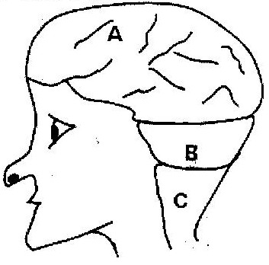

(a) Name the parts labeled B and C ( 2 marks)
(b) State three functions of the part labeled A ( 3 marks)
(c) State what would happen if the part labeled B was damaged. ( 1 mark)
- What is the function of the following cells in the retina of the human eye?(2 marks)
(a) Cones
(b) Rods
- (a) State the functions of the following parts of the mammalian ear
(i) Tympanic membrane ( 3 marks)
(ii) Eustachian tube ( 1 mark)
(iii) Ear ossicles ( 2 marks)
(b) Describe how semi- circular canals perform their functions ( 2 marks)
- State the importance of tactic response among some members of Kingdom Protista? ( 1 mark)
(a) What name is given to response to contact with surface exhibited by
tendrils and climbing stems in plants? ( 1 mark)
(b) State three biological importances of tropisms to plants (3 marks)
- The diagram below represents a reflex arc in human
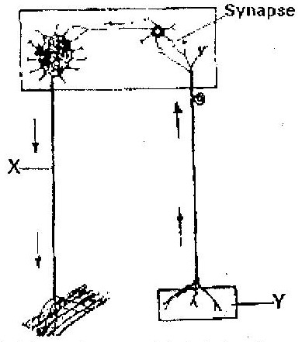

(a) Name the parts labeled X and Y ( 2 marks)
X __________________________
Y __________________________
(b) Name the substance that is responsible for the transmission of an impulse across
the synapse ( 1 mark)
- (a) State the function of the ciliary muscles in the human eye. (1 mark)
(b) State two functional differences between the rods and cones in the human eye ( 2 marks)
- State the function of each of the following parts of human ear ( 4 marks)
  - Ear ossicles
  - Cochlea
  - Semi- circular canals
  - Eustachian tube
- (a) Where in the human body are relay neurons found? ( 1 mark)
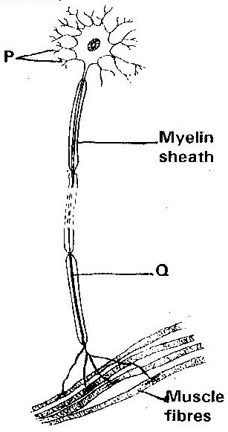
(b) The diagram below represents a neurone

(i) Name the neurone ( 1 mark)
(ii) Name the parts labeled P and Q ( 2 marks)
- (a) Name the hormone that is responsible for apical dominance ( 1 mark)
(b) What is thigmotropism? ( 1 mark)
- Describe the structure and functions of the various parts of the human ear
( 20 marks)
- Nocturnal animals such as the owl are capable of seeing fairly well at night
What two retinal adaptations have made this possible? ( 2 marks)
- State two functions of the human ear? ( 2 marks)
- State four differences between co- ordination of the human eye’s internal response to light and that of tropic movement of the flowering plant in response to light. ( 4 marks)

- The figure below shows a stem of a plant growing round a tree trunk
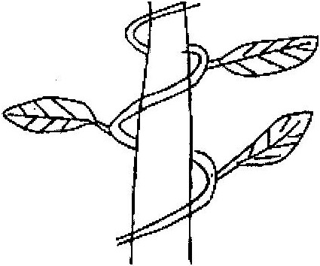

(i) What is the name of the response, which causes the twisted growth?
( 1 mark)
(ii) Explain how the twisting process is accomplished ( 2 marks)
(iii) Identify the state of leaves if the plant is autotrophic ( 2 marks)
- Euglena is positively phototactic. Of what biological significance is this characteristics? ( 1 mark)
- State the function of acetylcholine ( 2 marks)
- Where in the human body is the relay neurone located? ( 1 mark)
- State three effects of nicotine to human health ( 3 marks)
- state the part of the eye involved in
(i) Colour vision
(ii) Maintaining shape of the eyeball
(iii) Change in diameter of the lens

PRACTICAL REVISION QUESTIONS
SAMPLE PAPER 1
- Below are photographs labeled P,Q,R,S,T,U and V of twigs and leaves obtained from plants. Examine them.
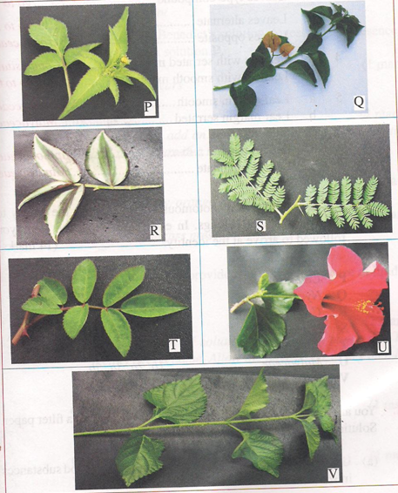
(a) Using observable features in the photographs. Complete the dichotomous key given below
1 a Simple leaves go to 2
b Compound leaves go to 5

2 a Leaves net veined go to 3
b leaves parallel- veined Commelinaceae

3 a ……………………………….. go to 4
b leaves with smooth margin Nyctaginaceae

4 a Leaves alternate Malvaceae
b Verbenaceae

5 a Malvaceae
b Leaves bipinnate Bignoniaceae

6 a leaflets with serrated margin Compositae
b leaflets with smooth margin Papilioceae

- Use the completed dichotomous key to identify the family to which each plant belongs
In each case show the steps you followed to arrive at the identity. ( 12 marks)

Identity Steps Followed
P
Q
R
S
T
U
V

2. You are provided with solutions labeled P,Q,S and a filter paper. The solution labeled P will be used in parts (a), (b) and (c).
Solution Q is iodine solution.

- Use the iodine solution to test for the presence of food substance in solution P.
Food substance ( 1 mark)

Procedure ( 1 mark)

Observation ( 1 mark)

Conclusion ( 1 mark)

Solutions S is Benedict’s solution

- Use the Benedict’s solution to test for the presence of the food substance is solution P.
Food substance ( 1mark)

Procedure ( 2 marks)

Observation ( 1mark)

Conclusion ( 1 mark)

(c) Using the filter paper provided to test for the presence of lipids in solution P.
Procedure ( 2 marks)

Observation ( 1mark)

Conclusion ( 1 mark)

3. Below are photographs labeled J and K of organs obtained from different animals. The organs perform similar functions. Examine them.
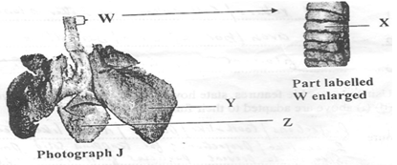
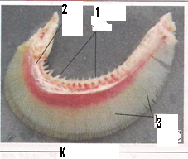

(a) Identify the organs ( 2 marks)
J
K
(b) State the functions performed by the organs ( 1 mark)
(c) Name the parts labeled X. Y and Z in photographs ( 3 marks)
X
Y
Z

(d) (i) Identify the parts labeled 1, 2 and 3 in photographs K ( 3 marks)
1.
2.
3.
(ii) Using observable features. State how the parts labeled 1 and 3 you identified in (d)(i) above are adapted to their function ( 4 mark)
1
2.
3

Sample paper 2
- Below is a photograph of a dissected animal. Examine the photograph

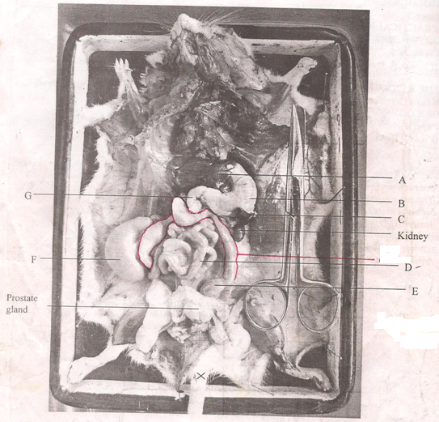
(a) Name the parts labeled A, B, C D and G ( 5 mks)

(b) State the function of the structures labeled E and F ( 1 mk)

(c) In the photograph label the structure where vitamin K is produced ( 1 mk)

(d) (i) Name the sex of the mammal in the photograph ( 1 mk)
(ii) Give a reason for your answer in (d) (i) above ( 1 mk)

(e) (i) The actual length of the dissecting scissors in the photographs is 15 cm
Calculate the magnification of the photograph ( 2 mks)

(ii) Calculate the actual length of the mammal from the tip of the nose to
point X on the tail ( 2 mks)

2. You are provided with substance labeled S,T,U X and Y. S(Egg solution), T(Dilute milk solution) and U(Starch solution) are food substance. While X is 10% sodium hydroxide solution and Y is 1% copper sulphate solution. Carry out tests to determine the food substance (s) in S. T and U. ( 9 mks)

Substance | Food substance being tested for | Procedure | Observations | Conclusion
S
T
U

3. Below are photographs of specimens obtained from plants. Examine the
Photographs
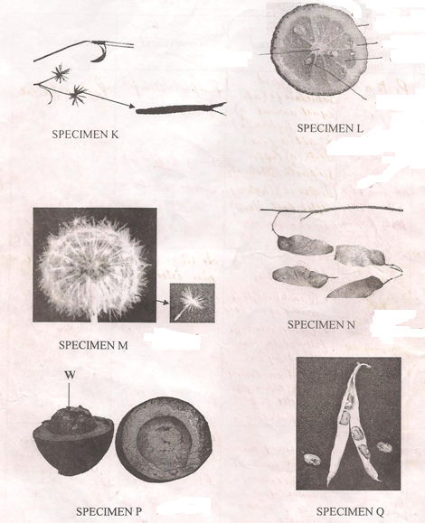
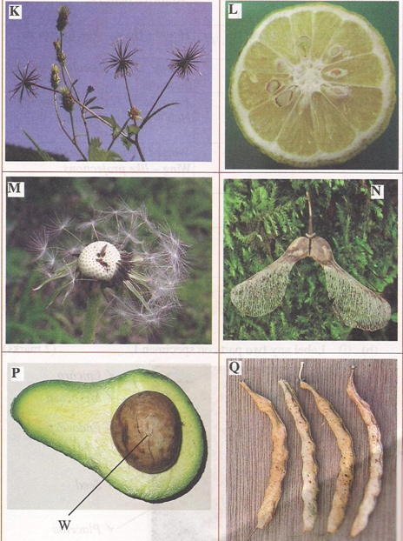

In the table below name the mode of dispersal and the features that adapt the specimen (s) to that mode of dispersal. ( 12 mks)

Specimen | Mode of dispersal | Adaptive features
K

L

M

N

P

Q

- (i) Label any two parts on specimen L ( 2 mks)

(ii) State the type of placentaion in specimen L ( 1 mk)

- Name the structure labeled W on specimen P ( 1 mk)

Sample paper 3
- You are provided with photographs of specimen U, X, Y and Z

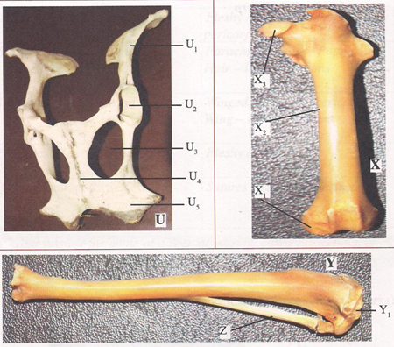
- Name the bones labeled U₁, U₄, U₅, X, Y and Z and where each is located in the mammalian body (12mks)
Bone | Bone identity | Location
U₁
U₄
U₅
X
Y
Z
- (i) Name the fluid substance found between X₁ and Y₁
(ii) State the function of the fluid substance named in (b)(i) above
- Name the structure that joins the bones together at the joint formed between X₁ and Y₁
- (i) State the difference between a hinge joint and the one formed between X₃ and U₂

(ii) State two structures labeled in the photographs that form a ball and socket joint(2mks)
- Name the structure at the elbow that performs same function as the patella

- You are provided with a specimen Q
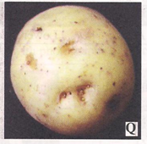
- Cut two equal cubes whose sides are about 1cm from specimen Q. Place one of the cubes into a boiling tube labeled A. Crush the other using pestle and mortar. Place the crushed material in another boiling tube labeled B.
To each boiling tube add 4ml of hydrogen peroxide.
- Record your observations. (2mks)

- Account for the results in (a)(i) above. (2mks)

- Write an equation for the breakdown of hydrogen peroxide. (1mk)

- Peel half of specimen Q and crush in a motar. Use the reagents provided to test for the various food substances in the extract obtained from the crushed material.

- Record the procedures, observations and conclusions in the table below.(9mks)
Food substance | Procedure | Observations | Conclusion
- The photographs labeled set E₁, E₂, M₁ and M₂ show seedlings that were grown under different conditions. Study them to answer the questions that follow

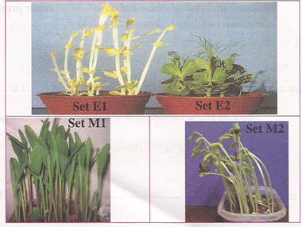
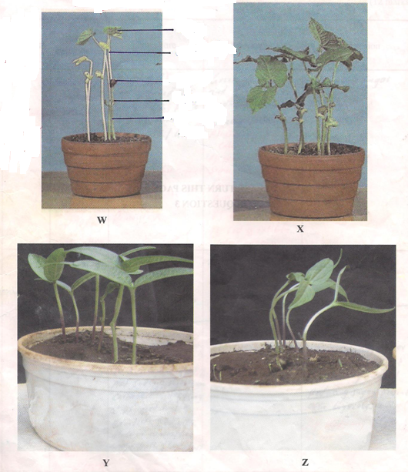
- Label any three parts of the seedlings in photograph W(E1) (3 mks)

- (i) Name the type of germination exhibited by the seedlings ( 1 mk)
………………………………………………………………………………………………

(ii) Give a reason for your answer in b(i) above ( 1 mk)
………………………………………………………………………………………………

- Seedlings in photographs W and X were planted at the same time. State the conditions under which the seedlings were grown ( 2 mks)
Seedlings in photographs W (E1) ……………………………………………………………

Seedlings in photographs X (E2) ………………………………………………………………

- When plants are grown in the condition named for seedlings in photograph W, they exhibit a certain phenomenon
  - Name the phenomenon ( 1 mk)

  - State the significance of the phenomenon in d(i) above ( 1mk)

- Using observable features only state three differences between the seedling in photographs W (E1) and X (E2) ( 3 mks)
- Seedlings in photographs Y and Z were planted at the same time but under different conditions. Explain how the response exhibited by the seedlings in photographs Z occurred. ( 2 mks)

