NAME……………………………………………………………………ADM NO…………..CLASS…………

FORM FOUR 231/2
BIOLOGY
PAPER 2
(THEORY)
FEB 2016
2HRS
KAHUHO UHURU HIGH SCHOOL
MID TERM EVALUATION EXAM

SECTION A (40 MARKS)

- The table below shows the approximate distribution of blood groups in a sample of 100 people in a population.

Blood group | Frequency | Rhesus +ve | Rhesus -ve
A | 26 | 22 | 4
B | 20 | 18 | 2
AB | 4 | 3 | 1
O | 50 | 43 | 8

- Calculate the percentage of Rhesus negative (Rh-ve) individuals in the population? (1 mark)
………………………………………………………………………………………………………………………………………………………………………………………………………………………………………………………………………
- Account for
(i) The large number of blood group O individuals in a population. (2 marks)
………………………………………………………………………………………………………………………………………………………………………………………………………………………………………………………………………
(ii) The small number of individuals with blood group AB. (2 marks)
………………………………………………………………………………………………………………………………………………………………………………………………………………………………………………………………………
- The diagram below represents a blood smear on a glass slide.

A
B
C

(i) State the importance of structure C being large numbers in the blood smear. (1 mark)
…………………………………………………………………………………………………………………………………………………………………………………………………………………………………………………………………………
(ii) Give a reason why structure C would be found in large numbers in high altitude than in low altitude. (1 mark)
…………………………………………………………………………………………………………………………………………………………………………………………………………………………………………………………………………
(iii) Name the process by which structure A would engulf structure B. (1 mark)
…………………………………………………………………………………………………………………………………………………………………………………………………………………………………………………………………………

2. Study the diagram below and answer the questions that follow.

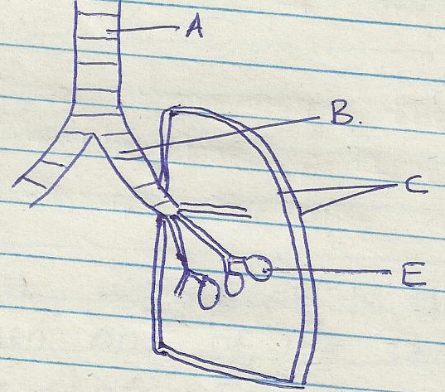

a) Name the part labeled A and B (2marks)
…………………………………………………………………………………………………………………………
…………………………………………………………………………………………………………………………
…………………………………………………………………………………………………………………………
b) State the function of the part labeled C (2marks)
…………………………………………………………………………………………………………………………
…………………………………………………………………………………………………………………………
…………………………………………………………………………………………………………………………
c) How is he part labeled E adapted to its function (2marks)
…………………………………………………………………………………………………………………………
…………………………………………………………………………………………………………………………
…………………………………………………………………………………………………………………………
d) Identify the structure that perform the same function as one illustrated above in (2marks)
i) Amoeba

ii) Fish

3. A health plant was kept in the dark for 48 hrs .Then one of its leaves (x) was enclosed in a glass flask as down below .The whole plant was then returned to light
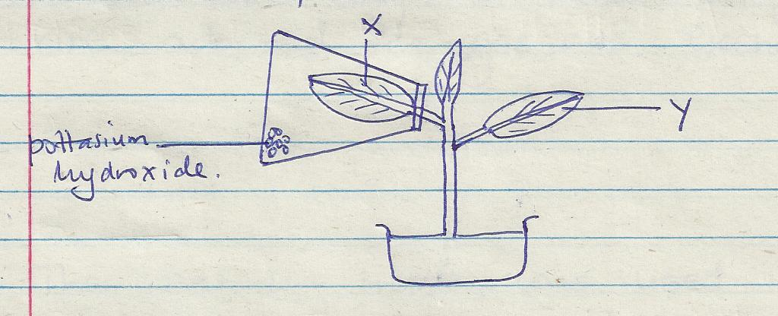

- After 48 hrs the leaves were tested for starch .What observations do you expect. (2marks)
…………………………………………………………………………………………………………………
…………………………………………………………………………………………………………………
…………………………………………………………………………………………………………………
b) i) What conclusions can you draw from this observation (1mark )
…………………………………………………………………………………………………………………
…………………………………………………………………………………………………………………
ii) Explain your conclusion in b (i) above (2marks)
…………………………………………………………………………………………………………………
…………………………………………………………………………………………………………………
…………………………………………………………………………………………………………………
- Why was the plant kept in the dark for 48 hrs (1mark)
…………………………………………………………………………………………………………………
…………………………………………………………………………………………………………………
- State two ways in which the green leaves are adapted for gaseous exchange (2marks)
…………………………………………………………………………………………………………………
…………………………………………………………………………………………………………………
…………………………………………………………………………………………………………………
4) Below is a diagram of a sperm cell.
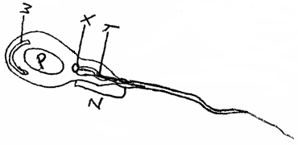

(a) Identify parts labeled X and Y. (2 marks)
…………………………………………………………………………………………………………………………………………………………………………………………………………………………………………………………………………
……………………………………………………………………………………………………………………………………
(b) Explain how parts W and Z adapt the cell to its function. (4 marks)

W………………………………………………………………………………………………………………………………………………………………………………………………………………………………………………………………………
…………………………………………………………………………………………………………………………………………………………………………………………………………………………………………………………………………
Z………………………………………………………………………………………………………………………………………………………………………………………………………………………………………………………………………
…………………………………………………………………………………………………………………………………………………………………………………………………………………………………………………………………………
(c) Using letter P identify or label on the diagram the part of the cell rich in DNA. (1 mark)

(d) State the function of part X. (1 mark)
………………………………………………………………………………………………………………………………………………………………………………………………………………………………………………………………………
5 Below is a diagram of a structure found in plants.

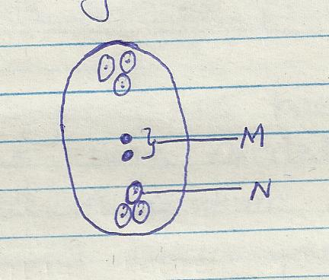

a) (i) Indentify the structure (1mrk)
…………………………………………………………………………………………………………………
…………………………………………………………………………………………………………………

(ii) Name the parts labeled M and N (2mrks)
…………………………………………………………………………………………………………………
…………………………………………………………………………………………………………………
…………………………………………………………………………………………………………………

b) Explain why cross pollination is more advantageous to a plant species than self –pollination (2marks)
…………………………………………………………………………………………………………………
…………………………………………………………………………………………………………………
…………………………………………………………………………………………………………………
c) Explain how double fertilization takes place in the above structure. (3marks)
…………………………………………………………………………………………………………………
…………………………………………………………………………………………………………………
…………………………………………………………………………………………………………………
…………………………………………………………………………………………………………………

SECTION B; (40 MARKS)
Answer question 6(compulsory )and either question 7 or 8 in the space provide after question 8 .
6 An investigation of haemolysis of human red blood cell was carried out .Red blood cells were placed in sodium chloride solution and percentage of haemolysed cell established.

Sodium chloride conce .g/cm³(%) | 0.33 | 0.36 | 0.38 | 0.39 | 0.42 | 0.44 | 0.48
Haemolysed red blood cells (%) | 100 | 91 | 82 | 69 | 30 | 15 | 0

a) (i) Using the data above, plot a graph of haemolysed red blood cell against salt concentration (6marks)
(ii) At what percentage of sodium chloride was the number of haemolysed cells equal to those that are not haemolysed.
…………………………………………………………………………………………………………………
………………………………………………………………………………………………………………… (1mark)
(iii) What is the percentage of cells haemolysed at salt concentration of 0.45 percent. (1 mark)
…………………………………………………………………………………………………………………
…………………………………………………………………………………………………………………
b) Account for the result obtained at
i) 0.33% salt concentration (2marks)
…………………………………………………………………………………………………………………
…………………………………………………………………………………………………………………
…………………………………………………………………………………………………………………
ii) 0.48% salt concentration (2marks)
…………………………………………………………………………………………………………………
…………………………………………………………………………………………………………………
…………………………………………………………………………………………………………………
iii) Suppose the red blood cells were placed in 0.50%salt concentration .Explain what would happen (2marks)
…………………………………………………………………………………………………………………
…………………………………………………………………………………………………………………
…………………………………………………………………………………………………………………
c) i) Distinguish between lymphocytes and phagocytes (2marks)
…………………………………………………………………………………………………………………
…………………………………………………………………………………………………………………
…………………………………………………………………………………………………………………

ii) State two ways in which white blood cells defend the body against infections. (2 marks)
…………………………………………………………………………………………………………………
…………………………………………………………………………………………………………………
…………………………………………………………………………………………………………………
d) State two adaption of red blood (2marks)
…………………………………………………………………………………………………………………
…………………………………………………………………………………………………………………
…………………………………………………………………………………………………………………
- a)What is apical dominance (2 marks)
- state Two applications of the above in agriculture (2 marks)
- Explain the role of the following hormones in growth and development of plants.
- Auxins (8marks)
- Gibberellins (8marks)
8 Explain the adaptation of the small intestine to their functions. (20marks)
………………………………………………………………………………………………………………………………………………………………………………………………………………………………………………………………………………………………………………………………………………………………………………………………………………
………………………………………………………………………………………………………………………………………………………………………………………………………………………………………………………………………………………………………………………………………………………………………………………………………………
………………………………………………………………………………………………………………………………………………………………………………………………………………………………………………………………………………………………………………………………………………………………………………………………………………
………………………………………………………………………………………………………………………………………………………………………………………………………………………………………………………………………………………………………………………………………………………………………………………………………………
………………………………………………………………………………………………………………………………………………………………………………………………………………………………………………………………………………………………………………………………………………………………………………………………………………
………………………………………………………………………………………………………………………………………………………………………………………………………………………………………………………………………………………………………………………………………………………………………………………………………………
………………………………………………………………………………………………………………………………………………………………………………………………………………………………………………………………………………………………………………………………………………………………………………………………………………
………………………………………………………………………………………………………………………………………………………………………………………………………………………………………………………………………………………………………………………………………………………………………………………………………………
………………………………………………………………………………………………………………………………………………………………………………………………………………………………………………………………………………………………………………………………………………………………………………………………………………
………………………………………………………………………………………………………………………………………………………………………………………………………………………………………………………………………………………………………………………………………………………………………………………………………………
…………………………………………………………………………………………………………………………………………………………………………………………………………………………………………………………………………

