**Name …………………………………………………………………….…… Adm.No. ……..……….… Class …….……….**

**231/2**

**BIOLOGY**

**Paper 2**

**(Theory)**

**July 2011**

**2 hours**

**KAHUHO UHURU HIGH SCHOOL**

**KCSE Mock Examination 2011 Form Four**

**INSTRUCTIONS TO CANDIDATES**

This paper has **TWO** sections, **A** and **B**

Answer **ALL** the questions in section **A**

Answer question **6** and any other **ONE** in section **B**

All answers should be written in the spaces provided on the question paper.

For Official Use Only

|  |  |  |
| --- | --- | --- |
| **SECTION** | **QUESTION** | **SCORE** |
| A | 1 |  |
|  | 2 |  |
| 3 |  |
| 4 |  |
| 5 |  |
| B | 6 |  |
| 7 or 8 |  |
|  | TOTAL |  |

**This paper consists of 8 printed pages**

**Candidates should check the question paper to ensure that all the printed pages are printed as indicated and no questions are missing**

**SECTION A (40 MARKS)**

1. Suggest the identity of the mammal (1mark)

………………………………………………………………………………………………………………………………………………………………………………………………………………………………………………………………………………………………………………………………

1. Give a reason for your answer above (1mark)
2. The figure below is a diagram of an intestinal villus.

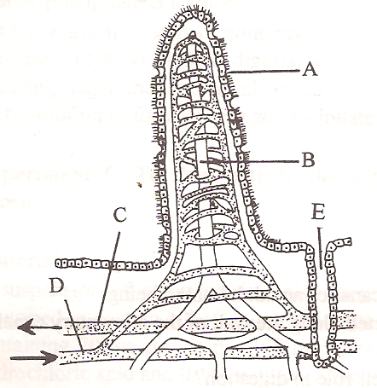

1. Name the parts labeled A&B (2marks)

A…………………………………………………..

C…………………………………………………..

1. What is the importance of intestinal villi (1mark)

……………………………………………………………………………………………………………………………………………………………………………………………………………………………………………………………………………………………………………………………………………………………………

1. (i)Name any TWO pancreatic enzymes (2marks)

………………………………………………………………………………………………………………………………………………………………………………………………………………………………………………………………………………………………………………………………………………………………………………………………………………………………………………………………………………………………………………………………………

(ii)Give one function of any one of the enzymes named above (1mark)

…………………………………………………………………………………………………………………………………………………………………………… ……………………………………………………………………………………………………………………………………………………………………………

1. The dental formula of a certain animal is as shown below.

I $\frac{2}{1}$, C $\frac{0}{0}$ PM $\frac{3}{2}$, M $\frac{3}{3}$.

………………………………………………………………………………………………………………………………………………………………………………………………………………………………………………………………………………………………………………………………

1. a) What is meant by the term sex linkage (2marks)

………………………………………………………………………………………………………………………………………………………………………………………………………………………………………………………………………………………………………………………………………………………………………………………………………………………………………………………………………………………………………………………………………………………

b) Name two sex linked traits in humans (2marks)

………………………………………………………………………………………………………………………………………………………………………………………………………………………………………………………………………………………………………………………………………………………………………………………………………………………………………………………………………………………………………………………………………………………

c) In *Drosophila melanogaster* the inheritance of red colour is sex linked.The gene for red eye is dominant over white eye.A cross was made between a homozygous red eyed female and a white eyed male. Work out the phenotypic ratio of F1 generation.(Use R to represent the gene for red eyes) . (4 marks)

1. The diagram below shows the transverse section of a young stem.

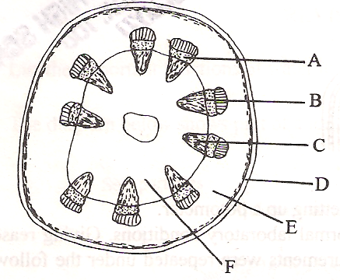

1. (i) What are the functions of the structures labeled. (3marks)

A……………………………………………………………………………………………………………………………

B…………………………………………………………………………………………………………………………….

C…………………………………………………………………………………………………………………………….

(ii)What type of cells are found in the part E…………………………………………………………………… (1mark)

1. Name one way in which parts labeled C are adapted to their functions (1mark)

…………………………………………………………………………………………………………………………………………………………………………………………………………………………………………………………………………………………………………………………………………………………

1. To what class does the stem belong? Give one reasons to support your answer (2marks)

………………………………………………………………………………………………………………………………………………………………………………………………………………………………………………………………………………………………………………………………………………………………………………………………………………………………………………………………………………………………………………………………………

1. What is the importance of root hairs (1mark)

…………………………………………………………………………………………………………………………………………………………………………………………………………………………………………………………………………………………………………………………………………………………

1. a) Name any TWO evidence of organic evolution (2marks)

………………………………………………………………………………………………………………………………………………………………………………………………………………………………………………………………………………………………………………………………………………………………………………………………………………………………………………………………………………………………………………………………………………………

b) Distinguish between homologous and analogous structures (2marks)

………………………………………………………………………………………………………………………………………………………………………………………………………………………………………………………………………………………………………………………………………………………………………………………………………………………………………………………………………………………………………………………………………………………

c) Explain the mechanism of evolution as proposed by the theory of natural selection (4marks)

…………………………………………………………………………………………………………………………………………………………………………………………………………………………………………………………………………………………………………………………………………………………………………………………………………………………………………………………………………………………………………………………………………………………………………………………………………………………………………………………………………………………………………………………………………

…………………………………………………………………………………………………………………………………………………………………………………………………………………………………………………………………………………………………………………………………………………………………………………………………………………………………………………………………………………………………………………………………………………………………………………………………………………………………………………………………………………………………………………………………………

1. The figure below illustrates the relationship between a developing foetus and the maternal tissues.

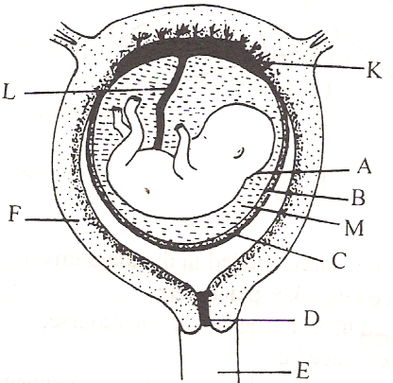

1. Name the parts labeled (3marks)

A………………………………………………………………….

D………………………………………………………………

L…………………………………………………………………..

1. Identify the part labeled K and describe its functions (2marks)

………………………………………………………………………………………………………………………………………………………………………………………………………………………………………………………………………………………………………………………………………………………………………………………………………………………………………………………………………………………………………………………………………

1. Name the fluid present in the cavity labeled M and give at least one of its functions (2marks)

………………………………………………………………………………………………………………………………………………………………………………………………………………………………………………………………………………………………………………………………………………………………………………………………………………………………………………………………………………………………………………………………………

**SECTION B (40 MARKS)**

Answer question 6 ( Compulsory) and either question 7 or 8 in the spaces provided after question 8.

1. In an experiment to investigate the effect of heat on germination of seeds, ten bags each containing 50 pea seeds were placed in water bath maintained at 800C. After every two minutes, a bag was removed and seeds contained in it planted.The number that germinated was recorded. The procedure used for pea seeds was repeated for wattle seeds.The results obtained were as shown in the table below.

|  |  |  |
| --- | --- | --- |
|  | **Number of seeds that germinated** | |
| **Time(Minutes)** | **Pea seeds** | **Wattle seeds** |
| **0** | **50** | **0** |
| **2** | **50** | **0** |
| **4** | **46** | **0** |
| **6** | **38** | **4** |
| **8** | **30** | **16** |
| **10** | **12** | **26** |
| **12** | **4** | **30** |
| **14** | **0** | **34** |
| **16** | **0** | **36** |
| **18** | **0** | **38** |
| **20** | **0** | **39** |
| **22** | **0** | **39** |

1. Using a suitable scale on the same axis, draw graphs of time in hot water against the number of seeds that germinate for each plant (8 marks)



b)From 0-2 minutes, all the seeds germinated. Explain. (2marks) ………………………………………………………………………………………………………………………………………………….…………………………………………………………………………………………………………………………………………………………………………………………………………………………………………………………………………………………………………………………………………………………………………

c)Account for the decrease in the number of pea seeds that germinated from 4-12 minutes (3 marks)

………………………………………………………………………………………………………………………………………………………………………………………………………………………………………………………………………………………………………………………………………………………………………………………………………………………………………………………………………………………………………………………………………………

d)From 14-22 minutes, zero pea seeds germinated. Explain why (2 marks)

………………………………………………………………………………………………………………………………………………………………………………………………………………………………………………………………………………………………………………………………………………………………………………………………………………………………………………………………………………………………………………………………………………

e)An increase in minutes had a corresponding increase in the number of wattle seeds that

germinated. Explain ( 2 marks)

………………………………………………………………………………………………………………………………………………………………………………………………………………………………………………………………………………………………………………………………………………………………………………………………………………………………………………………………………………………………………………………………………………

f)From 20-22 minutes, a higher number of wattle seeds germinated and were recorded. Explain ( 2 marks)

………………………………………………………………………………………………………………………………………………………………………………………………………………………………………………………………………………………………………………………………………………………………………………………………………………………………………………………………………………………………………………………………………………

g)State one method of breaking seed dormancy ( 1 mark)

………………………………………………………………………………………………………………………………………………………………………………………………………………………………………………………………………………………………………………………………………………………………………………………………………………………………………………………………………………………………………………………………………………

1. Describe the adaptations of Xerophytes to their habitats (20 marks)

8. Describe the adaptations of the mammalian ear to its functions (20 marks)

…………………………………………………………………………………………………………………………………………………………………………………………………………………………………………………………………………………………………………………………………………………………………………………………………………………………………………………………………………………………………………………………………………………………………………………………………………………………………………………………………………………………………………………………………………

…………………………………………………………………………………………………………………………………………………………………………………………………………………………………………………………………………………………………………………………………………………………………………………………………………………………………………………………………………………………………………………………………………………………………………………………………………………………………………………………………………………………………………………………………………

…………………………………………………………………………………………………………………………………………………………………………………………………………………………………………………………………………………………………………………………………………………………………………………………………………………………………………………………………………………………………………………………………………………………………………………………………………………………………………………………………………………………………………………………………………

…………………………………………………………………………………………………………………………………………………………………………………………………………………………………………………………………………………………………………………………………………………………………………………………………………………………………………………………………………………………………………………………………………………………………………………………………………………………………………………………………………………………………………………………………………

…………………………………………………………………………………………………………………………………………………………………………………………………………………………………………………………………………………………………………………………………………………………………………………………………………………………………………………………………………………………………………………………………………………………………………………………………………………………………………………………………………………………………………………………………………

…………………………………………………………………………………………………………………………………………………………………………………………………………………………………………………………………………………………………………………………………………………………………………………………………………………………………………………………………………………………………………………………………………………………………………………………………………………………………………………………………………………………………………………………………………

…………………………………………………………………………………………………………………………………………………………………………………………………………………………………………………………………………………………………………………………………………………………………………………………………………………………………………………………………………………………………………………………………………………………………………………………………………………………………………………………………………………………………………………………………………

…………………………………………………………………………………………………………………………………………………………………………………………………………………………………………………………………………………………………………………………………………………………………………………………………………………………………………………………………………………………………………………………………………………………………………………………………………………………………………………………………………………………………………………………………………

…………………………………………………………………………………………………………………………………………………………………………………………………………………………………………………………………………………………………………………………………………………………………………………………………………………………………………………………………………………………………………………………………………………………………………………………………………………………………………………………………………………………………………………………………………